Our Lady of the Valley Religious Education

April 2026 Activity Packet

Grades Pre-K-2

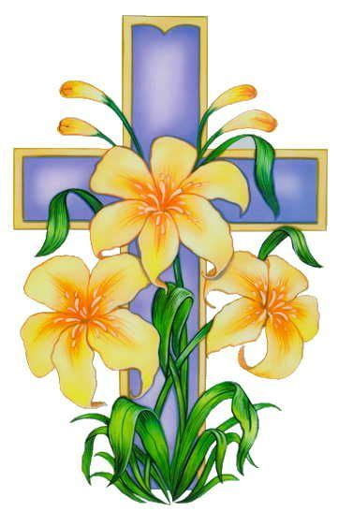
Name: ________________________________________
April 2026 Table of Contents
Overview………………………………………………………………………………………….3
Learning Standards………………………………………………………………………….......6
Lesson Pacing Guide……………………………………………………………………………10
Activities…………………………………………………………………………………………15
Pre-K/Kindergarten………………………………………………………………….....15
Week 1…………………………………………………………………………...15
Week 2…………………………………………………………………………...16
Week 3…………………………………………………………………………...17
Grade 1………………………………………………………………………………......19
Week 1…………………………………………………………………………...19
Week 2…………………………………………………………………………...20
Week 3…………………………………………………………………………...21
Grade 2…………………………………………………………………………..............23
Week 1…………………………………………………………………………...23
Week 2…………………………………………………………………………...25
Week 3…………………………………………………………………………...27
Review…………………………………………………………………………………………...29

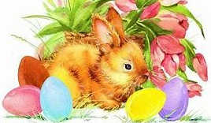

April 2026 Overview: Grades Pre-K-2
Theme: Month of the Holy Eucharist
Litany of the Holy Eucharist Title: Jesus, Bread of Life
Eighth Office of the Sacred Heart: Zealous Friend of Our Lord
Invocation of the Eighth Choir of Holy Angels: By the intercession of St. Michael and the celestial Choir of Archangels may the Lord give us perseverance in faith and in all good works in order that we may attain the glory of Heaven.
Eighth Aspiration to the Sacred Heart: Heart of Jesus, consumed with zeal for the glory of the Father, animate my heart with an ardent zeal for your glory, and my own sanctification.
Thematic Guiding Questions, Pre-K-2:
- What is the Holy Eucharist? Why do we celebrate it?
- How do the holy angels treat Our Lady and the Holy Eucharist? What do they teach us about how we should respond to Mother Mary and Jesus?
- How do the holy angels help us to prepare for Holy Communion?
- You will soon make your First Holy Communion! We take steps to prepare for the First Holy Communion. What have you been doing to get ready for First Holy Communion?
- Why do we do these things to get ready- what is special about Holy Communion?

Saint of the Month: St. Louis de Montfort was a French priest and third-order Dominican who lived in the late 1600s and early 1700s. Founder of the Company of Mary, a congregation for missionaries, St. Louis de Montfort offered to God his efforts to evangelize and bring hearts to Mary and Jesus. Spreading devotion to the Two Hearts through teaching the spiritual process of total consecration to Jesus through Mary, St. Louis de Montfort continues to make an impact on souls, thanks to the lasting contributions he made, especially in the form of his powerful writings. Saint Louis de Montfort developed devotion to Our Lady through devotion to the holy angels, who serve Our Lady, Queen of the Angels. He helped to increase love for Our Lady by describing her perfections as being greater than those of the holy angels, teaching that God loves Our Lady more than all of the holy angels, since she is the Mother of Jesus, our Savior. In his written correspondences, St. Louis de Montfort would salute the guardian angels of the recipients of his letters! He always gave honor to Our Lady, Queen of the Angels and the holy angels in her royal court, modeling to others that true devotion to Our Lady is made possible by imitating the holy angels’ devotion to her.
Monthly Challenge: At church, kneel before the Blessed Sacrament in the tabernacle, and say a special prayer. You may kneel on the communion rail to be closer to the Blessed Sacrament. Thank Jesus for giving you the gift of His Body, Blood, Soul, and Divinity in the Holy Eucharist, sharing His life with you at every Holy Communion. Ask God to bless all those preparing for First Holy Communion, and to help everyone who has made their First Holy Communion to receive Jesus with the same joy they did at their First Holy Communion, so that every Holy Communion is new and beautiful. Pray that the holy angels would help each First Communicant to prepare well for receiving Jesus, and pray that they would help you to be ready to receive Holy Communion with great love, too. Ask members of each of the choirs of holy angels to spiritually accompany each First Communicant to the altar. After thanking Jesus, thank Our Lady for giving you her Son, and for being with you. Visit an image of Our Lady, such as a statue or painting, or choose a holy card with an image of Our Lady to bring with you when you pray before the Blessed Sacrament.
Practice the eighth Office of the Sacred Heart. Pray to be a zealous friend of Christ by modeling friendship to Christ in your interactions with others. Ask Our Lord to help you to bring others into deeper friendships with Him. In your prayers, ask Jesus to help you to be a good friend to Him, and to others, that you may reveal His Heart of love to all those whom you meet, thereby inspiring in their hearts a similar zeal and love for Jesus. Meditate on how the holy angels serve as faithful friends to Christ and His people, then pray to imitate them in their friendship.
Overall Learning Goals: Our goal this month is to learn about what it means to have faith, as we explore how we can practice our faith in God, especially through devotion to Jesus’ Presence in the Holy Eucharist. We will learn about how God has shown His faithfulness to us, teaching us that we can put our trust in Him, believing what He says. It is our goal to better understand our beliefs, the cornerstones of our Catholic Faith, especially our beliefs about Jesus and the sacraments.
Summary of Activities: Through exploring Sacred Scripture and Sacred Tradition, we will learn about how faith transforms us. We will learn about how we live out our faith through traditions in our families and in the Church, with a special focus on Lent and Easter traditions that glorify the Body of Christ. Stories of the Holy Bible will show us how others before our time lived their faith in such a way that honored Christ’s Presence, and illuminate for us how Jesus is calling us to live out our faith in Him now. Our activities will focus on how we grow in faith through friendship with Jesus, particularly, as we encounter Him in the Holy Eucharist.
Additional Enrichment Ideas:
- Send Easter cards, similar to the tradition of sending Christmas cards; or, create cards with Easter blessings to exchange as a family
- Take part in the Easter Triduum of Holy Week: Holy Thursday Mass, Good Friday services, and Holy Saturday’s Easter vigil in the lead-up to Easter Sunday
- Have your Easter foods blessed by a priest. Then, as a family, at your Easter meal, say a special mealtime prayer for grace
- In the Easter season, as we celebrate new life in Jesus, go on a springtime nature walk to point out signs of new life you see. Talk about how you see God in the world around you, and how it makes you feel to see the beauty of His creation
- Read stories in the Holy Bible together during the Easter season, such as Luke 24:1-12, “The Resurrection of Jesus,” and Luke 24:13-35, “The Road to Emmaus” (https://bible.usccb.org/bible/luke/24)
- Divine Mercy Sunday is the Sunday after Easter, April 12 this year. If possible, visit the nearby Shrine of Divine Mercy in Stockbridge, MA. Walk the grounds, pray the outdoor Stations of the Cross, and at 3:00 p.m., pray the Divine Mercy chaplet. You can also visit the shrine’s website to watch Masses and live chaplet prayers: https://www.shrineofdivinemercy.org/watch-national-shrine
  - Go to a Divine Mercy prayer service. Divine Mercy services include singing of the Divine Mercy chaplet, chanting of the Divine Mercy litany, readings of excerpts from St. Faustina’s diary, Benediction, Adoration, and the Divine Praises
- Listen to or sing the “Alleluia” together as a family to share your joy for Jesus’ Resurrection during the Easter season. A traditional Latin chant for the Easter vigil “Alleluia” is available here: https://www.youtube.com/watch?v=q2JEjEo2NGI
- Honor Jesus’ Presence in the Holy Eucharist in a special way this month. Go to Eucharistic Adoration, or say Eucharistic prayers (see our prayer compendium on the parish website for more, using the clickable table of contents to navigate to the prayer collection section: https://olveasthampton.org/religious-education/). Say a prayer for all of our priests who bring us the Bread of Life, feeding our souls with the Holy Eucharist, and celebrating all of the other sacraments that guide us closer to Jesus in the Holy Eucharist
- The World Day of Prayer for Vocations is on April 26. Pray together as a family for more men and women religious in our Church, and for everyone to discover where God is calling them to use their talents

Suggested Prayer Starter: Jesus, help me to be like you in my faith.
Suggested Mealtime Prayer: At this Easter table, we pray to God with happy hearts. Lord, bless our family, friends, and food. Thank you, Jesus, for bringing us new life. Thank you for all You have given us. Amen.

Scripture Memory Card

Everything is possible
to one who has faith.
 (Mark 9:23)

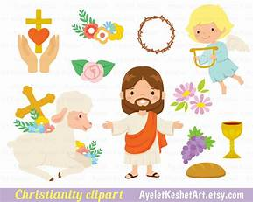

Learning Standards
Grade Level | Week | Activities | Learning Standards
Pre-K, Kindergarten | 1 | “Easter Eggs: Opening our Hearts to Faith” | K.6 We acknowledge God’s holy presence with respect, such as when we enter a church, pray, and go to Mass. In front of the tabernacle, we make the Sign of the Cross, which reminds us of how Jesus went onto the Cross out of love for us, to save us from sin.
Pre-K, Kindergarten | 2 | “Faith, Hope, and Butterflies” | K.3 We were created in God’s image, out of His love. We are made to be like Christ, loving and forgiving. Jesus helps us to grow more like Him.
Pre-K, Kindergarten | 3 | “The Sun and the Son: Following the Light of Faith” | K.7 When we go to church, we are in God’s house. It is a holy place where we experience God’s love, so we are respectful. We go to Mass and pray, following the priest as he celebrates the sacrament. In addition to attending Mass on Sundays, we attend for special holidays during the seasons, including Lent. At church, we show our love for God.  K.8 We are never alone, because God is always with us. We meet God by reading the Bible (the book of God’s words) and receiving the sacraments. He gave us Sacred Scripture (the Bible) and Sacred Tradition (the sacraments) so that we could know Him.
Grade 1 | 1 | “Alleluia: Singing our Faith in Jesus” | 1.4 Christ came to Earth so He could die on the Cross to save us from our sins. When we do something wrong, we sin. Jesus is without sin, so when He died for us, He redeemed us. His death helped to open Heaven for us. When He rose again, He showed that we can have new life in overcoming sin. We receive His resurrected Body in the Host, the consecrated Bread, at Mass to gain new life in Christ. Jesus helps us to avoid sin so we can be holier.
Grade 1 | 2 | “Signs of Spring: New Life and New Faith in Christ” | 1.7 Jesus is “hidden” in the Host; He is Present under the appearances of bread and wine. The consecrated Bread may be the form in which we see the Body outwardly, but the inner substance has changed, the bread fully becoming the Body of Christ.
Grade 1 | 3 | “The Road to Emmaus: Walking with Jesus” | 1.6 At Communion, we receive the Body of Christ in the Host.
Grade 2 | 1 | “Faith in our Friend, Jesus” | 2.7 God forgives us because He loves us. We see that He loves us because He gave us the sacraments to help us know Him and become closer to Him.
Grade 2 | 2 | “Before & After: How Faith in Jesus Helps Us” | 2.6 The sacraments are special celebrations of God’s love, signs of His Presence. The sacraments of Baptism, Confirmation, and Holy Orders, are received only once, because they leave marks on the soul for life, but the sacraments of Communion and Confession are received as often as possible… God is always part of our lives, and when we encounter Christ in the sacraments, our connection to Him is made stronger.
Grade 2 | 3 | “Faith in Jesus Forever: Easter and the Eucharist” | 2.1 God is all-knowing and all-powerful. We see signs of this in the sacraments, in the miracles God has worked, that no one besides God could bring to life.



April 2026 Lesson Pacing Guide (Suggested Schedule)
Grades Pre-K-2
Week Number/Date | Grade Level | Activities
Week 1  (April 6, 2026 – April 10, 2026) | Pre-K, Kindergarten | “Easter Eggs: Opening our Hearts to Faith”
Week 1  (April 6, 2026 – April 10, 2026) | Grade 1 | “Alleluia: Singing our Faith in Jesus”
Week 1  (April 6, 2026 – April 10, 2026) | Grade 2 | “Faith in our Friend, Jesus”
Week 2  (April 13, 2026 – April 17, 2026) | Pre-K, Kindergarten | “Faith, Hope, and Butterflies”
Week 2  (April 13, 2026 – April 17, 2026) | Grade 1 | “Signs of Spring: New Life and New Faith in Christ”
Week 2  (April 13, 2026 – April 17, 2026) | Grade 2 | “Before & After: How Faith in Jesus Helps Us”
Week 3  (April 20, 2026 – April 24, 2026) | Pre-K, Kindergarten | “The Sun and the Son: Following the Light of Faith”
Week 3  (April 20, 2026 – April 24, 2026) | Grade 1 | “The Road to Emmaus: Walking with Jesus”
Week 3  (April 20, 2026 – April 24, 2026) | Grade 2 | “Faith in Jesus Forever: Easter and the Eucharist”

Week Number/Date | Grade Level | Words to Practice | Definitions
Week 1  (April 6, 2026 – April 10, 2026) | Pre-K, Kindergarten | Crucifix | The Cross with the figure of Jesus on it. We look at the crucifix to remember how much Jesus loves us.
Week 1  (April 6, 2026 – April 10, 2026) | Grade 1 | Alleluia | A word translated from Hebrew into Greek, meaning “Praise the Lord.” This is said to celebrate Christ’s Resurrection on Easter Sunday. The “Alleluia” is not sung during Lent.
Week 1  (April 6, 2026 – April 10, 2026) | Grade 2 | Contrition | Saying that you are sorry for when you didn’t do what God asked you to do (in the Ten Commandments, His rules for us to follow). When you say the Act of Contrition, you are asking God to forgive you, and telling Him that you will make good choices to better follow Him.
Week 2  (April 13, 2026 – April 17, 2026) | Pre-K, Kindergarten | Easter | The day Jesus came back to life after dying on the Cross. This is on a different date every year, but always on a Sunday in the spring.
Week 2  (April 13, 2026 – April 17, 2026) | Grade 1 | Consecration | The holiest part of the Mass, when the bread and wine become the Body and Blood of Christ. When the priest consecrates the bread and wine, they are changed.
Week 2  (April 13, 2026 – April 17, 2026) | Grade 2 | Eucharist/Communion | The Eucharist is another word for the Host, the bread changed into Christ’s Body that we receive at Mass. The sacrament of Communion, of receiving Jesus’ Body, is called the Eucharist.
Week 3  (April 20, 2026 – April 24, 2026) | Pre-K, Kindergarten | Christian | Someone who believes in Jesus Christ, and lives their life like Him, with faith, hope, and love.
Week 3  (April 20, 2026 – April 24, 2026) | Grade 1 | Host | The consecrated bread changed into Christ’s Body that we receive at Mass after making our First Communion is called the “Sacred Host” because It is very holy.
Week 3  (April 20, 2026 – April 24, 2026) | Grade 2 | Absolution | Forgiveness of sins. We are absolved of our sins at Confession after we say an Act of Contrition expressing our sorrow for our sins, and promising to do all we can to stay away from sin.

Week Number/Date | Grade Level | Prayers to Practice | Text of Prayers
Week 1  (April 6, 2026 – April 10, 2026) | Pre-K, Kindergarten | The Lord’s Prayer (Our Father) | Our Father, Who art in Heaven,  Hallowed be Thy name.  Thy kingdom come.  Thy will be done on Earth, as it is in Heaven.  Give us this day our daily bread.  And forgive us our trespasses,  As we forgive those who trespass against us.  And lead us not into temptation,  But deliver us from evil. Amen.
Week 1  (April 6, 2026 – April 10, 2026) | Grade 1 | The Lord’s Prayer (Our Father) | Our Father, Who art in Heaven,  Hallowed be Thy name.  Thy kingdom come.  Thy will be done on Earth, as it is in Heaven.  Give us this day our daily bread.  And forgive us our trespasses,  As we forgive those who trespass against us.  And lead us not into temptation,  But deliver us from evil. Amen.
Week 1  (April 6, 2026 – April 10, 2026) | Grade 2 | Act of Contrition | Oh my God, I am heartily sorry for having offended Thee, and I detest all my sins, because I dread the loss of Heaven and the pains of Hell, but most of all because they offend Thee, my God, Who art all good, and deserving of all my love. I firmly resolve, with the help of Thy grace, to confess my sins, to do penance, and to amend my life. Amen.
Week 2  (April 13, 2026 – April 17, 2026) | Pre-K, Kindergarten | The Lord’s Prayer (Our Father) | Our Father, Who art in Heaven,  Hallowed be Thy name.  Thy kingdom come.  Thy will be done on Earth, as it is in Heaven.  Give us this day our daily bread.  And forgive us our trespasses,  As we forgive those who trespass against us.  And lead us not into temptation,  But deliver us from evil. Amen.
Week 2  (April 13, 2026 – April 17, 2026) | Grade 1 | The Lord’s Prayer (Our Father) | Our Father, Who art in Heaven,  Hallowed be Thy name.  Thy kingdom come.  Thy will be done on Earth, as it is in Heaven.  Give us this day our daily bread.  And forgive us our trespasses,  As we forgive those who trespass against us.  And lead us not into temptation,  But deliver us from evil. Amen.
Week 2  (April 13, 2026 – April 17, 2026) | Grade 2 | Act of Contrition | Oh my God, I am heartily sorry for having offended Thee, and I detest all my sins, because I dread the loss of Heaven and the pains of Hell, but most of all because they offend Thee, my God, Who art all good, and deserving of all my love. I firmly resolve, with the help of Thy grace, to confess my sins, to do penance, and to amend my life. Amen.
Week 3  (April 20, 2026 – April 24, 2026) | Pre-K, Kindergarten | The Lord’s Prayer (Our Father) | Our Father, Who art in Heaven,  Hallowed be Thy name.  Thy kingdom come.  Thy will be done on Earth, as it is in Heaven.  Give us this day our daily bread.  And forgive us our trespasses,  As we forgive those who trespass against us.  And lead us not into temptation,  But deliver us from evil. Amen.
Week 3  (April 20, 2026 – April 24, 2026) | Grade 1 | The Lord’s Prayer (Our Father) | Our Father, Who art in Heaven,  Hallowed be Thy name.  Thy kingdom come.  Thy will be done on Earth, as it is in Heaven.  Give us this day our daily bread.  And forgive us our trespasses,  As we forgive those who trespass against us.  And lead us not into temptation,  But deliver us from evil. Amen.
Week 3  (April 20, 2026 – April 24, 2026) | Grade 2 | Act of Contrition | Oh my God, I am heartily sorry for having offended Thee, and I detest all my sins, because I dread the loss of Heaven and the pains of Hell, but most of all because they offend Thee, my God, Who art all good, and deserving of all my love. I firmly resolve, with the help of Thy grace, to confess my sins, to do penance, and to amend my life. Amen.

April 2026 Pre-K-2 Activities: Week 1
Pre-K/Kindergarten- “Easter Eggs: Opening our Hearts to Faith”
On Easter Sunday, April 5 this year, we remember when Jesus came back after giving His life on the Cross. Mary Magdalene, a follower and friend of Jesus, saw Jesus three days after He had died, and couldn’t believe that it was really Him, alive. She went to tell Jesus’ apostles, His other followers and friends. They couldn’t believe that He was really alive, either, so they went to the tomb, a cave, where Jesus’ Body was buried, to see if His Body was still there. A rock was in front of the tomb, like a door, to keep the tomb closed.
The rock was rolled away from the cave, and they all could see that Jesus’ Body was not there. He really was walking around again, back to life! This was a surprise. No one had thought this could happen. It was a miracle. Jesus had not left them. He was still with them, and always would be in their hearts. Jesus is with us now, too, always in our hearts. Every time you look at a crucifix, a cross with Jesus on it, you can say a prayer and thank Jesus for giving His life to save us, and then coming back to life to be with us. At first, Mary Magdalene and the apostles couldn’t believe that Jesus had come back. Now, we know that Jesus has risen, that He can truly do anything out of love for us, because He is God. We have faith in Jesus: we trust in Him, because we see that He did not leave us alone. We believe that He is God, that He can do anything, and that He will keep helping us.
When you go on an Easter egg hunt, you open up the egg to see the surprise inside. On Easter, we remember the happiest surprise of all, a gift from God. We open our hearts to this joy. What did Jesus do on Easter? In the Easter egg, draw a picture of what we celebrate on Easter Sunday. You can also draw how you will show your faith in, and love for, God on Easter.

 April 2026 Pre-K-2 Activities: Week 2
Pre-K/Kindergarten- “Faith, Hope, and Butterflies”
On April 5, we celebrate Easter Sunday, remembering when Jesus came to life again after He gave up His life on the Cross. It is still the Easter season, which will be until May 24, the day of Pentecost. The season of Lent is 40 days, and the Easter season is 50 days. The last day of the Easter season is called “Pentecost,” because “Pente” means “5,” just like how the shape called a “pentagon” has 5 sides. During the Church year, we celebrate many special days in the lives of Jesus and Mary. Seasons like Lent and Easter repeat year after year. It’s like how we have the seasons of spring, summer, fall, and winter that come year after year. They are called “cycles,” because like circles, they keep going on. You can think of it like a bicycle wheel that keeps spinning when you pedal, not stopping.
Butterflies have life cycles, too. In the spring, we see everything growing again after winter, coming back to life. Flowers grow, baby animals are born, and caterpillars become butterflies. Caterpillars make a cocoon, which looks like a little sleeping bag, out of items like leaves. Over time, the caterpillar grows, and then is ready to come out of the cocoon as a beautiful butterfly. On butterfly wings, you can see all kinds of shapes and colors. Each butterfly is special. Jesus also helps us to grow. God the Father has made us all special and unique. He changes our hearts, filling us with even more love, joy, and kindness to share. We can trust in Jesus to keep helping us and giving us what we need to grow. When we trust in Jesus, He can help us to do wonderful things. When you pray, He lifts up your heart with hope, like a butterfly flying.
What can you do during the Easter season to grow in your faith, your hope and trust, in Jesus? How can we show our trust in Jesus? Draw your ideas on the butterfly wings.

April 2026 Pre-K-2 Activities: Week 3
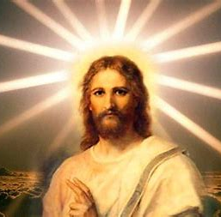
Pre-K/Kindergarten- “The Sun and the Son: Following the Light of Faith”
Spring is here, and flowers are growing! Flowers need sunlight to grow, and we need Jesus, the Son of God, to grow. When we trust in God, and believe in Him, we have faith. We have hope that God will help us. Even a tiny seed of faith can grow very big, like a beautiful Easter lily.
“Easter” comes from a German word, “eostarum,” meaning “dawn.” Dawn is right before the sun rises. The daylight starts to come after the night. Easter is like dawn, because Easter is a time of light, remembering our hope and joy in Jesus. Jesus brings light. He shows us what we need to do to be happy, kind, and to stay close to God. If we didn’t have light, we wouldn’t be able to see, and we wouldn’t know where to go. As Christians, we are followers of Christ. We live like Jesus, treating other people with love, and showing God our love for Him by going to church, praying, and teaching other people about God. We share Jesus’ light so that everyone can see His love. When we follow Jesus, He leads us to be in Heaven, His Kingdom, with Him someday.
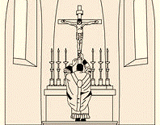
Priests used to say Holy Mass facing the East, where the sun rises. They would be turned towards the altar, towards Jesus, the Son. Now, priests usually say Holy Mass facing the people. Jesus is like the sun in the sky, because the sun rises: it comes up every day. When we see the sun, we’re happy, looking forward to going outside, and starting all of our adventures for the day. Jesus also rose, coming back to life after giving His life on the Cross. When we think about Jesus’ love for us, we have hope. We know that with Jesus, we can do wonderful things. It makes us happy to know He is always with us, in our hearts, watching over us and helping us.

A compass is a tool that shows us where to go. Compasses have the names of directions on them: north (up), south (down), east (right), or west (left). Below is a picture of a compass rose. This compass rose looks like a flower with petals, or a sun with rays of light.
Jesus always leads us in the right direction! Where is somewhere we can go to pray and show God our love for Him? In the middle of the compass rose, draw a picture of you spending time with Jesus there. You can cut out your compass and bring it with you to remember that Jesus is with you, wherever you go!

South
West
North
East

Bonus: Where does God want to lead us to be with Him someday?

_____________________________________________________________________________
April 2026 Pre-K-2 Activities: Week 1
Grade 1- “Alleluia: Singing our Faith in Jesus”
At Holy Mass, we did not sing the Alleluia during Lent. The Alleluia is a song of joy. Lent is a time when we are thinking about Jesus going on the Cross for us to save us from sins. The season of Lent is a time when we ask God to forgive us for when we have not followed His rules.
On Easter, we celebrate when Jesus came back to life after giving up His life on the Cross. We remember that God is stronger than death, that Jesus’ love and mercy is greater than sin. We are joyful that with God, anything is possible. He can and will do amazing things out of love for us. We sing the “Alleluia” again, because our hearts are so happy that Jesus is with us, to always help us and love us, giving us what we need. Singing is a way that we can praise God. Songs are prayers, too, ways we can tell God what is in our hearts: our love, joy, and hope for Him. When we go to church, pray, and share our love for God, we are living out our faith, showing what we believe, what we think, in the things that we do. We are showing God that we trust in Him, that we know He is with us, and that we want to thank Him for being with us.
After Easter Sunday, on April 5 this year, we celebrate an entire season of Easter, which is 50 days. During this time, we can keep sharing our joy in Jesus. We are joyful, because we have faith. We believe in the greatness of Jesus, the wonderful things He has done, like rising again.
What can you do this Easter to show your faith, and celebrate your joy for Jesus rising again? Draw your ideas on the Easter egg below.

What song do we sing again on Easter? ____________________________________________
April 2026 Pre-K-2 Activities: Week 2
Grade 1- “Signs of Spring: New Life and New Faith in Christ”
During the spring, we see the world around us filled with new life. It is a change from the snowy, quiet winter. The sun shines longer during the day, and under the warm sun, many colorful flowers grow. There are baby animals born in the spring, like rabbits and lambs. Birds are singing, and butterflies are fluttering through the sky. Butterflies start out as caterpillars. Caterpillars go into cocoons, like small shells they stay in, until it’s time to break through, and fly away as beautiful butterflies, like little chickens hatching from their eggs.
Just as caterpillars grow into butterflies, Jesus changes us, helping us to grow. He fills our hearts with more hope, joy, and love. When we go to Holy Mass, we live out our faith in God. We say what we believe. We pray, asking God to help us. We trust that God will answer our prayers, giving us what we need to keep growing in our faith. God helps us become stronger through the Holy Eucharist. When you receive the Holy Eucharist after making your First Holy Communion, you will be receiving Jesus. Receiving the Holy Eucharist, the Body of Christ, is how we live out what we believe: that Jesus is really with us, that the bread at Holy Mass is changed into His Body at the consecration. Jesus helps the hope in your heart to soar, just like a flying butterfly. In the Easter season, we celebrate Jesus rising back to life after dying on the Cross. He shows us that with God’s love, anything is possible.
On one of the butterfly’s wings, draw a sign of spring that you see in the world around you. On the other wing, write or draw how Jesus gives you hope and happiness. What is a sign of new life you see at church, during the Holy Mass?

April 2026 Pre-K-2 Activities: Week 3
Grade 1- “The Road to Emmaus: Walking with Jesus”
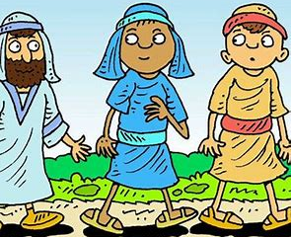
In the Holy Bible, there is a story about two friends walking on a road and talking together, going to a place called Emmaus. Another man walked up, asking them what they were talking about. The friends told him they were talking about Jesus dying on the Holy Cross. They were sad, because they were hoping that Jesus was the one to save the people. They had heard that Jesus was no longer in the tomb where He was buried, but that no one had actually seen Jesus walking around.
Once they got to the place they were going to, they invited the man to come eat with them. When they were sitting around the table, getting ready to eat, the man broke the bread. He blessed it, and gave it to the friends. They were surprised and happy, because they recognized who the man was: Jesus! It was true: Jesus had risen from the dead. At first, they hadn’t noticed Jesus when He was right in front of them, but now, they knew that Jesus was with them, and that He really was the Savior. Only God could bring about a miracle, something so amazing as this.
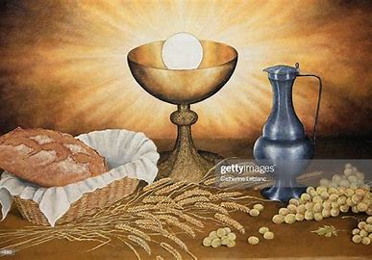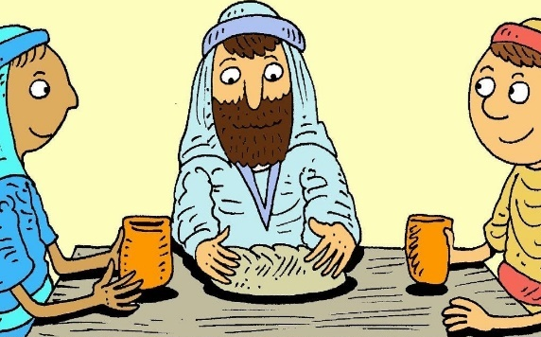
Jesus is still with us today. We can see God in His goodness all around us, in the beautiful things He created, like the sun, moon, stars, and ocean. In the people around us, family and friends, we also see God’s love. Every time we receive the Holy Eucharist, the Sacred Host, we receive Jesus. The bread at Holy Mass becomes Jesus’ Body: the priest breaks and blesses it. Jesus is in our hearts always. When the friends at Emmaus saw Jesus break the bread, they recognized Him, because Jesus is the Bread of Life.
The Holy Eucharist is different than regular food. Instead of helping our bodies live, like regular food, Jesus, in the Holy Eucharist, lets our souls live forever. When we go to Holy Mass, we see our friend, Jesus. He is Truly Present, really there with us. This is why we make the Sign of the Cross, bow, kneel, sing, and pray at the Holy Mass. These are like ways of saying “hello” to a friend, telling them that we love them, that they are special. This is how we talk with our friend, Jesus.
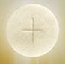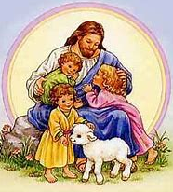
Jesus is a true friend, because He is loyal, faithful to us. He is always with us. Our best friends are by our side, walking with us through our lives, no matter what, just like Jesus. Friends are kind to each other, and share. Jesus shares with us: He has given us the sacraments, like the Holy Eucharist. He shares the love in His Heart with us through the sacraments. Going to Holy Mass, listening to and reading stories from the Holy Bible, helping our families, and being kind to others are ways we can be a good friend to Jesus, because these are ways we can share our love.
Draw a picture of you walking with Jesus like the friends on their way to Emmaus.

How can you share your love for our friend, Jesus? How can you be a loyal friend to Him?

Jesus is the _________________ of Life. We receive Jesus in the ______________________.

April 2026 Pre-K-2 Activities: Week 1
Grade 2- “Faith in our Friend, Jesus”

Saint Peter had not always been loyal to Jesus. He knew he had to tell Jesus he was sorry for when he had not been a true friend. Saint Peter was afraid of what others would think about him for being a follower, a friend, of Jesus, and he pretended that he didn’t know Jesus. Saint Peter denied Jesus three times: he told people who asked him about Jesus that he didn’t know him, even though he did (John 18:15-18). Saint Peter knew that there were people who didn’t believe in Jesus, who didn’t think that Jesus was truly God, or trust in Him. Saint Peter was afraid of what would happen to him if other people knew that he was Jesus’ friend. He thought that they might not trust or accept him, either.
But Saint Peter knew that this was not the right thing to do. Jesus was so kind and loving. Saint Peter knew Jesus was a true friend, and he felt bad for lying about knowing Jesus. Knowing Jesus is a special gift. To be His friend is a blessing. It makes us happy to be friends with Jesus, and it makes Jesus happy, too, because He wants to know us and help us. Saint Peter did not have to be afraid of what other people might do or think. All that mattered was that Jesus loved him, and would help him. Saint Peter wanted to heal his friendship with Jesus, so he told Jesus he loved him three times, to make up for when he had denied knowing Jesus three times (John 21:15-19). He showed Jesus contrition, showing Jesus that he was sorry. We do this when we say the Act of Contrition prayer at Confession.
Jesus forgave Saint Peter. He wasn’t angry with Saint Peter, but was happy to be friends again, and to help Saint Peter to keep making good choices. Saint Peter was ready to do good things for God, to be a teacher like Jesus and share His love for God with other people. He was not going to pretend not to know Jesus anymore. Instead, he was going to tell the whole world that Jesus is God, and that God is good. He would tell everyone that God is merciful, that God forgives. When we go to Confession, we can be like Peter, asking God to forgive us. We do this because we want to be friends with God again, to show that we love Him, and want to be loyal to Him- to stay friends. We can count on Jesus to be a faithful friend to us, always there to help when we pray to Him.

Imagine that you are like Saint Peter, going out to teach other people about Jesus, sharing what you have learned about Him.
Think about how Jesus treated Saint Peter. What did Jesus do when Saint Peter told Jesus he was sorry?
Make a card that you could give to someone in the Easter season. What would you want to share with other people about Who Jesus is, and what He has done?
Easter Card

I can be like Saint Peter and tell God I am sorry, asking Him to forgive me, when I say the Act of

__________________________________________________________

when I make the sacrament of

________________________________________________________.
April 2026 Pre-K-2 Activities: Week 2
Grade 2- “Before & After: How Faith in Jesus Helps Us”
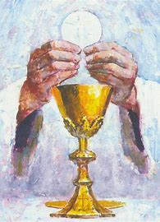
The Sacred Host is not regular food. It is very special. When we receive the Host, we are receiving Jesus, so we do special things to prepare to receive it. We make sure we are ready. We have faith in what Jesus has taught us. We believe that God, the Father, will do what He says. He promises to give us what we need, to help us, and to watch over us, keeping us safe. We believe that Jesus came back after dying on the Cross, and that we receive Him in the Holy Eucharist, the Sacred Host, which is Jesus’ Body. The Bread at the Holy Mass is blessed by the priest, and it becomes Jesus’ Body.
Because we believe this, we go to Confession first to prepare to receive Jesus, to make our hearts clean for Him. Out of love for Jesus, we go to Confession, have hope, trust that He will have mercy on us, forgiving us for our sins. Out of love, we want to receive Jesus in our hearts, and make Him happy. We thank God and praise Him out of love. Making a good Confession means that we focus on God, thinking about whether we have done what will make Him happy, and on what we can do better. After we go to Confession, we thank God for forgiving us, helping us to confess our sins, and being with us. At Confession, we tell God we are sorry, but after Confession, we work on showing God that we are sorry with the things we do. We can share our love for Jesus in the kind things we do for people. This makes Jesus happy.
Once we have gone to Confession, we are ready for Holy Communion. Holy Communion means to come together, to be with Christ, and meet Him in the Holy Eucharist. We spend time with our friends and family, because we love them, and want to know them better. Jesus gave us the sacraments, like Confession and Holy Communion, because He loves us. He wants to know us, and He wants us to know Him. Before receiving Jesus, we can pray for God to bless us, and help us to make a good Holy Communion. Making a good Holy Communion means we receive Jesus with love. We think about Jesus’ love for us when we receive the Holy Eucharist. We know He is with us in the Holy Eucharist. One way we can show our respect for Jesus is by blessing ourselves, making the Sign of the Cross, after receiving Holy Communion. It reminds us that Jesus went on the Cross for us out of love, and that God is with us. After Holy Communion, we can thank God for sending us His Son Jesus. We can thank Jesus for dying for us, and for coming to be with us in the sacrament of Holy Communion, in the Sacred Host we receive. Holy Communion helps us to have even more faith, hope, and love.
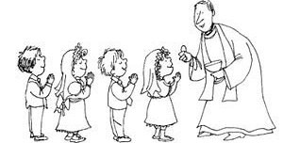
Praying before and after Confession, and praying before and after Holy Communion, is how we can talk to Jesus. The more we pray and get to know Jesus through going to church, and receiving the sacraments of Confession and Holy Communion, the more Jesus helps us to grow. Our hearts are filled with more love and hope, more happiness that we want to share to make God and others happy.

How do we feel before Confession? How do we feel after Confession?

How do we feel after receiving Holy Communion? How does Jesus feel when we make a good Holy
Communion?

What can we do to get ready for Holy Communion? _________________________________
_____________________________________________________________________________
_____________________________________________________________________________

April 2026 Pre-K-2 Activities: Week 3
Grade 2- “Faith in Jesus Forever: Easter and the Eucharist”
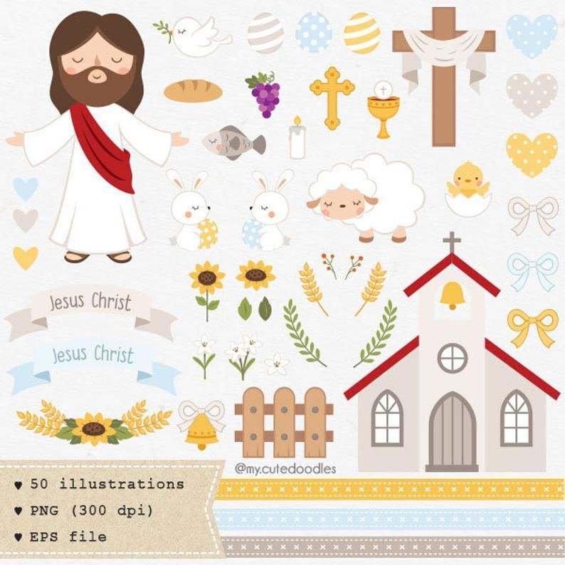
Easter Sunday is April 5 this year. On Easter, we celebrated Jesus coming back to life after dying on the Cross on Good Friday. Easter is a day of such joy and hope, that we might be sad when it passes by. But Easter is not over! Easter is not only a day, but a whole season. The Easter season is always 50 days, and will be until May 24 this year. During the Easter season, we continue to remember Jesus’ love that led Him to give His life on the Cross for us.
Jesus broke His Body by dying on the Cross. At the Holy Mass, the Bread is broken and blessed. The Bread becomes Jesus’ Body. Every time we go to Holy Mass, it is Easter again. We are remembering Jesus dying for us, and resurrecting- rising from the dead to be back with us. When we receive the Holy Eucharist, we are receiving Jesus’ resurrected Body. Jesus rose to life again, and He is giving us new hope, new life, whenever we receive Him in the Holy Eucharist, because we are receiving His Body, His life. Jesus died so that we could one day go to Heaven to be with Him. Before Jesus died, people had sins that were keeping them from being close to God. Jesus made up for their sins, because He had no sins. He was full of perfect love for God the Father. When Jesus died, He opened up the gates of Heaven to us. People can go to Heaven when their sins are cleaned away, and their hearts are fully open to loving God.
Now, we go to Confession to make up for sins. We receive absolution. Sins are washed away. Jesus forgives us. Receiving Jesus in the Holy Eucharist at Holy Communion, once we have gone to Confession, lifts up our hearts, making us happy. We remember that through Jesus, our souls can live forever, because His love lasts forever. The Holy Eucharist is food our souls need to live.

Cut out the pieces of the Easter egg. Glue them together. When sins bring us away from God, what sacrament brings us close to God again, and heals us? Write its name on the Easter egg. You can draw a picture of what it looks like to receive the sacrament also.

Everything is connected through Jesus. How is the Holy Mass like Easter? What do we remember happening at Easter, and what do we remember happening at the Holy Mass?
On the left, draw what Jesus did on Easter. On the right, draw what happens at the Holy Mass. How do we see Jesus at the Holy Mass?

On Easter, Jesus ___________________ At Holy Mass, Jesus ___________________

Read Lesson 7 (pages 30-34), “Jesus Opens Heaven for Us,” in your St. Joseph First Communion Catechism book.
Jesus went on the Cross to save us because He ______________ us, and He
__________________ His _______________________.

Jesus gives us _____________________________________ in the Holy Eucharist, which is also

called __________________________________.

April 2026 Pre-K-2 Review
Use this review sheet as a reference to track progress and check that learning goals are met.
Recap: What did we learn?
All Grades
- Easter Sunday is when we celebrate Jesus coming back after giving His life on the Cross
- After Easter Sunday, we continue to celebrate the Easter season
- We can have faith in Jesus, because He did not leave us. He overcame death to be with us forever
Pre-K/Kindergarten
- Mary Magdalene and the apostles couldn’t believe at first that Jesus had risen from the dead, but when they realized it had really happened, they were filled with joy
- Easter Sunday is a day of joy to open our hearts to growing in our faith, our hope in Jesus
- Through His miracles, like rising again, Jesus has shown that we can trust in Him, because He is always with us. We are never alone, with Jesus in our hearts to guide us
- Easter is a season of hope and light. Jesus’ love brings us hope
- We need Jesus to help us grow. When we start out by trusting and hoping in Jesus, asking Him to help us, He can make our hope and faith grow even bigger
- Jesus changes us. He makes us stronger. He shows us the way to Heaven
- We are Christians. Christians are followers of Christ. We live like Jesus, treating each other with love
- We can live like Jesus and grow in our faith by going to church, praying, and teaching other people about Him to share His light
Grade 1
- During Lent, the “Alleluia” is not sung at Holy Mass. It is a song of joy we sing again at Easter to celebrate our happiness that Christ has risen
- We believe in Jesus. We have faith in Him, trusting that He will help us, because we have seen from the amazing things He has done, like rising from the dead, that He is God, and can do anything out of love for us
- Going to Holy Mass and singing is one way we can show God our love for Him, and share our faith
- Being like Jesus, kind and loving, is how we can live out what we believe
- There are signs of new life all around us during the spring. Jesus gives us new life, too. He grows the hope in our hearts
- We see how much Jesus loves us in the Holy Mass, especially at the consecration, when the Bread becomes Jesus’ Body. Receiving Jesus fills us with even more love and hope
- By giving us His life, Jesus shows that we can put our hope in Him. He makes us strong
- Jesus is the Bread of Life. The Holy Eucharist is different from regular food. Regular food helps our bodies to live. Jesus’ Body, also called the Holy Eucharist, the Sacred Host, is Bread that lets our souls live forever.
- Every time we go to Holy Mass, we are with our friend, Jesus, because He is in the Holy Eucharist
- The friends at Emmaus didn’t recognize Jesus at first, after He had risen. If we keep our hearts open to loving Jesus, we can see God’s goodness everywhere, and in everyone
Grade 2
- Jesus forgives us, just as He forgave Peter when Peter told Him he was sorry for when he was not a good friend to Jesus
- Jesus wants to be our friend, so He is happy when we go to Confession. When we go to Confession, we say we are sorry for the things we did that brought us away from Jesus
- At Confession, we are forgiven of our sins, so we can become close friends with Jesus again. We tell Jesus we are sorry with words, but we also show that we love Him through the things we do
- Going forward, we can work on doing things that make us better friends, like praying more, helping our families, and being kind
- Praying before and after Confession, and before and after Communion, is how we can talk to Jesus, and share the hope, faith, love, and joy we feel. Prayer helps us prepare
- We know Jesus through the sacraments. Jesus wants us to know Him better
- Jesus helps us grow through the sacraments. We can become stronger, kinder, and an even more loyal friend to Jesus. Jesus changes our hearts for the better
- When we have faith, we show Jesus we believe in Him. We live out our faith by receiving the sacraments, as we show Him we believe He is there with us
- Confession heals us. It makes us whole by bringing us back into friendship with God
- Every Holy Mass we go to is like Good Friday and Easter Sunday
- At Holy Mass, we remember Jesus dying for us on the Cross on Good Friday when the priest breaks the Bread. The Bread becomes Jesus’ Body, which was broken on the Cross out of love for us
- At Holy Mass, we receive Jesus in the Eucharist, also called the Host. We receive new life in the Eucharist, because when Jesus resurrected on Easter Sunday, He rose to new life, and the Eucharist is Jesus’ resurrected Body
What vocabulary words did we practice?
Pre-K/Kindergarten
Week 1
Crucifix
Week 2
Easter
Week 3
Christian
Grade 1
Week 1
Alleluia
Week 2
Consecration
Week 3
Host
Grade 2
Week 1
Contrition
Week 2
Eucharist/Communion
Week 3
Absolution
What prayers did we practice?
Pre-K/Kindergarten
The Lord’s Prayer (Our Father)
Grade 1
The Lord’s Prayer (Our Father)
Grade 2
Act of Contrition
Checklist: Activity Completion
Pre-K/Kindergarten
Week 1: “Easter Eggs: Opening our Hearts to Faith”
Week 2: “Faith, Hope, and Butterflies”
Week 3: “The Sun and the Son: Following the Light of Faith”
Grade 1
Week 1: “Alleluia: Singing our Faith in Jesus”
Week 2: “Signs of Spring: New Life and New Faith in Christ”
Week 3: “The Road to Emmaus: Walking with Jesus”
Grade 2
Week 1: “Faith in our Friend, Jesus”
Week 2: “Before & After: How Faith in Jesus Helps Us”
Week 3: “Faith in Jesus Forever: Easter and the Eucharist”

Quick Check:
Tell us about your experience with these activities this month! Our April 2026 Google Form for Grades Pre-K-2 is available here: https://forms.gle/42QacQGTK5jQRudQ6

