May | 2025

Feast of the Queenship of Our Lady: May 31
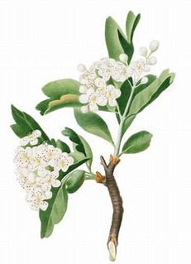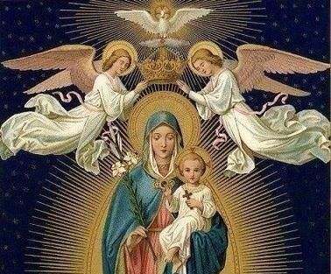

Sunday: The Holy Trinity | Monday: The Holy Spirit | Tuesday: The Holy Angels | Wednesday: St. Joseph | Thursday: The Holy Eucharist | Friday: Christ’s Passion | Saturday: Our Lady
 |  |  |  | 1 | 2 | 3
 |  |  |  | OLV Religious Education Class 9: 6:00 p.m., parish hall | First Friday | First Saturday; OLV First Holy Communion Mass, 11:00 a.m.; reception: noon
4 | 5 | 6 | 7 | 8 | 9 | 10
Feast of St. Monica; Eucharistic Adoration 2:00 | Feast of Pope St. Pius V | First Tuesday; St. Dominic Savio feast day | First Wednesday; Feast of St. Stanislaus |  |  | OLV Confirmation Mass, 11:00 a.m.; reception: noon*
11 | 12 | 13 | 14 | 15 | 16 | 17
Feast of Sts. Philip and James | Feast of Blessed Imelda Lambertini | Feast of Our Lady of Fatima; St. Robert Bellarmine | Feast of St. Boniface | Feast of St. Jean-Baptiste de la Salle; St. Dymphna | Feast of St. Simon Stock; Feast of St. Brendan | Feast of St. Pascal Baylon
18 | 19 | 20 | 21 | 22 | 23 | 24
 |  | Feast of St. Bernardine of Siena |  | Feast of St. Rita of Cascia |  | Feast of Our Lady, Help of Christians
25 | 26 | 27 | 28 | 29 | 30 | 31
 | Minor Rogation Day; Feast of St. Philip Neri | Minor Rogation Day; Feast of St. Bede, Feast of St. John I | Minor Rogation Day; Feast of St. Augustine of Canterbury | Feast of the Ascension of Our Lord
*Tentative date


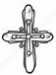May 2025 Planner

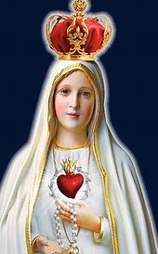

“Tell everybody that God grants us graces through the Immaculate Heart of Mary; that people are to ask her for them; and that the Sacred Heart of Jesus wants the Immaculate Heart of Mary to be venerated at His side.” -St. Jacinta
How can our family be like Mary this month (prayerful & contemplative)? What is our spiritual goal for May? How do we want to grow closer to God?
Mary Goals:


How can our family be like St. Martha this month and put our faith into action? How do we live out our faith and share it with others? What steps can we take to achieve our goals?
Martha Goals:

Prayer Intentions
What will we pray for this month? Who can we pray for?

