May | 2025

Feast of the Queenship of Our Lady: May 31
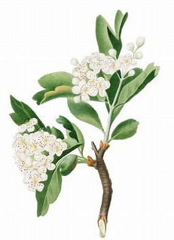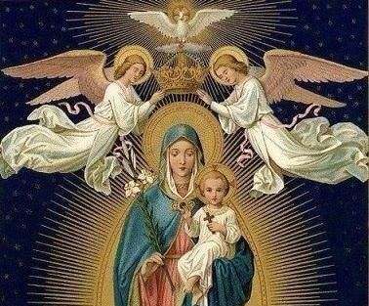

Sunday: The Holy Trinity | Monday: The Holy Spirit | Tuesday: The Holy Angels | Wednesday: St. Joseph | Thursday: The Holy Eucharist | Friday: Christ’s Passion | Saturday: Our Lady
 |  |  |  | 1 | 2 | 3
 |  |  |  | OLV Religious Education Class 9: 6:00 p.m., parish hall | First Friday | First Saturday; OLV First Holy Communion Mass, 11:00 a.m.; reception: noon
4 | 5 | 6 | 7 | 8 | 9 | 10
Feast of St. Monica; Eucharistic Adoration 2:00 | Feast of Pope St. Pius V | First Tuesday; St. Dominic Savio feast day | First Wednesday; Feast of St. Stanislaus | OLV Confirmation rehearsal: 6:00 p.m., church* |  | OLV Confirmation Mass, 11:00 a.m.; reception: noon*
11 | 12 | 13 | 14 | 15 | 16 | 17
Feast of Sts. Philip and James | Feast of Blessed Imelda Lambertini | Feast of Our Lady of Fatima; St. Robert Bellarmine | Feast of St. Boniface | Feast of St. Jean-Baptiste de la Salle; St. Dymphna | Feast of St. Simon Stock; Feast of St. Brendan | Feast of St. Pascal Baylon
18 | 19 | 20 | 21 | 22 | 23 | 24
 |  | Feast of St. Bernardine of Siena |  | Feast of St. Rita of Cascia |  | Feast of Our Lady, Help of Christians
25 | 26 | 27 | 28 | 29 | 30 | 31
 | Minor Rogation Day; Feast of St. Philip Neri | Minor Rogation Day; Feast of St. Bede, Feast of St. John I | Minor Rogation Day; Feast of St. Augustine of Canterbury | Feast of the Ascension of Our Lord
*Tentative date


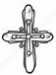May 2025 Planner

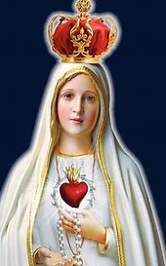

“Tell everybody that God grants us graces through the Immaculate Heart of Mary; that people are to ask her for them; and that the Sacred Heart of Jesus wants the Immaculate Heart of Mary to be venerated at His side.” -St. Jacinta
How can I be like Mary this month (prayerful & contemplative)? What is my spiritual goal for May? How do I want to grow closer to God?
Mary Goals:


Prayer Intentions
What will I pray for this month? Who can I pray for?

How can I be like St. Martha this month and put my faith into action? How do I live out my faith and share it with others? What steps can I take to act on my goals and achieve them?
Martha Goals:

