Our Lady of the Valley Religious Education

November 2024 Activity Packet

Grades Pre-K-2

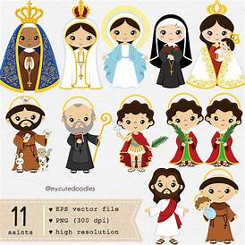

Name: ________________________________________

November 2024 Table of Contents
Overview………………………………………………………………………………………….3
Learning Standards………………………………………………………………………….......7
Lesson Pacing Guide……………………………………………………………………………14
Activities………………………………………………………………………………………....18
Pre-K/Kindergarten………………………………………………………………….....18
Week 1…………………………………………………………………………...18
Week 2…………………………………………………………………………...20
Week 3…………………………………………………………………………...21
Grade 1…………………………………………………………………………………..22
Week 1…………………………………………………………………………...22
Week 2…………………………………………………………………………...24
Week 3…………………………………………………………………………...25
Grade 2…………………………………………………………………………..............26
Week 1…………………………………………………………………………...26
Week 2…………………………………………………………………………...28
Week 3…………………………………………………………………………...30
Review…………………………………………………………………………………………...33

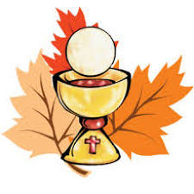
November 2024 Overview: Grades Pre-K-2
Theme: Month of the Holy Souls in Purgatory
Marian Title: Our Lady, Queen of All Saints
Monthly Prayer/Invocation: Our Lady, Queen of All Saints, pray for us. Regina Sanctorum omnium, ora pro nobis.
Thematic Guiding Questions, Pre-K-2:
- Who are the Holy Souls?
- What is Purgatory?
- In November, we pray for other souls in the Church. We pray for the living and the dead. Who are some friends and family members we can we pray for?
- How can we pray for other people? What prayers or special devotions can we offer for them?

Saint of the Month: St. Catherine Laboure was a French religious sister in St. Vincent de Paul’s “Daughters of Charity” community. Mother Mary appeared to St. Catherine Laboure in 1830, and asked St. Catherine to help spread devotion to her through the Miraculous Medal.
Monthly Challenge: Even if your patron saint’s feast day does not fall in the month of November, honor All Saints Day by celebrating your family members’ patron saints. These may be saints they were named after (baptismal patron saint names), saints whose names they chose for Confirmation, or saints they have special friendships with. For patron saint day celebrations, you might pray novena prayers dedicated to your patron saints, or say their favorite prayers/practice their favorite devotions, such as the prayer of the Holy Rosary. You might also celebrate by reading about your favorite saints; sharing religious medals depicting your patron saint with family members; preparing a themed meal with treats inspired by your patron saint; or sharing photos from your Confirmation to tell about how you chose your patron saint. Young children preparing for First Holy Communion will learn about the connections between the sacraments they will receive, from Baptism to Confirmation, and discover how Confirmation will build upon the graces they are to receive at Holy Communion. Reflect on how your saints were inspired by Our Lady, the Queen of All Saints. How did she help them get to Heaven and become saints?
Overall Learning Goals: This month, we will focus on God’s goodness in reflecting on this season of thanksgiving. We thank God for the lives of the people we know and love, remembering our family in Christ, our parish and the universal Church, including the souls in Purgatory and Heaven. Students will learn about the goodness of God, discussing with family how they have seen God’s goodness in their lives. The suggested thematic guiding questions (below) can help to spark discussion. Our goal is to think about God’s goodness in action- examples of how we know that God is good. Connecting learning activities to the season, the goal is to show that God is good in how He lovingly provides for us (for example, at the Thanksgiving meal, pointing out the food and family He has blessed us with). The learning standards linked to the activities emphasize that God’s goodness stems from His love for us, because God is love. This is the overarching takeaway that students should have in their learning.
Summary of Activities: Our activities this month are centered around expressing thankfulness for God’s goodness, which we see in the people and places around us. Students preparing to make their First Communion will reflect on why they are looking forward to receiving the Eucharist- why they are thankful to soon be receiving the sacraments. This is intended to open a broader conversation about why we are thankful to experience God’s goodness as a community, a church family.
To fulfill our learning goals, we will draw upon Sacred Scripture and Sacred Tradition in our lessons. We will draw upon Sacred Scripture through focusing our attention on one key verse each month, thinking about its meaning, how it relates to our theme, and how we can live it out, including in family prayers. Each month, our newsletter will highlight the key verse. This month is Psalm 107:1: “Give thanks to the Lord for He is good; His mercy endures forever.” Sacred Tradition will be drawn upon by linking activities to the sacraments, talking about what the sacraments mean to us personally, and how we, individually and as a Church family, experience the love of God through receiving them.
Teaching Tips Guide, PK-2
Materials needed for activities: be creative! Children may use whichever art supplies they like as they work on their drawings- colored pencils, crayons, markers, etc. Families are encouraged to complete activities together.
Scripture and prayer: pray together as a family to thank God for His goodness and mercy. Each family member can say their intention, praying for God to bless someone they know with His goodness, and/or saying what good things from God they are thankful for. Our Scripture verse can be set to song to help remember it.
Vocabulary words and prayers to know: Gradually begin introducing vocabulary words and prayers, which we will continue to practice in the months ahead. We will revisit words, prayers, and concepts being taught in order to reinforce learning. Integrating prayer into daily life and using vocabulary words in conversation, especially through telling stories, helps children absorb new information. Our goal is consistency and regularity.
*Use the recommended lists of words and prayers to know as a guide, and know that the pacing guide can be adjusted to meet scheduling/learning needs. Children may practice vocabulary words listed for the grades above, or may return to content provided for previous grades to continue practicing and refreshing their memory about past learning.
However, the earlier (and more often) that children practice their prayers, the better they can learn and retain them. Our youngest children have the most absorbent minds. The early childhood period (birth to age 8) is the most critical for brain development, and is when children make the greatest cognitive leaps, meaning that they can learn new information very quickly, forming patterns of behavior that become deeply ingrained.
**It’s strongly recommended that you display children’s completed activities, and place index cards with vocabulary words, our Scripture verse, or the words of prayers being practiced, in a central place, such as on a refrigerator. This will continue to tangibly remind children of what they are learning, and will deepen their self-esteem, increasing their motivation, as they see what they have accomplished. Keeping a portfolio of completed activities, such as in a binder or folder, is an excellent way to track progress over time.
Additional Enrichment Ideas:
- Remember the Holy Souls in a special way. Make the sign of the Cross whenever you go by a Catholic cemetery or Catholic church. This shows respect, and is a special prayer in itself. Say a prayer for the Souls in Purgatory when you visit a cemetery, such as the “Eternal rest” prayer (Requiem Prayer). When you say “grace” at a family meal, offer a special intention for the Holy Souls.
- This month, we remember St. Cecilia, whose feast is November 22. You can celebrate St. Cecilia, the patron saint of music, this month through song, such as by listening to the “Litany of Saints,” an example of God’s goodness and beauty in music. A traditional chanted version of the Litany in Latin is available here: https://www.youtube.com/watch?v=FvdB-_VVF-M. An English version is available here: https://www.youtube.com/watch?v=rDNTwvmNodk&t=42s
- Make a family litany of saints. Write down each of your favorite saints, and pray to those saints together
- Listen to (and sing! It’s praying twice ) sacred music together that ties into the theme, such as “Te Deum,” a song of thanksgiving. Children might also choose to create their own song of thanksgiving about what they are grateful for
- Hold an All Saints Day party or themed meal. Exchange holy cards or prayers dedicated to your favorite saints. Have a family meal with dishes inspired by the saints, or make a snack dedicated to your family’s patron saint. Talk about individual patron saints, sharing something you admire about your saint, or an interesting fact about their life. Children might choose to dress up as their favorite saint
- Honor God in the Month of the Holy Souls by going to Mass for All Saints Day (November 1; First Friday this year) and All Souls Day (November 2; First Saturday this year), before fulfilling your Sunday Mass obligation on November 3, making for three special Masses in a row. Three is a significant number in the Bible, reminding us of the Holy Trinity. These three consecutive days are very special times to go to Mass in thanksgiving for God’s goodness
- Have a Mass said for a loved one. Masses may be said for the living or the deceased
- Go to Eucharistic Adoration to say prayers of thanksgiving to God
- Remember loved ones who have passed into the next life by saying a prayer for them at the cemetery. Make the Sign of the Cross when you go by a Catholic cemetery or a Catholic church
- Pray the Requiem Prayer and offer intentions for the Souls in Purgatory at meals
- As a family, share your favorite stories or verses from the Bible. Reflect on your favorite prayers. Collect everyone’s favorite Scripture verses and prayers, writing them in cards to keep in a box, like a recipe box, a cornucopia of prayers. This will help everyone to learn new verses, stories, prayers, or to think about them in a new light
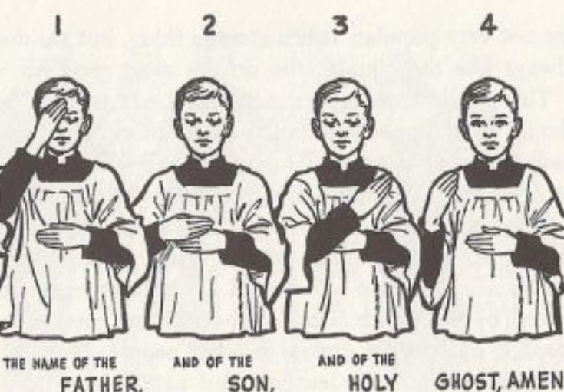
Making the Sign of the Cross

Learning Standards
Grade Level | Week | Activities | Learning Standards
Pre-K, Kindergarten | 1 | “All Saints and All Souls: Praying the Mass as God’s Family” | K.7 When we go to church, we are in God’s house. It is a holy place where we experience God’s love, so we are respectful. We attend Mass at church and pray, following the priest as he celebrates the sacrament. In addition to attending Mass on Sundays, we attend for special holidays during the seasons, including Advent and Lent. At church, we show our love for God. Outside of church, we can continue to love God through the kind things we do, because God is always with us, and is happy when He sees us being loving.  K.8 We are never alone, because God is always with us. We meet God by reading the Bible (the book of God’s words) and receiving the sacraments. He gave us Sacred Scripture (the Bible) and Sacred Tradition (the sacraments) so that we could know Him.
Pre-K, Kindergarten | 2 | “Saying Grace: Thanking God for the Bread of Life” | K.2 Everything God does is from love. There are times that are hard, but God is with us to help us, and make us stronger. He gives us our life experiences so that we can grow.  K.4 We talk to God through prayer. We pray every day to help us do the right things. Praying helps us to know God. We say prayers such as the “Hail Mary,” the “Our Father” and the “Glory Be.”
Pre-K, Kindergarten | 3 | “Giving Thanks for God’s Goodness” | K.1 God is love. He wants all of us to be loving to each other, so we use kind words and do kind things to show our love. God’s Greatest Commandments are: “You shall love the Lord your God with all your heart, with all your soul, and with all your mind,” and “You shall love your neighbor as you love yourself.”  K.2 Everything God does is from love. There are times that are hard, but God is with us to help us, and make us stronger. He gives us our life experiences so that we can grow.  K.6 We acknowledge God’s holy presence with respect, such as when we enter a church, pray, and go to Mass. In front of the tabernacle, we make the Sign of the Cross, which reminds us of how Jesus went onto the Cross out of love for us, to save us from sin.
Grade 1 | 1 | “The Communion of Saints: Our Family, the Church” | 1.1 Jesus and Mary are examples of full faith in God the Father. Their lives were lived without sin, and with total love. We can follow their example in our daily lives, especially as we prepare to receive the sacraments that will bring us into closer union with God. We are a community of faithful who show our faith in God by trusting in His  1.2 It is important to avoid sin so that we can stay close to God. There are two main types of sin: mortal and venial. Mortal sins are very serious, and venial are less serious. All sins bring us away from God, but we can get back to God through Confession.
Grade 1 | 2 | “Goodness like Jesus” | 1.1 Jesus and Mary are examples of full faith in God the Father… We can follow their example in our daily lives, especially as we prepare to receive the sacraments that will bring us into closer union with God.  1.4 Christ came to Earth so He could die on the Cross to save us from our sins. When we do something wrong, we sin. Jesus is without sin, so when He died for us, He redeemed us. His death helped to open Heaven for us. When He rose again, He showed that we can have new life in overcoming sin. We consume His resurrected Body in the Host, the consecrated Bread, at Mass to gain new life and hope in Christ. Jesus helps us to avoid sin so we can be holier.  1.10 Our churches are places where we come together as God’s family to pray, sing, and share our love for God. The angels and saints in Heaven are with us at the Mass, singing and listening to our prayers. We share our love for God with each other. As one big Church community, we share our talents to give God our love, and prepare our hearts to receive Jesus. Our beautiful churches are made to remind us of Heaven, and how great God is, so that we will be inspired to pray and use our gifts for God. We are in communion with Christ.
Grade 1 | 3 | “Sharing God’s Goodness like St. Elizabeth” | 1.4 Christ came to Earth so He could die on the Cross to save us from our sins. When we do something wrong, we sin. Jesus is without sin, so when He died for us, He redeemed us. His death helped to open Heaven for us. When He rose again, He showed that we can have new life in overcoming sin. We consume His resurrected Body in the Host, the consecrated Bread, at Mass to gain new life and hope in Christ.  1.1 Jesus and Mary are examples of full faith in God the Father. Their lives were lived without sin, and with total love. We can follow their example in our daily lives, especially as we prepare to receive the sacraments that will bring us into closer union with God. We are a community of faithful who show our faith in God by trusting in His plan for our lives.
Grade 2 | 1 | “Birthdays in Heaven: Celebrating Our Forever Friends, the Saints” | 2.4 The saints are people in Heaven, including Mother Mary. They teach us how to be like Jesus. We can ask them to help us be holy. The saints loved God in their lives on Earth, exemplifying how to receive God’s graces reverently through the sacraments, and how to use them to become holier.
Grade 2 | 2 | “Giving Thanks for the Eucharist”  &  “The Art of Giving Thanks” Storyboards | S2.1 “Eucharist” means “thanksgiving” in Greek. At the Mass, we give thanks to Christ for His life and sacrifice, expressing our gratitude to God for all of His blessings, including the Eucharist.  S2.7 The Eucharist is the resurrected Body of Christ. The Mass memorializes the Sacrifice of Christ, reliving His Passion, Death, and Resurrection.
Grade 2 | 3 | “Counting Our Blessings: God’s Graces and the Parts of the Mass” | 2.1 God is all-knowing and all-powerful. We see signs of this in the sacraments, in the miracles God has worked, that no one besides God could bring to life.  2.3 Jesus is the Son of God. As the Second Person of the Trinity, He is God, the same nature as the Father, as well as the Holy Spirit.

November 2024 Lesson Pacing Guide (Suggested Schedule)
Grades Pre-K-2
Week Number/Date | Grade Level | Activities
Week 1  (November 4, 2024 – November 8, 2024) | Pre-K, Kindergarten | “All Saints and All Souls: Praying the Mass as God’s Family”
Week 1  (November 4, 2024 – November 8, 2024) | Grade 1 | “The Communion of Saints: Our Family, the Church”
Week 1  (November 4, 2024 – November 8, 2024) | Grade 2 | “Birthdays in Heaven: Celebrating Our Forever Friends, the Saints”
Week 2  (November 11, 2024 – November 15, 2024) | Pre-K, Kindergarten | “Saying Grace: Thanking God for the Bread of Life”
Week 2  (November 11, 2024 – November 15, 2024) | Grade 1 | “Goodness like Jesus”
Week 2  (November 11, 2024 – November 15, 2024) | Grade 2 | “Giving Thanks for the Eucharist” & “The Art of Giving Thanks” Storyboards
Week 3  (November 18, 2024 – November 22, 2024) | Pre-K, Kindergarten | “Giving Thanks for God’s Goodness”
Week 3  (November 18, 2024 – November 22, 2024) | Grade 1 | “Sharing God’s Goodness like St. Elizabeth”
Week 3  (November 18, 2024 – November 22, 2024) | Grade 2 | “Counting Our Blessings: God’s Graces and the Parts of the Mass”

Week Number/Date | Grade Level | Words to Practice | Definitions
Week 1  (November 4, 2024 – November 8, 2024) | Pre-K, Kindergarten | Mass of the Catechumens | The first part of the Mass, which goes up to the Offertory (before the prayers of consecration and Communion). In this part of the Mass, God speaks to us as we read His words in the Bible. This was the part of the Mass that people being taught about the Catholic Faith before their baptism (catechumens) could attend. After the priest’s sermon, they would leave, because they could not yet receive Communion, which happens in the second part of the Mass.
Week 1  (November 4, 2024 – November 8, 2024) | Pre-K, Kindergarten | Mass of the Faithful | The second part of the Mass, going from the Offertory prayers to the very end. This part of the Mass includes the Offertory (when the Sacrifice of the Mass is offered, Jesus’ Body, the Host), the Canon (when the Bread becomes the Body of Christ at the consecration), and Communion, when we receive Christ’s Body. People who have been baptized take part in the Mass of the Faithful as they pray with the priest. We speak to God, responding to His Word, through prayer.
Week 1  (November 4, 2024 – November 8, 2024) | Grade 1 | Communion of Saints | The community of people in Heaven. We are linked with everyone in the Catholic Church, people on Earth, and people in Heaven. The Church also includes the souls in Purgatory. Through God, we are all connected. We continue to pray for people who have passed away and who are in Purgatory. People in Heaven pray for us, and people in Purgatory who are waiting to go to Heaven will remember us in their prayers when we pray for them.
Week 1  (November 4, 2024 – November 8, 2024) | Grade 2 | Requiem | From the Latin word meaning “rest.” “Requiem” is the first word in Latin in the prayer said for someone who has passed away, and is now resting in peace (“Eternal rest grant unto them, O Lord”).
Week 2  (November 11, 2024 – November 15, 2024) | Pre-K, Kindergarten | The Lord’s Prayer | Another name for the “Our Father” prayer. When Jesus, Our Lord, taught us how to pray, He told us to pray this prayer to Our Father in Heaven.
Week 2  (November 11, 2024 – November 15, 2024) | Grade 1 | Amen | “I believe” in Greek. We say “Amen” to show that we believe something is true, such as that the bread is the Body of Christ at the Mass.
Week 2  (November 11, 2024 – November 15, 2024) | Grade 2 | Eucharist | Another word for the Host, the bread changed into Christ’s Body that we receive at Mass. The sacrament of Communion, of receiving Jesus’ Body, is called the Eucharist. “Eucharist” means thanksgiving, because we give thanks for Jesus.
Week 3  (November 18, 2024 – November 22, 2024) | Pre-K, Kindergarten | Purgatory | People who have passed away and are on their way to Heaven first go to Purgatory. This is where their souls are wiped clean of all sins they might still have. Jesus does not have any sins. To meet Jesus in Heaven, sins on a person’s soul must be purged (the root word of “Purgatory”). This means that sins must be taken away from them, so that they can be completely pure and clean of heart, just like Jesus.
Week 3  (November 18, 2024 – November 22, 2024) | Pre-K, Kindergarten | Sign of the Cross | A prayerful gesture to show respect and love for the Blessed Trinity. The shape of the Cross is formed by blessing first your forehead (“In the name of the Father,”), then chest (“and of the Son,”), and the left and right shoulders (“and of the Holy Spirit”).
Week 3  (November 18, 2024 – November 22, 2024) | Grade 1 | Sanctuary Lamp | The light standing before the altar (in the church’s sanctuary) that is always left on. The light keeps glowing to remind us of God’s love for us that lasts forever. It helps us to remember that He is with us always.
Week 3  (November 18, 2024 – November 22, 2024) | Grade 2 | Evangelist | Someone who shares good news, telling other people about God and His great love. Mark, Matthew, Luke, and John, the writers of the Gospels, are known as evangelists, because by writing about the life of Jesus, they shared the good news of Jesus’ Resurrection from the dead, and of His love, a love that saved people from sin.
Week 3  (November 18, 2024 – November 22, 2024) | Grade 2 | Lectionary | The book of readings used by the priest at the Mass. The root word “lect” means “to read.” A “lector” is someone who reads from the Bible out loud at the Mass.

Week Number/Date | Grade Level | Prayers to Practice | Text of Prayers
Week 1  (November 4, 2024 – November 8, 2024) | Pre-K, Kindergarten | Petition for the Souls in Purgatory | Jesus, Mary, I love you. Save souls. Amen.
Week 1  (November 4, 2024 – November 8, 2024) | Grade 1 | Petition for the Souls in Purgatory | Jesus, Mary, I love you. Save souls. Amen.
Week 1  (November 4, 2024 – November 8, 2024) | Grade 2 | Requiem Prayer/ Invocation for the Holy Souls in Purgatory | Eternal rest grant unto them, O Lord; and let perpetual light shine upon them. May they rest in peace. Amen.
Week 2  (November 11, 2024 – November 15, 2024) | Pre-K, Kindergarten | Our Father | Our Father, Who art in Heaven,  Hallowed be Thy name.  Thy kingdom come.  Thy will be done on Earth, as it is in Heaven.  Give us this day our daily bread.  And forgive us our trespasses,  As we forgive those who trespass against us.  And lead us not into temptation,  But deliver us from evil. Amen.
Week 2  (November 11, 2024 – November 15, 2024) | Grade 1 | Blessing before meals | Bless us, O Lord, and these Thy gifts, which we are about to receive from Thy bounty. Through Christ Our Lord. Amen.
Week 2  (November 11, 2024 – November 15, 2024) | Grade 2 | Grace after meals | We give Thee thanks, almighty God, for all Thy benefits, Who livest and reignest, world without end. Amen.
Week 3  (November 18, 2024 – November 22, 2024) | Pre-K, Kindergarten | Sign of the Cross | In the name of the Father,  And of the Son,  And of the Holy Spirit. Amen.
Week 3  (November 18, 2024 – November 22, 2024) | Grade 1 | Blessing before meals | Bless us, O Lord, and these Thy gifts, which we are about to receive from Thy bounty. Through Christ Our Lord. Amen.
Week 3  (November 18, 2024 – November 22, 2024) | Grade 2 | Grace after meals | We give Thee thanks, almighty God, for all Thy benefits, Who livest and reignest, world without end. Amen.

November 2024 Pre-K-2 Activities: Week 1
Pre-K/Kindergarten- “All Saints and All Souls: Praying the Mass as God’s Family”
On November 1, we will celebrate All Saints Day. Saints are the people who are with God in Heaven. On November 22, we will remember St. Cecilia, the saint of music. She is one of the saints we remember when we pray the Litany (song) of the Saints at Mass, because singing is one of the ways we pray and share the love for God we have in our hearts. We pray to the saints to ask them to help us get to Heaven. Someday, we can meet the saints in Heaven. When we go to Mass, we share our love for God as one Church family. People in Heaven are part of the Church. They are at the Mass with us in our hearts. When we pray to God, they pray with us, and they pray for us. We love our families, and in our Church family, we show our love for each other, and for God, by praying for each other. Because the saints are God’s friends, they are our friends, too! Friends help each other, and the saints want to help us.
There are two parts of the Mass. The first part of Mass is called the Mass of the Catechumens. This part of the Mass is when we hear stories from the Bible read to us. We think about how God talks to us through His holy book, the Bible, which tells the story of Jesus, God the Father’s Son. When we read about Jesus, we think about His love for us. We get ready to receive Jesus in our hearts at Communion, thinking about how we can show Jesus our love for Him.
The Mass of the Faithful is when people who have made their First Communion receive the bread changed into Jesus’ Body, called the Host, or the Eucharist. It used to be that when the first part of the Mass was over, people who had not been baptized or made their First Communion yet would leave. They were called “catechumens,” because they were still learning about Jesus, and were not ready to receive the Host yet. Now, everyone stays for both parts of the Mass. You can ask the saints to pray for you as you continue to learn about Jesus, and get ready for making your First Communion, when you can receive Jesus during the Mass of the Faithful!
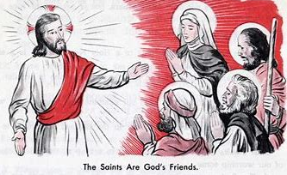

Look at the two pictures below. Write which one is of the Mass of the Catechumens, and which is of the Mass of the Faithful.

Mass of the ___________________________________________________________________
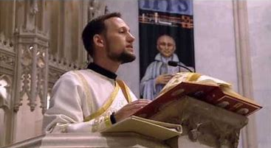

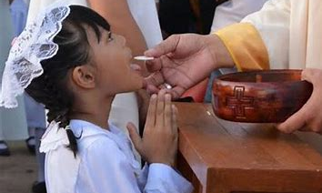
Mass of the __________________________________________________________________

Draw a picture of a saint we can ask to pray for us when we are at Mass. What is the name of the saint you picked?

I will ask Saint __________________________ to pray for me at Mass.
November 2024 Pre-K-2 Activities: Week 2
Pre-K/Kindergarten- “Saying Grace: Thanking God for the Bread of Life”
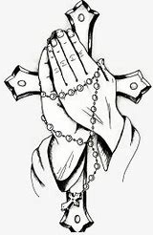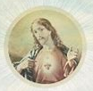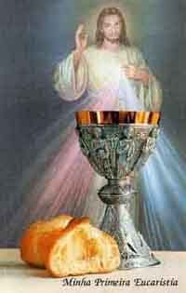
When we say our prayers, we thank God for what He gives us. Jesus teaches us to pray. He gave people the “Our Father” prayer to say. We talk to God the Father, our Father in Heaven, when we say this prayer. This prayer is also called “The Lord’s Prayer, because Jesus, God’s Son, gave it to us. Jesus is called “Our Lord.” In the “Our Father” prayer, we ask God to “give us this day our daily bread.” We ask God to give us what we need each day. We need to eat food like bread to live. God gave us prayers as a way to ask God for what we need, and to thank Him for giving us gifts we call blessings. Before we eat, we say “grace” to thank God for our food. God gives us food for our souls, the Eucharist. The Eucharist is called the “Bread.” It is bread that becomes Jesus’ Body at Mass. When you make your First Communion, you will receive Jesus when you receive the Bread, His Body.
God made each person with a soul. A soul is where God lives in us. We are kind, loving, and gentle with ourselves and others, because we know God is in each of us. The souls of people who love God go to Heaven when it is time for them to meet Him. God is in us, but because we are not God, we need God to help us to get to Heaven someday. God knows everything, and can do anything. We all use the special talents God gave us to help each other by being kind, praying for people, and teaching about Jesus. God blesses our kindness. We show God we love Him and are thankful to Him when we act like Jesus.
Think about something good God has done for you. Draw a picture of what you are thankful to God for.

November 2024 Pre-K-2 Activities: Week 3
Pre-K/Kindergarten- “Giving Thanks for God’s Goodness”
God is good. In November, we celebrate the holiday of Thanksgiving, but we can thank God for His blessings throughout the entire year. Whenever we make the Sign of the Cross, we are thanking God and showing love for Him. We make the shape of the cross to remember that Jesus gave His life for us on the Cross out of love for us. The Cross is a sign of God the Father’s love and goodness, of the blessings He shares with us, like His Son, Jesus. When we thank God for our food at mealtimes, we bless ourselves, making the Sign of the Cross. We also can make the Sign of the Cross when we go by a Catholic church or a cemetery. We thank God for the people He has given us in our Church family. Our Church is a big family: people in Heaven and Purgatory are part of our Church family, too.
God loves people in Earth, in Heaven, and in Purgatory who will soon be in Heaven. He never forgets anyone. He gives us what we need to help us get to Heaven. This month, we remember people who are in Purgatory. People in Purgatory are souls who have passed away, and are waiting to go to Heaven. When we pray for people in Purgatory, we help to make it easier for them to wait until their souls are clean, and it is time for them to see Jesus, which will make them very happy. God wants to bring people to Heaven, because He is good, and wants to share the beauty and happiness of Heaven with everyone.
Draw a picture of how you can tell God “thank you” for His goodness.
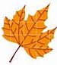

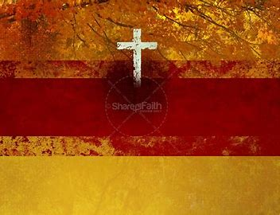

November 2024 Pre-K-2 Activities: Week 1
Grade 1- “The Communion of Saints: Our Family, the Church”
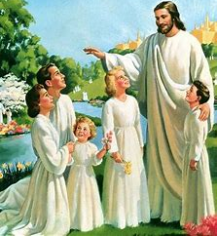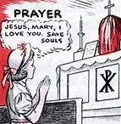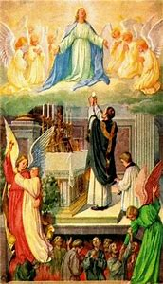
Once you make your First Communion, you will be able to start receiving Communion at Mass. When we receive Communion, we receive Jesus. Jesus comes into our hearts. Before we go to Communion, we pray to unite our hearts with Jesus. If we want to “unite” our heart with Jesus’ Heart, it means we want to give our hearts to Jesus, to share our love with Him. We want to connect with Jesus, to become closer to Him, so that we can be more like Him. God is good, and we want to be like Him. Having a good heart like Jesus’ Heart means helping other people, sharing, and being kind. It makes us happy to make God happy, and to help the people in His family. We are all children in God’s family.
November 1 is All Saints Day. On All Saints Day, we go to Mass and celebrate the Communion of Saints. Saints are people in Heaven, together with God. November 2 is All Souls Day. We pray for people in Purgatory who are waiting to go to Heaven. We can say “Jesus, Mary, I love you, save souls” to help the people in Purgatory go to Heaven soon. While they wait, their souls are cleaned. Our souls have to be clean, full of love, before we can meet God in Heaven, because God is love. Purgatory is like Confession. You will make your First Confession before making your First Communion. People go to Confession to tell the priest about times when they did not listen to God. God calls us to love Him and other people. We show our love for God by listening to Him, and doing what He has called us to do. Our souls are cleaned at Confession so that we are ready to receive Communion with love. At Mass, the saints are with us in our hearts. They are part of God’s family, the Church, and are still connected to us. So are people in Purgatory.
We can pray that the saints in Heaven help us love God like they do. They went to Heaven because they were loving, and had clean hearts. The more time we spend loving God on Earth, the less time we will have to spend in Purgatory. The saints help us listen to God so that someday, we can go to Heaven to be with Him forever.
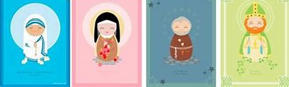
When a person goes to Heaven, it is called their birthday in Heaven. A feast day is a saint’s birthday in Heaven. We celebrate our birthday, the day we are born on. We might have a party with family and friends, sharing cards, cake, and gifts. We celebrate our love for each other with birthday parties. We can celebrate the saints’ birthdays in Heaven, too, sharing our love for them.
Some saints who have feast days in November are:
- St. Albert, saint of scientists
- St. Cecilia, saint of music
- St. Elizabeth of Hungary, saint of bakers
- St. Sylvester, saint of animals
Make a card for a saint with a November feast day, their birthday in Heaven. In your card, you can write a prayer to your saint, or something you love about your saint. Draw a picture of the saint (and what special things they are patron of, things you can pray to them for). Write the date of their feast day. How can celebrate your saint on their feast day?

Feast day: November __________, 2023
Happy birthday in Heaven, Saint

__________________________________!

November 2024 Pre-K-2 Activities: Week 2
Grade 1- “Goodness like Jesus”
Jesus is the greatest example of goodness. He treated other people with love and kindness. The way Jesus lived taught people about the goodness of God the Father. Jesus helped people in need, such as by healing the sick. Jesus fed people, giving the hungry bread to eat. Jesus blessed the bread. He prayed for and with people. Jesus still heals and feeds us today. He does this through the Eucharist, His Body. It is called the Bread of Heaven, because it is food for our souls that Jesus gives us.
When Jesus gave His life, His Body, on the Cross, He made it possible for people to go to Heaven. People get to Heaven through the help of Jesus, through receiving the Eucharist with love. This month, we think of people in Purgatory who are waiting to go to Heaven to be with Jesus. We can pray for them so that their wait will be over, and they can meet Jesus, which will give them happiness forever. At our meals, when we say grace, we can ask God to help the souls in Purgatory, and to lead us to Heaven someday, too.
When we eat our meals, and when we go to Communion at Mass, we thank God for the food He gives us for both our bodies and souls. After we pray, we say “Amen,” which means “I believe.” Saying thanks to God, making the Sign of the Cross, bowing, and kneeling at church are ways we show God that we believe in Him and love Him. Jesus was a teacher Who told people about how much they are loved by God. We can be like Jesus in the good things we do to show our love for God and the people He brings us to be our friends.
What is something good that you can do for a family member or friend to make them happy, and be loving like Jesus? Write your idea and draw a picture.
______________________________________________________________________________
_ _ _ _ _ _ _ _ _ _ _ _ _ _ _ _ _ _ _ _ _ _ _ _ _ _ _ _ _ _ _ _ _ _ _ _ _ _ _ _ _ _ _ _ _ _ _ _ _ _ _ _
______________________________________________________________________________
______________________________________________________________________________
_ _ _ _ _ _ _ _ _ _ _ _ _ _ _ _ _ _ _ _ _ _ _ _ _ _ _ _ _ _ _ _ _ _ _ _ _ _ _ _ _ _ _ _ _ _ _ _ _ _ _ _
______________________________________________________________________________

November 2024 Pre-K-2 Activities: Week 3
Grade 1- “Sharing God’s Goodness like St. Elizabeth”
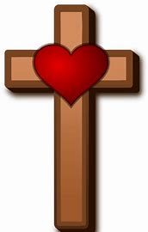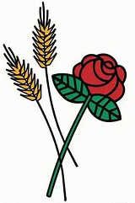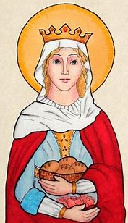
November 1 was All Saints Day in the Church. On All Saints Day, we thank God for His saints. A saint is a person in Heaven. The saints loved God very much when they lived on Earth. They were loving, kind, and good like Jesus. After their lives on Earth, they went to Heaven to love God forever. Heaven is a beautiful, happy place full of music. We are with the saints, people who love God like we do. Heaven is perfect, because we are with God, and God is love. Love makes our hearts happy.
One very special saint we remember in November is St. Elizabeth of Hungary, a queen. Her birthday in Heaven (the day she went to Heaven) is November 19. When the Church changed calendars, the new date to celebrate St. Elizabeth of Hungary’s life became November 17.
When we go to church, we see a sanctuary lamp, a lamp near the altar, where the priest says the Mass. Sanctuary lamps never stop shining. The saints are people who shine Jesus’ light forever. Light helps us to see. When we are a light for Jesus, we help people to see how good and kind Jesus is, and how much Jesus loves them. St. Elizabeth of Hungary was a light for Jesus. She shared food with people who were poor and hungry. She showed them how God gives us what we need. One day, the bread St. Elizabeth was carrying changed into roses! God made this happen to show that when we do kind things out of love for Him, it is something beautiful that makes Him happy. When we give flowers to a friend, we give them something lovely that makes them smile. St. Elizabeth wanted to help bring people to Heaven. She gave them hope by teaching them about Jesus, which made them want to share His love with other people. St. Elizabeth still shines for Jesus. She prays for us.
We, too, can be lights shining for Jesus, just like the saints. Next to the lamp, write and draw how you can be like St. Elizabeth and shine a light for Jesus.
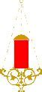
November 2024 Pre-K-2 Activities: Week 1
Grade 2- “Birthdays in Heaven: Celebrating Our Forever Friends, the Saints”
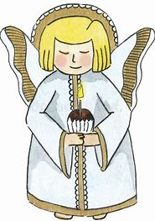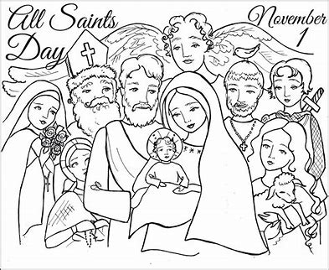
November is the month of the Holy Souls in Purgatory. On November 2, All Souls Day, we remember people in Purgatory in a special way. These are souls who have passed away, and are now waiting to be with God in Heaven. People need their souls to be clean before they can be with God forever in Heaven. God is full of love. To be with God, our souls need to have any sins that are left behind wiped away, so that they can be like God, full of love. Souls in Purgatory wait for their souls to become completely clean before going to Heaven. This is like when we go to Confession to clean our souls before Communion, so that we are ready to receive Jesus.
They need our prayers to help them as they wait. When we are hungry, it can be challenging to wait for food to fill our bellies. When people are waiting to be with God, their souls are hungry. They want to be with God, but have to be patient. When we pray for the souls in Purgatory, we are helping them while they wait. They can feel our love for them, which helps. One prayer we can say is the “Requiem Prayer.” “Requiem” means “rest.” We pray, “Eternal rest grant unto them, O Lord, and let perpetual light shine upon them.” We ask God to bring people who are resting in peace, who have passed away, to Heaven. We pray that they will be in the light of Heaven forever, where they are loved by God. Light helps us to see. In the bright light of Heaven, we see God, the angels, and saints. We see how much God loves us.
We pray for God to make us, and all of the people we know and love, saints someday. Saints are all of the people in Heaven. All Saints Day is the feast day we celebrate on November 1. It is like a party for the saints, when we celebrate their birthdays in Heaven, the days they went to Heaven. At meals, we remember. We think of people we love. We share food, and we pray, thinking of God’s love for us and thanking Him for our food. Feasts are big meals. At Mass, we celebrate Jesus, Mary, the angels, and saints with feast days. We share a meal, the Eucharist, as a Church family. We remember Jesus going on the Cross and giving His life out of love for us. He gave us the Bread of Heaven, His Body, to help us to get to Heaven.
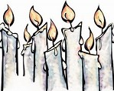

Draw and write your answers to the questions below.

How can we celebrate the saints
on All Saints Day?

How can we remember souls in Purgatory on All Souls Day?

____________________________________ ____________________________________

____________________________________ ____________________________________

What can we do to become saints someday? _______________________________________

November 2024 Pre-K-2 Activities: Week 2
Grade 2- “Giving Thanks for the Eucharist”
The word “Eucharist” means “thanksgiving.” At the Mass, we give thanks to God for all of His blessings. We are especially thankful for the gift of Jesus’ life. When we receive Jesus in the Eucharist at the Mass, we are given special graces from God that help us to live good lives. With God’s grace, our hearts can become more and more loving, just like Jesus.
We celebrate the holiday of Thanksgiving with a meal we share with our family and friends. Sometimes the Mass is called a heavenly “banquet” or “feast,” because the Eucharist feeds our souls. The Eucharist gives us hope that helps us to keep moving forward, just like how the food we eat makes our bodies stronger, so that we can keep moving. At Mass, we gather together as God’s family to share our love for Him.
Think about why you are looking forward to making your First Communion, and why you are thankful for the Eucharist. What will you thank God for at Mass?
_ _ _ _ _ _ _ _ _ _ _ _ _ _ _ _ _ _ _ _ _ _ _ _ _ _ _ _ _ _ _ _ _ _ _ _ _ _ _ _ _ _ _ _ _ _ _ _ _ _ _ _
______________________________________________________________________________
______________________________________________________________________________
_ _ _ _ _ _ _ _ _ _ _ _ _ _ _ _ _ _ _ _ _ _ _ _ _ _ _ _ _ _ _ _ _ _ _ _ _ _ _ _ _ _ _ _ _ _ _ _ _ _ _ _
______________________________________________________________________________
______________________________________________________________________________
_ _ _ _ _ _ _ _ _ _ _ _ _ _ _ _ _ _ _ _ _ _ _ _ _ _ _ _ _ _ _ _ _ _ _ _ _ _ _ _ _ _ _ _ _ _ _ _ _ _ _ _
______________________________________________________________________________
______________________________________________________________________________
_ _ _ _ _ _ _ _ _ _ _ _ _ _ _ _ _ _ _ _ _ _ _ _ _ _ _ _ _ _ _ _ _ _ _ _ _ _ _ _ _ _ _ _ _ _ _ _ _ _ _ _
______________________________________________________________________________
______________________________________________________________________________
_ _ _ _ _ _ _ _ _ _ _ _ _ _ _ _ _ _ _ _ _ _ _ _ _ _ _ _ _ _ _ _ _ _ _ _ _ _ _ _ _ _ _ _ _ _ _ _ _ _ _ _
______________________________________________________________________________
______________________________________________________________________________
_ _ _ _ _ _ _ _ _ _ _ _ _ _ _ _ _ _ _ _ _ _ _ _ _ _ _ _ _ _ _ _ _ _ _ _ _ _ _ _ _ _ _ _ _ _ _ _ _ _ _ _
_____________________________________________________________________________
Grade 2- “The Art of Giving Thanks” Storyboards
Draw a picture of your family sharing a meal on Thanksgiving Day. Think about what details you can include to show what you are thankful for.

Now, draw a picture of your family at Mass in the church.

What do these pictures have in common? How is giving thanks on Thanksgiving Day like how we give thanks at Mass? Talk about it with a family member, then write your ideas.

__________________________________________________________________

__________________________________________________________________

__________________________________________________________________
November 2024 Pre-K-2 Activities: Week 3
Grade 2- “Counting Our Blessings: God’s Graces and the Parts of the Mass”
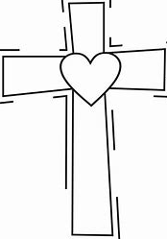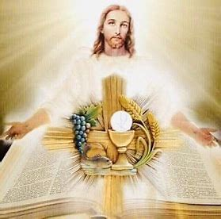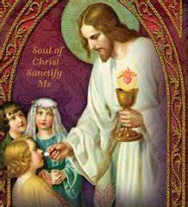
At Mass, we remember Jesus’ Sacrifice that He made because of His love for us. God gives us everything we need, because of His great love for us. Our bodies get hungry for food, and so do our souls. Our souls need the love of God. God gives each of our souls the food it needs, which is different from regular food we eat every day. Our souls are filled with the greatest joy and peace that can come only from God.
Our minds are hungry to learn. We are curious about who Jesus is, and what He does. Our hearts and souls need to be fed, too. Our souls need God’s love, which makes us strong. When we go to Mass, we hear God’s Word. The priest reads from the Gospels in the Bible. He uses the lectionary, a book of the readings for the Mass, to read out loud to us. The root word “lect” in “lectionary” means “to read.” “Lectors” are people who read. The Gospels that are read are stories of Jesus that help us to learn about Him. The people who wrote the Gospels, Mark, Matthew, Luke, and John, knew Jesus. They saw the amazing things He did, and wrote about Him. They are called “evangelists.” “Evangelists” are people who share the good news of Jesus and His love. The priest also does this when he tells us in his sermon about what the Gospel story means, and how we can live out what God is asking us to do in the story.
After we hear God’s word, we receive Jesus in the Eucharist. The Word, the stories from the Bible, came alive in Jesus. Jesus is the living Word. When we receive Jesus, we feel God’s love in our hearts. Feeling God’s love makes us want to share it, just like the evangelists did, so that everyone can know the happiness of being friends with Jesus. God gives us graces, special blessings, at Communion that help us to be loving and kind like Him. Before Communion, we ask God to help us be ready to receive Him in our hearts. After Communion, we pray, thanking God for His graces, for the wonderful blessing of receiving Communion. This is like when we have a meal at home, and we say grace. We thank God for our food before we eat, and thank Him again after we have eaten for the good food He gave us out of love.
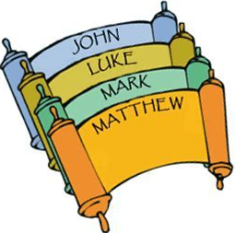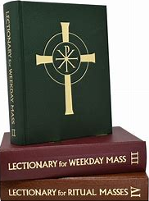
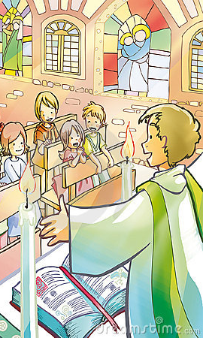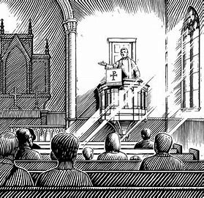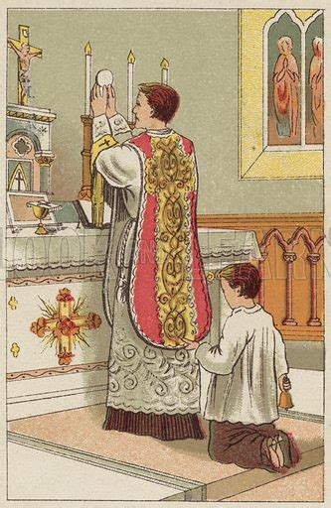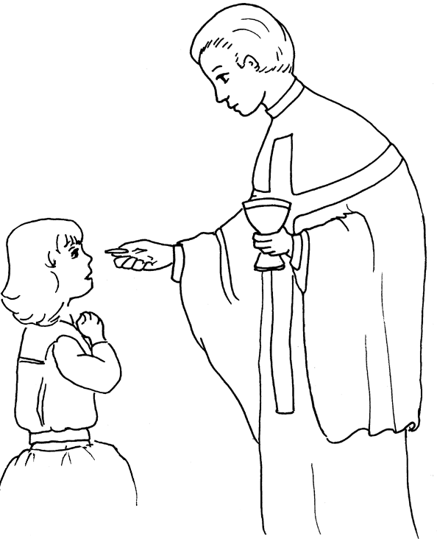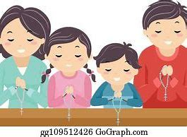
---------------------------------------------------------------------------------------------------------------
Put these five parts of the Mass in order. Number them and fill in the blanks. Match them to the pictures above. Read “The Holy Mass” (pages 53-58) in your St. Joseph First Communion Catechism book.
______. We listen as the priest preaches, or says, the _______________________ he
wrote. He tells us what the stories of Jesus’ life mean, and how we can be like Jesus by
living with love every day.

______. God fills our souls with His words. We read from a book called the
___________________________, which tells us about Jesus’ life.

_______. The priest prays and blesses the ________________________ and
_____________________. They become Jesus’ _____________________________ and
___________________________. He offers them up to God out of love, remembering when
Jesus gave His life out of love for us. We say prayers of love for God with the priest, and ask Him to come into our hearts so that we are ready to receive Him in the _______________________________.

_______. We say prayers of thanks to God for giving us food for our souls that we
received in the _______________________________. We ask God to bless us, the people in
our family, our parish, and our worldwide Church family.

_______. God fills our souls by giving us the ___________________, Jesus’ Body. We
receive it at _________________________ during Mass. Jesus is God’s Word, come to life.

Think about why you are thankful that Jesus gave us His Body, the Eucharist. What is a prayer you can say before you make your First Communion? What is a prayer you can say after you make your First Communion?

Prayer Before Communion

_____________________________________________________
_____________________________________________________
_____________________________________________________
_____________________________________________________
_____________________________________________________
______________________________________________________
Prayer After Communion

_____________________________________________________
_____________________________________________________
_____________________________________________________
_____________________________________________________
_____________________________________________________
______________________________________________________

How can you share your love for God like the evangelists?

______________________________________________________________________________

______________________________________________________________________________
November 2024 Pre-K-2 Review
Use this review sheet as a reference to track progress and check that learning goals are met.
Recap: What did we learn?
All Grades
- God is good, because God is love. He does everything from love
- In His goodness, God gives us what we need, caring for us
- We give thanks to God for His goodness
- All Saints Day and All Souls Day are celebrated in November
- The saints are people in Heaven. They lived with love for God while on Earth, and now love God forever in Heaven
- We can be like the saints by following God and sharing our love for Him
- In November, we pray for the Holy Souls, who are in Purgatory, waiting to be with God in Heaven
Pre-K/Kindergarten
- There are two major parts of the Mass: the Mass of the Catechumens and the Mass of the Faithful
- The Mass of the Catechumens is when we prepare to receive Communion, such as by hearing stories about God’s love for us from the Bible
- The Mass of the Faithful is when we receive Communion, Jesus’ Body. The bread is changed into Jesus’ Body during the Mass of the Faithful.
- Jesus’ Body is also called the Host, or the Eucharist
- The saints are with us at the Mass. They are in Heaven with God, and are still part of His family, the Church
- The saints pray for us when we ask them to help us
- The “Our Father” prayer is also called “The Lord’s Prayer”
- Jesus taught us this prayer to show us how we can talk to God the Father
- In the “Our Father,” we ask God to “give us this day our daily bread.” God gives us food for our bodies and for our souls
- The soul is where God lives in us. All people have souls. We treat each other with love, because we know God is in each of us
- We make the Sign of the Cross to show our love and thanks for God. The Sign of the Cross reminds us of Jesus going on the Cross out of love for us
Grade 1
- At Communion, we pray to bring our hearts closer to Jesus, to have a good and loving heart like Jesus’ Heart
- Going to Confession before Communion helps our hearts to be clean so that we are ready to receive Jesus with loving hearts at Communion
- Confession is when we tell the priest about when we did not listen to God. Listening to God means loving Him and other people, because that is what God has called us to do
- The Communion of Saints is the Church, God’s family. The saints are people with God in Heaven. They are connected to us still, even though they are in Heaven, and not on Earth with us, because they are in communion with God. At Mass, when we receive the Eucharist (Communion), we are in communion with God, connected with Him. Going to Mass shows us what Heaven will be like, where we can love God
- On All Saints Day, we remember the saints in Heaven. When we pray, we can ask the saints to help us to love God like them
- A feast day is a saint’s birthday in Heaven, the day they went to Heaven
- On All Souls Day, we pray for people in Purgatory who are waiting for their souls to be cleaned before they go to Heaven to be in communion with God forever. Purgatory cleans the soul, like Confession does before we go to Communion and receive Jesus
- The soul needs to be cleaned before being with God, because God is love. A clean soul can be filled with love
- St. Elizabeth of Hungary is an example of a saint who lived with love for God. She shared what she had with people in need out of her love for Jesus
- The sanctuary lamp is the light that keeps on shining in the church
- We can each be a light for Jesus, helping other people to see His love
- When we live with love on Earth, we can one day go to Heaven and shine with Jesus
- We say “Amen” after we pray to say that we believe in God. We show that we believe in God by blessing ourselves, bowing, and kneeling at church
Grade 2
- “Eucharist” means “thanksgiving”
- We pray prayers of thanksgiving to tell God that we love Him, that we are thankful for what He has given us in His love
- The Eucharist is food for our souls
- God makes us stronger through the Eucharist, because it gives us hope that we need to keep moving forward
- We are thankful for how God cares for our souls through the sacraments, like the Eucharist
- We receive special graces from God at Communion. He helps us to be loving like Him
- The evangelists were 4 men who knew Jesus, and wrote down the stories of His life. These stories are called the Gospels, and they are in the Bible
- We can be like the evangelists by sharing the good news of God’s love
- Priests read from the lectionary, the book of readings, at the Mass. The lectionary includes the Gospels for each week
What vocabulary words did we practice?
Pre-K/Kindergarten
Week 1
Mass of the Catechumens
Mass of the Faithful
Week 2
The Lord’s Prayer
Week 3
Purgatory
Sign of the Cross
Grade 1
Week 1
Communion of Saints
Week 2
Amen
Week 3
Sanctuary lamp
Grade 2
Week 1
Requiem
Week 2
Eucharist
Week 3
Evangelist
Lectionary
What prayers did we practice?
Pre-K/Kindergarten
Petition for the Souls in Purgatory
Our Father
Sign of the Cross
Grade 1
Blessing before meals
Petition for the Souls in Purgatory
Grade 2
Grace after meals
Requiem Prayer/ Invocation for the Holy Souls in Purgatory
Checklist: Activity Completion
Pre-K/Kindergarten
Week 1: “All Saints and All Souls: Praying the Mass as God’s Family”
Week 2: “Saying Grace: Thanking God for the Bread of Life”
Week 3: “Giving Thanks for God’s Goodness”
Grade 1
Week 1: “The Communion of Saints: Our Family, the Church”
Week 2: “Goodness like Jesus”
Week 3: “Sharing God’s Goodness like St. Elizabeth”
Grade 2
Week 1: “Birthdays in Heaven: Celebrating Our Forever Friends, the Saints”
Week 2: “Giving Thanks for the Eucharist” & “The Art of Giving Thanks” Storyboards
Week 3: “Counting Our Blessings: God’s Graces and the Parts of the Mass”
“Counting Our Blessings: God’s Graces and the Parts of the Mass” (Grade 2) Answer Key
1. 2. 3. 4. 5.
---------------------------------------------------------------------------------------------------------------
Put these five parts of the Mass in order. Number them and fill in the blanks. Match them to the pictures above. Read “The Holy Mass” (pages 53-58) in your St. Joseph book.

2. We listen as the priest preaches, or says, the sermon he wrote. He tells us what the stories of Jesus’ life mean, and how we can be like Jesus by living with love every day.
1. God fills our souls with His words. We read from a book called the Bible, which tells us about Jesus’ life.
3. The priest prays and blesses the bread and wine. They become Jesus’ Body and
Blood. He offers them up to God out of love, remembering when Jesus gave His life out of love for us. We say prayers of love for God with the priest, and ask Him to come into our hearts so that we are ready to receive Him in the Eucharist.
5. We say prayers of thanks to God for giving us food for our souls that we received in the Eucharist. We ask God to bless us, the people in our family, our parish, and our worldwide Church family.
4. God fills our souls by giving us the Eucharist, Jesus’ Body. We receive It at Communion during Mass. Jesus is God’s Word, come to life.

Quick Check:
Tell us about your experience with these activities this month! Our November 2024 Google Form for Grades Pre-K-2 is available here: https://forms.gle/kB85yvtSBBZ1K2FV7

