Our Lady of the Valley Religious Education

October 2024 Activity Packet

Grades Pre-K-2

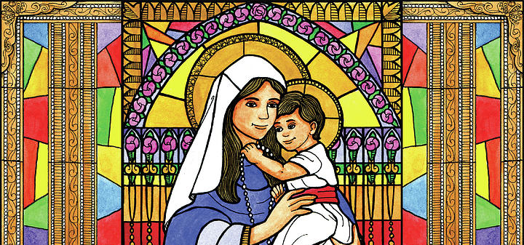

Name: ________________________________________
October 2024 Table of Contents
Overview……………………………………………………………………………………….....3
Learning Standards……………………………………………………………………………...5
Lesson Pacing Guide………………………………………………………………………....…14
Activities………………………………………………………………………………………....18
Pre-K/Kindergarten…………………………………………………………………….18
Week 1…………………………………………………………………………...18
Week 2…………………………………………………………………………...20
Week 3…………………………………………………………………………...22
Grade 1…………………………………………………………………………………..24
Week 1…………………………………………………………………………...24
Week 2…………………………………………………………………………...26
Week 3…………………………………………………………………………...28
Grade 2…………………………………………………………………………..............30
Week 1…………………………………………………………………………...30
Week 2…………………………………………………………………………...32
Week 3…………………………………………………………………………...39
Review…………………………………………………………………………………………...41

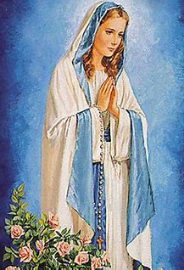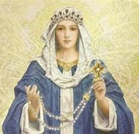
October 2024 Overview: Grades Pre-K-2
Theme: Month of the Holy Rosary
Marian Titles: Queen of the Holy Rosary; Mystical Rose
Monthly Prayer/Invocation: Our Lady, Queen of the Holy Rosary, pray for us. Our Lady, Mystical Rose, pray for us. Regina sacratissimi Rosarii, ora pro nobis. Rosa mystica, ora pro nobis.
Thematic Guiding Questions, Pre-K-2:
- What is the Rosary? Why and how do we pray it?
- How do you think the Rosary helps us to know and love Jesus?
- How does praying the Rosary make you feel, and how do you think God feels when He hears you praying the Rosary (why does He want us to pray the Rosary)?
- How does the symbol of a rose remind us of Our Lady and the Rosary?

Saint of the Month: St. Margaret Mary Alacoque was a French Visitation sister who was visited by Jesus in the 1670s, and taught about His Sacred Heart so that she could spread devotion to Him by drawing other people closer to His loving Heart.
Monthly Challenge: Pray one decade of the Rosary each day (10 “Hail Mary” prayers; 1 “Our Father” prayer; 1 “Glory Be” prayer; and 1 “Fatima” prayer). As a family, reflect on one of the Mysteries of the Rosary, and talk about how that Mystery shows us the love of Jesus and Mary.
Overall Learning Goals: Our goal this month is to identify how we can each uniquely shine God’s light in the world like Mary and the saints. We will learn about how we can honor Jesus and Mother Mary through prayer, with a special focus on how we live out the prayers of our hearts through saying the Rosary and going to Mass.
Summary of Activities: To achieve our learning goals, we will complete activities that engage us with the lives of the saints, and that familiarize us with liturgical devotions and feast days in the Church that help us to love Jesus more deeply. We will identify specific devotions that afford us opportunities to shine Jesus’ light of love like Mary and the saints, using art, music, reading, and reflection to guide us. Our activities will focus on how we grow in our faith through our prayer lives, and how we can reverently share our personal faith with others like the saints did, connecting prayer and action.
Additional Enrichment Ideas:
- Visit the St. Therese Shrine in Nasonville, Rhode Island, in honor of St. Therese of Lisieux’s feast day this month. Receive an indulgence for visiting the shrine in honor of the shrine’s 100th anniversary. Go on a rosary walk at the shrine. Head to the shrine’s website for more information about the shrine, including its history, St. Therese’s biography, event dates, and a novena to St. Therese:
  - https://burrillvillecatholic.org/novena-to-st-therese
  - https://burrillvillecatholic.org/the-life-of-st-therese
  - https://burrillvillecatholic.org/anniversary-%26-feast-days
  - https://burrillvillecatholic.org/history-of-the-shrine
- This month, hold a Sacred Heart enthronement ceremony in your home in honor of St. Margaret Mary Alacoque’s feast day on October 17, as well as the Feast of Christ the King on October 27. Place a blessed image of Jesus’ Sacred Heart in a central location, and consecrate your home to Him. Learn more about enthronement ceremonies, and registering yours, at these sites:
  - https://welcomehisheart.com/
  - https://www.catholiccompany.com/content/sacred-heart-jesus-enthronement-ceremony
- Host your own All Hallow’s Eve party to celebrate the evening before All Saints Day. Carve pumpkins with Catholic symbols like crosses and rosaries, or pictures of the saints, to create jack-o-lanterns that remind your family of Jesus’ light and love that is always with us. Have themed treats that remind you of the lives of the saints, and that the Lord is sweet

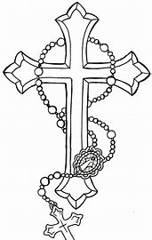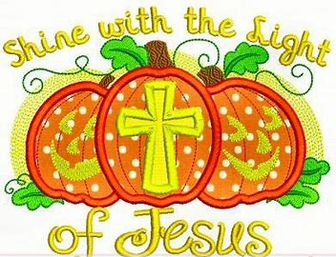
Learning Standards
Grade Level | Week | Activities | Learning Standards
Pre-K, Kindergarten | 1 | “Pray the Little Way: St. Therese and the Rosary” | K.7 When we go to church, we are in God’s house. It is a holy place where we experience God’s love, so we are respectful. We attend Mass at church and pray, following the priest as he celebrates the sacrament. In addition to attending Mass on Sundays, we attend for special holidays during the seasons, including Advent and Lent. At church, we show our love for God. Outside of church, we can continue to love God through the kind things we do, because God is always with us, and is happy when He sees us being loving.  K.9 Mary, the Mother of Jesus, is our Mother, too- She is always with us. We can pray for Her to help us to get to know Jesus better, because as His Mother, Mary is very close to Jesus. She is the greatest saint, because She has no sins, and can teach us to be more holy like Her.
Pre-K, Kindergarten | 2 | “Holy Habits” | K.1 God is love. He wants all of us to be loving to each other, so we use kind words and do kind things to show our love. God’s Greatest Commandments are: “You shall love the Lord your God with all your heart, with all your soul, and with all your mind,” and “You shall love your neighbor as you love yourself.”  K.4 We talk to God through prayer. We pray every day to help us do the right things. Praying helps us to know God. We say prayers such as the “Hail Mary,” the “Our Father” and the “Glory Be.”  K.7 When we go to church, we are in God’s house. It is a holy place where we experience God’s love, so we are respectful. We attend Mass at church and pray, following the priest as he celebrates the sacrament. In addition to attending Mass on Sundays, we attend for special holidays during the seasons, including Advent and Lent. At church, we show our love for God. Outside of church, we can continue to love God through the kind things we do, because God is always with us, and is happy when He sees us being loving.
Pre-K, Kindergarten | 3 | “Caring for God’s Creation” | K.1 God is love. He wants all of us to be loving to each other, so we use kind words and do kind things to show our love. God’s Greatest Commandments are: “You shall love the Lord your God with all your heart, with all your soul, and with all your mind,” and “You shall love your neighbor as you love yourself.”  K.4 We talk to God through prayer. We pray every day to help us do the right things. Praying helps us to know God. We say prayers such as the “Hail Mary,” the “Our Father” and the “Glory Be.”  K.7 When we go to church, we are in God’s house. It is a holy place where we experience God’s love, so we are respectful. We attend Mass at church and pray, following the priest as he celebrates the sacrament. In addition to attending Mass on Sundays, we attend for special holidays during the seasons, including Advent and Lent. At church, we show our love for God. Outside of church, we can continue to love God through the kind things we do, because God is always with us, and is happy when He sees us being loving.
Grade 1 | 1 | “Living and Loving the Mass with Our Lady of the Rosary” | 1.1 Jesus and Mary are examples of full faith in God the Father. Their lives were lived without sin, and with total love. We can follow their example in our daily lives, especially as we prepare to receive the sacraments that will bring us into closer union with God. We are a community of faithful who show our faith in God by trusting in His plan for our lives.  1.9 In addition to expressing our belief through gestures of reverence, we use our words to communicate our belief, including by saying “Amen,” which means “I believe.”  1.10 Our churches are places where we come together as God’s family to pray, sing, and share our love for God. The angels and saints in Heaven are with us at the Mass, singing and listening to our prayers. We share our love for God with each other. As one big Church community, we share our talents to give God our love, and prepare our hearts to receive Jesus. Our beautiful churches are made to remind us of Heaven, and how great God is, so that we will be inspired to pray and use our gifts for God. We are in communion with Christ.
Grade 1 | 2 | “Chapels and Chaplets” | 1.10 Our churches are places where we come together as God’s family to pray, sing, and share our love for God. The angels and saints in Heaven are with us at the Mass, singing and listening to our prayers. We share our love for God with each other. As one big Church community, we share our talents to give God our love, and prepare our hearts to receive Jesus. Our beautiful churches are made to remind us of Heaven, and how great God is, so that we will be inspired to pray and use our gifts for God. We are in communion with Christ.
Grade 1 | 3 | “Saint-o-Lanterns: Shining like the Saints” | 1.1 Jesus and Mary are examples of full faith in God the Father. Their lives were lived without sin, and with total love. We can follow their example in our daily lives, especially as we prepare to receive the sacraments that will bring us into closer union with God. We are a community of faithful who show our faith in God by trusting in His plan for our lives.  1.10 Our churches are places where we come together as God’s family to pray, sing, and share our love for God. The angels and saints in Heaven are with us at the Mass, singing and listening to our prayers. We share our love for God with each other. As one big Church community, we share our talents to give God our love, and prepare our hearts to receive Jesus. Our beautiful churches are made to remind us of Heaven, and how great God is, so that we will be inspired to pray and use our gifts for God. We are in communion with Christ.
Grade 2 | 1 | “Humble like Our Lady: The Rosary of Humility” | S1.3 The Act of Contrition is said by the penitent during Confession, before the priest gives the absolution.  2.6 The sacraments are special celebrations of God’s love, signs of His Presence. Some sacraments are received only once, including Baptism, Confirmation, and Holy Orders, because they leave marks on the soul for life, but other sacraments are received regularly, these being Communion and Confession.  S2.9 Eucharistic living is more than physically receiving Communion each week, encompassing the Christlike actions that we continue to embody in our daily lives, treating others mercifully.
Grade 2 | 2 | “Praying to God at Confession and Communion” | S2.4 Jesus Christ is Really and Truly Present in the Eucharist.  S2.5 The Eucharist is not merely a symbol, but is efficacious.  S2.8 The Eucharist forms our hearts, disposing us to love like Christ. Receiving the Eucharist allows us to share in the love that led Christ to sacrifice His life for our salvation, so that we, too, can participate in the sacramental covenant, offering ourselves as a gift to God. As members of Christ’s Body, it is important to reflect His qualities, His way of life.  S1.9 Sacraments such as Confession allow us to encounter God in our earthly lives, receiving a foretaste of Heaven through experiencing His merciful love. Sacraments like Confession prepare us for being with Christ in Heaven by purging us of the sins distancing us from Christ.
Grade 2 | 3 | “Saint-o-Lanterns: Reverence like the Saints” | 2.4 The saints are people in Heaven, including Mother Mary. They teach us how to be like Jesus. We can ask them to help us be holy. The saints loved God in their lives on Earth, exemplifying how to receive God’s graces reverently through the sacraments, and how to use them to become holier.  S2.4 Jesus Christ is Really and Truly Present in the Eucharist.  S2.5 The Eucharist is not merely a symbol, but is efficacious.  S2.8 The Eucharist forms our hearts, disposing us to love like Christ. Receiving the Eucharist allows us to share in the love that led Christ to sacrifice His life for our salvation, so that we, too, can participate in the sacramental covenant, offering ourselves as a gift to God. As members of Christ’s Body, it is important to reflect His qualities, His way of life.  S1.9 Sacraments such as Confession allow us to encounter God in our earthly lives, receiving a foretaste of Heaven through experiencing His merciful love. Sacraments like Confession prepare us for being with Christ in Heaven by purging us of the sins distancing us from Christ.
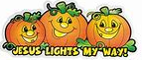
October 2024 Lesson Pacing Guide (Suggested Schedule)
Grades Pre-K-2
Week Number/Date | Grade Level | Activities
Week 1  (October 7, 2024 – October 11, 2024) | Pre-K, Kindergarten | “Pray the Little Way: St. Therese and the Rosary”
Week 1  (October 7, 2024 – October 11, 2024) | Grade 1 | “Living and Loving the Mass with Our Lady of the Rosary”
Week 1  (October 7, 2024 – October 11, 2024) | Grade 2 | “Humble like Our Lady: The Rosary of Humility”
Week 2  (October 14, 2024 – October 18, 2024) | Pre-K, Kindergarten | “Holy Habits”
Week 2  (October 14, 2024 – October 18, 2024) | Grade 1 | “Chapels and Chaplets”
Week 2  (October 14, 2024 – October 18, 2024) | Grade 2 | “Praying to God at Confession and Communion”
Week 3  (October 21, 2024 – October 25, 2024) | Pre-K, Kindergarten | “Caring for God’s Creation”
Week 3  (October 21, 2024 – October 25, 2024) | Grade 1 | “Saint-o-Lanterns: Shining like the Saints”
Week 3  (October 21, 2024 – October 25, 2024) | Grade 2 | “Saint-o-Lanterns: Reverence like the Saints”

Week Number/Date | Grade Level | Words to Practice | Definitions
Week 1  (October 7, 2024 – October 11, 2024) | Pre-K, Kindergarten | Convent | A place where nuns live. Nuns are women who make special promises to give their lives to God. A community where nuns live out their promises to God. They pray to God, and work for Him together.
Week 1  (October 7, 2024 – October 11, 2024) | Grade 1 | Chaplet | Meaning “little crown,” a small chain of beads that looks like a garland or crown of flowers. Each bead represents a prayer to say. Rosaries are a type of chaplet. Other types of chaplets are shorter strings of beads with fewer, or different, prayers than the Rosary.
Week 1  (October 7, 2024 – October 11, 2024) | Grade 2 | Humility | Humbleness. Knowing that we need God to help us, and putting Him first. Thinking of God and others before we think of ourselves.
Week 2  (October 14, 2024 – October 18, 2024) | Pre-K, Kindergarten | Habit | There are two meanings to this word. First, a habit is something we do. A holy habit is something we do that shows our love for God, and that helps us to be more like Jesus. A habit is also the type of clothing that a priest or nun wears. Priests’ and nuns’ habits represent the promises they make to God, and show the world that they have given their lives to God. A nun’s habit usually includes a veil, a long dress, and a Rosary or scapular. A priest or monk’s habit will often have a hood, tunic or robe/cloak, belt, Rosary, and scapular. Habits are different colors, but are often black, white, brown, or gray.
Week 2  (October 14, 2024 – October 18, 2024) | Grade 1 | Chapel | A small space for prayer, inside or outside of a church, with its own altar. People may visit chapels for personal prayer and Adoration of the Eucharist. Sometimes Masses for smaller groups of people are celebrated in chapels.
Week 2  (October 14, 2024 – October 18, 2024) | Grade 2 | Prie-dieu | A kneeler. This word means to “pray” to “God” in French. These small, portable kneelers are put in the aisle at the time of Communion so that people may kneel to receive the Eucharist by tongue.
Week 3  (October 21, 2024 – October 25, 2024) | Pre-K, Kindergarten | Monastery | A monastery is a place where priests called monks live. Monasteries have churches where monks pray, chant (sing holy songs), and go to Mass. Monks are men who promise to give their lives completely to God. They live away from the world, in a separate community. They work for God, following the rules for their community, and keeping their promises to God.
Week 3  (October 21, 2024 – October 25, 2024) | Grade 1 | Incense | Incense comes from a plant called frankincense, a little bit of which is burned at the Mass. The incense, which smells sweet like perfume, is a reminder to send sweet prayers up to God. When we see the incense’s smoke rising up, we remember to look up to God, because He is watching over us and wants to help us.
Week 3  (October 21, 2024 – October 25, 2024) | Grade 2 | Reverence | Respect for the holiness of God. Reverence can be shown through gestures of respect such as a Sign of the Cross and genuflection before the altar of God in a church.

Week Number/Date | Grade Level | Prayers to Practice | Text of Prayers
Week 1  (October 7, 2024 – October 11, 2024) | Pre-K, Kindergarten | Glory Be | Glory be to the Father,  And to the Son, and to the Holy Spirit.  As it was in the beginning, is now,  And ever shall be,  World without end. Amen.
Week 1  (October 7, 2024 – October 11, 2024) | Grade 1 | Our Father | Our Father, Who art in Heaven,  Hallowed be Thy name.  Thy kingdom come.  Thy will be done on Earth, as it is in Heaven.  Give us this day our daily bread.  And forgive us our trespasses,  As we forgive those who trespass against us.  And lead us not into temptation,  But deliver us from evil. Amen.
Week 1  (October 7, 2024 – October 11, 2024) | Grade 2 | Act of Contrition | Oh my God, I am heartily sorry for having offended Thee, and I detest all my sins, because I dread the loss of Heaven and the pains of Hell, but most of all because they offend Thee, my God, Who art all good, and deserving of all my love. I firmly resolve, with the help of Thy grace, to confess my sins, to do penance, and to amend my life. Amen.
Week 2  (October 14, 2024 – October 18, 2024) | Pre-K, Kindergarten | Glory Be | Glory be to the Father,  And to the Son, and to the Holy Spirit.  As it was in the beginning, is now,  And ever shall be,  World without end. Amen.
Week 2  (October 14, 2024 – October 18, 2024) | Grade 1 | Our Father | Our Father, Who art in Heaven,  Hallowed be Thy name.  Thy kingdom come.  Thy will be done on Earth, as it is in Heaven.  Give us this day our daily bread.  And forgive us our trespasses,  As we forgive those who trespass against us.  And lead us not into temptation,  But deliver us from evil. Amen.
Week 2  (October 14, 2024 – October 18, 2024) | Grade 2 | Act of Contrition | Oh my God, I am heartily sorry for having offended Thee, and I detest all my sins, because I dread the loss of Heaven and the pains of Hell, but most of all because they offend Thee, my God, Who art all good, and deserving of all my love. I firmly resolve, with the help of Thy grace, to confess my sins, to do penance, and to amend my life. Amen.
Week 3  (October 21, 2024 – October 25, 2024) | Pre-K, Kindergarten | Glory Be | Glory be to the Father,  And to the Son, and to the Holy Spirit.  As it was in the beginning, is now,  And ever shall be,  World without end. Amen.
Week 3  (October 21, 2024 – October 25, 2024) | Grade 1 | Our Father | Our Father, Who art in Heaven,  Hallowed be Thy name.  Thy kingdom come.  Thy will be done on Earth, as it is in Heaven.  Give us this day our daily bread.  And forgive us our trespasses,  As we forgive those who trespass against us.  And lead us not into temptation,  But deliver us from evil. Amen.
Week 3  (October 21, 2024 – October 25, 2024) | Grade 2 | Act of Contrition | Oh my God, I am heartily sorry for having offended Thee, and I detest all my sins, because I dread the loss of Heaven and the pains of Hell, but most of all because they offend Thee, my God, Who art all good, and deserving of all my love. I firmly resolve, with the help of Thy grace, to confess my sins, to do penance, and to amend my life. Amen.

October 2024 Pre-K-2 Activities: Week 1
Pre-K/Kindergarten- “Pray the Little Way: St. Therese and the Rosary”
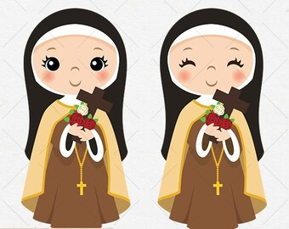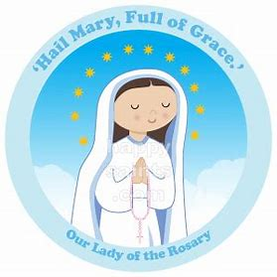
In October, we celebrate the traditional feast day of St. Therese of Lisieux on October 3. St. Therese was a nun who lived in the country of France in the 1800s. She loved Jesus and Mary, and decided to become a nun when she was very young. St. Therese gave her life to serving Jesus. She went to the convent, which is where nuns live. Nuns go to Mass, pray, and work.
The month of October honors the Holy Rosary. The feast day of Our Lady of the Rosary is October 7. St. Therese prayed the Rosary to share her love for Mother Mary and Jesus. She kept rosary beads in her pocket. She counted the beads on the rosary to keep track of good deeds she did each day. St. Therese made sure she was doing her best to be loving like Jesus. She worked hard to do better each day.
Rosary beads are joined in a circle, like a crown of little flowers. The beads help us remember the number of prayers we say. A “Hail Mary” is said on each of the little beads, and the “Our Father” on the big beads. We start off learning the words of each prayer, then build up as we learn to say all of the prayers in the Rosary. St. Therese was called the “Little Flower. She was like Mother Mary, a sweet and good person who made God happy with her kindness, prayers, and love, just like a beautiful flower brings joy.
St. Therese showed that everything we do for God, big or little, is important and good. When we do something with love, it makes a big difference. Love changes the world. St. Therese did each thing, no matter how small it seemed, with love for God, whether she was sweeping floors, or praying the Rosary. St. Therese called this the “Little Way.” She prayed while she worked at every task. St. Therese may have been young, a “little flower,” but she helped other people to grow in love for God, and still does! God loves her very much, just as He loves you.

In the Rosary box below, draw something you can do out of love for God. How can you use the Little Way like St. Therese? What can you give to God?

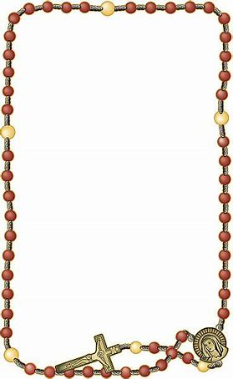

I can be like St. Therese when I:

_________________________________________________________________.

October 2024 Pre-K-2 Activities: Week 2
Pre-K/Kindergarten- “Holy Habits”
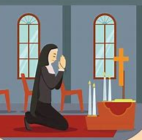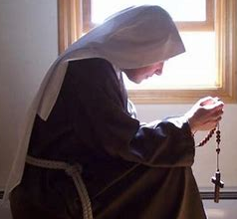
During the month of October, we celebrate the Holy Rosary. Praying the Rosary is a wonderful holy habit we can start. A habit is something we do a lot. A holy habit is a good thing we can do each day to show our love for God.
The word “habit” also is used when we are talking about the clothing a monk or nun wears. Monks, holy men who give their lives to God, and nuns, holy women who give their lives to God, wear habits, special clothes that show they are people who live for God, who have given their lives to Jesus. Habits remind us of how we can be holy like monks and nuns. Monks and nuns make promises to God to follow what He is asking them to do. God chooses something special for each person to do. Being a monk or nun is something God chooses some men and women to do.
Some monks and nuns have rosary beads that they wear on their belts. Rosaries have crosses on them to remind us of Jesus. Jesus gave His life on the Cross for us out of love. He saved people and helped them get to Heaven. Carrying rosary beads everywhere they go remind monks and nuns to pray throughout the day.
Nuns cover their hair by wearing veils like Mother Mary. Monks may wear hoods that cover their heads. Some monks have beards, or shave their heads. Veils and hoods show that nuns and monks are humble. They wear simple clothes without patterns. They focus on Jesus, and want other people to look to Him, too. Colors monks and nuns wear remind us of Jesus. Some wear white, a pure color reminding them to have clean, loving hearts like Jesus. Black is worn to show they are sorry for sins, things that bring people away from God, and that they will pray to make up for sins. Brown is a color for humbleness, a reminder to put God first. Blue is worn for Mary as a reminder to be gentle and faithful to God like Her.
Like monks and nuns, we can all do good things for God, and live our lives for Him. God may choose us to do something different than a monk or nun, but we can all pray to show God our love.

Color the habits of these paper doll friends. The colors of habits are reminders of Jesus and His life. Which colors will you choose? Label (write on the lines) which friend is a monk, and which is a nun.

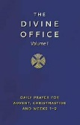
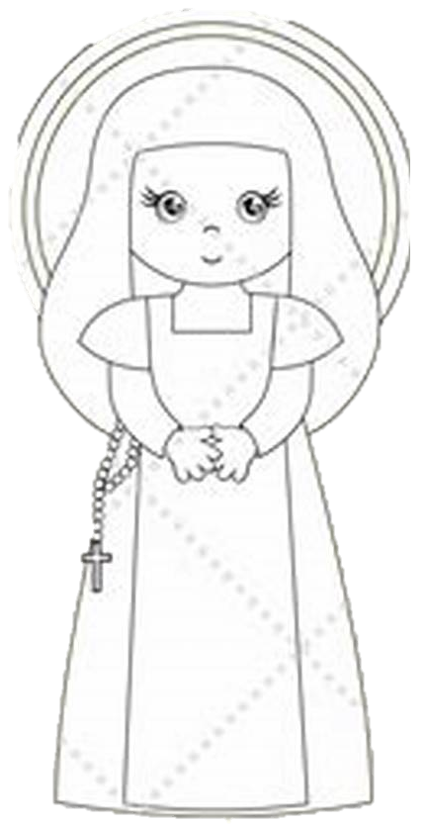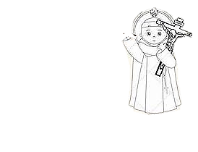

____________________________________ ____________________________________

What is a holy habit you can start, something good that you can do for God, like a monk or nun would do? Draw a picture of your idea.



October 2024 Pre-K-2 Activities: Week 3
Pre-K/Kindergarten- “Caring for God’s Creation”
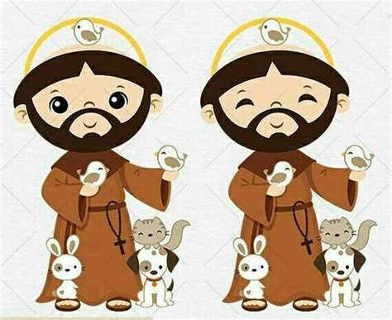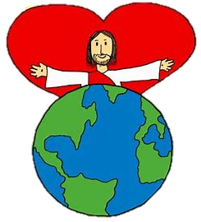
We celebrate the feast day of St. Francis of Assisi on October 4. St. Francis was a monk who lived in Italy in the 1100s and 1200s. Like St. Therese, St. Francis decided to give his life to God. He wanted to live a life of prayer. Monks are men who give their lives to God, like priests, but they are called “brother” instead of “father.” Priests care for the people who go to their churches. Monks live away from the world in a peaceful place called a monastery, where they go to Mass, pray, and work. Nuns, called “sisters,” like St. Therese, are women who give their lives for God and live away from the world in a convent.
St. Francis gave up everything he had to follow God. He wanted to live like Jesus. Jesus did not live with a lot of things. Jesus shared what He had with other people. St. Francis loved animals, and animals loved him, because he was very gentle, peaceful, and kind like Jesus. God made animals, and St. Francis loved everything God made, because what is made by God is good. St. Francis blessed the animals- he said special prayers to God for them. Animals like wolves were calm with St. Francis. He told them stories about Jesus. They listened!
Just like St. Francis, we can care for the people and animals God created by treating them with gentleness. We can keep Jesus’ peace in our hearts, and bring it everywhere we go, by praying and acting with kindness. We can ask St. Francis to help us bring peace. We can pray for other people. Praying is a beautiful way to care for other people, a way to show love, as we ask God to be with them, and bring them happiness.

Draw a picture of how you can be like St. Francis of Assisi, and care for God’s creation, the people and things He has made.


I will care for God’s creation like St. Francis by

__________________________________________________________________.

October 2024 Pre-K-2 Activities: Week 1
Grade 1- “Living and Loving the Mass with Our Lady of the Rosary”
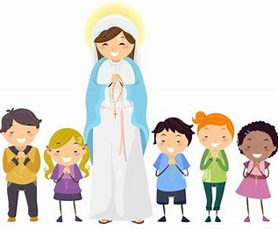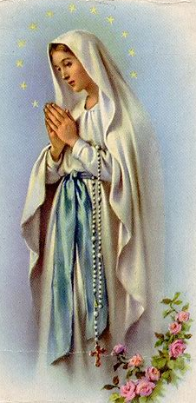
October is the Month of the Holy Rosary. Praying the Rosary throughout the year is a wonderful way to honor Mother Mary. Mother Mary is our Mother in Heaven, where She lives with Jesus, the angels, and saints. Mother Mary has come down from Heaven to tell people on Earth to pray. In the year 1208, Mother Mary brought the Rosary to St. Dominic, a monk from the country of Spain who gave his life to serving God. She wanted him to teach other people about the Rosary, which helps people to keep track of the prayers they say, and to think about Jesus and Mary. We can bring the Rosary everywhere with us to remind us to pray, including when we go to Mass. At Mass, we remember Jesus giving His life for us on the Cross out of love for us. The Rosary also helps us to remember Jesus’ life and love for us.
The Rosary’s beads remind us of the amazing things Jesus and Mary did out of love for God the Father, and for us. The Joyful Mysteries of the Rosary remind us of happy times, like when Mother Mary learned that She would be Jesus’ Mother, when Jesus was born, and when Jesus began to teach people, sharing His love for God the Father. The Sorrowful Mysteries seem sad, because they are about Jesus dying on the Cross, but they are really about Jesus’ love. The Glorious Mysteries remind us that God’s love wins over everything, because Jesus came back to life. The Glorious Mysteries are about the good things that happened after Jesus rose from the dead. They show that when we believe in God, when we trust in Him, remembering He loves us, our souls will never die, because we will one day go to Heaven to be with God forever.
The Rosary is also called a chaplet. A chaplet is a small circle of beads, like a crown. Mother Mary wears a crown, because She is the Queen of Heaven. When we pray the Rosary, it is like we are putting a crown on Her, showing Her we love Her. Every day, we can pray a decade of the Rosary (10 Hail Mary beads) and think about something that Jesus and Mary did. Praying is how we can thank Jesus and Mary for helping us. They love us so much, that they are very happy to hear us pray.

In the space below, draw your own Rosary chaplet. Think about what you can draw on your Rosary beads to remind you of Jesus and Mary, and to show how you love them.

What will you pray for when you pray your chaplet?

______________________________________________________________________________
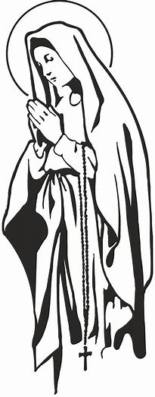
October 2024 Pre-K-2 Activities: Week 2
Grade 1- “Chapels and Chaplets”
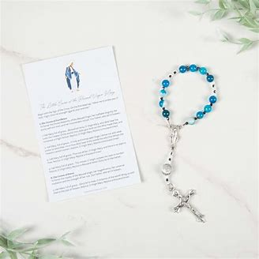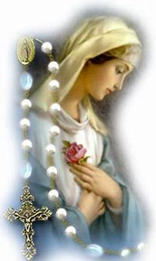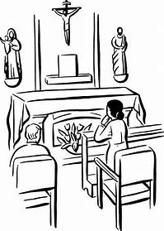
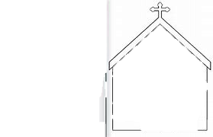
The Rosary looks like a beaded necklace with a crucifix, a cross with Jesus on it. The Rosary is not a necklace to wear, though. We use the Rosary to pray. Each bead helps us to count the prayers we have said. We say a “Hail Mary” for every small bead, and an “Our Father” for every large bead. There are five sets of 10 small “Hail Mary” beads, and 5 big “Our Father” beads. This reminds us to say 50 Hail Mary prayers. In between the last “Hail Mary” bead and “Our Father” bead in each set, we say a “Glory Be” prayer.
The Rosary is a type of chaplet. Some chaplets are smaller, more like bracelets. They look like little crowns. The Little Crown of the Blessed Virgin Mary chaplet has 12 “Hail Mary” beads. There is one bead for every star in Mother Mary’s crown. Mother Mary wears a crown, because She is Queen of Heaven. Mother Mary has a special place in Heaven, because She is Jesus’ Mother.

In October, we celebrate the Month of the Holy Rosary. October 7 is the feast day of Our Lady of the Rosary. Mother Mary gave St. Dominic the Rosary to share with people.

The word “chaplet” sounds like the word “chapel,” but chaplets and chapels are different. A chapel is where we can go to pray. It is usually a smaller room in a church used for people to pray privately. Sometimes chapels may be used for Masses with small groups of people. This is like how chaplets are usually smaller versions of the Rosary.
Chapels may be used for Eucharistic Adoration. The Eucharist, the Host, is put on a small altar. People pray while looking at the Eucharist, adoring Jesus. People go to chapels to spend time with Him, telling Him they love Him. People may pray the Rosary, or other chaplets, in a chapel.
Chapels are peaceful, quiet places that help us to keep our minds and hearts on Jesus and Mother Mary. Chaplets help us to think about Jesus and Mary, too, because when we pray each “Our Father” bead, we think about something that happened in Jesus’ and Mary’s lives, like when Jesus was born, or when He went on the Cross for us.

In the space below, draw yourself in a chapel. What do we see in a chapel? What can people do when they visit a chapel?

October 2024 Pre-K-2 Activities: Week 3
Grade 1- “Saint-o-Lanterns: Shining like the Saints”
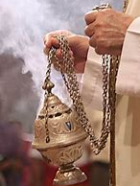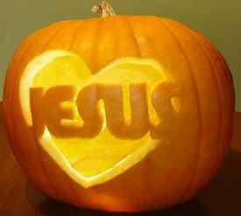
When we go to church, we know that Jesus is with us. He is at the Mass. When people receive the Eucharist at Communion, they are receiving Jesus. At Mass, we show our love and respect for Jesus. The things we see and hear at Mass remind us to pray, to share our love for Jesus. God hears our prayers and watches over us. Our prayers go up to God in Heaven. Sometimes incense is used at Mass. Incense comes from a plant called frankincense. Frankincense smells very sweet, which is why the Three Kings brought Jesus frankincense as a gift when He was born. Just as we burn candles, priests burn incense to give something sweet and good to God. Incense rises up to the ceiling, and reminds us to send our prayers up to God, our Father in Heaven.
The saints also hear us when we ask them to help us. They want to help us know and love Jesus better. October 17 is the traditional feast day of St. Margaret Mary Alacoque. St. Margaret Mary taught about Jesus’ Sacred Heart. She reminds us that His Heart is filled with love for us. She shows us not to give up, but to keep praying and trying to be better each day, because Jesus is with us and loves us. He wants to help us because He loves us.
October is the month of Halloween, also called All Hallows Eve, because it is the night before (the eve of) All Saints Day. All Saints Day is a holy day. “Hallow” comes from “hallowed,” which means “holy.” In the Our Father, we say “hallowed be Your Name,” because we want to bless God’s Name, to say God’s Holy Name with love. On Halloween, some people carve pumpkins and put candle lights inside to make jack-o-lanterns. The saints had the light of Jesus’ love shining in their hearts. We shine God’s light in our hearts with our goodness. The saints went to Heaven because they were always shining God’s light into the world, bringing His love to other people. Saints lived like Jesus, praying and treating God and their neighbors with love and respect. People see God in us when we are loving and kind like Him, just as the saints were.
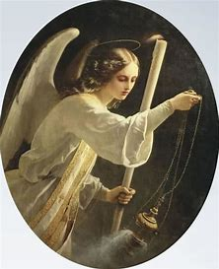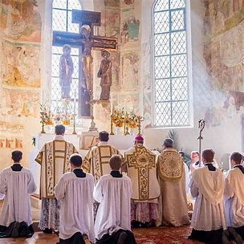
Make a saint-o-lantern. Draw a picture of the saint you would “carve” into your pumpkin. You can also draw something that reminds you of your saint, like a heart for St. Margaret Mary. Which saint did you choose? How can you be like your saint?
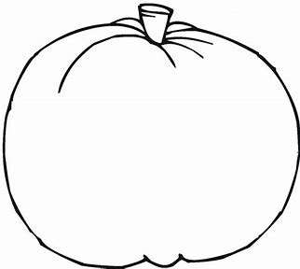

I can be like Saint ______________________________________________________________

when I _______________________________________________________________________

_____________________________________________________________________________.

October 2024 Pre-K-2 Activities: Week 1
Grade 2- “Humble like Our Lady: The Rosary of Humility”
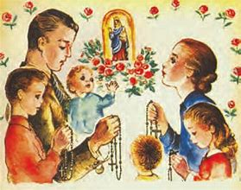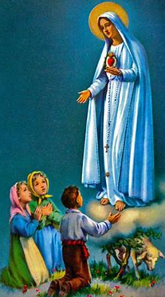
October 7 is the feast day of Our Lady of the Rosary, a special title for Mother Mary, who gave us the Rosary to pray. Mother Mary loved God. She lived with humility, which means She was humble. She wanted to do what God had planned for Her. She believed God’s plan was best, so She put God first. God is perfect. We all need God to be the best we can be. He helps our souls to become more perfect so that we can one day be with Him in Heaven. When we get ready for Communion, we are learning how to make ourselves ready to be with God. When we treat Jesus with love on Earth, such as when we respectfully receive Him at Communion, we are preparing ourselves to love Him in Heaven someday.
Mother Mary always thinks of other people. She is a loving Mother to Jesus, and to us. She is always wanting to help us and send us blessings from God, which She does through the Rosary. Praying the Rosary is how we can talk to Mother Mary and ask Her to help us receive Jesus at Communion with all the love in our hearts. Mother Mary can help us to humbly, kindly give our hearts to God like She did. Mother Mary received the wonderful gift of Her Son, Jesus, because She followed God’s plan for Her, listening to Him and loving Him with Her whole Heart.
When we say the Act of Contrition, we show humility. A humble heart is a loving heart that is open to learning and growing, to listening to God. At Confession, we say the Act of Contrition to tell God that we are sorry for times we did not listen to Him as we could have. We also tell Him that we love Him, and will work on loving Him by putting Him first. When we pray, we can say a Rosary of Contrition, asking Mother Mary to help us make a good Confession and to have humble, loving hearts like Hers. While praying the Rosary, we think of Jesus’ and Mary’s love for God the Father, and how they followed His rules, the 10 Commandments, listening to God’s plan. God’s plan is for us to treat each other with kindness and love. Thinking about Jesus and Mary while we pray the Rosary, we learn about how we can live like them, too. To help you as you pray, read “Some Things to Help Me Pray” on page 39 of your St. Joseph’s First Communion Catechism book.
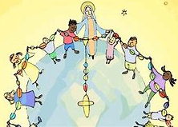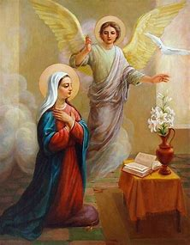
Inside the rosary below, draw a picture of what you can do to be humble, to grow in humility.
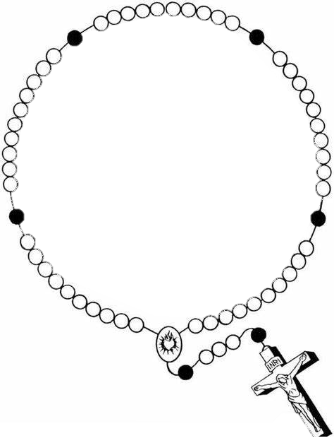
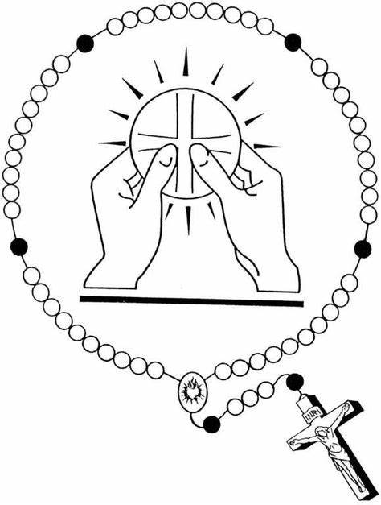
How do praying the Rosary and receiving Communion help us to become more humble?

__________________________________________________

__________________________________________________

__________________________________________________

October 2024 Pre-K-2 Activities: Week 2
Grade 2- “Praying to God at Confession and Holy Communion”
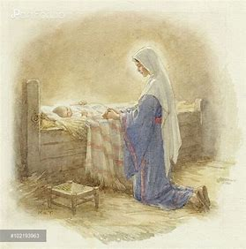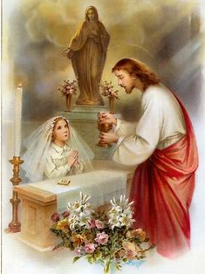
Making your First Communion will be very special! This is an exciting time, when you are getting ready to receive Jesus in the Eucharist. Every time we receive Communion, we can prepare ourselves to receive Jesus with love. Receiving Communion is important, and so is what we do in the time leading up to Communion.
Before going to Communion, we go to Confession. At Confession, we pray, asking God to show His mercy (forgiveness) and love to us, and to fill our hearts with love so that we are ready for Communion. This month, the Month of the Holy Rosary, we can use a special prayer, the Rosary, to help us prepare for the time of First Communion.
Praying is the best thing we can do to get ready for Communion. When we pray, God listens to us, and He answers us. He brings faith, hope, and love into our hearts so that we feel peaceful. We need faith, hope, and love to make a good Confession and a good Communion, to become closer to Jesus’ Heart, because He has faith, hope, and love in His Heart, too.
When we pray, we show we believe in God, that we know He is with us, no matter what. This is called having “faith.” Praying helps us to trust that God will help us, so that we do not have to be afraid. This is how we have “hope.” Praying is how we talk to God. We talk to our friends to get to know them better. Praying is how we show that we love God, because we want to know Him better and be friends. Jesus prayed to God, His Father in Heaven, because He believed He would help, trusted in His plan, and loved Him. This is why Jesus gave us His life on the Cross, out of love for God, and for us. It was God’s plan for this to happen, and for Jesus to come back to life, giving us new life in the Eucharist, His Body we receive at Communion.
When you receive Communion by tongue, you kneel to show respect for God. This helps us love Him more. Kneeling before Jesus in the Eucharist at Communion, we are like Mother Mary when She was kneeling before Her Son, the baby Jesus, in His crib. The kneeler that is used during Mass to receive Communion is called the prie-dieu. This is a French word that means “pray to God.” While we kneel at Mass, including when we receive Communion, we pray to God. After Communion, we pray again, thanking Jesus for being with us and giving us His life.
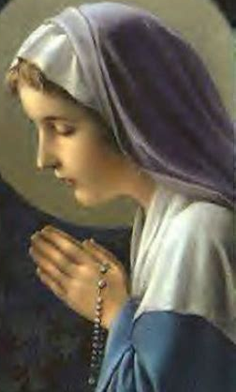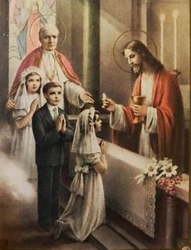
In your St. Joseph’s First Communion Catechism book, read Lesson 11, pages 47-52. Write or draw your answers to the questions below.

What is can you do before Holy Communion to prepare to receive Jesus?

What do you do during Holy Communion to show respect for God?

What is one thing you can do after Holy Communion?

Why is it important that we do these things?

______________________________________________________________________________

______________________________________________________________________________

Bonus:
Read Lessons 9 and 10, “The Sacrament of Penance” and “How to Make a Good Confession” (pages 40-46) in your St. Joseph First Communion Catechism book.
What do we do when we go to Confession? Put the steps below in order, writing the correct number, 1-5, next to each scene, to show how we make a good Confession. Draw a picture for each step. You may also cut out the scenes and glue them on a separate piece of paper to read like a comic book or a timeline of events.

_____. The priest gives me my penance (telling me
what I need to do to show God that I am sorry).
Then I say the Act of Contrition to tell God that
I love Him, and will work on staying away from sin.

______. I go in the confessional, make the Sign
of the Cross (bless myself), and say,
“Bless me Father, for I have sinned.”

______. I do an examination of conscience, thinking about how
I followed the 10 Commandments. I pray.

________. The priest absolves (forgives) me
of my sins. I go back in the church and do what
the priest has told me for my penance. I pray.

________. I tell the priest my sins.

October 2024 Pre-K-2 Activities: Week 3
Grade 2- “Saint-o-Lanterns: Reverence like the Saints”
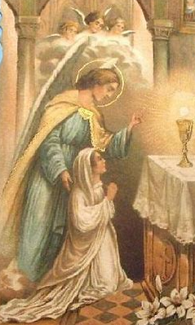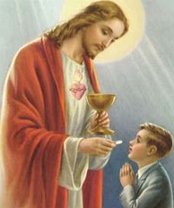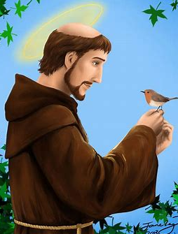
On October 27, we celebrate the traditional feast day of Christ the King. In October, we can do special things to show respect for Christ the King, and for the Queen of Heaven, Mother Mary, such as praying the rosary. Everything we do at Mass is to show respect for God, also called “reverence.” One way we show reverence is by blessing ourselves with holy water when we enter and leave the church. This reminds us that we are in a holy place with God. We remember to bring Jesus in our hearts out into the world when we leave the Church, taking God’s love at the Mass with us. We show respect by kneeling or bowing and blessing ourselves (genuflecting) when we go by the tabernacle on the altar of the church, where Jesus is in the Hosts. When we hear Jesus’ Holy Name said during Mass, we bow our heads. People bow to show respect when they meet royalty, like a king or queen. Jesus is King, so we show Him our respect by bowing and kneeling when we see Him at the Mass. He is with us in the Eucharist.
Some people bow before they receive Communion. We bless ourselves after we receive Communion. This is like when we bless ourselves before eating a meal, and say a prayer called “grace,” when we thank God for the food He gave us. The Eucharist, the bread that becomes Jesus’ Body at Mass, is the holiest, most special food we can receive. This is why we show respect for Jesus in the Eucharist by bowing before receiving Him, and blessing ourselves after.
Look at the pictures on page 3 of your St. Joseph’s First Communion Catechism. Then, look at the pictures on page 58, next to the part about “The Communion.” These are pictures of people showing reverence, respect for God, by making the Sign of the Cross, praying, and receiving Communion with love. At Communion, we see people receiving Communion by tongue. This is a way to show respect for God. They do this to make sure that the Host, the Eucharist, does not fall on the floor. Sometimes pieces of the Eucharist may fall, and could be stepped on when people walk by. People may receive by tongue to be careful that this does not happen.
The saints are people who loved Jesus on Earth and are now with Him in Heaven. The saints always treated Jesus with reverence. St. Francis loved everything God made. He blessed God’s creation, including the animals he saw, like the birds. Saints shine God’s light in the world. They show people how loving and good God is through the kind things they do and say. We can become saints by being respectful and loving to God, and showing our love for God to others. The saints and angels are with us at Mass. You can ask them to help you as you get ready to make your First Communion.

On the pumpkin below, make your own “saint-o-lantern” by drawing a picture of a saint who was reverent. Think about what it looks like to be “reverent,” respectful, to God. What did your saint friend do that showed respect for God? How can you show your love and respect for God as you prepare to receive Holy Communion for the first time?
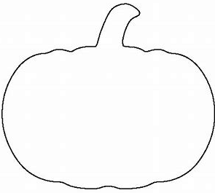

Saint __________________________________________________ showed love for God by

_________________________________________________________. I can show love and

respect for God by ____________________________________________________________

_____________________________________________________________________________.
October 2024 Pre-K-2 Review
Use this review sheet as a reference to track progress and check that learning goals are met.
Recap: What did we learn?
All Grades
- October is the month of the Holy Rosary
- October is when we remember Our Lady of the Rosary
- The Rosary is a special prayer that helps to learn about Jesus’ and Mary’s lives so that we can love them better
Pre-K/Kindergarten
- St. Therese of Lisieux’s feast day is on October 3. St. Therese used the “Little Way” of prayer
- She offered up everything she did as a prayer, out of love for God. No matter how small the task she did might have seemed, it made a big difference thanks to her love
- St. Therese was a nun, a woman who gives her life to God. Nuns live at a convent
- St. Therese prayed the Rosary, and used rosary beads to count the good deeds she did each day
- We can be like St. Therese and do good things out of love for God
- A monk is a man who gives his life to God. Monks live in a monastery
- Monks and nuns make special promises to God, and live away from the world
- Monasteries and convents are places of prayer. Monks and nuns wear habits, clothes that show their humbleness and faith in God. Habits remind us of Jesus
- Rosaries on monks’ and nuns’ habits remind them to always pray and give everything to Jesus and Mary
- St. Francis of Assisi was a monk who gave up everything for God. He loved everything God made, and cared for animals
- A habit is also something we do a lot. We can start holy habits, good things we do for God, every day. Like monks and nuns, we can pray and use our lives to love Jesus
Grade 1
- Chapels are places we can go to pray. They are usually smaller spaces within a church
- People go to chapels for Eucharistic Adoration, where the Eucharist is placed on a small altar, and people may pray before Jesus
- Rosaries are prayer beads, a type of chaplet. Most chaplets are smaller than rosaries
- Mother Mary gave the Rosary to St. Dominic to share with people. He was called to teach them about loving and honoring Jesus and Mary through the Rosary’s prayers
- The Rosary’s big beads remind us to say 5 “Our Father” prayers. The little beads remind us to pray a total of 50 “Hail Mary” prayers, 10 for each of the 5 life events of Jesus and Mary we remember for each Rosary Mystery category
- There are three categories of Rosary Mysteries: Joyful, Sorrowful, and Glorious. There are 5 events from Jesus’ and Mary’s lives within each Mystery, for a total of 15
- The Joyful Mysteries remind us of happy events from Jesus’ and Mary’s lives, especially from when Jesus was a child. The Sorrowful Mysteries are about the sadness of Jesus suffering and dying, but the Glorious Mysteries remind us that His love overcame all. These Mysteries are about the good things that happened when Jesus rose from the dead
- We remember Jesus’ life and love for us in the Rosary and at Mass
- At Mass, incense is used to remind us to pray. Incense, from the frankincense plant, is burnt like a candle. The incense smoke goes up to the ceiling like our prayers to God that go up to Heaven
- All Hallow’s Eve is the night before All Saints Day. What is “hallowed” is holy. All Saints Day is a holy day
- Saints like St. Margaret Mary Alacoque show us how to love and respect Jesus. St. Margaret Mary taught people to love Jesus’ Sacred Heart
Grade 2
- Prayer is the best way to get ready to receive Communion, because it is how we talk to God. By talking to God, we learn to be a good friend to Him. We learn how He wants us to love and respect Him
- We go to Confession before Communion. We pray for God’s forgiveness at Confession. He forgives us for when we did not listen to Him, and His love fills our hearts, so that we are ready to receive Him in Communion
- Praying the Rosary can help us to prepare for Communion, since it helps us to think about Jesus’ life. As we think about Jesus’ love, and how we can have a heart like His, so that we are ready to receive Him in our hearts
- We show our respect for Jesus on the inside and on the outside. We pray to love Jesus more, and we show our love by bowing, kneeling, and blessing ourselves before Jesus
- When receiving Communion by tongue, we kneel. The kneeler is called a prie-dieu
- People receive Communion by tongue so that the Host does not fall on the floor. They want to make sure that no pieces of the Host are stepped on
- We receive Jesus in the Eucharist. Jesus is King, and we want to show our respect for Him as the King of our lives
- Mother Mary and the saints show us how to live with love and respect for Jesus. They listened to what God was asking them to do
- Mother Mary loved God, so She listened to His plan. She put Him first. She had a humble heart
- We can pray for humility like Mother Mary’s when we pray the Rosary, which She gave us to pray, as a way to help us become closer to Her Son
What vocabulary words did we practice?
Pre-K/Kindergarten
Week 1
Convent
Week 2
Habit
Week 3
Monastery
Grade 1
Week 1
Chaplet
Week 2
Chapel
Week 3
Incense
Grade 2
Week 1
Humility
Week 2
Prie-dieu
Week 3
Reverence
What prayers did we practice?
Pre-K/Kindergarten
Glory Be
Grade 1
Our Father
Grade 2
Act of Contrition
Checklist: Activity Completion
Pre-K/Kindergarten
Week 1: “Pray the Little Way: St. Therese and the Rosary”
Week 2: “Holy Habits”
Week 3: “Caring for God’s Creation”
Grade 1
Week 1: “Living and Loving the Mass with Our Lady of the Rosary”
Week 2: “Chapels and Chaplets”
Week 3: “Saint-o-Lanterns: Shining like the Saints”
Grade 2
Week 1: “Humble like Our Lady: The Rosary of Humility”
Week 2: “Praying to God at Confession and Communion”
Week 3: “Saint-o-Lanterns: Reverence like the Saints”
Quick Check:
Tell us about your experience with these activities this month! Our October 2024 Google Form for Grades Pre-K-2 is available here: https://forms.gle/SusTRaUmGNW8Guzj8

Grade 2- “Praying to God at Confession and Communion” Answer Key
What do we do when we go to Confession? Put the steps below in order, writing the correct number, 1-5, next to each step, to show how we make a good Confession.
4. The priest gives me my penance (telling me what I need to do to show God that I am sorry).
Then I say the Act of Contrition to tell God that I love Him, and will work on staying away from sin.

2. I go in the confessional, make the Sign of the Cross (bless myself), and say, “Bless me Father, for I have sinned.”

1. I do an examination of conscience, thinking about how I followed the 10 Commandments. I pray.

5. The priest absolves (forgives) me of my sins. I go back in the church and do what
the priest has told me for my penance. I pray.

3. I tell the priest my sins.

