Our Lady of the Valley Religious Education

September 2024 Activity Packet

Grades 3-6

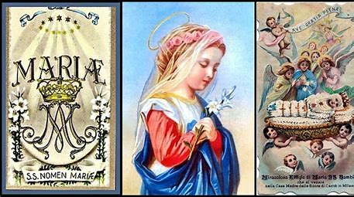

Name: ________________________________________
September 2024 Table of Contents
Overview………………………………………………………………………………………….3
Learning Standards……………………………………………………………………………...5
Lesson Pacing Guide…………………………………………………………………………....12
Activities………………………………………………………………………………………....17
Grade 3…………….…………………………………………………………………….17
Week 1…………………………………………………………………………...17
Week 2…………………………………………………………………………..19
Week 3…………………………………………………………………………..21
Grade 4………………………………………………………………………………….23
Week 1…………………………………………………………………………..23
Week 2…………………………………………………………………………..25
Week 3…………………………………………………………………………..27
Grade 5………………………………………………………………………….............29
Week 1…………………………………………………………………………..29
Week 2…………………………………………………………………………..32
Week 3…………………………………………………………………………..34
Grade 6………………………………………………………………………….............36
Week 1…………………………………………………………………………..36
Week 2…………………………………………………………………………..38
Week 3…………………………………………………………………………..40
Review…………………………………………………………………………………………..42
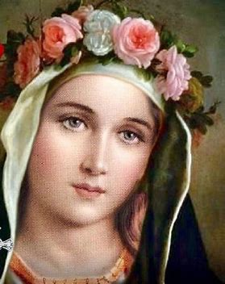
September 2024 Overview: Grades 3-6
Theme: Month of Our Lady’s Nativity (Birthday); Month of the Holy Name of Mary
Marian Title: Our Lady, Queen of Angels
Monthly Prayer/Invocation: Our Lady, Queen of Angels, pray for us. Regina Angelorum, ora pro nobis.
Thematic Guiding Questions, 3-6:
- What does it mean that we celebrate Our Lady’s “Nativity”? Why do we celebrate this?
- We were all born with a special purpose, something God has given us to do. What was Mother Mary’s special purpose?
- What do you think God made you to do, and how can you use the talents God gave you to be like Mother Mary and honor Him?
- At Baptism, we are given our name, and at Confirmation, we choose the name of a saint who will be our role model to inspire us to live good lives for Jesus. God made each of us unique. Our names tell something special about who we are. What does Our Lady’s Name mean, and what does it say about her? How can we honor her holy Name?
  - What are some special titles for Our Lady? Which is your favorite, and why?

Saint of the Month: St. Pius of Pietrelcina (Padre Pio), a Capuchin (Franciscan) priest who had the holy wounds of Christ. He lived in recent times (d. 1968), and was known for being an excellent confessor who could read souls. Padre Pio listened compassionately, and helped many people through his wisdom, joy, and faithful trust in God.
Monthly Challenge: To honor Our Lady, Queen of the Angels, grow in devotion to the holy angels. Say the “Guardian Angel” prayer, asking guardian angels to watch over your family. You might say this prayer as part of evening prayers; at meals; or in the morning, to begin each day.
Bonus challenge: Sign up for our religious education Flocknote newsletter at Our Lady of the Valley to receive catechetical emails that offer reflections on saints; feast days; and special devotions being offered in our parish, as well as those celebrated in the universal Church. Email us or leave a comment on our newsletter to let us know what topics you would like to be covered in future digital newsletters! You may use this link to sign up for our OLV religious education enrichment newsletter: https://ourladyofthevalley23.flocknote.com/Enrichment
Overall Learning Goals: Our goal this month is to learn about how we celebrate the love of God in our Church through feast days, with a special focus on the Nativity (the birthday) of the Blessed Virgin Mary. It is our goal to further appreciate how Mary, the Mother of Jesus and Mother of the Church, enriches the celebration of each feast throughout the liturgical year. Ultimately, our goal is to honor Jesus as the source of new life and growth, and Mary as the channel of grace who guides us to Him.
Summary of Activities: To achieve our learning goals, we will explore special days in the Church we celebrate during the month of September, from the Holy Name of Mary to the Exaltation of the Cross and Michaelmas. We will learn about how Mother Mary and Jesus guide church life for both priests and laypeople in God’s family, applying our learning through studies of Sacred Scripture and Tradition, reflection, art, and music. We will consider how we each can individually live out our faith, using Jesus, Mary, and the saints as our models, while reflecting on how we all, as one Church, help each other to grow.
Additional Enrichment Ideas:
- Celebrate the birthday of Mother Mary on September 8. Decorate a home shrine table for Mother Mary with flowers. Have flower seeds blessed by a priest (a tradition on September 8). Sing Marian hymns together or pray the Rosary as a family.
- Visit the Museum of Family Prayer, operated by Holy Cross Family Ministries in Easton, MA. See their website for listings of upcoming events and additional prayer resources: https://www.museumoffamilyprayer.org/events-and-programs
- Have a Michaelmas feast. In honor of the Feast of the Archangels on September 29, eat meals with blackberries. Desserts with blackberries, or bannock breads with raisins, are eaten in honor of St. Michael. Legend has it that when St. Michael battled Satan, Satan fell in a blackberry bush, defeated. People eat blackberries on Michaelmas to celebrate the victory of St. Michael, and the triumph of God’s goodness. Other traditional harvest foods, such as carrots, are incorporated into Michaelmas meals. (Angel food cake is another popular choice, naturally! ) Michaelmas is the Catholic thanksgiving.
  - Sing songs of thanks and pray together as a family to share your gratitude to God. Say the St. Michael the Archangel Prayer. Listen to “Christ, Fair Glory of the Holy Angels” here: https://www.youtube.com/watch?v=NTK4dE-_OP4.

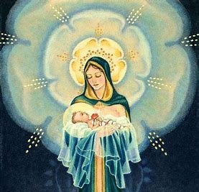

Learning Standards
Grade Level | Week | Activities | Learning Standards
Grade 3 | 1 | “Planting Seeds: Growing in Faith like Mother Mary” | 3.6 A disciple is one who learns, a student of Christ who listens and follows Him, living out the virtues. An apostle is one who is “sent” by Christ out into the world as a leader of the Church to preach and teach, one Christ chooses to live like Him, as a priest. 3.7 Jesus chose 12 men to be His original apostles, whose mission is distinct from that of disciples: Bartholomew, Andrew, Peter, Philip, Thaddeus, Thomas, John, James the Greater, James the Lesser, Judas, Simon, and Matthew. Today, apostolic succession in the Church continues the tradition of ordaining men to be priests, apostles of Christ who, through power given by God, who act on His behalf.
Grade 3 | 2 | “Hail, Mary: Blessing Our Lady’s Holy Name” | 3.2 God is at the center of life. All of the sacraments point back to Him as the source of all love, all virtue. We use outward gestures to show our respect for God’s presence.
Grade 3 | 3 | “Spiritual Mothers and Fathers: Mary, Mother of the Church and Priesthood Sunday” | 3.7 Jesus chose 12 men to be His original apostles, whose mission is distinct from that of disciples: Bartholomew, Andrew, Peter, Philip, Thaddeus, Thomas, John, James the Greater, James the Lesser, Judas, Simon, and Matthew. Today, apostolic succession in the Church continues the tradition of ordaining men to be priests, apostles of Christ who, through power given by God, who act on His behalf.
Grade 4 | 1 | “Hail, Holy Queen: The Holiness of Mother Mary” | 4.6 Regularly attending Mass helps us to live out our calling, follow Christ, and abide by God’s law.
Grade 4 | 2 | “Holy Name, Holy Heart: Loving God like Immaculate Mary” | 4.4 The Church year is called the liturgical year, because it organizes our celebration of the liturgy, the public worship of God (namely, through the Mass). The liturgical seasons reflect Christ’s life: Advent and Lent memorialize His birth, dying, and rising. The liturgy not only includes the Mass, but the liturgy of the hours, and certain devotional practices.
Grade 4 | 3 | “Pray Every Day: The Liturgy of the Hours” | 4.4 The Church year is called the liturgical year, because it organizes our celebration of the liturgy, the public worship of God (namely, through the Mass). The liturgical seasons reflect Christ’s life: Advent and Lent memorialize His birth, dying, and rising. The liturgy not only includes the Mass, but the liturgy of the hours, and certain devotional practices.
Grade 5 | 1 | “Birthday Blessings: Mother Mary’s Gift of the Scapular” | 5.5 Though we all have unique callings to live out our love for God, we all can be part of celebrating the traditions of the Church. Sacred Tradition is the living faith that has been transmitted to us by the Church as instituted by Christ. The Bible is divine revelation through the written word of God, but Sacred Tradition encompasses the worship of the faithful, the application of teachings. Sacred Tradition encompasses the tangible practices that are used to express devotion to God. The sacraments define Sacred Tradition, because they are encounters with Christ; Christ is active in the sacraments.  5.8 Sacraments such as the Eucharist are visible signs of God’s love we can encounter today. Throughout His life, Jesus did miraculous things to show us that He is God, and that He will do amazing things out of love for us, to bring us closer to Him. We can read about these miracles in Scripture. Sacramentals are reminders of these signs that call us to reverently show our love to God, responding to Him as He speaks to us through Sacred Scripture and Sacred Tradition.
Grade 5 | 2 | “Our Sanctuary: Jesus, Mary, and the Heart of the Church” | 5.1 The global Church is so large, spread across such a wide territory, that it is divided in such a way that allows for governance of smaller areas underlying Rome (the Vatican), the central seat of power in the Church. There are smaller groups of worshippers in local parish churches, which are collected regionally into larger groups of faithful called dioceses. Many dioceses make up the global Church  5.3 There are a variety of different roles fulfilled in leading the Church forward, both as a global body, and within local territories. Priests, bishops, cardinals, and the Pope have received the sacrament of Holy Orders, serving the Church in distinct ways.
Grade 5 | 3 | “Mother Teresa and Mother Mary: Friends in Christ” | 5.4 We each have a different calling, something that God is asking us to do, by using the special talents and personalities He gave us. We are all made in God’s image, but are completely unique. There is no one else like you. Some are called to Holy Orders, and others serve God in different ways, but all of us can live out our callings to do good things out of love for God.  5.5 Though we all have unique callings to live out our love for God, we all can be part of celebrating the traditions of the Church. Sacred Tradition is the living faith that has been transmitted to us by the Church as instituted by Christ. The Bible is divine revelation through the written word of God, but Sacred Tradition encompasses the worship of the faithful, the application of teachings. Sacred Tradition encompasses the tangible practices that are used to express devotion to God. The sacraments define Sacred Tradition, because they are encounters with Christ; Christ is active in the sacraments.
Grade 6 | 1 | “Blessed Are You: Songs of Praise” | 6.1 Catholics throughout history have used their talents to glorify God, turning away from sin to pursue virtue and make a positive impact on the world, attesting to the greatness of God…  6.4 A variety of saints have faithfully lived out God’s will for them throughout history…  6.9 Mary, Mother of Jesus, has played an essential role in salvation history, guiding us through change and uncertainty with Her steadfast love, Her role as Mother that will never change…
Grade 6 | 2 | “The Lord is Sweet: Mother Mary, the New Eve” | 6.4 A variety of saints have faithfully lived out God’s will for them throughout history…  6.9 Mary, Mother of Jesus, has played an essential role in salvation history, guiding us through change and uncertainty with Her steadfast love, Her role as Mother that will never change…
Grade 6 | 3 | “Eucharistic Graces: Opening our Hearts to Jesus like Mary” | 6.4 A variety of saints have faithfully lived out God’s will for them throughout history…  The saints’ defense of Christ and the Eucharist show us the importance of Jesus and the sacraments through which we come to more deeply know His Heart. They were willing to give everything for Christ, the Mass, and the sacraments, because they knew that God is everything; they knew the power of His love, which overcomes all earthly challenges and suffering.  6.9 Mary, Mother of Jesus, has played an essential role in salvation history, guiding us through change and uncertainty with Her steadfast love, Her role as Mother that will never change…

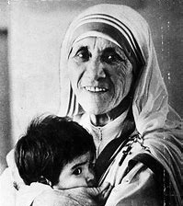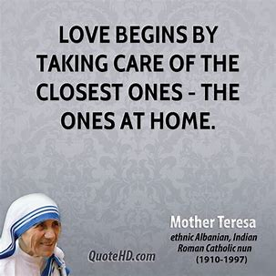
September 2024 Lesson Pacing Guide (Suggested Schedule)
Grades 3-6
Week Number/Date | Grade Level | Activities
Week 1  (September 9, 2024 – September 13, 2024) | Grade 3 | “Planting Seeds: Growing in Faith like Mother Mary”
Week 1  (September 9, 2024 – September 13, 2024) | Grade 4 | “Hail, Holy Queen: The Holiness of Mother Mary”
Week 1  (September 9, 2024 – September 13, 2024) | Grade 5 | “Birthday Blessings: Mother Mary’s Gift of the Scapular”
Week 1  (September 9, 2024 – September 13, 2024) | Grade 6 | “Blessed Are You: Songs of Praise”
Week 2  (September 16, 2024 – September 20, 2024) | Grade 3 | “Hail, Mary: Blessing Our Lady’s Holy Name”
Week 2  (September 16, 2024 – September 20, 2024) | Grade 4 | “Holy Name, Holy Heart: Loving God like Immaculate Mary”
Week 2  (September 16, 2024 – September 20, 2024) | Grade 5 | “Our Sanctuary: Jesus, Mary, and the Heart of the Church”
Week 2  (September 16, 2024 – September 20, 2024) | Grade 6 | “The Lord is Sweet: Mother Mary, the New Eve”
Week 3  (September 23, 2024 – September 27, 2024) | Grade 3 | “Spiritual Mothers and Fathers: Mary, Mother of the Church and Priesthood Sunday”
Week 3  (September 23, 2024 – September 27, 2024) | Grade 4 | “Pray Every Day: The Liturgy of the Hours”
Week 3  (September 23, 2024 – September 27, 2024) | Grade 5 | “Mother Teresa and Mother Mary: Friends in Christ”
Week 3  (September 23, 2024 – September 27, 2024) | Grade 6 | “Eucharistic Graces: Opening our Hearts to Jesus like Mary”

Week Number/Date | Grade Level | Words to Practice | Definitions
Week 1  (September 9, 2024 – September 13, 2024) | Grade 3 | Rituale | The book of prayer rituals a priest uses when he is blessing people and holy items such as scapulars or Miraculous Medals. A ritual is something that we do often, sometimes every day. The Rituale gives the priest the words of the prayers that he needs to say every time he says a special blessing for someone or something.
Week 1  (September 9, 2024 – September 13, 2024) | Grade 4 | Ciborium | The cup holding the Hosts, kept inside the tabernacle. The ciborium is different from a typical chalice. It is larger and is closed with a lid. Within the tabernacle, it is covered by a veil.
Week 1  (September 9, 2024 – September 13, 2024) | Grade 5 | Scapular | 2 small squares of woolen cloth that are worn over the shoulders (the “scapulae”). Scapulars express hope in Mary’s protection, offering spiritual benefits.
Week 1  (September 9, 2024 – September 13, 2024) | Grade 6 | Canticle | A song. Prayerful songs such as the Canticle of Zechariah or the Canticle of Mary are sung in praise of God and the miracles He works in our lives.
Week 2  (September 16, 2024 – September 20, 2024) | Grade 3 | Biretta | The square hat with three peaks and a “tuft” (resembling a pompom) worn by a priest at the Mass when processing (entering or exiting, walking down the aisle) and at certain points during the Mass while seated; the hat is removed when the name of Jesus is spoken to show reverence.
Week 2  (September 16, 2024 – September 20, 2024) | Grade 3 | Hosanna | An exclamation of joy in celebration of Christ’s coming.
Week 2  (September 16, 2024 – September 20, 2024) | Grade 4 | Immaculate Heart | The Heart of Mother Mary. Mary’s Heart is “Immaculate,” because She is without sin. Her Heart is completely pure, clean, and perfect. In images, Her heart is shown as being pierced by a sword, because She felt Jesus’ pain when He gave His life on the Cross. Mother Mary’s Heart is full of love.
Week 2  (September 16, 2024 – September 20, 2024) | Grade 5 | Sanctuary | The part of the church that contains the high altar. In the cruciform (cross-shaped) design of the church, it is the top (the vertical beams) of the cross.
Week 2  (September 16, 2024 – September 20, 2024) | Grade 6 | Original sin | The first sin, made by our first parents, Adam and Eve. When Adam and Eve disobeyed God by taking the forbidden fruit from the Tree of Knowledge of Good and Evil, they were cast out of the Garden of Eden, punished for their sin of pride. Because of their sin, all of the human beings descended from Adam and Eve have “original sin,” inheriting the fallen nature of humankind that comes from them, and the suffering that goes with it. Baptism removes original sin.
Week 3  (September 23, 2024 – September 27, 2024) | Grade 3 | Clergy | Men who serve Christ as priests, bishops, and cardinals in the Catholic Church. Clergy lead people in worshipping God.
Week 3  (September 23, 2024 – September 27, 2024) | Grade 3 | Holy Orders | The sacrament that makes men into ministers of the Church, priests, who act and speak on behalf of Christ. They have the power to bless, forgive sins, preach, and offer the Sacrifice of the Mass.
Week 3  (September 23, 2024 – September 27, 2024) | Grade 3 | Ordination | When men who have been learning about and preparing for the priesthood officially become priests. The men receive the power to serve as priests and provide the sacraments from God. They receive the sacrament of Holy Orders when they are ordained. A bishop celebrates the ordination Mass that makes men priests.
Week 3  (September 23, 2024 – September 27, 2024) | Grade 4 | Liturgy of the hours | Prayers prayed by clergy throughout the day. There are morning (praise) and evening (thanksgiving) prayers, as well as Scripture readings. Some laypeople also choose to pray the liturgy of the hours.
Week 3  (September 23, 2024 – September 27, 2024) | Grade 5 | Supernatural | Heavenly. Supernatural things are above, or beyond, nature, the Earth. They are divine, of God.
Week 3  (September 23, 2024 – September 27, 2024) | Grade 6 | Actual sin | Sins people actually commit, beyond original sin inherited from Adam and Eve. Confession forgives actual sin.

Week Number/Date | Grade Level | Prayers to Practice | Text of Prayers
Week 1  (September 9, 2024 – September 13, 2024) | Grade 3 | Prayer in Honor of All the Holy Angels | Holy, holy, holy Lord God of hosts! Heaven and earth are full of Thy glory. Hosanna in the highest!
Week 1  (September 9, 2024 – September 13, 2024) | Grade 4 | Daytime Prayer (Liturgy of the Hours, Little Office of the Blessed Virgin Mary) | God, come to my assistance.  Lord, make haste to help me.  Glory to the Father, and to the Son, and to the Holy Spirit:  as it was in the beginning, is now, and will be for ever. Amen.
Week 1  (September 9, 2024 – September 13, 2024) | Grade 5 | Mary, Help of Those in Need Prayer | Holy Mary,  help those in need,  give strength to the weak,  comfort the sorrowful,  pray for God’s people,  assist the clergy,  intercede for religious.  May all who seek your help  experience your unfailing protection. Amen.
Week 1  (September 9, 2024 – September 13, 2024) | Grade 6 | Invocations of the Immaculate Heart of Mary | O heart most pure of the Blessed Virgin Mary, obtain for me from Jesus a pure and humble heart.  Sweet heart of Mary, be my salvation.
Week 2  (September 16, 2024 – September 20, 2024) | Grade 3 | Prayer in Honor of All the Holy Angels | Holy, holy, holy Lord God of hosts! Heaven and earth are full of Thy glory. Hosanna in the highest!
Week 2  (September 16, 2024 – September 20, 2024) | Grade 4 | Daytime Prayer (Liturgy of the Hours, Little Office of the Blessed Virgin Mary) | God, come to my assistance.  Lord, make haste to help me.  Glory to the Father, and to the Son, and to the Holy Spirit:  as it was in the beginning, is now, and will be for ever. Amen.
Week 2  (September 16, 2024 – September 20, 2024) | Grade 5 | Mary, Help of Those in Need Prayer | Holy Mary,  help those in need,  give strength to the weak,  comfort the sorrowful,  pray for God’s people,  assist the clergy,  intercede for religious.  May all who seek your help  experience your unfailing protection. Amen.
Week 2  (September 16, 2024 – September 20, 2024) | Grade 6 | Invocations of the Immaculate Heart of Mary | O heart most pure of the Blessed Virgin Mary, obtain for me from Jesus a pure and humble heart.  Sweet heart of Mary, be my salvation.
Week 3  (September 23, 2024 – September 27, 2024) | Grade 3 | Prayer in Honor of All the Holy Angels | Holy, holy, holy Lord God of hosts! Heaven and earth are full of Thy glory. Hosanna in the highest!
Week 3  (September 23, 2024 – September 27, 2024) | Grade 4 | Daytime Prayer (Liturgy of the Hours, Little Office of the Blessed Virgin Mary) | God, come to my assistance.  Lord, make haste to help me.  Glory to the Father, and to the Son, and to the Holy Spirit:  as it was in the beginning, is now, and will be for ever. Amen.
Week 3  (September 23, 2024 – September 27, 2024) | Grade 5 | Mary, Help of Those in Need Prayer | Holy Mary,  help those in need,  give strength to the weak,  comfort the sorrowful,  pray for God’s people,  assist the clergy,  intercede for religious.  May all who seek your help  experience your unfailing protection. Amen.
Week 3  (September 23, 2024 – September 27, 2024) | Grade 6 | Invocations of the Immaculate Heart of Mary | O heart most pure of the Blessed Virgin Mary, obtain for me from Jesus a pure and humble heart.  Sweet heart of Mary, be my salvation.

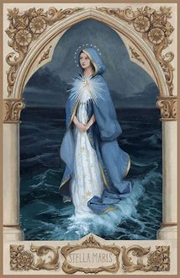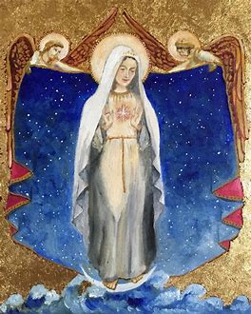
September 2024 3-6 Activities: Week 1
Grade 3- “Planting Seeds: Growing in Faith like Mother Mary”
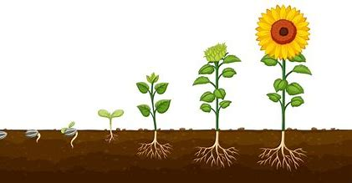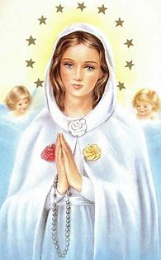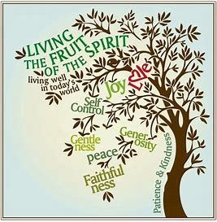
September 8 is the birthday of Mother Mary. A tradition in the Church is for priests to bless seeds on the birthday of Mother Mary. There are many blessings in the Church, when priests ask God to do good things for us, to watch over us, to help us. The priest uses a book called the Rituale, which has the prayers for each blessing. A ritual is something that we keep doing, like saying a prayer every morning. The rituals in the priest’s book tell him what he needs to do and say to honor God and bless items in God’s Name.
Mother Mary is often thought of as being like a flower. She is called the “Mystical Rose.” She has a beautiful, sweet Heart full of love. We give roses as gifts to people we love, and Mother Mary gave Her life to God. She gave the love in Her Heart to Her Son, Jesus. We put crowns of flowers on Mary statues in May, and we have flowers blessed on the feast day of the Assumption, August 15, when we remember Mother Mary going up to Heaven.
Although Mother Mary was not an apostle, a man sent out to serve Jesus and build His Church as a priest, Mother Mary was a disciple. Disciples learn from and live like Jesus. Mother Mary gave birth to Jesus, a priest. If Mother Mary had not been born, Jesus would not have been born. The birthdays of Jesus and Mary are both very special. We love Mother Mary for being such a kind and gentle mother to Jesus, and to all of us. Priests bless seeds and flowers in honor of Mother Mary, because she inspires us to listen to God’s plan for us, and to have hope and faith in Him, like she did. When we say a prayer, showing our faith in God, it may seem to start out small, but faith grows bigger and bigger over time, just like a mustard seed. Like Mother Mary, we can be disciples of Jesus who do things with love, and give other people hope. Mother Mary is a blessing to us, and will bring us blessings from God when we ask Her. Prayer helps us to grow.

- God gives us good things in our lives. Blessings are like flowers that make us happy. On each flower, write or draw a blessing in your life. What do you thank God for?

- On the Feast of the Assumption of Mary, people would have celebrations called “first fruits” festivals. They used the first fruits, the foods they harvested, to make cakes. God wants us to create good fruits. He wants us to do good things, to be good people who are kind and loving. Doing good things brings joy and peace. These are examples of Fruits of the Spirit, good fruits that grow from our faith in God. Seeds need water and sun to grow into flowers. We need God to keep growing. Choose a fruit of the Spirit. What can you do to grow strong in your faith like Mary, and to produce this Fruit of the Spirit?
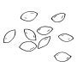I will plant seeds of faith in God by _____________________________________
to help me grow a Fruit of the Spirit called_________________________.
- Why is Mother Mary called a “rose”? _______________________________________
______________________________________________________________________________
- What can you do to bless Mary, to honor Her, on Her birthday? How can you be a disciple of Jesus like Mary?
______________________________________________________________________________
______________________________________________________________________________
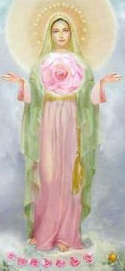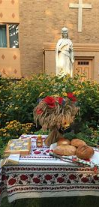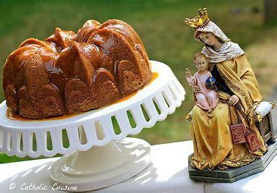

September 2024 3-6 Activities: Week 2
Grade 3- “Hail, Mary: Blessing Our Lady’s Holy Name”
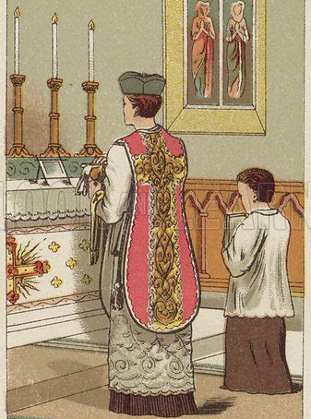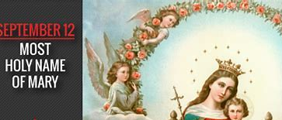
The Feast of the Holy Name of Mary is celebrated on September 12. The Feast of the Holy Name of Jesus is on January 5 in the traditional Church calendar, the day after the Solemnity of Mary, Mother of God. As the Mother of Jesus, Mother Mary is very holy, which means Her name is very holy. Just as we say Jesus’ Holy Name with respect, we say Mother Mary’s name with love and respect. God calls us to treat our parents with respect, which means we are called to treat Mary, our Mother in Heaven, with respect, too.
At the Traditional Mass that is said in Latin, the priest wears a biretta, a special black hat. There is usually a pompom called a “tuft” on the biretta. When the name of Jesus is said during the Mass, such as in the Gloria and the Creed, the priest removes his hat, the biretta. We bow our heads during Mass when we hear Jesus’ Name. This is to show respect for Jesus and His Holy Name. When the priest goes by a statue of Mother Mary in the church, you may also see him tip his hat to Her as a sign of respect. We sing songs of praise using the names of Mary and Jesus. The “Hosanna” is a song of joy that gives glory, honor and love, to Jesus by blessing Him. On birthdays, we sing “Happy Birthday” to our friends and family. The Feast of the Holy Name of Mary is just a few days after Mary’s birthday. We can celebrate these Marian feast days by singing songs dedicated to Mother Mary.
At the end of the month, on September 29, we will celebrate another special feast day: the Feast of the Archangels. Archangels are the head angels in Heaven: St. Michael, St. Gabriel, and St. Raphael. These are the most powerful angels who are very close to God. We pray for them to protect us, and they watch over us. St. Gabriel was the angel who came to tell Mary that God chose Her to be Jesus’ Mother. When he saw Her, he said, “Hail, Mary.” St. Gabriel was showing Mary respect. “Hail” was a way of saying “hello” to someone royal. This is where our “Hail Mary” prayer comes from, since we pray for the help of Mother Mary, the Queen of Heaven.
At Mass, we call on the angels, showing them respect. Some women wear veils at the Mass to honor the presence of the angels at Mass. The angels are always singing with joy, because they are happy to be in Heaven, loving God forever. We can be like the angels by singing at Mass, and letting everything we do and say be to bless and praise God.
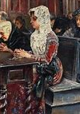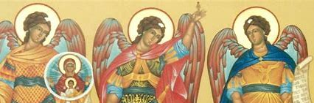

- What did St. Gabriel say to Mother Mary to show respect for Her?

- What do priests do at Mass to show respect for Jesus’ Name, and for Mother Mary?

- What are some ways in which the people at Mass show respect for Jesus, Mary, and the angels?

- Write your own prayer or song using Mary’s Holy Name. What can you say to show respect for Mother Mary?

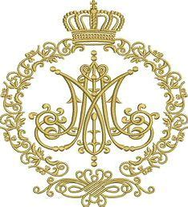
___________________________________________________
___________________________________________________
___________________________________________________
___________________________________________________
___________________________________________________
___________________________________________________
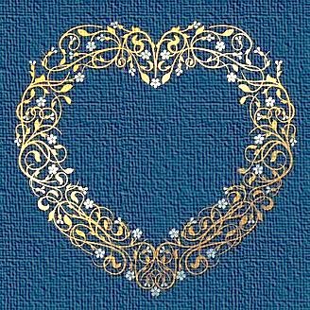

September 2024 3-6 Activities: Week 3
Grade 3- “Spiritual Mothers and Fathers: Mary, Mother of the Church and Priesthood Sunday”
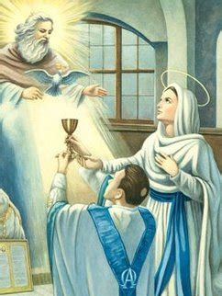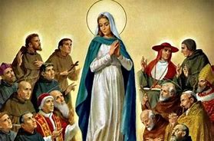
September 29, the last Sunday of this month, is Priesthood Sunday. This month, we have been celebrating Mother Mary, and will remember Her in a special way as Mother of the Church. Mary is the Mother of Jesus, a priest. Mother Mary is Mother to us all, and watches over Her priests in the Church. They are serving Her by serving Jesus, Her Son.
Mother Mary is a spiritual Mother to us. She cares for our souls. Our mothers love us so much. They give us food that we need, make us feel better when we are sick, cheer us up, teach us, and pray for us, like Mother Mary does. She gave birth to Jesus, Whose Body is the food our souls need. Priests are spiritual fathers. A priest is called “father,” because he cares for our souls, too.
Each priest is “another Christ.” They are not God, but they continue Jesus’ work on Earth by giving the sacraments to people. Jesus put the sacraments into place. At the Last Supper, He started the sacrament of Holy Orders and the sacrament of Communion. He broke the bread and blessed it, telling His apostles to share the bread with other people. He made the apostles priests. Holy Orders is the sacrament that makes men priests, so that they can give sacraments such as Communion to people. At their ordination, when they receive Holy Orders, priests are given powers from God, such as the power to bless. Priests give their lives to the Church like Jesus did.
Now, priests change the bread into the Body of Christ at the Mass so that everyone can know Jesus and receive His love in their hearts. On Priesthood Sunday, we can pray for all of the priests, also called clergy, we know. We can pray that more men will answer God’s call to become priests so that there will always be priests to give people the sacraments their souls need to live. When we pray, we can ask Mary, Mother of the Church to help all priests. She can bring them special blessings through Her Son, Jesus.
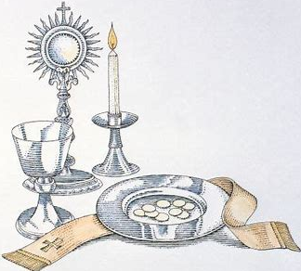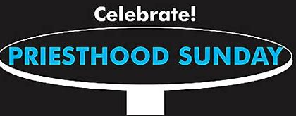
- How does Mother Mary care for our souls?
______________________________________________________________________________
______________________________________________________________________________
- How do priests help us and care for our souls?
______________________________________________________________________________
______________________________________________________________________________
- What is the name of the sacrament that makes men priests?
______________________________________________________________________________
- Write a thank-you note to a priest you know, or a prayer you can say for a priest. Why are we blessed to have priests in our Church?

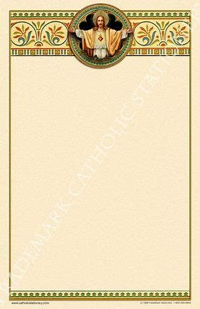

_________________________________________________________
_________________________________________________________
_________________________________________________________
_________________________________________________________
_________________________________________________________
_________________________________________________________
_________________________________________________________
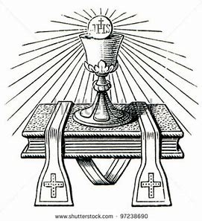

September 2024 3-6 Activities: Week 1
Grade 4- “Hail, Holy Queen: The Holiness of Mother Mary”
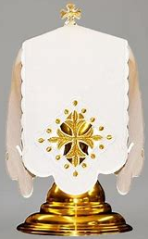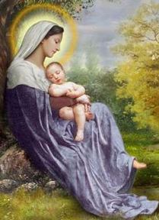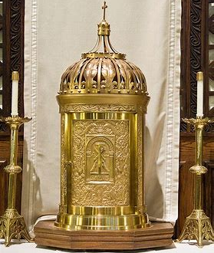
On September 8, we will celebrate the birthday of Mother Mary. Just as we celebrate the birthday of Jesus on December 25, we celebrate the birthday of His Mother, Mary, in our Church. Because of Mother Mary being born, Jesus could be born. If Mother Mary had not been born, She could not have grown up to give birth to Jesus. If Jesus had not been born, He could not have died for us, saved us from sin, or opened new life to us on Earth through the Eucharist, and new life in Heaven after our lives on Earth.
Mother Mary is like the ciborium. The ciborium is a gold chalice, or cup, with a lid. It holds the Eucharist, the Body of Christ, when It is in the tabernacle, the large gold container that looks like a small palace or shrine. Mother Mary held Jesus, just like the ciborium holds the Eucharist. The Eucharist is Jesus’ Body.
The ciborium has a veil put over it in the tabernacle. Veils are put on holy things. We are called to be holy like Mother Mary, and we can grow to be more like Her through love and kindness. Brides wear veils at weddings. When you look at paintings or statues of Mother Mary, you will see that She is wearing a veil. Veils are worn to show respect for God and His holy angels, who are with us at the Mass, praising God from Heaven. Whenever we go to Mass, we are seeing what Heaven will be like, where the saints and angels love God, singing and adoring Him.
Life is a very special gift from God. Birthdays are how we can share our love with the people God gives us. September 8 is a wonderful day to share our love for Mother Mary. Mother Mary is the Queen of Heaven. She is a beautiful example of holiness, because of Her love for God. On Mother Mary’s birthday, we can give Her the gift of prayer, saying a prayer that honors Her, such as the “Hail Mary” or “Hail Holy Queen.” Mother Mary is happy when we love Her Son, because She loves Him so much, too. She always treated Jesus with love, and loves when we receive Jesus with respect. She is joyful to see our reverence for Jesus when we genuflect (kneel) and bless ourselves by the tabernacle, or when we pray the Rosary and kiss the crucifix (Jesus on the Cross). Our Lady is always wanting to give us the gift of Her motherly love. She prays for us because She wants us to be with Her in Heaven someday.

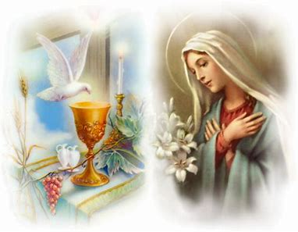
- Why are veils worn in church, and put on items like the ciborium?
______________________________________________________________________________

- What makes Mother Mary holy?
______________________________________________________________________________

- How can we become more holy to be like Mother Mary? _______________________
_____________________________________________________________________________

- What is the “ciborium” at church? _________________________________________
______________________________________________________________________________

- How is Mother Mary like the ciborium?
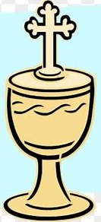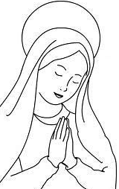

- ____________________________________________________________
- _____________________________
_____________________________

September 2024 3-6 Activities: Week 2
Grade 4- “Holy Name, Holy Heart: Loving God like Immaculate Mary”
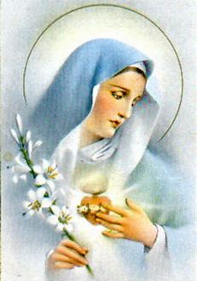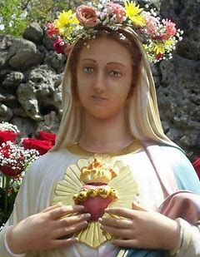
A few days after we celebrate Mother Mary’s birthday, we celebrate another feast day dedicated to Mother Mary: the Feast of the Holy Name of Mary, which is on September 12. We honor Mary when we say Her holy name with love and respect. The name “Mary” comes from a Latin word meaning “sea.” Mother Mary is called “Stella Maris,” the “Star of the Sea.” At night, when it is dark, we look at the stars, which give us light that helps us to see where we are going. Mother Mary is like a star that guides us. Just like Jesus made stormy seas calm, Mother Mary helps us as we sail through life, like a lighthouse that helps sailors to see where to go when they are on their boats in the ocean at night.
August was the month of the Immaculate Heart of Mary. On the First Saturday of every month, we offer special Masses and prayers to the Immaculate Heart of Mary. When we talk about Mary, using Her Name, we talk about Her beautiful Heart. We get to know Mary through Her Heart. Through getting to know Mary, we get to know Jesus. Mother Mary’s Heart is filled with love for Jesus. Mother Mary’s Heart is “immaculate,” which means “clean,” because there are no sins in Her Heart. Mother Mary was born without any sins, and She never sinned throughout Her life. There was no room in Her Heart for sin, because She gave Her Heart to loving God.
To “sin” means to act without love for God, to not listen to what He is calling us to do. We respect God and listen to what He calls us to do by following the 10 Commandments, which tell us how to treat God and others with love. To love means to think about God and other people, to put them first. Mother Mary did this by serving and giving to God. She devoted Her life to caring for others, especially Jesus, and still cares for us from Heaven. Mother Mary’s Immaculate Heart has a crown of flowers around it, because good things grow from love like Hers. When we pray, we can ask Mother Mary to give us hearts like Hers, hearts that are pure and humble, full of love.
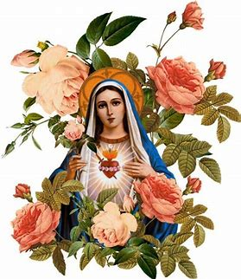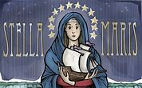
- Draw and label a picture of Mother Mary’s Immaculate Heart. What is around Mary’s heart, and why?

______________________________________________________________________________
______________________________________________________________________________
- What we have in our hearts is what we love. Think about what is in Mother Mary’s Heart, and what is in your heart. Draw and write your ideas in the hearts below.
What does Mother Mary love? What do you love?

- How can you love like Mary, and make your heart like Hers? ___________________
______________________________________________________________________________
______________________________________________________________________________
- Listen to the song “Immaculate Mary” (you can listen to a version here: https://www.youtube.com/watch?v=hXqTGl6mbYg&t=194s). Be sure to sing along! What does it mean that Mary’s Heart is “Immaculate”? Why do you think we should praise (bless) Her Name like the song says?
______________________________________________________________________________
______________________________________________________________________________
______________________________________________________________________________
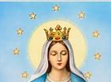

September 2024 3-6 Activities: Week 3
Grade 4- “Pray Every Day: The Liturgy of the Hours”
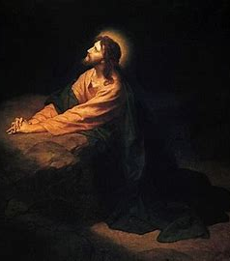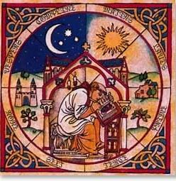
September 29, the fourth Sunday of the month, is Priesthood Sunday this year. On this day, we pray for our priests, thanking them for sharing God’s love with us. Priests were chosen for a special mission by God. They give their lives to serving the Church like Jesus. Jesus prayed often. He always spoke to His Father in Heaven. Jesus did what God the Father asked Him to do. Because He prayed before He did anything, Jesus always did the right thing. To follow Jesus’ example of love and mercy, priests pray. They pray when they give us the sacraments, such as Confession and Communion. When we pray, we are getting ourselves ready to receive the sacraments. Praying helps us to be like Jesus, looking to God the Father to guide us.
At the Traditional Latin Mass, the priest prays over each person who receives Communion, asking God to save each person’s soul, and bring them to Heaven. Priests also pray the liturgy of the hours. “Liturgy” is another word for prayer. We usually use the word “liturgy” when we are talking about the Mass, because the Mass is how we pray together as a Church family. The liturgy also includes the Divine Office (the liturgy of the hours that priests pray) and other liturgical devotions, types of prayer, like the Rosary or Adoration. The liturgy of the hours is another way of telling God our love for Him in prayer. It is like a continuation of the Mass throughout the day. “Divine” means “godly,” so the Divine Office is like a special schedule of prayers God gives us to use in honoring Him.
You may see books with the prayers of the liturgy of the hours that are used to say a special prayer at different times of the day. There is a book called “The Little Office of the Blessed Virgin Mary” that is filled with special prayers for Mother Mary to say at certain hours during the day. To pray the liturgy of the hours, priests will say prayers at morning, noon, and night. In monasteries and convents, monks and nuns chant (sing) the prayers.
At school, our day is organized by classes we go to. We know what time school starts, when we go to each class, when we have lunch and recess, and when it is time to go home at the end of the day. Our school schedule is organized to help us learn and grow. Our schedule of prayers helps us to grow, too. Priests have days organized by prayers. Not only priests say the liturgy of the hours. We can all pray throughout the day. Even if we do not read from the Divine Office, we can let everything we say and do be a prayer, something good and beautiful we give to God. Helping others and doing what God calls us to do are ways we make each of our lives a prayer. We live out the words of the prayers we say. We give glory to the Father, the Son, and the Holy Spirit.

- Who says the liturgy of the hours? __________________________________________
- Why do they pray the liturgy of the hours? __________________________________
_____________________________________________________________________________
- Why is it good for all of us to pray throughout the day? ________________________
______________________________________________________________________________
______________________________________________________________________________
- Make your own daily schedule of prayers. Choose the prayers you would say to honor God, and the times you will say them. Why did you choose these prayers?
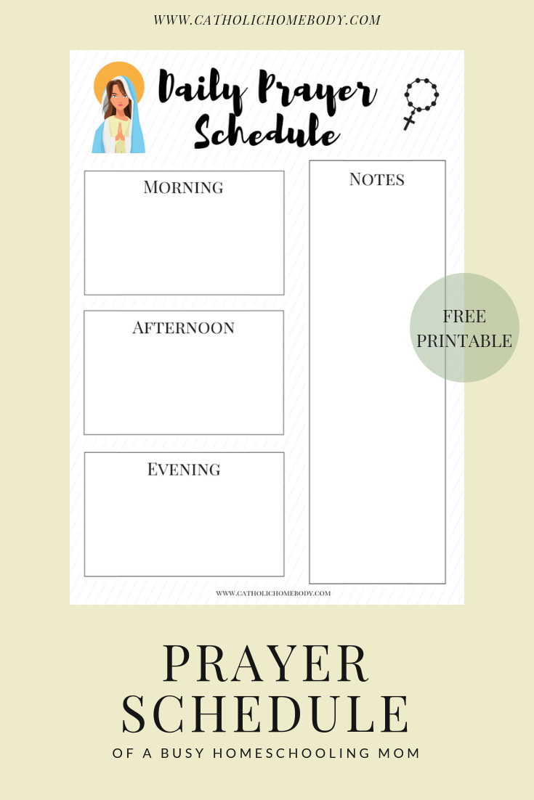
Special intentions I will pray for today:
- ________
_____________
_____________
- ________
_____________
_____________
_____________
- ________
_____________
_____________
______________
______________________________________________________________________________
______________________________________________________________________________
______________________________________________________________________________
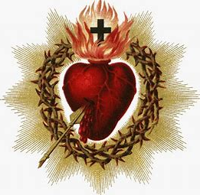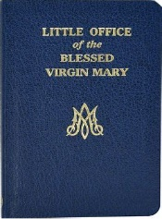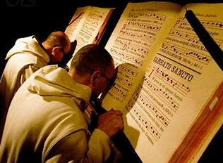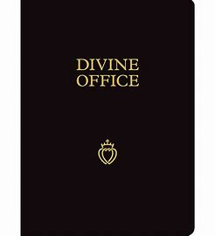
September 2024 3-6 Activities: Week 1
Grade 5- “Birthday Blessings: Mother Mary’s Gift of the Scapular”
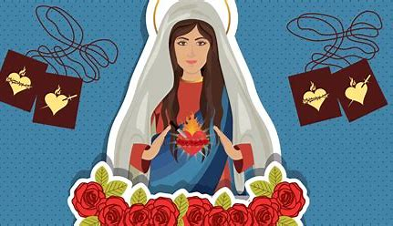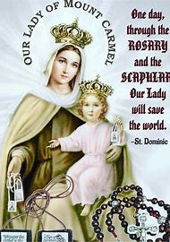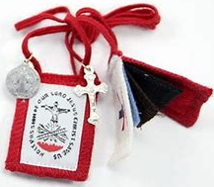
In the year 1251, Mother Mary came down from Heaven to give a special message to St. Simon Stock, a Catholic priest living in England. She gave Him the brown scapular, two pieces of brown woolen cloth connected on a long string, to be worn over the shoulders. The “scapula” is another word for the shoulder blade, so a “scapular” is something that you put around your neck, to fall over your shoulders.
Mother Mary promised that She would give special protection to people wearing the scapular, and help to lead them to Heaven. She said that to receive special graces from the scapular, people should wear it every day, and say prayers honoring Mary, such as the Rosary. In fact, wearing a scapular is as important as carrying rosary beads. Both the scapular and the Rosary open us up to special blessings from Mother Mary. She asked St. Simon Stock to teach people about the scapular, and to share it with them, so that they can become closer to Her, and to Jesus. We can also do this to help bring people closer to Jesus and Mary, leading them to Heaven.
There are 17 different types of scapulars in all. Some Catholics wear the fivefold scapular, which has five different scapulars connected on a red cord. The fivefold scapular has a white scapular for the Holy Trinity, a blue scapular for the Immaculate Conception, a red scapular for the Passion of Jesus, a black scapular for Our Lady of Sorrows, and the brown Our Lady of Mount Carmel scapular Mother Mary gave to St. Simon Stock. Every scapular is dedicated to parts of the lives of Jesus and Mary, and reminds us of how we want to grow in holiness to be more like Jesus and Mary. Some scapulars have holy medals and crosses attached. They may have symbols of Mary, such as Her Immaculate Heart. Each color and image on these scapulars has a special meaning. White reminds us of the pure, clean Hearts of Jesus and Mary. Red reminds us of the Blood Jesus shed out of love for us on the Cross. Blue is the color of Mary.
On our birthdays, we may celebrate by giving presents. Mother Mary is always giving to us, sharing the gift of Her love. She gave the gift of the scapular to share Her love with us. Mother Mary helps us when we are in need. Wearing the scapular reminds us that Jesus and Mary are with us, ready to protect us, and that we need only call upon them, saying a prayer, for them to hear us and answer. When we wear the scapular, we are giving a gift to Mary by sharing our love with Her.

- Choose your favorite type of scapular. Design one of your own. Think about how you want to grow to be more like Mother Mary. Which images and colors can you use to represent and honor Her?

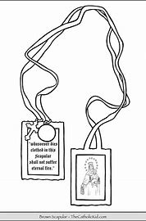

- Why should we wear the scapular? What did Mother Mary promise to people who wear it? ________________________________________________________________
______________________________________________________________________________
______________________________________________________________________________

- How is the scapular different from the Rosary? How is it like the Rosary? Why do we need both?

Both
Rosary
Scapular

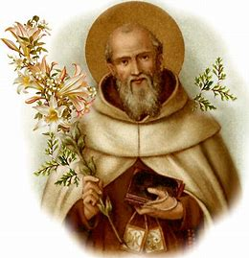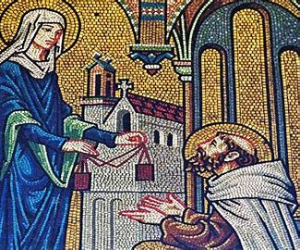
St. Simon Stock receives the scapular

September 2024 3-6 Activities: Week 2
Grade 5- “Our Sanctuary: Jesus, Mary, and the Heart of the Church”
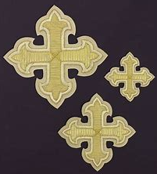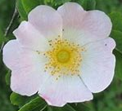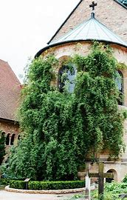
Hildesheim Cathedral and the Thousand-Year Rose
Each part of a church honors Jesus in a special way. The sanctuary of the church includes the altar area. In general, our churches are sanctuaries, places where we go to give glory to God, to be peaceful and safe in His Presence, where we are loved and comforted. Our churches are homes for our hearts. At Church, we are in the house of God. We spend time with Jesus and Mary, loving them with the saints and angels. When we pray for Jesus and Mary to bless and help us, we go to their Hearts. The Hearts of Jesus and Mary are sanctuaries for us. We place our worries at God’s altar, and He takes them up for us, helping us to carry every cross.
One special church, a sanctuary of God’s peace and beauty, is called the Hildesheim Cathedral, which is in the European country of Germany. This cathedral is home to the Thousand Year Rose. A rosebush at the cathedral has been growing for nearly one thousand years. Its roses are believed to be the oldest living roses in the world. They have survived all kinds of changes through the years, including wars. Hildesheim Cathedral is dedicated to the Assumption of Mary (when Mother Mary went to Heaven).
When we give ourselves to Mother Mary, she brings our prayers to Jesus, and helps us to become closer to Him so that we can get to Heaven. Going to Mary helps our hearts to be filled with Her peace and love. Our hearts become like sanctuaries for God to make holy. Then, our hearts can grow with more love. What is given to Jesus and Mary becomes more beautiful and good. Things from God last forever. Offering our hearts to Jesus when we receive Communion opens us up to living forever in Heaven. The Eucharist is food for our souls to keep on living, just like the thousand-year rose.
One way to give our hearts to God is through total consecration to Jesus through Mary. To consecrate ourselves, we say special prayers for 33 days in a row. We can also say a prayer each morning that comes from our hearts, simply giving our day to Mary, and asking Her to help us be a good reflection, or mirror, a living example, of Jesus throughout the day. These prayers of consecration are for everyone. They are different from the promises priests and nuns make when they consecrate themselves and take religious vows. To learn more about total consecration, see this Holy Heroes video: https://www.youtube.com/watch?v=pRJE6WHQUuQ&t=164s.
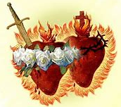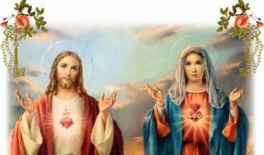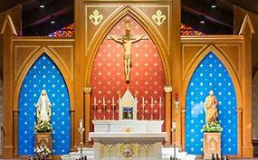
- How are the Hearts of Jesus and Mary like sanctuaries for us? __________________
______________________________________________________________________________
- What can happen when we give our hearts to Jesus and Mary? _________________
_____________________________________________________________________________
- What is consecration to Jesus through Mary? How can we consecrate ourselves?
______________________________________________________________________________
______________________________________________________________________________
______________________________________________________________________________
______________________________________________________________________________
- The thousand-year rose reminds us of how things that are given to God are made to survive, to be beautiful forever. What helps our souls to survive, and get to Heaven?
______________________________________________________________________________
______________________________________________________________________________

Why do you think it is special that the Hildesheim Cathedral is dedicated to the Assumption of Mary? __________________________________________________________
______________________________________________________________________________
- What does it mean for a church to be a “sanctuary”? How are churches our homes?
______________________________________________________________________________

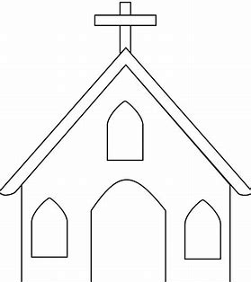
- ____________________________________________________________________________________________________________________________________
- ___________________________
_________________________________
_________________________________
_________________________________
September 2024 3-6 Activities: Week 3
Grade 5- “Mother Teresa and Mother Mary: Friends in Christ”
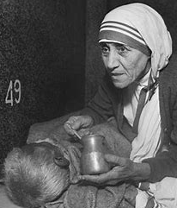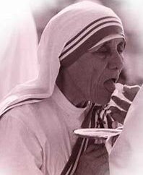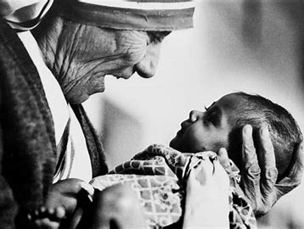
Mother Teresa receives Holy Communion
On September 5, we celebrate the feast day of a very special saint, St. Teresa of Calcutta (1910-1997), better known as Mother Teresa. Mother Teresa, born in Albania, was a nun who served the poor in Calcutta, India. She began the Missionaries of Charity, an order that continues her service to Christ by caring for people who are in need. Mother Teresa comforted and healed people who were completely alone, including children. She took in people who had no home or family, giving them food and shelter, a sanctuary of peace away from the busyness and noise of the world. Some people were sick and dying in the streets. Mother Teresa treated everyone with dignity and respect, because they were made by God. She was a spiritual mother caring for souls through prayer and love.
When she looked at each person, Mother Teresa saw Jesus in them. She cared for people as though she was caring for Jesus, because she knew that God lives in each person’s heart. Mother Teresa made sure that no one was alone. She showed people God’s love, reminding them that He is always with them, no matter what. When people saw Mother Teresa, they saw a reflection of God, someone gentle and strong, caring and brave, Who gives to others and provides what they need, thinking more of others than themselves.
Mother Teresa never gave up. There were many people she was caring for, but she received the food she needed from Jesus. Her hope came from Him. She would receive the Eucharist daily, and be given the strength she needed so that she did not become tired. Mother Teresa taught the nuns she served with to be joyful, to always smile, and be thankful to God for the blessing to serve Him by caring for His children. It is a gift to love God by loving and caring for others.
Mother Teresa was loyal to God, continuing her service faithfully, because she knew that this service is what God was calling her to do. As a young woman, Mother Teresa heard God speaking into her heart while she was on a train ride. It was a miracle, a supernatural happening, something that comes from God. This is when she knew how God wanted her to serve Him with her compassionate heart, a heart like Jesus that felt for others. Mother Mary also listened to God’s calling for Her, becoming Jesus’ Mother, and then the Mother in Heaven of us all, bringing Jesus to all of us. Mother Teresa wants to be our friend, too. She is in Heaven praying for us, ready to help care for us. We can be friends with all of the saints through Jesus and Mary, one family in Christ.
- How was Mother Teresa like Mother Mary? What did they have in common? How did Mother Mary and Mother Teresa each uniquely serve Jesus?

Mother Teresa
Mother Mary
- Mother Teresa served people who were suffering from sicknesses affecting their bodies, but she spoke often about how lonely the homeless and poor felt. Others would ignore the poor when they passed by them in the streets, but not Mother Teresa. Mother Teresa said, “The hunger for love is much more difficult to remove than the hunger for bread.” What do you think Mother Teresa meant by this? How does Jesus take away hunger?
______________________________________________________________________________
______________________________________________________________________________
______________________________________________________________________________
______________________________________________________________________________
- Mother Teresa had a special love for Mother Mary. If she was facing a situation where she was worried, or did not know what to do, she would pray, “Mary, Mother of Jesus, please be a mother to me now.” What can we do to be like Mother Teresa? How can we be friends of saints like Mother Teresa and the greatest saint, Mother Mary?
______________________________________________________________________________
______________________________________________________________________________
______________________________________________________________________________
______________________________________________________________________________
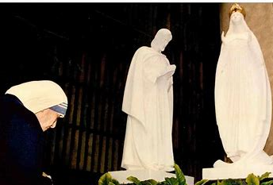
Mother Teresa at Our Lady of Knock Shrine, Ireland
September 2024 3-6 Activities: Week 1
Grade 6- “Blessed Are You: Songs of Praise”
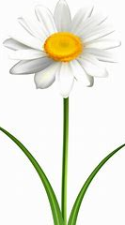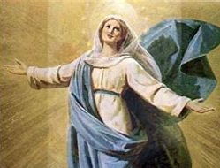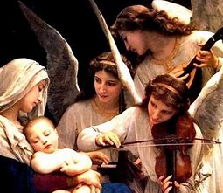
Singing is how we express what is in our hearts. We lift our hearts in prayer through song. We sing throughout the seasons of the Church, but most especially for joy as we celebrate God’s love at the Mass. There are as many kinds of songs as there are saints in the Church, from psalms to canticles. A psalm is a specific kind of song that we find in the Old Testament, the part of the Bible that we read to learn about life before Jesus, when the Jewish people waited for their Savior to come. Canticles are songs that we would find in the Bible outside of the book of Psalms in the Old Testament.
In the New Testament, we read about the life of Jesus, our Savior. We learn about the events that happened when Jesus redeemed, or saved, God’s people, and created the Church, beginning Catholic Christianity. One of the stories we read about in the New Testament is when Mother Mary was expecting baby Jesus, and went to visit her cousin, Elizabeth. At the visit, Mother Mary sang a song to God that is called the “Canticle of Mary” (the “Magnificat” in Latin). Mary praised God for being with Her and blessing Her with the gifts He had given Her. She is a human, but like the angels, brings messages from Heaven, appearing to people around the world to tell them to pray and turn away from sin, while honoring God with praise of Him.
The angels in Heaven sing to give glory to God. By singing at Mass, we can be like the angels sharing our joy and love for God. September 29 is the Feast of the Archangels, when we remember the angels Gabriel, Michael, and Raphael. Angels are messengers. Just as angels bring people messages from God, like the angel Gabriel telling Mary she was chosen to be the Mother of Jesus, we can share the good news of Jesus through song. The Feast of the Archangels, also called Michaelmas, is known as the Catholic Thanksgiving. From August 15 (the Feast of the Assumption, when Mary went to Heaven) until September 29, we observe St. Michael’s Lent, 40 days (except for Sundays) when we can pray and fast before feasting on harvest foods at Michaelmas. In between the seasons of Lent and Advent, this is a time to become closer to Mary, Jesus, the saints, and angels.
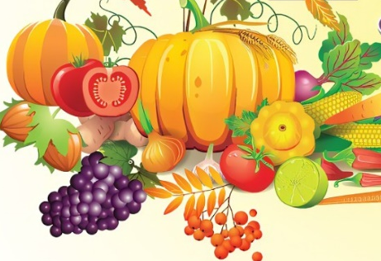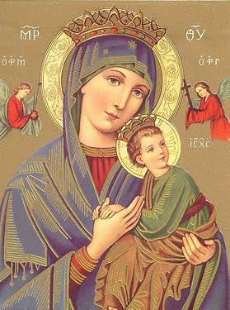
- How are Mother Mary and the angels connected?
Mother Mary | The Holy Angels

Why is it special that St. Michael’s Lent begins with the Feast of the Assumption?
____________________________________________________________________________________________________________________________________________________________
- What can you do to honor God during St. Michael’s Lent? What could you add to your prayer life?
____________________________________________________________________________________________________________________________________________________________
- How is a canticle different from a psalm? ____________________________________
______________________________________________________________________________
- Think about how you can share your thanks for God in a song, which you can use in prayer on Michaelmas. Write your own song of praise for God.
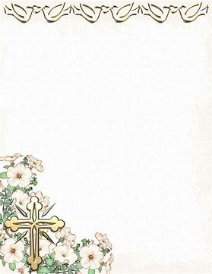

_________________________________________________
_________________________________________________
_________________________________________________
_________________________________________________
_________________________________________________
_________________________________________________
_________________________________________________
_________________________________________________
_______________________________
________________________________
________________________________

September 2024 3-6 Activities: Week 2
Grade 6- “The Lord is Sweet: Mother Mary, the New Eve”
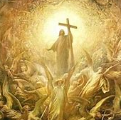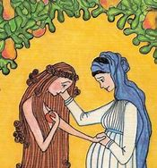
September 14 is the Feast of the Exaltation of the Cross. To “exalt” means to lift something up, to praise and honor. When we think of the Cross, we may think of it with sadness, knowing that Jesus gave His life up for us on the Cross. In rising again, though, Jesus showed us that He can conquer death, that He can overcome any challenge, any heavy burden, including the Cross. He turned the Cross into a symbol of victory, of triumph. This is why, on September 14, we celebrate the Exaltation of the Cross, “exalting” Jesus and the Cross. We give honor to crucifixes, kissing these representations of Jesus on the Cross, because they remind us of Jesus’ love for us, God’s greatness in overcoming sin and death with true love: generous, godly love.
Two days before the Exaltation of the Cross, we celebrate the feast day of the Holy Name of Mary. Mother Mary has many titles, names we give Her to honor Her, to exalt Her. We call Her the Mother of God, the Queen of Heaven, and Queen of the Angels. Mother Mary is also called the New Eve. Sometimes the Cross is called a “tree.” It is said that the wood, or bark, of the Cross is the same wood of the Tree of the Knowledge of Good and Evil. This is the tree Adam and Eve ate the forbidden fruit from. The sin of pride led Adam and Eve to eat the forbidden fruit, because they put themselves first. They thought they did not need to listen to God. They trusted in their own knowledge over God’s wisdom, thinking that the fruit would not hurt them. What hurt Adam and Eve was bringing themselves away from God. This is the same sin that hurt people who brought themselves away from Jesus, wanting to put Him on the Cross instead of looking at the sins in their hearts and asking for forgiveness.
Mother Mary is the New Eve, because She listened to God. She was humble and obedient, following His plan. She did not have the original sin, the first sin Adam and Eve brought into the world through their choice to disobey God, that all human beings (except for Mary and Jesus) inherit. Mary gave birth to Jesus, the New Adam. Jesus obediently gave His life as a gift on the Cross. He paid the price of human sin, redeeming (saving) us. Jesus, the “fruit” of Mary’s womb, made up for the forbidden fruit, the fruit Adam and Eve were told not to eat. Mother Mary always loved the Lord, our God. She knows God is sweet. Sin entered the world through taste, but it was also forgiven and redeemed through taste, as we receive the Body of Christ at Communion. We taste that the Lord is sweet, receiving Jesus’ love in our hearts when we eat the Bread that becomes Christ’s Body, that helps us to get to Heaven, to be faithful to God the Father like Jesus and Mary, the New Adam and New Eve.
- In the table below, compare Mary and Eve. Then compare Jesus and Adam. What did they do differently? Why is Mary called the New Eve, and Jesus the New Adam?
Eve (Old Testament) | Mother Mary (New Testament)

Mary is the New Eve, because _____________________________________________________
______________________________________________________________________________
Adam (Old Testament) | Jesus (New Testament)

Jesus is the New Adam, because ___________________________________________________
______________________________________________________________________________
- Pray and reflect on the words from the Bible “Taste and see that the Lord is good” (Psalm 34:9). What do these words mean to you? When have you seen the Lord’s sweetness in your life? How has Jesus helped you to carry crosses?
______________________________________________________________________________
______________________________________________________________________________
______________________________________________________________________________
______________________________________________________________________________
- Why do we celebrate the Exaltation of the Cross? What can you do to honor Jesus and the Cross on this day?
______________________________________________________________________________
______________________________________________________________________________
______________________________________________________________________________
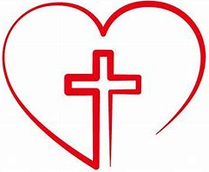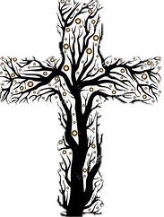
September 2024 3-6 Activities: Week 3
Grade 6- “Eucharistic Graces: Opening our Hearts to Jesus like Mary”
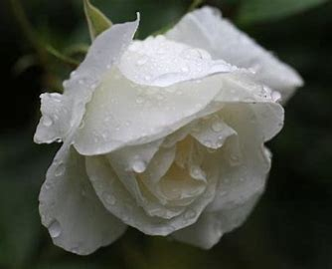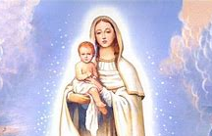
Mother Mary was made full of grace by God. Before Adam and Eve sinned, God intended for every person to be full of grace. Once Adam and Eve disobeyed God, they brought sin into human life. Everyone born after Adam and Eve would inherit their original sin. Although original sin is washed away in Baptism, when we become children of God, we are not completely sinless like Mother Mary. Before being baptized, we had original sin that was passed down to us from Adam and Eve, since we are their descendants (people born from them, part of their family tree). We need Confession to be forgiven of actual sin, the sins we actually commit.
Mother Mary did not have original sin or actual sin, because the graces God gave Her meant that She never could sin. To bring the sinless Son of God into the world, She had to be without sin, too. We may not have the same full graces that Mother Mary does, but we receive graces from God through the sacraments. Graces help us to stay away from sin and to become holier. In Heaven, our souls will be made perfect. On Earth, we not only need to have faith and do good works for God to get to Heaven, but we need Him to give us graces to keep growing.
The Eucharist forgives minor (venial, smaller) sins we may still be attached to after Confession. The more we open our hearts to loving and listening to God, the more graces we can receive from Him, especially at Communion. We meet Jesus at Communion. Receiving Communion can help us be more like Jesus, the One we receive, as we work on being faithful to God’s plan.
Every August 5, the Feast of Our Lady of Snows, white roses fall like snow from the ceiling of the St. Mary Major church in Rome, a miraculous sign from God. White reminds us of Mother Mary’s pure Heart. The roses are beautiful and sweet like Mother Mary’s loving Heart. Jesus and Mary want to shower us with graces from Heaven like these roses. This miracle reminds us that with God’s grace, anything is possible. Prayers and devotions like wearing the scapular or Miraculous Medal help to open us to receiving graces. We can pray to have a heart of mercy and kindness like Mary, a heart that gives grace to others by being compassionate and forgiving. The virtues of faith, hope, and love, which Mary and Jesus lived out, help us keep away from sin.
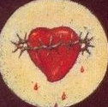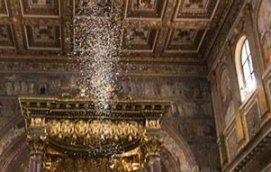
St. Mary Major, Rome
- How are actual and original sin different?
Original sin | Actual sin

Why was Mother Mary made without original or actual sin? __________________________
______________________________________________________________________________
______________________________________________________________________________
- How do we open our hearts up to receiving graces from God? ___________________
______________________________________________________________________________
______________________________________________________________________________
- What happens at St. Mary Major Church in Rome every year? What does this teach us, or remind us of?
______________________________________________________________________________
______________________________________________________________________________
______________________________________________________________________________
- When have you seen God’s grace in your life? How has this helped you in your faith?
______________________________________________________________________________
______________________________________________________________________________
______________________________________________________________________________
- St. Mary Major was one of the first churches dedicated to Mother Mary. The special church has relics of the crib Christ was born in, and of His Cross. We put things we treasure in our hearts, just like relics in the church. How can we dedicate our homes and our hearts to Mother Mary? Write your ideas in/around the treasure chest.
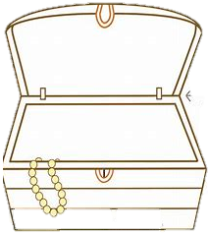

September 2024 3-6 Review
Use this review sheet as a reference to track progress and check that learning goals are met.
Recap: What did we learn?
All Grades
- September is the month we celebrate the birthday of Mother Mary
- Mother Mary is the Mother of Jesus. Since Mary was born, Jesus could be born. We celebrate Mother Mary’s birthday because She is a Mother to us all in the Church
- Mother Mary was faithful to God the Father. She is an example of obedience to God’s plan, because She listened to Him
Grade 3
- Our faith grows over time. When we give our hearts to Jesus and Mary, they fill them with love that continues to grow
- Priests have the power to bless. They use a book of prayers called the Rituale to bless people and things, like seeds on Mother Mary’s birthday
- We use the Holy Names of Jesus and Mary with love and respect
- Like the angels, we sing to God to praise Him, using songs like the “Hosanna”
- The priest wears a biretta, a hat, in the traditional Mass. He takes the hat off to show respect for the Name of Jesus when it is said
- Our priests serve Jesus in a special way. They make promises to God to be good servants to Him. We pray for them on Priesthood Sunday, when we celebrate them
- Men receive the sacrament of Holy Orders to become priests, also called clergy. The Mass when they receive this sacrament is called the “ordination” Mass
Grade 4
- Mother Mary is like the ciborium. The ciborium holds the Host, Jesus’ Body, in the tabernacle, just like Mother Mary held Jesus
- The ciborium is veiled. Holy things have veils put over them in the Church
- Mother Mary is very holy. She is Queen of Heaven. We honor Her in a special way
- Mother Mary has an Immaculate Heart, a perfect, clean heart, without sin. Her Heart is filled with only love
- We can pray for our hearts to be like Mary’s loving Heart
- Priests pray the liturgy of the hours, prayers said throughout the day at special times, morning, noon, and night
- Like priests who pray the liturgy of the hours, we can pray every day
- Prayer helps us to grow and be more like Jesus, who always prayed to God the Father
Grade 5
- Mother Mary gave the gift of the scapular to us when She appeared to St. Simon Stock in 1251. She promised that people who wear the scapular every day and pray for Her blessings will be saved
- There are 17 types of scapulars. The brown scapular was given to St. Simon Stock
- Both the Rosary and scapular help us to grow in our faith and become closer to Mother Mary and Jesus
- The sanctuary of a church is the altar area. Sanctuaries in general are places of peace
- We can make our hearts like sanctuaries for God. Consecration to Jesus through Mary is how we can give our hearts to God. There are 33 days of consecration prayers
- Mother Mary and Mother Teresa are both spiritual mothers who cared for souls, and still do in Heaven. They were devoted to God, doing what He called them to do
Grade 6
- Psalms and canticles are both songs for God, but canticles appear in parts of the Bible other than the book of Psalms from the Old Testament
- The Old Testament tells of the time before Jesus, and the New Testament is about His life
- The angels in Heaven love God, and sing to Him to honor Him. Our songs are prayers in which we praise God
- We celebrate the Feast of the Archangels on September 29. Angels are messengers who remind us to share our gratitude for, and love of, God
- Michaelmas, September 29, is the Catholic Thanksgiving. We fast and pray for the 40 days leading up to it (St. Michael’s Lent) as a way to show thanks to God
- Original sin is sin that comes from Adam and Eve, who committed the first sin. It is forgiven in Baptism
- Actual sin refers to sins we actually commit, beyond inherited sin. It is forgiven in Confession
- Mother Mary was without both original sin and actual sin. She is full of grace. She is called the New Eve, because She was obedient to God. Adam and Eve disobeyed God, but human sin was redeemed through Jesus’ faithfulness to God the Father
- We receive graces from God through the sacraments. Through prayer and devotion to Jesus and Mary, we can open ourselves up to receiving more graces, growing holier, and staying away from sin
What vocabulary words did we practice?
Grade 3
Week 1
Rituale
Week 2
Biretta
Hosanna
Week 3
Clergy
Holy Orders
Ordination
Grade 4
Week 1
Ciborium
Week 2
Immaculate Heart
Week 3
Liturgy of the hours
Grade 5
Week 1
Scapular
Week 2
Sanctuary
Week 3
Supernatural
Grade 6
Week 1
Canticle
Week 2
Original sin
Week 3
Actual sin
What prayers did we practice?
Grade 3
Prayer in Honor of All the Holy Angels
Grade 4
Daytime Prayer
Grade 5
Mary, Help of Those in Need Prayer
Grade 6
Invocations of the Immaculate Heart of Mary
Checklist: Activity Completion
Grade 3
Week 1: “Planting Seeds: Growing in Faith like Mother Mary”
Week 2: “Hail, Mary: Blessing Our Lady’s Holy Name”
Week 3: “Spiritual Mothers and Fathers: Mary, Mother of the Church and Priesthood Sunday”
Grade 4
Week 1: “Hail, Holy Queen: The Holiness of Mother Mary”
Week 2: “Holy Name, Holy Heart: Loving God like Immaculate Mary”
Week 3: “Pray Every Day: The Liturgy of the Hours”
Grade 5
Week 1: “Birthday Blessings: Mother Mary’s Gift of the Scapular”
Week 2: “Our Sanctuary: Jesus, Mary, and the Heart of the Church”
Week 3: “Mother Teresa and Mother Mary: Friends in Christ”
Grade 6
Week 1: “Blessed Are You: Songs of Praise”
Week 2: “The Lord is Sweet: Mother Mary, the New Eve”
Week 3: “Eucharistic Graces: Opening our Hearts to Jesus like Mary”
Quick Check:
Tell us about your experience with these activities this month! Our September 2024 Google Form for Grades 3-6 is available here: https://forms.gle/RibF7jTZUcipkT3e8

