Our Lady of the Valley Religious Education

May 2024 Activity Packet

Grades 3-6

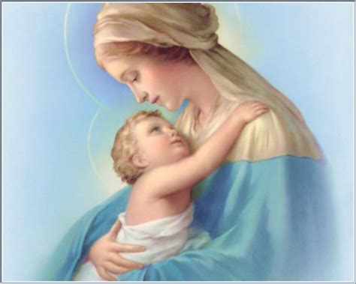

Name: ________________________________________
Materials Included in Packet
Overview…………………………………………………………………………………………3
Standards………………………………………………………………………………………...5
Pacing Guide…………………………………………………………………………………….7
Activities………………………………………………………………………………………...10
Week 1…………………………………………………………………………………………..10
Grade 3………………………………………………………………………………….10
Grade 4………………………………………………………………………………….12
Grade 5………………………………………………………………………….............17
Grade 6………………………………………………………………………………….19
Review…………………………………………………………………………………………..21

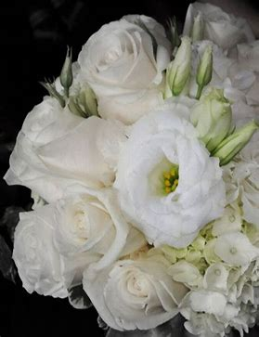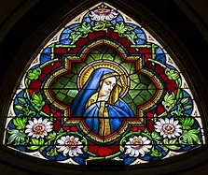
May 2024 Overview: Grades 3-6
Theme: Month of the Blessed Virgin Mary
Monthly Prayer/Invocation: Mother of God, give me the grace of loving Jesus. Give me the grace of loving you. Mother of love, pray for us.
Thematic Guiding Questions, 3-6: Who is the Blessed Virgin Mary? Why do we honor the Blessed Virgin Mary in our faith?
- Why do you think May is a special month to celebrate Mother Mary?
- How does Mother Mary help us to know Jesus better?
Saint of the Month: In 1917, Our Lady appeared to children in Fatima, Portugal. Our Lady of Fatima taught them the importance of praying, especially the Rosary, and living holy lives as Catholics, so that we can go to Heaven to someday be with Her and Jesus. Mother Mary is always watching over us and caring for us, just as She cared for Jesus as His Mother, showing us how we can love Christ as well.

Monthly Challenge: Honor Mother Mary in a special way this month. Read a book or watch a video about Mother Mary’s apparition to the children of Fatima. Make a small Mary garden or shrine at home with holy cards, a statue, and flowers that remind you of Mother Mary, like roses, or come to say a prayer by the Mary grotto at our parish. Make the sign of the Cross when you visit the statue at the Mary shrine. See the Marian prayers in our prayer compendium for additional ideas about how to honor Mother Mary in prayer.
Overall Learning Goals: Our goal this month is to explore how we can take part in acts of kindness by spiritually caring for each other. We will look to Mother Mary as an example of kindness, identifying how Our Lady has lived out kindness in Her dedication to God.
Summary of Activities: To apply our learning, we will articulate how we can each grow in kindness, and take special steps to honor Mother Mary in Her month of May. Our activities engage with music, prayer, and reflection, especially through a Marian lens, as we study Marian titles and apparitions throughout history, around the world. We will deepen our devotion to the Eucharist, and learn more about using sacramentals such as the Miraculous Medal to become closer to Jesus and Mary.
Additional Enrichment Ideas:
- Create a Mary garden in your backyard. You can plant flower seeds in clay pots to put around an outdoor statue of Mary. You could also make an indoor Marian shrine, picking out your favorite flowers to put on a home altar around a small statue of Mary. If you don’t have a statue, you can use a laminated prayer card or print image of Mary (when placing outside, the image can be put on a post).
- Crown your statue of Mary with flowers, or make your own crown. Sing your favorite songs about Mary, like “Immaculate Mary” at your home May crowning. You can find a compilation of Marian songs here: https://www.youtube.com/watch?v=rbbZjFm1P-g
- In honor of Mother Mary and Her Miraculous Medal, begin saying a perpetual novena. Whereas a novena is nine consecutive days of prayer, a perpetual novena is ongoing. The Miraculous Medal perpetual novena includes the Memorare, a special prayer to Mother Mary. For the perpetual novena prayers, visit https://miraculousmedal.org/worship-and-prayer/perpetual-novena/. Visit the Miraculous Medal Shrine website to see Mass and praying of the perpetual novena livestreamed: https://miraculousmedal.org/livestream/
- Sign up for daily emails from Aleteia with Scripture verses to focus on each day, prayer (https://cdn.forms-content.sg-form.com/4a69ede7-d3a2-11ed-8377-fe995a783794)
Scripture Memory Card
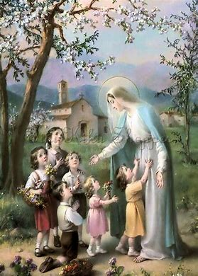
“Put on then, as God’s chosen ones, holy and beloved, heartfelt compassion, kindness, humility, gentleness, and patience.” -Colossians 3:12



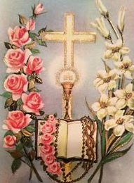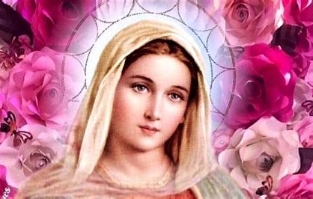

Standards
Grade Level | Activities | Learning Standards
Grade 3 | “Our Lady of the Miraculous Medal” | 3.3 Sacramentals are blessed objects that remind us of the sacraments, calling us to use them in pursuing virtuous lives, and to see God in everywhere in the world around us. Sacramentals include rosaries, holy water, sacred statues, and images (such as of saints).
Grade 4 | “Spiritual Bouquet: Songs and Prayers for Our Lady” | 4.6 There are two major parts of the Mass: the Mass of the Catechumens and the Mass of the Faithful… The Mass of the Catechumens was traditionally for the unbaptized still learning the Mass, and goes up to the Offertory. The Mass of the Faithful includes Communion, and so it was traditionally for those who had already made their sacraments (rites of initiation), going from the Offertory to the end of the Mass. God speaks to us in the first part of the Mass through the readings, and we respond in the second part when we receive Communion, allowing Christ to enter our hearts.  4.9 There are seven spiritual works of mercy, good works that assist people spiritually by helping them on their way to Heaven. These works, including praying for the living and the dead, lovingly care for the soul.
Grade 5 | “Universal Kindness: Marian Apparitions Around the World” | 5.1 The global Church is… large, spread across a wide territory… There are smaller groups of worshippers in local parish churches, which are collected regionally into larger groups of faithful called dioceses. Many dioceses make up the global Church.  5.5 We all have unique callings to live out our love for God. We all can be part of celebrating Church traditions.
Grade 6 | “The Litany of Mary: A Song for the Greatest Saint” | 6.9 Mary, Mother of Jesus, has played an essential role in salvation history, guiding us through change and uncertainty with Her steadfast love, Her role as Mother that will never change. As a Mother, She knows all of us uniquely; though She has many spiritual children around the world, none of us are forgotten.

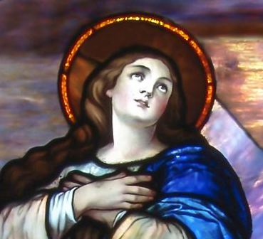

May 2024 Pacing Guide (Suggested Schedule)
Grades 3-6
Week Number/Date | Grade Level | Activities
Week 1 | Grade 3 | “Our Lady of the Miraculous Medal”
Week 1 | Grade 4 | “Spiritual Bouquet: Songs and Prayers for Our Lady”
Week 1 | Grade 5 | “Universal Kindness: Marian Apparitions Around the World”
Week 1 | Grade 6 | “The Litany of Mary: A Song for the Greatest Saint”

Week Number/Date | Grade Level | Words to Know | Definitions
Week 1 | Grade 3 | Sacramental | A blessed item that reminds us of the sacraments, which we can use to guide our prayers and prepare us to receive Jesus in the sacraments. The Rosary, statues of saints, and images of the Holy Family (Jesus, Mary, and Joseph) are examples of sacramentals.
Week 1 | Grade 4 | Litany | A prayer that asks for the intercession, the help, of many saints in Heaven. There are different types of litanies, such as the Litany of Mary, that lists Mother Mary’s many titles, such as Mother of Hope. We hear the Litany of the Saints prayed at the Mass.
Week 1 | Grade 5 | Apparition | An appearance. Mother Mary has appeared to people in the world all throughout history, coming down from Heaven to tell people on Earth to become closer to Jesus, especially by praying the Rosary, going to Mass, and going to Confession. Mother Mary’s messages are reminders to keep living out our faith.
Week 1 | Grade 6 | Mediatrix | Mother Mary is the Mediatrix of All Graces, because She “mediates” graces between God and humans. She goes between us and God, like a bridge through which graces flow, from God to us. She is a channel of grace, because Only God can give graces, but Mother Mary helps us to receive these graces. She prays for us always. Through Her prayers, our prayers can be answered.

Week Number/Date | Grade Level | Prayers to Know | Text of Prayers
Week 1 | Grade 3 | Hail, Holy Queen | Hail, Holy Queen, Mother of mercy. Hail, our life, our sweetness, and our hope. To thee do we cry, poor banished children of Eve. To thee do we send up our sighs, mourning and weeping in this valley of tears. Turn then, most gracious Advocate, thine eyes of mercy towards us. And after this our exile, show unto us the blessed fruit of thy womb, Jesus. O clement, O loving, O sweet Virgin Mary.
Week 1 | Grade 4 | Hail, Holy Queen | Hail, Holy Queen, Mother of mercy. Hail, our life, our sweetness, and our hope. To thee do we cry, poor banished children of Eve. To thee do we send up our sighs, mourning and weeping in this valley of tears. Turn then, most gracious Advocate, thine eyes of mercy towards us. And after this our exile, show unto us the blessed fruit of thy womb, Jesus. O clement, O loving, O sweet Virgin Mary.
Week 1 | Grade 5 | Hail, Holy Queen | Hail, Holy Queen, Mother of mercy. Hail, our life, our sweetness, and our hope. To thee do we cry, poor banished children of Eve. To thee do we send up our sighs, mourning and weeping in this valley of tears. Turn then, most gracious Advocate, thine eyes of mercy towards us. And after this our exile, show unto us the blessed fruit of thy womb, Jesus. O clement, O loving, O sweet Virgin Mary.
Week 1 | Grade 6 | Hail, Holy Queen | Hail, Holy Queen, Mother of mercy. Hail, our life, our sweetness, and our hope. To thee do we cry, poor banished children of Eve. To thee do we send up our sighs, mourning and weeping in this valley of tears. Turn then, most gracious Advocate, thine eyes of mercy towards us. And after this our exile, show unto us the blessed fruit of thy womb, Jesus. O clement, O loving, O sweet Virgin Mary.

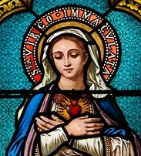
May 2024 3-6 Activities
Grade 3: “Our Lady of the Miraculous Medal”
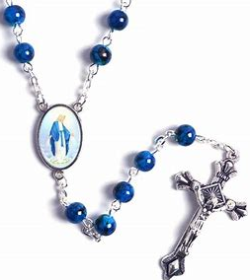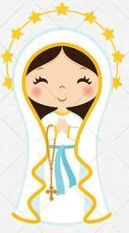
In 1830, a nun named Catherine Labouré, who is now a saint, was visited by Mother Mary. Mother Mary brought St. Catherine Labouré a message from Heaven. Mother Mary told St. Catherine Labouré that She would bring people many special graces, but that they needed to keep praying. To inspire people to pray, Mother Mary wanted to give them a sacramental called the Miraculous Medal. She asked St. Catherine to have the Medal made for people around the world to wear. When people wear the Miraculous Medal and pray for Mother Mary to help them to be holy and do good things for God, they open up their hearts to receive graces from God, special gifts for our souls that make us more holy.
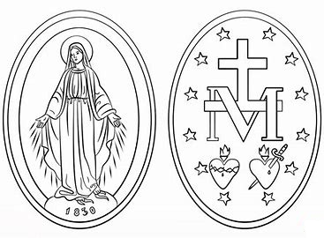
On the front of the medal, we see a picture of Mother Mary. She is standing on a globe, and rays of light are coming from the rings She wears on Her fingers. This is what She looked like when St. Catherine saw Her. The picture reminds us that Mother Mary is watching over and helping people all over the world. The rays of light coming from Her hands are like the graces, the blessings, She brings us from God when we pray. If we stand outside in the sun, we can feel how warm the sun is from its rays of light. This is like how when we pray, we can feel God with us, listening to us and protecting us.
On the back of the Miraculous Medal, we can see the letter “M” for “Mary,” with a Cross. There are also 12 stars and 2 hearts: one for Jesus, and one for Mary. Jesus’ Heart has a crown of thorns around it, and Mary’s has a sword. Jesus wore the crown of thorns on the Cross. Mother Mary was sad for Jesus when He was on the Cross, because She knew it hurt Him. This hurt Her heart, too. But Jesus and Mary are both kind and loving. Jesus went on the Cross to save us. Mary and Jesus both prayed to God the Father, and got through hard times. Their hearts were strong, because they were full of love for God and us.
Mother Mary wanted to give us the Miraculous Medal, because She is kind, and knew that the Miraculous Medal would help us. When we look at the pictures on the Medal, we remember how much Jesus and Mary love us. We remember the sacraments, like Holy Communion, and how Jesus is with us. The Medal reminds us to pray, which helps us to become closer to God. When we keep praying, miracles, amazing things only God can do, can happen. This is why the Medal is called “Miraculous.”
In the Miraculous Medal, draw a picture of something kind you can do to honor Mother Mary in this month of May. What is something kind you could do for someone else that would make Mother Mary happy?

- Why should we talk to Mary when we pray?
______________________________________________________________________________
______________________________________________________________________________
- What is something you can pray for Mary to help you with?
______________________________________________________________________________
- What is one of the pictures on the Miraculous Medal? How does this picture remind you of the kindness of Mary and Jesus?
______________________________________________________________________________
______________________________________________________________________________
______________________________________________________________________________
_____________________________________________________________________________________

Grade 4: “Spiritual Bouquet: Songs and Prayers for Our Lady”
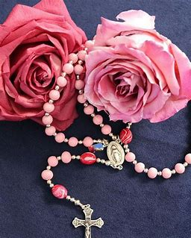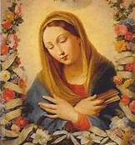
May is the month of Our Lady. During this month, we can do special things to honor Mother Mary. One thing we can do is say prayers and sing songs that are dedicated to Mother Mary. The “Hail Mary,” the Memorare, “Hail, Holy Queen,” and the Rosary are all prayers that are said to honor Mother Mary. Songs like “Immaculate Mary,” “Bring Flowers of the Rarest (Queen of the May),” “Salve Regina,” and “Ave Maria” are sung for Our Lady.
The Litany of Mary is a prayer that is sung after the Rosary. A litany is a type of prayer known as “petition.” When we petition Jesus, Mary, and the saints, we ask them to help us. Mother Mary is the greatest of the saints. She is the Mother of Jesus, the Queen of Heaven, and has no sins, only grace, from God. In the Litany of Mary, we ask Mother Mary to pray for us, because Mother Mary’s prayers help us to become closer to Jesus. Mother Mary hears our prayers, and brings them to Jesus. She helps to make sure that we receive special blessings from God.
Another litany is the Litany of the Saints. You will hear the Litany of the Saints, a prayer asking the saints to help us, during the Mass of the Faithful. There are two parts of the Mass: the Mass of the Catechumens, and the Mass of the Faithful. God talks to us in the Mass of the Catechumens. We hear parts of God’s book, the Bible, like the Epistles (letters) and the Gospels (stories of Jesus’ life), read aloud. The priest gives a sermon telling us about God, and what God is saying to us in the Bible. During the Mass of the Faithful, we prepare to receive Communion, and we talk to God, praying that He will help us to open our hearts to receive Jesus with love and respect. We ask God to accept the Sacrifice of the Mass, the prayers we offer to Him.
We can also ask Mother Mary to help the people around us, all of the people in our Church family. Mother Mary is kind. She does spiritual works of mercy, praying for us out of love. We can be kind like Mother Mary by praying for others, which is a spiritual act of mercy, something we can do to help people that is compassionate and thoughtful.
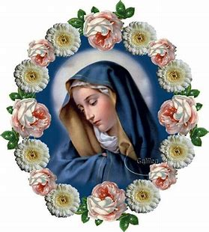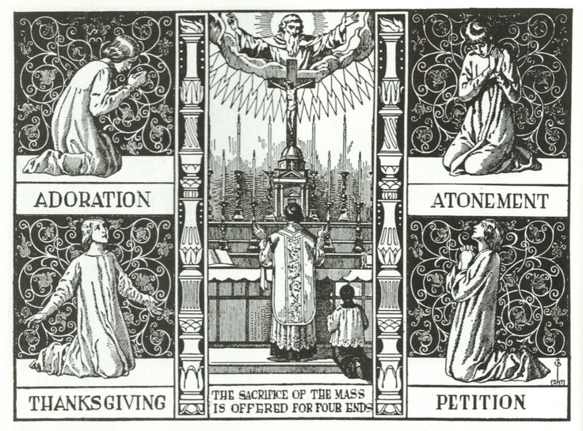

Grade 4: “Spiritual Bouquet: Songs and Prayers for Our Lady” continued
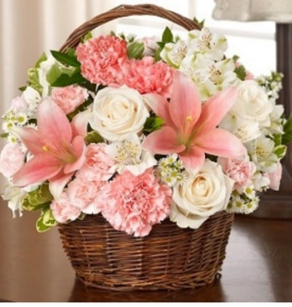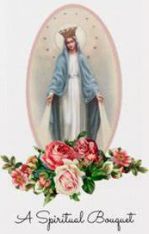
Mother’s Day is on Sunday, May 14 this year. You can honor your mom by praying with her and for her. You can also honor our Mother in Heaven, Mother Mary, through your prayers. Flower bouquets are bunches of flowers. A bouquet has many different types of flowers, like roses and lilies, that are put together in a vase. Sometimes bouquets have many of the same flower. Whichever flowers are chosen, bouquets are beautiful, and make people happy. Flower bouquets are popular gifts for holidays like Mother’s Day.
You can also give someone a spiritual bouquet. Like flower bouquets, spiritual bouquets are beautiful gifts. If you offer a spiritual bouquet, it means you are promising to pray for someone. You give them many beautiful prayers that are like sweet-smelling, colorful flowers, because they make people happy. Most of all, it makes Jesus and Mary happy when you pray in your heart out of love for others. Because Mother’s Day is on a Sunday, you can offer your prayers at Mass for your mom, and ask Mother Mary to bless her.
You might choose to say the Rosary, a chaplet, or a novena (nine days of prayers in a row), for someone. You could say 3 Hail Mary prayers, or 2 Our Father prayers and 1 Glory Be prayer one day. When you go to Adoration, you can offer your prayers for someone. In your spiritual bouquet card, write which prayers you plan to offer in your spiritual bouquet. What is something you can do to honor Mother Mary, to make Her happy?
______________________________________________________________________________
______________________________________________________________________________
Write your own prayer to say in honor of Mother Mary. What do you love about Mother Mary? What is something special about Mother Mary that reminds you of your mom?
______________________________________________________________________________
______________________________________________________________________________
______________________________________________________________________________
______________________________________________________________________________
______________________________________________________________________________
On the next page, cut out a spiritual bouquet card you can write out and give to a loved one. You could give your mom a spiritual bouquet on Mother’s Day.


A Spiritual Bouquet for
______________________
I will pray
______________________
______________________
for you.

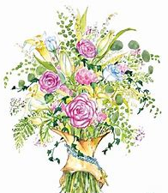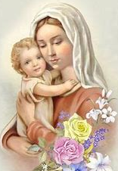

Grade 5: “Universal Kindness: Marian Apparitions Around the World”
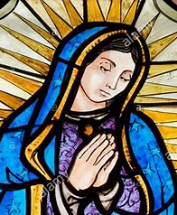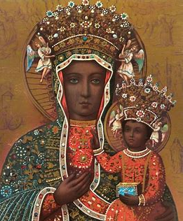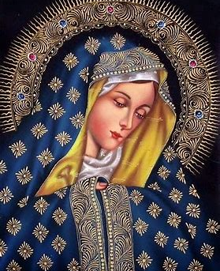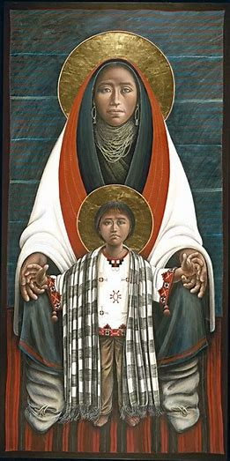
A Marian apparition is when Mary appears to, or visits, people on Earth. Mary comes down from Heaven to bring a message, sharing with us what we need to do in order to be better followers of Jesus, and go to Heaven. She has appeared to people in nearly every time in history, in just about every place across the globe.
When you look at artwork of Mother Mary, you can see how cultures around the world honor Her. There are members of the Catholic Church everywhere around the world. Our Church is large, but Mother Mary helps to bring the whole Church together, because She is our Mother in Heaven, the Mother of us all. She can bring all of us closer to Jesus.
Mary’s calling from God was to be the Mother of Jesus, to raise the Son of God. It was also Her calling to care for God’s children, all of us, which is why She has come back to Earth to help people by bringing messages of hope from God. We can always pray for Mother Mary to show us how to be a light in the Church, to do what God is asking us to do. She is kind, listening to the prayers in our hearts, and responding to them by going to Jesus, speaking up for us.
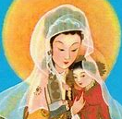
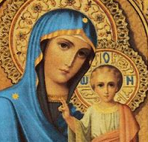
When someone reports to the Church that they saw a Marian apparition, the Church investigates the details, looking into the story to make sure that the apparition really happened, that it truly was Mother Mary who appeared. Research Marian apparitions, investigating where and when they happened. You can start by choosing one suggested from this list:
- Our Lady of the Pillar
- Our Lady of Mt. Carmel
- Our Lady of La Vang
- Our Lady of Sheshan
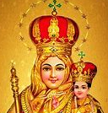
- Our Lady of Czestochowa
- Our Lady of Kibeho
- Our Lady of Akita
- Our Lady of La Salette
- Our Lady of Soufanieh
- Our Lady of Vailankanni (Velankanni)
- Our Lady of Fatima


Draw a picture of Mary as she appeared, based on your research. On the map of the world, color in the country/region where Mary appeared.

What did you learn from this apparition about how to be a good follower of Christ? What did Mary say we should do to serve the Church? ________________________________
________________________________
________________________________
________________________________
________________________________________________________________________________________________________________________________
_________________________________
In what country did Mary appear? ___________________________
In what year did Mary appear? ______________________________
Who did Mary appear to? __________________________________
_______________________________________________________
Name of Marian Apparition:
_________________________
_________________________

Based on what you learned about this apparition, how do you think Mother Mary is an example of kindness? How can you be kind like Mother Mary? __________________________________
____________________________________________________________________________________________________________________________________________________________
Grade 6: “The Litany of Mary: A Song for the Greatest Saint”
Mother Mary is the greatest saint in our Church. Our Blessed Mother is the Queen of Heaven. She is above the angels. Words fall short of capturing the greatness of God, and the holiness of the saints in Heaven who love Him. But throughout history, people have written songs, poems, and stories about Mary, the Mother of Jesus, honoring Mother Mary through beautiful descriptions of Mary’s kindness, generosity, and goodness. Songs and prayers are used to call on Mary, asking Her to help lead us to Heaven, where She is with Jesus.
Often prayed after the Rosary, the Litany of Mary, also called the Litany of Loreto (the place where it was written) is a song that uses many different titles to shed light on a part of Mary’s beautiful Immaculate Heart. For example, the title “Mother of Hope” for Mary that we hear sung in the litany describes the hopefulness in Mother Mary’s Heart. Although Mother Mary faced difficult times, especially when She saw Her Son, Jesus, suffering on the Cross, She had hope in Her Heart, knowing that God loves us, and will use every experience for our good, to help us become stronger. Mother Mary knew God would overcome any challenge.
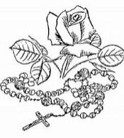
We look to Mother Mary as an example of kindness, because Her Heart was fully open to loving God. Mother Mary’s kindness shines from Her Heart. She leads us to Jesus, the Light of the World, because, just like how the moon reflects the light of the sun, She reflects His loving kindness with Her own gentleness, compassion, and sweetness. Being kind means we can be more like Mary and Jesus. Mother Mary is the Mediatrix of All Graces. To mediate is to help people work together. Mother Mary is a mediator, since She listens to our prayers when we ask Her to help us. She brings our prayers to Jesus, and helps us to become closer to Him. Mary can help to bring us special graces that come from God. When you pray for Mary to help you, you can use one of Her titles to address Her: “Mary, Mother of Hope, pray for us,” is an example of what you can say when you talk to the Blessed Mother.
Draw a picture representing each title. Then, think about how Mary represents that title. You can research why these titles were given to describe Mary, or write about how you think Mary symbolizes each title.
Marian Title | Meaning of Title/Symbol
Morning Star

Mystical Rose

Gate of Heaven

Queen of Angels

- Which title or symbol do you think best represents Mother Mary, and what She means to you? Why? You can see a full list of Marian titles in the Litany of Mary here: https://www.ewtn.com/catholicism/devotions/litany-of-loreto-246. To listen to the Litany sung in Latin, visit: https://www.youtube.com/watch?v=FPHk5ehKhi0 or https://www.youtube.com/watch?v=oKsh2EDNt-E
__________________________________________________________________________________________________________________________________________________________________________________________________________________________________________
- Why is Mother Mary an example of kindness?
____________________________________________________________________________________________________________________________________________________________
- What could you do to reflect the kindness of Jesus and Mary?
____________________________________________________________________________________________________________________________________________________________

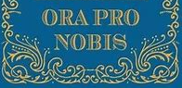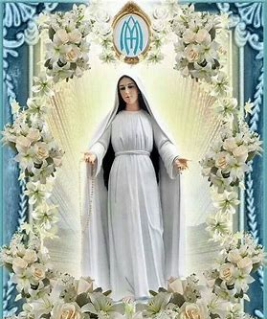
May 2024 3-6 Review
Use this review sheet as a reference to track progress and check that learning goals are met.
Recap: What did we learn?
All Grades
- May is a special month dedicated to Mother Mary
- Mary is the Mother of Jesus. As Mother of God, She has a special role in the Church
- Mary is Mother to all of us as well, because as baptized members of the Church, we are the children of God
- Mother Mary is kind. She helps us when we ask Her, and is a gentle, loving Mother, always listening to our prayers
- We were all made uniquely by God, and, like Mother Mary, can each do kind things that honor Him
Grade 3
- Mother Mary appeared to St. Catherine Labouré in 1830. She gave her a special message to share with the world, reminding them to pray
- Mother Mary told St. Catherine to have a medal made with Mother Mary’s picture on it
- This Miraculous Medal would remind people to pray, and ask Mother Mary to help them
- Mother Mary can help us to receive special graces, gifts that help our souls become holier, through God. We receive these graces from praying
- Wearing the Miraculous Medal opens our hearts up to prayer, and to receive these special graces
Grade 4
- May is a time to make special offerings in honor of Mother Mary, such as through songs and prayers dedicated to Her
- The Litany of Mary is a prayer of petition sung to ask Mother Mary to help us
- The Litany of the Saints is another litany, which is sung during the Mass of the Faithful
- Holy Mass is made up of two parts: the Mass of the Catechumens, and the Mass of the Faithful
- God talks to us in the Mass of the Catechumens, when we hear God’s Word spoken. We listen to God through readings from the Bible
- In the Mass of the Faithful, we respond to God by praying. When we talk to Him, we ask Him to help us prepare to receive Communion. We respond to God with love when we receive Communion respectfully
- We can complete spiritual works of mercy, caring for the souls of other people with love, by petitioning Jesus, Mary, and the saints to bless them
Grade 5
- Marian apparitions are appearances, visits, of Mary
- Throughout history, all around the world, Mother Mary has brought messages from Heaven to people, reminding them of what God is asking them to do to be good followers of Him
- Mother Mary wants to help people to get to Heaven so that they can one day be with Her and Her Son, Jesus. She listens to our prayers and brings them to Jesus
Grade 6
- Mother Mary is the Mediatrix of All Graces. When we pray, She brings our prayers to Jesus, and can direct special graces to us from God
- There are many titles used to describe Mother Mary, and many symbols associated with Her. We hear of these titles and symbols in the Litany of Mary, or Litany of Loreto
- Mother Mary’s titles capture Her holiness. They honor Her pure soul, Her Immaculate Heart that is full of loving kindness She shares with us
- Mother Mary is a reflection of God’s mercy. She is an example of how to be compassionate and kind as God calls us to be
What vocabulary words did we practice?
Grade 3
Sacramental
Grade 4
Litany
Grade 5
Apparition
Grade 6
Mediatrix
What prayers did we practice?
Grade 3
Hail, Holy Queen
Grade 4
Hail, Holy Queen
Grade 5
Hail, Holy Queen
Grade 6
Hail, Holy Queen
Checklist: Activity Completion
Grade 3
“Our Lady of the Miraculous Medal”
Grade 4
“Spiritual Bouquet: Songs and Prayers for Our Lady”
Grade 5
“Universal Kindness: Marian Apparitions Around the World”
Grade 6
“The Litany of Mary: A Song for the Greatest Saint”
Quick Check:
Tell us about your experience with these activities this month! Our May 2024 Google Form for Grades 3-6 is available here: https://forms.gle/XckGEoioH8a5BQwA6

