Our Lady of the Valley Religious Education

February 2024 Activity Packet

Grades 7-9

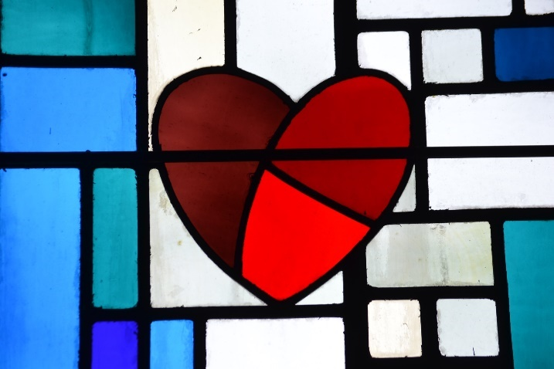

Name: ________________________________________
Materials Included in Packet
Overview…………………………………………………………………………………………3
2024 Lenten Schedule……………………………………………………………………….......5
Standards……………………………………………………………………………………......7
Pacing Guide……………………………………………………………………………………11
Activities………………………………………………………………………………………...15
Week 1…………………………………………………………………………………..15
Grade 7……………………………………………………………………….....15
Grade 8………………………………………………………………………….17
Grade 9……...…………………………………………………………………..19
Week 2…………………………………………………………………………………..21
Grade 7………………………………………………………………………….21
Grade 8………………………………………………………………………….23
Grade 9……...…………………………………………………………………..25
Week 3…………………………………………………………………………………..26
Grade 7………………………………………………………………………….26
Grade 8………………………………………………………………………….28
Grade 9……...…………………………………………………………………..30
Review…………………………………………………………………………………………..34

February 2024 Overview: Grades 7-9
Theme: Month of the Holy Family
Monthly Prayer/Invocation: Jesus, Son of God and Son of Mary, bless our family. Mary, Mother of Jesus and Our Mother, nourish our family with your faith and your love. Keep us close to your Son, Jesus. Joseph, foster-father to Jesus, guardian and spouse of Mary, keep our family safe. Holy Family of Nazareth, make our family one with you. May we always have God at the center of our hearts and homes until we are all one family, happy and at peace in our true home with you. Amen.
Thematic Guiding Questions, 7-9: Who is in the Holy Family? Why do we honor the entire Holy Family?
- How is each person in the Holy Family a model of God’s love to us?
- Why are they all needed to teach us about God (Jesus is God: why do you think Jesus chose to live in a family)?

Saint of the Month: St. Josephine Bakhita had a great love for God. She loved going to Eucharistic Adoration to be with Jesus. St. Josephine dealt with challenges in her life, but thanked Jesus for freeing her, for helping her through times of suffering. She was happy to be part of Christ’s family, teaching us that we are all united in Christ, and are called to love each other as brothers and sisters in His Church.
Monthly Challenge: At a family meal, offer prayer intentions for each other. Share something you love about each family member, and offer a special prayer for them. Pray together for blessings on your family from Jesus, through the intercession of Mother Mary and St. Joseph. Look at a family photo album, or a scrapbook with pictures from when you made your sacraments. Share memories and talk about how you have felt God’s presence in your lives as a family.
Overall Learning Goals: Our overall goal this month is to learn about how God’s love brings light to every part of our lives, guiding us and leading us to be more like Christ, within our family units, and as one Church family united in Jesus.
Summary of Activities: We will discover how God reveals His love to us through the lives of the Holy Family, as revealed in Sacred Scripture (the Bible) and Sacred Tradition (the sacraments), exploring how we can discern where God is calling us to use our talents out of love for Him. We will learn about communicating our love for God through activities related to prayer, sacred art and music, and reflection.
Suggested personal prayer starter: “God, you created me to know, love, and serve you.” Tell God about what your goals are. Ask Him to help you achieve them, and that His will be done in your life, because He can fulfill your dreams in ways even better than you imagined. Ask God to help you discern how He wants you to serve Him.
Additional Enrichment: Please see the enclosed Lenten calendar. You can use this to track your Lenten resolution (what you choose to practice as a sacrifice for Lent, or what you choose to add for spiritual growth in this season). Each day that you live out what you have dedicated yourself to doing for God can be colored in purple (the liturgical color for penitential seasons like Lent), and pink on Laetare Sunday, the fourth Sunday of Lent.
- Consider taking part in a Lenten reading program. Add books for the mind, heart, and soul to your Lenten practice. Some recommended reads: The Story of a Soul by St. Therese, Fulton Sheen’s Life of Christ or Seven Words of Jesus and Mary, Pope Benedict’s Jesus of Nazareth series, and Pope Benedict’s saint books, such as Holy Women, dedicated to female saints around the world. As a family, you can read a book of the Bible together, use a devotional, or focus on specific readings. Each family member can share what they learned as you talk together at mealtime.
Eucharistic Adoration is an excellent devotional practice to love and praise God. In the peace of an adoration chapel, we can come to more deeply love Christ’s Presence in the Eucharist. If you cannot attend in person, you can see a livestream of St. Maximilian Kolbe’s Adoration chapel in Poland on YouTube: https://www.youtube.com/watch?v=2W-KSOPWWBY

Lenten Calendar 2024
Sunday | Monday | Tuesday | Wednesday | Thursday | Friday | Saturday
 |  |  | February 14  Day 1  Ash Wednesday  Meatless Day | February 15  Day 2 | February 16  Day 3  Meatless Friday | February 17  Day 4
February 18  First Sunday of Lent (Little Easter)* | February 19  Day 5 | February 20  Day 6 | February 21  Day 7  Ember Day** | February 22  Day 8 | February 23  Day 9  Ember Day  Meatless Friday | February 24  Day 10  Ember Day
February 25  Second Sunday of Lent (Little Easter) | February 26  Day 11 | February 27  Day 12 | February 28  Day 13 | February 29  Day 14 | March 1  Day 15  First Friday  Meatless Friday*** | March 2  Day 16  First Saturday
March 3  Third Sunday of Lent (Little Easter) | March 4  Day 17 | March 5  Day 18 | March 6  Day 19 | March 7  Day 20 | March 8  Day 21  Meatless Friday**** | March 9  Day 22
March 10  Fourth Sunday of Lent,  Laetare Sunday  (Little Easter) * | March 11  Day 23 | March 12  Day 24 | March 13  Day 25 | March 14  Day 26 | March 15  Day 27  Meatless Friday | March 16  Day 28
March 17  Fifth Sunday of Lent,  Passion Sunday (Little Easter) | March 18  Day 29 | March 19  Day 30 | March 20  Day 31 | March 21  Day 32 | March 22  Day 33  Meatless Friday | March 23  Day 34
March 24  Sixth Sunday of Lent,  Palm Sunday (Little Easter) | March 25  Day 35 | March 26  Day 36 | March 27  Day 37 | March 28  Day 38  Holy Thursday | March 29  Day 39  Good Friday  Meatless Friday | March 30  Day 40  Holy Saturday
March 31
Easter Sunday

*Sundays: Little Easters; Lenten fast lifted. Therefore, these are not counted as part of the 40 days of Lent. The full Lenten fast ends on Easter Sunday, March 31 this year
**Though no longer required by the Church in the new rite/liturgical calendar, Ember Days were traditionally penitential days of fasting and abstinence from meat (partial on the Wednesday and Saturday Ember Days), which continue to be observed by a number of Catholics today. Ember Days take place during the spring, summer, fall, and winter. Spring Ember Days are those on the Wednesday, Friday, and Saturday after the First Sunday of Lent. Since the First Sunday of Lent falls on February 18 this year, the Spring Ember Days are February 21, 23, and 24. These are excellent days to go to Confession and make reparations
***First Fridays during each month are dedicated to the Sacred Heart. It is traditionally a day to go to Mass and ask for reparations, praying for God’s mercy
****Ash Wednesday and all Fridays in Lent are meatless. Some Catholics choose to abstain from meat on Fridays year-round, not only during Lent, in observance of the day that Jesus died (a Friday, the day we commemorate on Good Friday, March 29 this year)
*Laetare Sunday: pink vestments are worn as a celebration of joy. “Laetare,” meaning “rejoice,” comes from the first word of the Latin Introit (the first Proper, or changing reading, of the Mass said on this day), chanted when the priest approaches the altar at the beginning of the Mass

Standards
Grade Level | Week | Activities | Learning Standards
Grade 7 | 1 | “Love of the Sacred Heart of Jesus” | 7.9 We can learn more about Church history and how our faith has been transmitted across the times through reading and researching more about the Church. Reading official documents like papal encyclicals (letters from popes, available on the Vatican website), can give us insight into how the Church has responded into the needs of the times, while reaffirming Catholic teachings.
Grade 7 | 2 | “The Heart of Lent” | 7.5 Art and architecture call our attention to God, witnessing to His glory, and serving as a form of revelation. Looking at art and architecture, our faith can be reignited.
Grade 7 | 3 | “Lenten Reflection Journal: New Life in Christ” | 7.2 There are seven deadly sins: pride, greed, lust, anger, gluttony, envy, and sloth.  7.3 There are seven “contrary virtues” counteracting the seven deadly sins: humility, liberality, chastity, meekness, temperance, brotherly love, and diligence.
Grade 8 | 1 | “God’s Love at Candlemas & Lent” | 8.3 Mary’s “yes” to God is known as the “fiat.” Her openness to God’s plan for her (“Be it done to me according to Your Word”) is an example of strong faith in God. The fiat foreshadowed Jesus’ own willingness to fulfill the Father’s plan for Him (“Thy will be done”).  8.8 The Rosary shows us the sacraments’ layers of meaning by commemorating the events of Jesus’ and Mary’s lives, helping us to better understand their roles in salvation history. The Joyful Mysteries are the Annunciation, the Visitation, the Nativity, the Presentation at the Temple, and the Finding at the Temple.
Grade 8 | 2 | “‘Feast and Fast’ Lenten Reflection Journal” | 8.6 Sacraments, and the infinite graces flowing from them, are free gifts from God that must be freely accepted. God is personal and loving, giving us free will as an extension of His love… Praying the Act of Faith, Act of Hope, and Act of Love before and after receiving Communion can help us to open our hearts more fully to God, to prayerfully welcome His graces.
Grade 8 | 3 | “God’s Love on Ash Wednesday” | 8.5 We rely on Sacred Scripture and Sacred Tradition to help us know and follow Christ.
Grade 9 | 1 | “God’s Perfect Love” | 9.8 Jesus instituted seven sacraments that align with major life stages… The liturgical seasons are also representative of Christ’s life cycle of dying and rising, following two overlapping calendars: the Sanctoral and Temporal Cycles. While the Sanctoral Cycle tends towards set, unchanging dates for feast days of saints (that aren’t necessarily closely connected to the liturgical season), the Temporal Cycle is more likely to have moveable (changing) feast dates, because they are connected to the seasons tracing the rhythms of Christ’s life on Earth.
Grade 9 | 2 | “Love and Christ’s Sacrifice” | 9.4 Christ has achieved our salvation objectively, but to be saved subjectively, we must live out a life of faith and good works, in accordance with the Gospels, using our free will to follow Christ, recognizing Him as our Savior.  9.10 God has a special plan for each person, a distinct purpose He created them for, which the Gifts of the Holy Spirit give us the clarity to discern. We are all called to love, which is ultimately how we all can serve God, though we all live out this vocation in a unique way.
Grade 9 | 3 | “Valentine for a Saint” | 9.6 The saints are models of the good life, a life emulating Christ… In preparing for Confirmation, choosing a saint name to be called by at Confirmation forges a new identity in Christ, speaking to who we aspire to become in the future… In learning about the life of the saint, we can learn to witness to Christ as they did, harnessing our talents, and faithfully practicing the Faith…

February 2024 Pacing Guide (Suggested Schedule)
Grades 7-9
Week Number/Date | Grade Level | Activities
Week 1  (February 5, 2024 – February 9, 2024) | Grade 7 | “Love of the Sacred Heart of Jesus”
Week 1  (February 5, 2024 – February 9, 2024) | Grade 8 | “God’s Love at Candlemas & Lent”
Week 1  (February 5, 2024 – February 9, 2024) | Grade 9 | “God’s Perfect Love”
Week 2  (February 12, 2024 – February 16, 2024) | Grade 7 | “The Heart of Lent”
Week 2  (February 12, 2024 – February 16, 2024) | Grade 8 | “‘Feast and Fast’ Lenten Reflection Journal”
Week 2  (February 12, 2024 – February 16, 2024) | Grade 9 | “Love and Christ’s Sacrifice”
Week 3  (February 19, 2024 – February 23, 2024) | Grade 7 | “Lenten Reflection Journal: New Life in Christ”
Week 3  (February 19, 2024 – February 23, 2024) | Grade 8 | “God’s Love on Ash Wednesday”
Week 3  (February 19, 2024 – February 23, 2024) | Grade 9 | “Valentine for a Saint”

Week Number/Date | Grade Level | Words to Practice | Definitions
Week 1  (February 5, 2024 – February 9, 2024) | Grade 7 | Encyclical | A letter written by the pope and sent to all of the bishops in the Church.
Week 1  (February 5, 2024 – February 9, 2024) | Grade 8 | Omniscient | All-knowing. God is omniscient.
Week 1  (February 5, 2024 – February 9, 2024) | Grade 9 | Dignity | The value of human beings. Every human being was made by God, in His image. This means we were made like Him, with good qualities, that make us special. Every person has dignity, inherent value, for being made and loved by God. To treat someone with dignity means to treat them with respect, compassion, and kindness, recognizing that they are God’s creation.
Week 2  (February 12, 2024 – February 16, 2024) | Grade 7 | Contrary Virtues | Virtues, holy qualities, that are the opposites of the deadly sins: humility, liberality, chastity, meekness, temperance, brotherly love, and diligence. These bring us closer to God, helping us to do good works.
Week 2  (February 12, 2024 – February 16, 2024) | Grade 8 | Omnipresent | All-present; everywhere, all the time. God is omnipresent.
Week 2  (February 12, 2024 – February 16, 2024) | Grade 9 | Repentance | Expression of sorrow for sins committed. To “repent” is to ask God for forgiveness, to want to make up for wrongdoing with good works, and resolve to do better in the future.
Week 3  (February 19, 2024 – February 23, 2024) | Grade 7 | 7 Deadly Sins | Sloth, gluttony, wrath, greed, envy, lust, and pride. These sins cause great danger to the soul, bringing about a spiritual death, a distancing from God, needing to be healed by Confession. Closeness to God allows for life, because the soul is nourished by grace.
Week 3  (February 19, 2024 – February 23, 2024) | Grade 8 | Salvation history | God’s saving action throughout history. The events leading to our salvation.
Week 3  (February 19, 2024 – February 23, 2024) | Grade 9 | Evangelization | Sharing the good news. Spreading the word of God.

Week Number/Date | Grade Level | Prayers to Practice | Text of Prayers
Week 1  (February 5, 2024 – February 9, 2024) | Grade 7 | Act of Love (Prayer Before Communion) | O my God, I love you above all things, with my whole heart and soul, because you are all good and worthy of all my love. I love my neighbor as myself for the love of you. I forgive all who have injured me and I ask pardon of all whom I have injured.
Week 1  (February 5, 2024 – February 9, 2024) | Grade 8 | Act of Love (Prayer Before Communion) | O my God, I love you above all things, with my whole heart and soul, because you are all good and worthy of all my love. I love my neighbor as myself for the love of you. I forgive all who have injured me and I ask pardon of all whom I have injured.
Week 1  (February 5, 2024 – February 9, 2024) | Grade 9 | Act of Love (Prayer Before Communion) | O my God, I love you above all things, with my whole heart and soul, because you are all good and worthy of all my love. I love my neighbor as myself for the love of you. I forgive all who have injured me and I ask pardon of all whom I have injured.
Week 2  (February 12, 2024 – February 16, 2024) | Grade 7 | Act of Love (Prayer Before Communion) | O my God, I love you above all things, with my whole heart and soul, because you are all good and worthy of all my love. I love my neighbor as myself for the love of you. I forgive all who have injured me and I ask pardon of all whom I have injured.
Week 2  (February 12, 2024 – February 16, 2024) | Grade 8 | Act of Love (Prayer Before Communion) | O my God, I love you above all things, with my whole heart and soul, because you are all good and worthy of all my love. I love my neighbor as myself for the love of you. I forgive all who have injured me and I ask pardon of all whom I have injured.
Week 2  (February 12, 2024 – February 16, 2024) | Grade 9 | Act of Love (Prayer Before Communion) | O my God, I love you above all things, with my whole heart and soul, because you are all good and worthy of all my love. I love my neighbor as myself for the love of you. I forgive all who have injured me and I ask pardon of all whom I have injured.
Week 3  (February 19, 2024 – February 23, 2024) | Grade 7 | Act of Love (Prayer Before Communion) | O my God, I love you above all things, with my whole heart and soul, because you are all good and worthy of all my love. I love my neighbor as myself for the love of you. I forgive all who have injured me and I ask pardon of all whom I have injured.
Week 3  (February 19, 2024 – February 23, 2024) | Grade 8 | Act of Love (Prayer Before Communion) | O my God, I love you above all things, with my whole heart and soul, because you are all good and worthy of all my love. I love my neighbor as myself for the love of you. I forgive all who have injured me and I ask pardon of all whom I have injured.
Week 3  (February 19, 2024 – February 23, 2024) | Grade 9 | Act of Love (Prayer Before Communion) | O my God, I love you above all things, with my whole heart and soul, because you are all good and worthy of all my love. I love my neighbor as myself for the love of you. I forgive all who have injured me and I ask pardon of all whom I have injured.

February 2024 7-9 Activities
Week 1
Grade 7- “Love of the Sacred Heart of Jesus”
At the beginning of February, we celebrate two special occasions in the Church. First, February 2 is Candlemas, the day we remember when Mary and Joseph brought Jesus to be presented to God the Father at the temple, 40 days after Jesus was born. This day is also known as the “Purification of Mary.” On Candlemas, candles are blessed. The light from candles represents the purity and truth of God. God is the light that we follow, just as the Holy Family obediently followed Him. Ending the Christmas season with Candlemas, we follow the light into Lent.
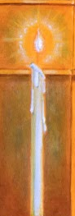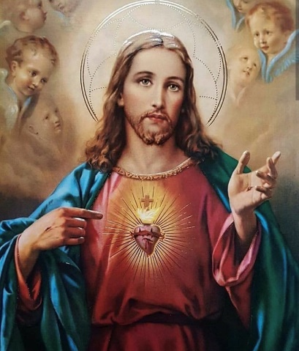
February 2 is also the First Friday of the month. On the First Friday of every month, we honor the Sacred Heart of Jesus, making reparations, which means we ask for forgiveness, and make up for sins (Friday was the day that Jesus died on the Cross). First Fridays can be observed with prayer, and by going to Mass. Our Lord, Jesus, told St. Margaret Mary Alacoque, who increased Catholic devotion to the Sacred Heart around the world, that people who honored the Sacred Heart would be blessed. He made 12 promises about the graces and peace people would be given from loving the Sacred Heart, such as that homes with images of the Sacred Heart would be blessed. Looking at an image of the Sacred Heart, we see the crown of thorns around Jesus’ Heart, remembering the Sacrifice He made on the Cross out of love for us, which we recall not only in the 40 days of Lent, but at every Mass.
St. Margaret Mary Alacoque showed her love for God by sharing what Jesus told her, teaching about the Sacred Heart. She followed Christ’s light, leading others to do the same, knowing that when we come to the Sacred Heart of Jesus, we find the greatest love: the love of God.
- When Jesus was presented at the Temple, he was visited by a man named Simeon, who waited his whole life to see the Messiah, the Savior. Listen to Nunc Dimittis, a Latin hymn (Gregorian chant), also called “The Song of Simeon,” here: https://m.youtube.com/watch?v=GrDTzQtfvwk. You can read the lyrics in English here: https://hymnary.org/text/now_may_your_servant_lord. How do you think this song, and sacred music in general, expresses love for God? How does it relate to the light of Candlemas?
__________________________________________________________________________________________________________________________________________________________________________________________________________________________________________
- In February, we see heart decorations celebrating Valentine’s Day. Why do you think Jesus’ Sacred Heart is the ultimate symbol of love?
__________________________________________________________________________________________________________________________________________________________________________________________________________________________________________
- Look at a papal encyclical, a letter to bishops around the world from the pope, on the topic of the Sacred Heart. Read section 12 (the number next to the paragraph) of “Miserentissimus Redemptor” (“Most Merciful Redeemer/Savior”) by Pope Pius XI, published in 1928, about reparations to the Sacred Heart. You can access the encyclical here: (link: https://www.vatican.va/content/pius-xi/en/encyclicals/documents/hf_p-xi_enc_19280508_miserentissimus-redemptor.html)
Why is it important to make reparations to the Sacred Heart? What is one way this can be done? How can you honor the Sacred Heart (think of Simeon and St. Margaret Mary Alacoque as examples of love for God)?
________________________________________________________________________________________________________________________________________________________________________________________________________________________________________________________________________________________________________________________

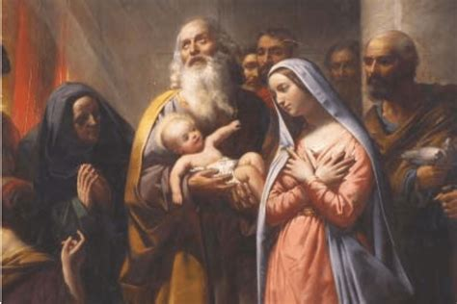

Grade 8- “God’s Love at Candlemas & Lent”

This year, Lent will begin on February 14. Lent is a time of purification. We work on learning more about God, and growing in His love, cleansing our hearts of sin, so that we can bring the light in. February 2 is Candlemas, also known as the Purification and the Presentation of Christ at the Temple. This day marks the end of the Christmas season, and the start of preparations for Lent. Candlemas is a day of light. We remember the light of God that leads us on the path to Heaven, guiding us to do good things out of love. Candles are blessed, and we think of the pure hearts of the Holy Family, when Joseph and Mary brought Jesus to be presented before God at the temple. Mary’s love for God brought Her peace and harmony as She presented Jesus to God the Father, just as He would offer Himself up on the Cross, which we remember during Lent.
In the Bible, 40 is the number that represents purification. All of the numbers in the Bible are symbolic: they have meaning. The Purification (Presentation at the Temple, Candlemas) is celebrated 40 days after Christmas. Jesus was in the desert, when He battled Satan’s temptations, for 40 days, which is why Lent is 40 days. During the 40 days of Lent, we focus on purifying ourselves by becoming closer to God.
God is love, so His plan is perfect, because He does everything out of love for us, to purify us. Our souls become perfected in this way. Because God is omniscient, knowing everything, He knows what we need to become holier. Looking at sacred art, we see harmony and balance that reflects how God’s plan brings everything together for our good.
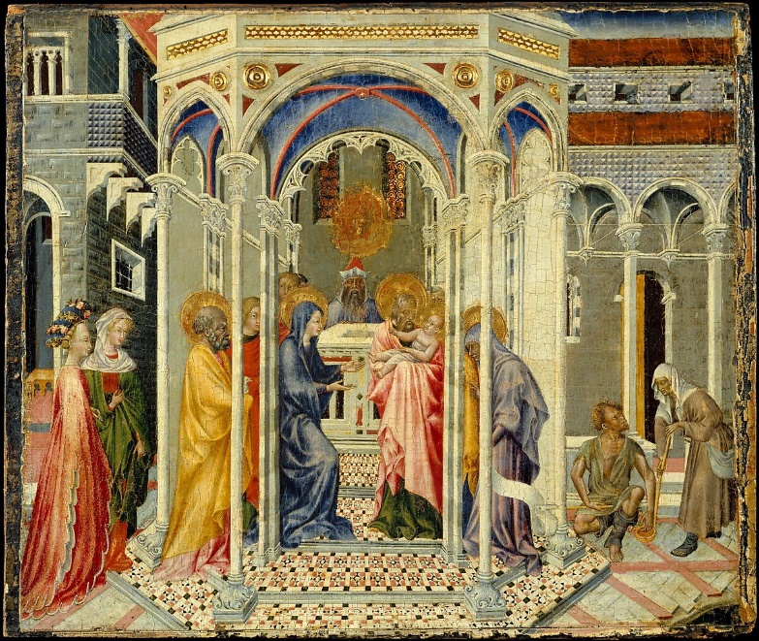
The Presentation of Christ in the Temple (1435) by Giovanni di Paolo
“God’s Love at Candlemas & Lent” Continued
- Painters plan their paintings carefully, grouping figures in balanced numbers. They plan how to arrange their work so that you will notice what they want you to see first, the center, or focus, of the painting. Renaissance painters like di Paolo were particularly focused on creating harmony and balance in their paintings. Look closely at the colors, shapes, patterns, and groupings of numbers in The Presentation of Christ in the Temple by Giovanni di Paolo. How do you think this painting represents the harmony and balance God brings? What do you notice about it that honors God?
________________________________________________________________________________________________________________________________________________________________________________________________________________________________________________________________________________________________________________________
- How is Lent an important time for us to live out God’s special plan for us? What can you do to share your talents to honor God during Lent; what can you offer up to God in this season to grow in His love?
________________________________________________________________________________________________________________________________________________________________________________________________________________________________________________________________________________________________________________________
- How are Candlemas and Lent linked? How do you think the connections between holy days/seasons throughout the liturgical year show God’s perfect omniscience, His wisdom?
______________________________________________________________________________________________________________________________________________________________________________________________________________________________________________________________________________________________________________________________________________________________________________________________________
- How do you think the Bible (Sacred Scripture) and the sacraments (Sacred Tradition) reflect God’s love, and how can you more deeply engage with Sacred Scripture and Tradition in the season of Lent?
______________________________________________________________________________________________________________________________________________________________________________________________________________________________________________________________________________________________________________________________________________________________________________________________________

Grade 9- “God’s Perfect Love”
The sacraments are signs of God’s love for us. God is love. He is perfect, because of His pure love. Because He loves us, God brings everything together for our good, to help us. In God, there is harmony and order. In sacred art, we see a reflection of the harmony and balance God brings. The artists of the Renaissance particularly valued symmetry, a strong sense of balance, in their work, using their skill in geometry to create extremely precise paintings. They thoughtfully grouped numbers of figures, colors, patterns, and shapes together. In the Bible, numbers are symbolic. Special meanings are associated with each number, such as the number 7, which represents completion and perfection. There are 7 Gifts of the Holy Spirit, which we receive at Confirmation. In total, there are 7 sacraments. God created the world in 7 days. With God, everything has a purpose. He has factored everything into His perfect plan.
One of the Gifts of the Holy Spirit is piety. Piety is considered to be the order of the soul, when all is right in our soul, and there is peace. The liturgical year, our Church’s calendar of feast days and seasons, is ordered harmoniously, so that all of the seasons and feast days within them complement, or balance, each other. Just as there is rhythm in music, and in paintings, there is a rhythm to the Church year that helps us to grow in holiness and express our love for God year-round. The cycle of seasons repeats, never ending, but following the pattern of Christ’s dying and rising. At Advent, we remember Christ being born, and at Lent, we remember His dying, but in the sacraments, we always have new life in Christ. When we receive the Eucharist, we receive Christ’s resurrected Body. Learning about Christ’s life throughout the year, we model our own lives after His, working towards Heaven, where our own souls can live forever.
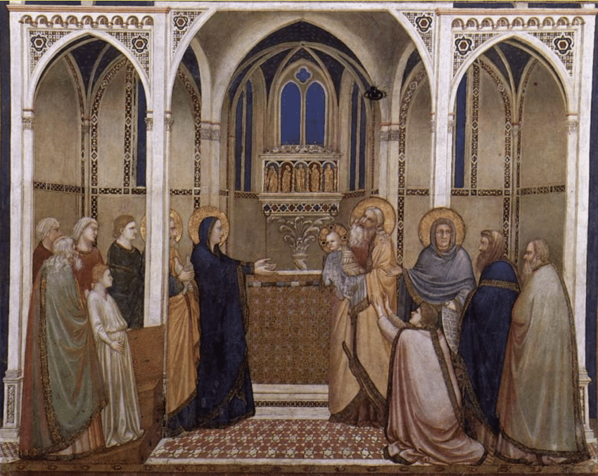
Presentation of Christ in the Temple (1311-1320) by Giotto
- How do you think Giotto’s painting Presentation of Christ in the Temple reflects God’s harmony and balance?
__________________________________________________________________________________________________________________________________________________________________________________________________________________________________________

- How do the sacraments help us to grow in piety- how can they bring order and harmony to the soul?
__________________________________________________________________________________________________________________________________________________________________________________________________________________________________________
- How do you think the Gifts of the Holy Spirit complement each other? Why do you think we need a balance of all of them to continue growing in holiness and living good lives?
__________________________________________________________________________________________________________________________________________________________________________________________________________________________________________
- Why do you think the number 5, the number of Christ’s wounds at the Crucifixion, is symbolic of love? How does this relate to Lent?
__________________________________________________________________________________________________________________________________________________________________________________________________________________________________________
- God calls us to love each other. He made us all with dignity, value. We have dignity, because we were made in God’s image- made with qualities like God, gifts like intelligence, the ability to reason. How can living out love for God, sharing God’s love with others and affirming their dignity, bring harmony? How can you affirm the dignity of others?
__________________________________________________________________________________________________________________________________________________________________________________________________________________________________________

Week 2
Grade 7- “The Heart of Lent”
On February 14 this year, we will begin the season of Lent, a penitential season. We repent of sins, telling God we are sorry for when we have not followed His Commandments, asking for His forgiveness, and going forward with a spirit of hope as we do good things out of love for God, making up for past sin. This is why it is especially important to go to Confession during Lent, when we are absolved (forgiven) of our sins.
The 7 Deadly Sins are so serious, that they are deadly for our souls. Pride, one of the 7 deadly sins, is the sin that led Adam and Eve to disobey God. Sin keeps us away from God, and we need God for life, so when we stay away from sin, we are kept close to God, receiving new life in Him through the sacraments. God’s love, which we experience in the sacraments throughout the year, keeps us strong. The love at the heart of Jesus’ Sacrifice is our focus in this season, which helps us to overcome the challenges of our sacrifices, so that when we give something up for God, we gain so much more. Doing all things in love for God brings us peace and harmony.
Being humble helps us to stay close to God, and away from sin. Humility comes from strength and love, which we can grow in as we receive God’s graces from the sacraments. Making sacrifices during Lent keeps us humble, as we honor Jesus for His Sacrifice for us on the Cross, and rely on God to help us grow stronger. Jesus and Mother Mary had no sins: their hearts were pure, so they had the greatest love for God the Father.
In February, there are two special feast days celebrating Mother Mary: the Purification, also known as the Presentation at the Temple (Candlemas, Feb. 2- when Mary and Joseph brought Jesus to be presented to God at the temple), and Our Lady of Lourdes (Feb. 11). The holy water from where Mary appeared in Lourdes, France, still miraculously cures people. Lent is an excellent time to call on Mary and follow Her example of obedience to God, Her “yes” to His plan to use Her gifts for Him, and dedicate Her Heart to Him. Mother Mary can help the love for God in our hearts to grow, keeping us open to hope for God’s amazing plans for us to become who He calls us to be, at Lent and always.
- God heals, giving us what we need to be strong. How do you think Lent is a season of healing and purification? How can the sacraments help us during Lent?
__________________________________________________________________________________________________________________________________________________________________________________________________________________________________________
- Why is Mother Mary the greatest example of humility and purity of heart? How can you call on Mary to help you in this season?
__________________________________________________________________________________________________________________________________________________________________________________________________________________________________________
- The lives of Jesus and Mary thread the liturgical year together. In every season, we see their impact. How do you think Advent and Lent are connected?
________________________________________________________________________________________________________________________________________________________________________________________________________________________________________________________________________________________________________________________
- Artists carefully choose and arrange colors and shapes in patterns, thinking about how everything relates. Math is essential to art as artists plan numbers of figures to group, and how to balance all that they want to include in their art. God unites all things, bringing harmony to our lives. He can bring together all things, because He is perfect; God is perfect, because He is love. Look at the painting Presentation at the Temple by Ambrogio Lorenzetti. How does this painting capture the harmony and balance God brings?
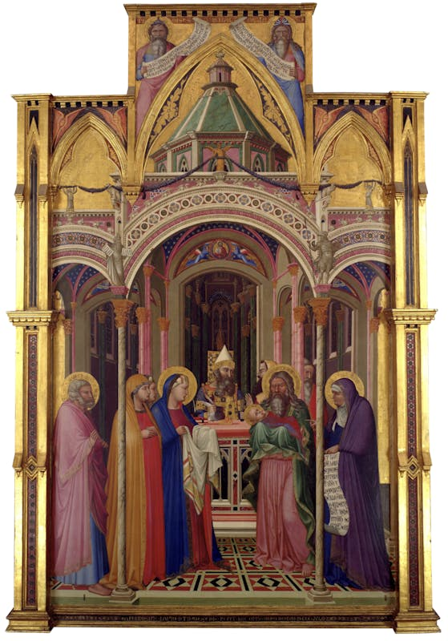
Presentation at the Temple (1342) by Ambrogio Lorenzetti
________________________________________________________________________________________________________________________________________________________________________________________________________________________________________________________________________________________________________________________

Grade 8- “Feast & Fast” Lenten Reflection Journal
Lent is a penitential season, meaning we ask for God’s forgiveness. We remember Jesus dying for our sins, offering Himself up for us. Through His Sacrifice, He opened the gates of Heaven to us, creating the opportunity for us to one day share in the glory of eternal life in paradise with Him. Since we make our own sacrifices to honor Jesus during Lent, such as abstaining from meat on Fridays, we might think of Lent as mostly a season of fasting. In the past, Catholics would not eat meat on any Fridays during the year, since Friday is the day Jesus died. During Lent, traditional Catholics would abstain from butter, eggs, and cheese, in addition to meat.
However, Lent is not about what we don’t have, but about what we do have. We have God’s great love to fill our hearts. God carries us through. He is omnipresent- with us always, everywhere, to help us. We can “feast” on His graces by receiving the sacrament of Confession, which purifies our hearts, clearing away sins. This leaves room in our hearts to receive His love, and to share it. Aside from fasting from foods like meat, we can fast from what doesn’t bring us closer to God, “feasting” on what does: praying more, helping others by giving our time, sharing our talents, and letting God’s love guide all we do.
The sacraments we receive give us the strength we need. The Mass is not only a feast, a heavenly banquet where we experience God’s Presence in the Eucharist, but a commemoration of Christ’s Sacrifice. Before Mass, not only during Lent, we fast (at least one hour prior). Love is at heart of every sacrifice: Jesus’ sacrifice, and everything we do out of love for Him and those around us. During Lent, if we have an abundance mindset, where we focus on what God has blessed us with, we can continue to grow in love.
- Lent is 40 days, the number of days Jesus spent in the desert. While in the desert, Jesus battled Satan, who tried to tempt Jesus to lose trust in God, His Father. Jesus quoted the Bible to call out Satan’s lies and resist temptation. How can Sacred Scripture (the Bible) and Sacred Tradition (the sacraments) help us in making Lenten sacrifices?
- How is Lent both a fast and a feast?
- What is Pre-Lent? What are some past traditions people in the Church participated in during Pre-Lent, and how have these changed now? You can research additional information on Lenten traditions and the liturgical year on CatholicCulture.org.
- How can you integrate prayer, fasting, and giving into your life during Lent?
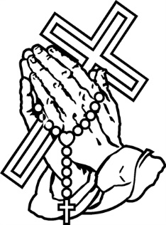
PRAY FAST GIVE

Grade 8- “Feast & Fast” Lenten Journal continued
Reflect on the questions from the previous page in your journal.


__________________________________________________________________________________________________________________________________________________________________________________________________________________________________________________________________________________________________________________________________________________________________________________________________________________________________________________________________________________________________________________________________________________________________________________________________________________________________________________________________________________________________________________________________________________________________________________________________________________________________________________________________________________________________________________________________________________________________________________________________________________________________________________________________________________________________________________________________________________________________________________________________________________________________________________________________________________________________________________________________________________________________________________________________________________________________________________________________________________________________________________________________________________________________________________________________________________________________________________________________________________________________________________________________________________________________________________________________________________________________________________________________________________________________________________________________________________________________________________________
Grade 9- “Love and Christ’s Sacrifice”
As a penitential season, Lent is a time of repentance, a time to tell God we are sorry for our sins, and ask for His forgiveness. We can repent by making sacrifices, and offering up challenges we face to God. When we go to Confession, we can better identify what leads us to sin, and recognize what we can change in the future. Then, we know what goals we can work on during Lent. Traditionally, in the Church, Lent was a time to prepare for Baptism. Adults would be baptized in the Faith on Easter. Their knowledge of the Church’s teachings was tested during Lent, which they observed by studying and learning.
Using Lent as a time to learn, we, too, can discern what God is calling us to do with our lives out of love for Him. God gave each of us the gift of life out of love. At Lent, we remember that Christ offered up His life to save us all: this is called “universal salvation,” salvation for everyone. Jesus opened the door to Heaven, and through doing good things to honor God, we can take steps to get there, to one day walk through that door. At Lent, the fast helps us to focus on what matters most. Clearing away things we don’t need, removing distraction, we can better focus on how God is asking us to follow Him as disciples, students. Ultimately, we can honor Christ during Lent by sharing our time and talents with others. Lent is about Christ’s love for us, and we can reflect our love for Him through honoring the gifts of others.
- How can the sacraments of Confession and Communion prepare you for Confirmation? What do they reveal to you about Christ’s love and Sacrifice?
____________________________________________________________________________________________________________________________________________________________
- How do you think Lent provides opportunities for you to grow spiritually?
__________________________________________________________________________________________________________________________________________________________________________________________________________________________________________
- One prayer practice you can start now, and use during Lent, is the daily examen. St. Ignatius’s daily examen is similar to an examination of conscience before Confession, where you can look back at your actions and think about your relationship with God.
- At the end of the day, take a moment to pause and be still. Go through the events of the day in your mind, thanking God for the blessings He gave you.
- Reflect on the things that brought you closer to God during the day, remembering where you saw His presence
- Ask the Holy Spirit to help you become closer to God tomorrow, taking the steps you need to follow Him. You can end your examen by praying an “Our Father.”
How did praying the examen give you a new perspective? During Lent, how can you call on the Holy Spirit, our advocate, to help you?
____________________________________________________________________________________________________________________________________________________________
Week 3
Grade 7- “Lenten Reflection Journal: New Life in Christ”
Contrary virtues are virtues that are the opposites of the 7 deadly sins. Humility (humbleness), for example, is the opposite of pride. Vices are things that lead people to sin, but virtues lead us away from sin, closer to God. Practicing virtues helps us to avoid sin. If we focus on doing what is good, being humble and kind, for instance, we can avoid being prideful. Rather than thinking about Lent in terms of giving something up, we can think of what we gain in following Christ, focusing on how we can use the 40 days of Lent to grow in virtue, the good qualities that help us to be loving like Christ. Lent is a fresh start.
We grow through the love of God. As long as we continue to pray and devote what we do to God, we can keep growing. God’s love is at the center of our year in the Church, linking together all of the seasons. Lent is about letting light in, just like Advent. At Christmas, we celebrate Jesus’ birth. Easter is about rebirth. Lent is like the springtime of the Church. In the weeks leading up to Easter, we remember the events leading to Christ’s Sacrifice on the Cross, and on Easter Sunday, we celebrate Christ’s Resurrection, when He triumphed over death, rising again.
Charity, or love, is the greatest of all of the theological virtues, virtues that come from God, because it allows us to practice all of the other virtues. Everything good stems from God’s love. If we do everything in love, the rest will follow, and sins fall away. God’s plan falls into place.
In your journal on the next page, reflect on these questions:
- Why is Lent like springtime in the Church?
- How does focusing on practicing virtues help us to see Lent differently?
- How can we bring what we learn during Lent to celebrating God’s love year-round?
- What symbol(s) would you use to represent the spirit of Lent, what Lent is truly about? (You may draw your ideas in the box.) Why?

Grade 7- “Lenten Reflection Journal: New Life in Christ” continued


______________________________________________________________________________________________________________________________________________________________________________________________________________________________________________________________________________________________________________________________________________________________________________________________________________________________________________________________________________________________________________________________________________________________________________________________________________________________________________________________________________________________________________________________________________________________________________________________________________________________________________________________________________________________________________________________________________________________________________________________________________________________________________________________________________________________________________________________________________________________________________

Grade 8- “God’s Love on Ash Wednesday”
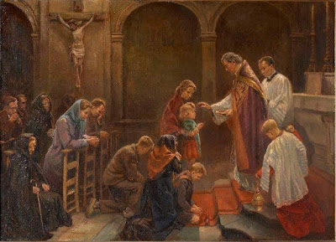
When we observed Ash Wednesday on February 14, we began the season of Lent. It is appropriate that we start Lent by remembering the creation story. As the priest makes the Sign of the Cross with ashes on our foreheads, he says a blessing that comes from Genesis 3:19: “Remember, man, you are dust, and unto dust you shall return.” We are reminded that God created us out of love, and that we need Him. We represent this Scriptural understanding by wearing ashes, a sign of humility and repentance. We show our trust in God to help us, and at the Mass, receive the Eucharist, a sacrament that is a beautiful sign of God’s love for us, as He provides us spiritual food we need for new life in the form of Christ’s Body. At every Mass, we experience all of salvation history, remembering Jesus’ life, thinking of the life to come, and using our lives now to love Him and take steps towards Heaven.
The reading from Genesis circles back to the story of the Fall, of Adam and Eve bringing suffering into the world by eating the forbidden fruit, believing the lies of Satan instead of obeying God. It is because of the Fall, and the state of sin inherited by our first parents, that we needed Jesus to save us. At Lent, we repent of our sins, honoring Jesus’ Sacrifice by offering up our own sacrifices out of love for Him. Jesus and Mary, the New Adam and New Eve, brought hope into the world, restoring balance and healing our relationship with God through their obedience to Him. Rather than taking, they gave.
Jesus suffered to spare us from greater suffering. The body may die and become dust, but through Christ, the soul lives forever. The word “human” comes from the word for “humus,” a layer of the earth, to emphasize that humans are earthly beings. But we are called for more, called to follow God, who can never turn to dust. Earthly things are temporary, but if we “store up treasures in Heaven,” doing all we can for Jesus, we will have a lasting legacy, because we will be helping to build up God’s kingdom, which is eternal.
- What does the Ash Wednesday blessing from Genesis mean?
____________________________________________________________________________________________________________________________________________________________
- Why is it important to keep our focus on the eternal, on what comes from God?
____________________________________________________________________________________________________________________________________________________________
- Read 1 Corinthians 13:4-7 (https://bible.usccb.org/bible/1corinthians/13). How does this description of true charity (love) represent Jesus; what Bible story/event from Jesus’ life shows how He lived this out?
__________________________________________________________________________________________________________________________________________________________________________________________________________________________________________
- In this upcoming season of Lent, what can you do to become closer to Jesus and Mary, the New Adam and New Eve, to practice charity and “store up treasures in Heaven”?
__________________________________________________________________________________________________________________________________________________________________________________________________________________________________________
- Listen to When Jesus was presented at the Temple, he was visited by a man named Simeon, who waited his whole life to see the Messiah, the Savior. Listen to Nunc Dimittis, a Latin hymn (Gregorian chant), also called “The Song of Simeon,” here: https://m.youtube.com/watch?v=GrDTzQtfvwk. You can read the lyrics in English here: https://hymnary.org/text/now_may_your_servant_lord. How do you think this song expresses love for God, especially as described in 1 Corinthians 13:4-7?
__________________________________________________________________________________________________________________________________________________________________________________________________________________________________________

Grade 9- “Valentine for a Saint”
On February 14, we celebrated the feast of St. Valentine, the patron saint of love. Though St. Valentine may be the patron saint of love, all of the saints lived out their love for God. One of the ways they did this was through evangelization. They spread the good news, telling others about God’s love, and showing them God’s love through acts of kindness. The saints became saints, going to Heaven, because of their great love for God, and for the people He gave them to serve. We are all saints in the making, and can learn from the lives of the saints how to love each other as God has called us to do.
When Lent started on February 14 this year, Ash Wednesday, the priest made the Sign of the Cross with ashes on our foreheads. Ashes are a sign of repentance in the Old Testament of the Bible. Wearing ashes is a way to express that we are sorry for our sins, and want to turn away from sin to love God more in the future. Doing good things for God is a starting point. But what we do on the outside is just one part of our path to becoming closer to God. It’s important to look inside, too, thinking about where our hearts are leading us, and making sure that what we do is out of love for God. God knows what is in our hearts. A heart of love will always be blessed.
Make a valentine dedicated to your favorite saint. This can be the saint you have chosen for Confirmation, or one you are considering choosing. You can draw scenes from their life, symbols of their patronage (images that are associated with their ministry or virtuous qualities, like lilies for St. Joseph’s purity of heart), and write words you associate with the saint (such as a Gift of the Holy Spirit they represent- fortitude, wisdom, etc.).

Grade 9- “Valentine for a Saint” Continued
Choose between Option A or Option B. You may complete Option A by answering the reflection questions, or complete Option B by writing a prayer to the saint you chose.
Option A: Reflection Questions
- What do you love about the saint you chose, and why?
____________________________________________________________________________________________________________________________________________________________
- How did your saint represent God’s love in how they treated others?
____________________________________________________________________________________________________________________________________________________________
- How do you think your saint showed their love for God in their words/actions?
____________________________________________________________________________________________________________________________________________________________
- How could you be like this saint in living out God’s love?
____________________________________________________________________________________________________________________________________________________________
- When you think about the saint you’ve chosen, do you think they represent action (doing external good works), contemplation (spending time in prayer/turning thoughts to God), or both? What examples do you see of the saint’s inner holiness?
__________________________________________________________________________________________________________________________________________________________________________________________________________________________________________
Option B: Prayer Writing
Write a prayer to your saint friend, expressing what you admire about them, and how you would like for them to help you grow in your love for God. Think about the Gifts of the Holy Spirit your saint represents, and how you would like them to help you further develop these Gifts.
__________________________________________________________________________________________________________________________________________________________________________________________________________________________________________________________________________________________________________________________________________________________________________________________________________________________________________________________________________________________________________________________________________________________________

*Bonus*
Venerable Fulton J. Sheen would always write “JMJ” at the top of each page of his notes. “JMJ” stands for “Jesus, Mary, Joseph.” In this way, Fulton Sheen dedicated all his work to Jesus, Mary, and Joseph. By remembering Who he was writing for, Fulton Sheen could do his best work, with all of his words coming from his heart, and being used to honor the Holy Family. Keeping Our Lord first, Sheen allowed God to guide everything he wrote. He kept his heart open to the Holy Spirit’s inspiration, so that God would send him the right words. With your own JMJ stationary, you can devote your heart, mind, and soul to God as you write in His honor. And don’t forget to pray for the canonization of our holy friend, Fulton Sheen, who is currently on the road to sainthood!

+J M J+
______________________________________________________________________________
______________________________________________________________________________
______________________________________________________________________________
______________________________________________________________________________
______________________________________________________________________________
______________________________________________________________________________
______________________________________________________________________________
______________________________________________________________________________
______________________________________________________________________________
______________________________________________________________________________
______________________________________________________________________________
______________________________________________________________________________
______________________________________________________________________________
______________________________________________________________________________
______________________________________________________________________________
______________________________________________________________________________
______________________________________________________________________________
______________________________________________________________________________
______________________________________________________________________________
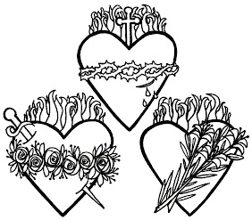
February 2024 7-9 Review
Use this review sheet as a reference to track progress and check that learning goals are met.
Recap: What did I learn?
All Grades
- God is love. He is perfect, because He is love
- God brings harmony into our lives, bringing all together for our good, out of love
- Sacred art reflects love for God, as it communicates the harmony and balance God brings
- Looking at sacred art reminds us of God’s perfect love for us
- The pure Hearts of Jesus and Mary provide examples of true love during Lent
- Sacrifices during Lent are made from love, just as Jesus gave His life for us in love
- Lent helps us to grow in love for God, as it is a season celebrating His love and mercy
- Lent is for our sanctification (growth in holiness) and purification (cleansing of the soul)
Grade 7
- First Fridays are dedicated to the Sacred Heart of Jesus, which is filled with love for us
- Candlemas marks the end of the Christmas season, but its light leads us into Lent
- The contrary virtues help us to avoid the 7 deadly sins
- Love is the greatest of the theological virtues, which come from God
- Advent and Lent are both seasons of hope. Christ is born at Advent, reborn at Lent
- Lent is a time to ask for God’s forgiveness and be healed by His mercy
- At Confession, our sins are forgiven as we come to God with humble hearts, reaching out to God with love
- Sins keep us away from God. In keeping our hearts clean through Confession, we can continue to stay close to God
- We receive new life in Christ, thanks to His Sacrifice, and His resurrected Body, which we receive in the Eucharist
Grade 8
- God is omniscient, all-knowing. He is also omnipresent- always here. His love never leaves us
- 40 is the number of purification in the Bible. Lent is 40 days for us to purify ourselves
- The liturgical calendar reflects God’s wisdom. We see how all the feast days and seasons are linked through His love
- Lent, and the Mass in general, are about both the feast and the fast. We feast on what brings us closer to God, focusing on His goodness and growing in love for Him, while fasting from what keeps us from becoming closer to Him, offering up sacrifices in love
- On Ash Wednesday, we recall the story of creation, remembering that God created us out of love, and that we need Him in our daily lives
- At Lent, and always, God calls us to pursue what is eternal, because His love is forever
Grade 9
- We see God’s perfect plan at work in how He brings everything together in harmony through the sacraments and the order of the liturgical year
- The liturgical year is a cycle of seasons that reflect Christ’s dying and rising
- God’s love is what brings all together, and gives us hope of new life
- God brings harmony, order and peace, to the soul
- Numbers in the Bible all have symbolic meanings. God’s ordering, arrangement, of these numbers shows His genius
- Lent is a time of repentance. We can repent by going to Confession and making sacrifices
- At Lent, we learn, and honor God’s love by sharing our gifts with others for Him
- The daily examen (prayer) can help us learn what we need to do to grow closer to God
- All of the saints are examples of love for God. Their love helped them get to Heaven
- The saints shared their love for God through evangelization, telling others the good news of Christ’s life and Resurrection
What vocabulary words did I practice?
Grade 7
Week 1
Encyclical
Week 2
Contrary Virtues
Week 3
7 Deadly Sins
Grade 8
Week 1
Omniscient
Week 2
Omnipotent
Week 3
Salvation history
Grade 9
Week 1
Dignity
Week 2
Repentance
Week 3
Evangelization
What prayers did I practice?
Grade 7
Act of Love (Prayer Before Communion)
Grade 8
Act of Love (Prayer Before Communion)
Grade 9
Act of Love (Prayer Before Communion)
Checklist: Activity Completion
Grade 7
Week 1: “Love of the Sacred Heart of Jesus”
Week 2: “The Heart of Lent”
Week 3: “Lenten Reflection Journal: New Life in Christ”
Grade 8
Week 1: “God’s Love at Candlemas & Lent”
Week 2: “‘Feast and Fast’ Lenten Reflection Journal”
Week 3: “God’s Love on Ash Wednesday”
Grade 9
Week 1: “God’s Perfect Love”
Week 2: “Love and Christ’s Sacrifice”
Week 3: “Valentine for a Saint”
Quick Check:
Tell us about your experience with these activities this month! Our February 2024 Google Form for Grades 7-9 is available here: https://forms.gle/LUtv36bu3FFtAicMA

