Our Lady of the Valley Religious Education

January 2024 Activity Packet

Grades 3-6

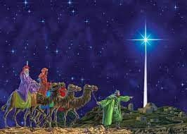
Name: ________________________________________

Materials Included in Packet
Overview…………………………………………………………………………………………3
Standards………………………………………………………………………………………...5
Pacing Guide…………………………………………………………………………………….8
Additional Resources…………………………………………………………………………...15
Activities………………………………………………………………………………………...17
Week 1…………………………………………………………………………………..17
Grade 3………………………………………………………………………….17
Grade 4………………………………………………………………………….18
Grade 5………………………………………………………………………….19
Grade 6………………………………………………………………………….22
Week 2…………………………………………………………………………………..23
Grade 3………………………………………………………………………….23
Grade 4………………………………………………………………………….25
Grade 5………………………………………………………………………….26
Grade 6………………………………………………………………………….28
Week 3…………………………………………………………………………………..30
Grade 3………………………………………………………………………….30
Grade 4………………………………………………………………………….33
Grade 5………………………………………………………………………….35
Grade 6………………………………………………………………………….36
Review…………………………………………………………………………………………..38

January 2024 Overview: Grades 3-6
Theme: Month of the Holy Name of Jesus
Monthly Prayer/Invocation: Blessed be the Most Holy Name of Jesus without end.
Thematic Guiding Questions, 3-6: Why is Jesus’ name “holy”? What does His name mean? Why do we celebrate Jesus’ name?
- What would it look like/sound like to pray to Jesus with love?
- How do we show respect for holy things, like Jesus’ Name (think about when we are in church, for example)?
Saint of the Month: St. Thomas Aquinas was a very talented scholar. He spent His life learning more about God. He used his studies to write books about God that helped people to understand how great God is, and how much God loves us. His books explained what we believe as Catholics, and how we can honor Jesus by being holy.
Monthly Challenge: Use Jesus’ Name in prayer. Pray the Litany of the Holy Name of Jesus, or listen to the litany being sung. Write Jesus’ name on a card to keep with you, saying His name as a prayer. You can keep the Jesus card under a pillow as a reminder to pray before you go to sleep, or you can put the card with a picture of Jesus above your door to remind you that He is with you.
Overall Learning Goals: On January 6, we complete the Twelve Days of Christmas with the celebration of Epiphany, when we remember the visit of the Three Kings to Baby Jesus. This month, our goal is to think about how we can bring greater peace into our hearts by following the star like the Three Kings did: following Jesus, praying in His Holy Name. We will reflect on how it helps us to continue seeking God, and growing in our faith, together, just as the Three Kings, the wisemen, searched for Christ, traveling in faith as a team of followers dedicated to loving God. The journey was far, but they were blessed for never giving up.
Summary of Activities: Our activities this month are unified around the theme of discovering peace in Jesus, especially when invoking His Holy Name. We will look at how keeping Christ as the center, the King, of our lives can help us to know Him on a deeper level and find greater peace. We will learn about how peace grows from love, with our activities focusing on how God shows His love for us, and how we can show our love for Him, looking to God when we are seeking peace. This month’s activities promote peace through prayer, sacramentals like the Rosary, liturgical devotions such as Eucharistic Adoration, reading the Bible, and reflection, including through journaling and drawing to process how God is speaking to us in our lives. Through the examples of Mother Mary, the Three Kings, and other saints, we learn about channeling the peace of Christ in our daily lives.
Enrichment Ideas: Practice prayers by praying the Rosary together. For reference, you can use the “Additional Resources” page in this packet, which lists each of the Rosary’s Mysteries, and texts for three of its prayers.
To celebrate Epiphany, the Twelfth Day of Christmas, you could introduce new traditions, such as making Epiphany cakes, or taking part in an Epiphany play at home. Another wonderful way to welcome the new year and celebrate Epiphany is to bless your home, praying for God’s blessings on all those who visit.
You can visit the Catholic Culture site for more ideas: https://www.catholicculture.org/culture/library/view.cfm?id=12020&repos=1&subrepos=0&searchid=2259868

Standards
Grade Level | Week | Activities | Learning Standards
Grade 3 | 1 | “The Wisemen and Peace” | 3.2 God is at the center of life. All of the sacraments point back to Him as the source of all love, all virtue.
Grade 3 | 2 | “Prayer Corner Design: A Place for Peace” | 3.3 Sacramentals are blessed objects that remind us of the sacraments, calling us to use them in pursuing holy lives. They help us look at the world in a “sacramental” way so that we can see God in everything.
Grade 3 | 3 | “Peace and the Rosary” | 3.4 The Rosary is an example of a sacramental. We pray it to become closer to Jesus through Mary, as we think about the Mysteries of the Rosary.
Grade 4 | 1 | “Imagining the Visit of the Magi” | 4.1 God calls us to honor Him in a variety of ways…
Grade 4 | 2 | “Prayers of Peace” | 4.8 Doing good works is an essential part of the Christian life. Christ was Himself a servant who lived to care for others…
Grade 4 | 3 | “A Recipe for Peace” | 4.2 The 10 Commandments are organized in a specific order. They remind us to put God and others before ourselves to serve as Jesus did…  calling us to love God and our neighbors as we love ourselves.  4.7 Adoration… is a powerful devotion in which we honor the Real Presence of Christ in the Eucharist, glorifying God.
Grade 5 | 1 | “Christ the King, Prince of Peace” | 5.9 Jesus triumphed over Death through the Resurrection. His miracles foreshadowed His triumph, because He showed His power over nature, sin, sickness, and death.
Grade 5 | 2 | “Peace in Jesus’ Presence” | 5.6 We use the Roman missal to help us pray the Mass.  5.7 Masses are celebrated at local churches, but when we celebrate the Mass, we are in communion with all of the Catholic faithful; we are one Church, on Earth and in Heaven… In the Mass, we see faith, hope, and charity alive. We can practice living out these virtues in how we pray the Mass, and let the spirit of Christ enter our hearts.
Grade 5 | 3 | “Prayers for the New Year” | 5.8 Sacraments such as the Eucharist are visible signs of God’s love we can encounter today.
Grade 6 | 1 | “Epiphany Reflection Journal: St. Augustine and Peace” | 6.1 Catholics throughout history have used their talents to glorify God…and make a positive impact on the world. An example is St. Augustine of Hippo (354 A.D.-430 A.D.).
Grade 6 | 2 | “Hearts of Peace” | 6.9 Mary, Mother of Jesus, has played an essential role in salvation history, guiding us with Her steadfast love, Her role as Mother that will never change.
Grade 6 | 3 | “Jesus the King: Then, Now, and Forever” | 6.7 The Old Testament tells the stories of the people who lived before Jesus. Their stories hint at His coming. Jesus’ life is the focus of the New Testament, which shows how He fulfilled the Jewish prophecies of the Old Testament.

January 2024 Pacing Guide (Suggested Schedule)
Grades 3-6
Week Number/Date | Grade Level | Activities
Week 1  (January 1, 2024 – January 5, 2024) | Grade 3 | “The Wisemen and Peace”
Week 1  (January 1, 2024 – January 5, 2024) | Grade 4 | “Imagining the Visit of the Magi”
Week 1  (January 1, 2024 – January 5, 2024) | Grade 5 | “Christ the King, Prince of Peace”
Week 1  (January 1, 2024 – January 5, 2024) | Grade 6 | “Epiphany Reflection Journal: St. Augustine and Peace”
Week 2  (January 8, 2024 – January 12, 2024) | Grade 3 | “Prayer Corner Design: A Place for Peace”
Week 2  (January 8, 2024 – January 12, 2024) | Grade 4 | “Prayers of Peace”
Week 2  (January 8, 2024 – January 12, 2024) | Grade 5 | “Peace in Jesus’ Presence”
Week 2  (January 8, 2024 – January 12, 2024) | Grade 6 | “Hearts of Peace”
Week 3  (January 15, 2024- January 19, 2024) | Grade 3 | “Peace and the Rosary”
Week 3  (January 15, 2024- January 19, 2024) | Grade 4 | “A Recipe for Peace”
Week 3  (January 15, 2024- January 19, 2024) | Grade 5 | “Prayers for the New Year”
Week 3  (January 15, 2024- January 19, 2024) | Grade 6 | “Jesus the King: Then, Now, and Forever”

Week Number/Date | Grade Level | Words to Practice | Definitions
Week 1  (January 1, 2024 – January 5, 2024) | Grade 3 | Pilgrimage | A holy journey to a blessed place, such as a shrine. Going on pilgrimages, travels to seek closer relationships with God, can help us grow in our faith.
Week 1  (January 1, 2024 – January 5, 2024) | Grade 4 | Adoration | Praise and love of God. Eucharistic Adoration is when we see the Host on the altar, outside of the tabernacle, in a vessel called a “monstrance.” We lift our hearts to pray, sharing our love for God, and thanking Jesus for the gift of His life, of the Eucharist that allows us to be so close to Him on Earth.
Week 1  (January 1, 2024 – January 5, 2024) | Grade 5 | Propers | Prayers and songs of the Mass that change based on the liturgical season and cycle of readings, such as the Epistle and Gospel.
Week 1  (January 1, 2024 – January 5, 2024) | Grade 6 | Metanoia | A Greek word for turning away from what doesn’t come from God; the choice to follow God. A spiritual conversion, when the heart is opened to God.
Week 2  (January 8, 2024 – January 12, 2024) | Grade 3 | Sacramental | A blessed item that reminds us of the sacraments, which we can use to guide our prayers and prepare us to receive Jesus in the sacraments. The Rosary, statues of saints, and images of the Holy Family (Jesus, Mary, and Joseph) are examples of sacramentals.
Week 2  (January 8, 2024 – January 12, 2024) | Grade 4 | Benediction | A blessing.
Week 2  (January 8, 2024 – January 12, 2024) | Grade 5 | Roman Missal | The book that holds the Bible readings which change during the liturgical seasons, times of special holy days during the Church year. These parts of the Bible that are read at Mass include the Epistles and Gospels. The missal helps us to pray the Mass.
Week 2  (January 8, 2024 – January 12, 2024) | Grade 6 | Psalm | A song sung to God. The Book of Psalms is part of the Wisdom literature of the Old Testament.
Week 3  (January 15, 2024- January 19, 2024) | Grade 3 | Rosary | A string of beads which each represent a prayer to be prayed. The Rosary is a powerful devotion that can help us to become closer to Jesus and Mary.
Week 3  (January 15, 2024- January 19, 2024) | Grade 4 | Decalogue | Another title for the 10 Commandments (“deca” is the root word meaning “ten”).
Week 3  (January 15, 2024- January 19, 2024) | Grade 5 | Ordinaries | Parts of the essential structure of the Mass that don’t change, like the consecration.
Week 3  (January 15, 2024- January 19, 2024) | Grade 6 | Prophet | One who comes to speak on behalf of God, sharing prophecies (stories of what will happen in the future, according to God’s plan).

Week Number/Date | Grade Level | Prayers to Practice | Text of Prayers
Week 1  (January 1, 2024 – January 5, 2024) | Grade 3 | Serenity Prayer | O God, grant me the serenity to accept the things I cannot change, the courage to change the things I can, and the wisdom to know the difference. Living one day at a time; enjoying one moment at a time; accepting hardship as the pathway to peace. Taking as Jesus did this sinful world as it is, not as I would have it; trusting that He will make all things right if I surrender to His will; that I may be reasonably happy in this life and supremely happy with Him forever in the next. Amen.
Week 1  (January 1, 2024 – January 5, 2024) | Grade 4 | Serenity Prayer | O God, grant me the serenity to accept the things I cannot change, the courage to change the things I can, and the wisdom to know the difference. Living one day at a time; enjoying one moment at a time; accepting hardship as the pathway to peace. Taking as Jesus did this sinful world as it is, not as I would have it; trusting that He will make all things right if I surrender to His will; that I may be reasonably happy in this life and supremely happy with Him forever in the next. Amen.
Week 1  (January 1, 2024 – January 5, 2024) | Grade 5 | Serenity Prayer | O God, grant me the serenity to accept the things I cannot change, the courage to change the things I can, and the wisdom to know the difference. Living one day at a time; enjoying one moment at a time; accepting hardship as the pathway to peace. Taking as Jesus did this sinful world as it is, not as I would have it; trusting that He will make all things right if I surrender to His will; that I may be reasonably happy in this life and supremely happy with Him forever in the next. Amen.
Week 1  (January 1, 2024 – January 5, 2024) | Grade 6 | Serenity Prayer | O God, grant me the serenity to accept the things I cannot change, the courage to change the things I can, and the wisdom to know the difference. Living one day at a time; enjoying one moment at a time; accepting hardship as the pathway to peace. Taking as Jesus did this sinful world as it is, not as I would have it; trusting that He will make all things right if I surrender to His will; that I may be reasonably happy in this life and supremely happy with Him forever in the next. Amen.
Week 2  (January 8, 2024 – January 12, 2024) | Grade 3 | Serenity Prayer | O God, grant me the serenity to accept the things I cannot change, the courage to change the things I can, and the wisdom to know the difference. Living one day at a time; enjoying one moment at a time; accepting hardship as the pathway to peace. Taking as Jesus did this sinful world as it is, not as I would have it; trusting that He will make all things right if I surrender to His will; that I may be reasonably happy in this life and supremely happy with Him forever in the next. Amen.
Week 2  (January 8, 2024 – January 12, 2024) | Grade 4 | Serenity Prayer | O God, grant me the serenity to accept the things I cannot change, the courage to change the things I can, and the wisdom to know the difference. Living one day at a time; enjoying one moment at a time; accepting hardship as the pathway to peace. Taking as Jesus did this sinful world as it is, not as I would have it; trusting that He will make all things right if I surrender to His will; that I may be reasonably happy in this life and supremely happy with Him forever in the next. Amen.
Week 2  (January 8, 2024 – January 12, 2024) | Grade 5 | Serenity Prayer | O God, grant me the serenity to accept the things I cannot change, the courage to change the things I can, and the wisdom to know the difference. Living one day at a time; enjoying one moment at a time; accepting hardship as the pathway to peace. Taking as Jesus did this sinful world as it is, not as I would have it; trusting that He will make all things right if I surrender to His will; that I may be reasonably happy in this life and supremely happy with Him forever in the next. Amen.
Week 2  (January 8, 2024 – January 12, 2024) | Grade 6 | Serenity Prayer | O God, grant me the serenity to accept the things I cannot change, the courage to change the things I can, and the wisdom to know the difference. Living one day at a time; enjoying one moment at a time; accepting hardship as the pathway to peace. Taking as Jesus did this sinful world as it is, not as I would have it; trusting that He will make all things right if I surrender to His will; that I may be reasonably happy in this life and supremely happy with Him forever in the next. Amen.
Week 3  (January 15, 2024- January 19, 2024) | Grade 3 | Serenity Prayer | O God, grant me the serenity to accept the things I cannot change, the courage to change the things I can, and the wisdom to know the difference. Living one day at a time; enjoying one moment at a time; accepting hardship as the pathway to peace. Taking as Jesus did this sinful world as it is, not as I would have it; trusting that He will make all things right if I surrender to His will; that I may be reasonably happy in this life and supremely happy with Him forever in the next. Amen.
Week 3  (January 15, 2024- January 19, 2024) | Grade 4 | Serenity Prayer | O God, grant me the serenity to accept the things I cannot change, the courage to change the things I can, and the wisdom to know the difference. Living one day at a time; enjoying one moment at a time; accepting hardship as the pathway to peace. Taking as Jesus did this sinful world as it is, not as I would have it; trusting that He will make all things right if I surrender to His will; that I may be reasonably happy in this life and supremely happy with Him forever in the next. Amen.
Week 3  (January 15, 2024- January 19, 2024) | Grade 5 | Serenity Prayer | O God, grant me the serenity to accept the things I cannot change, the courage to change the things I can, and the wisdom to know the difference. Living one day at a time; enjoying one moment at a time; accepting hardship as the pathway to peace. Taking as Jesus did this sinful world as it is, not as I would have it; trusting that He will make all things right if I surrender to His will; that I may be reasonably happy in this life and supremely happy with Him forever in the next. Amen.
Week 3  (January 15, 2024- January 19, 2024) | Grade 6 | Serenity Prayer | O God, grant me the serenity to accept the things I cannot change, the courage to change the things I can, and the wisdom to know the difference. Living one day at a time; enjoying one moment at a time; accepting hardship as the pathway to peace. Taking as Jesus did this sinful world as it is, not as I would have it; trusting that He will make all things right if I surrender to His will; that I may be reasonably happy in this life and supremely happy with Him forever in the next. Amen.

Additional Resources, Grades 3-6
An excellent way to put our theme of peace into practice this month is to say the Rosary, all the better when you pray as a family. The prayers of the Rosary need not be memorized, as we will continue to practice these prayers, revisiting them in upcoming weeks. For your reference, the Mysteries of the Rosary are listed below, followed by the texts for three prayers that are part of the Rosary. Typically, one of the Mystery categories is prayed per day (such as the Joyful Mysteries on Mondays, and the Sorrowful Mysteries on Tuesdays), rather than praying all three in one day. More information is included in the Grade 3 Rosary activity.
Joyful Mysteries
- The Annunciation: the Angel Gabriel tells Mary She was chosen to give birth to God’s Son
- The Visitation: Mary goes to see Her cousin, Elizabeth, who is pregnant with John the Baptist
- The Nativity: Mary gives birth to Jesus in Bethlehem
- The Presentation in the Temple: Mary and Joseph bring Baby Jesus to the Temple, showing dedication to God the Father
- The Finding at the Temple: the Child Jesus is found preaching at the temple
Sorrowful Mysteries
- The Agony in the Garden: Jesus waits, knowing He will soon Sacrifice His life for us
- The Scourging at the Pillar: Jesus is wounded
- The Crowning with Thorns: a crown of thorns is put on Jesus’ head
- The Carrying of the Cross: Jesus walks with the Cross to the hill called Calvary
- The Crucifixion: Jesus dies on the Cross
Glorious Mysteries
- The Resurrection: Jesus is raised from the dead; He comes back to life
- The Ascension: Jesus rises (ascends) into Heaven
- The Descent of the Holy Ghost: Pentecost. The Holy Spirit comes to the apostles
- The Assumption: Mary is assumed into (reaches) Heaven
- The Coronation: As Mother of Jesus, Mary is crowned Queen of Heaven
Rosary Prayers
Apostle’s Creed
I believe in God, the Father almighty, Creator of Heaven and Earth. And in Jesus Christ, His only Son, our Lord, who was conceived by the Holy Ghost, born of the Virgin Mary, suffered under Pontius Pilate, was crucified, died, and was buried: He descended into Hell, the third day He arose again from the dead; He ascended into Heaven, seated at the right hand of God the Father almighty; from thence He shall come to judge the living and the dead. I believe in the Holy Ghost, the holy Catholic Church, the communion of Saints, the forgiveness of sins, the resurrection of the body, and life everlasting. Amen.

Hail, Holy Queen
Hail, Holy Queen, Mother of mercy. Hail, our life, our sweetness, and our hope. To thee do we cry, poor banished children of Eve. To thee do we send up our sighs, mourning and weeping in this valley of tears. Turn then, most gracious Advocate, thine eyes of mercy towards us. And after this our exile, show unto us the blessed fruit of thy womb, Jesus. O clement, O loving, O sweet Virgin Mary.
Pray for us, O Holy Mother of God. That we may be made worthy of the promises of Christ.

Fatima Prayer
O my Jesus, forgive us our sins.
Save us from the fires of Hell.
Lead all souls to Heaven,
Especially those in most need of Thy mercy. Amen.

*For students reading Scripture/praying a Scriptural Rosary (praying with the Bible stories that correspond with the Mysteries): Reminder: the first number we see, listed before the colon (for example, Matthew 2:1) tells us the chapter within the book of the Bible we are reading. The next numbers, which come after the colon (for example, Matthew 2:1) tell us the verse, or verses, we will be reading in the chapter. These are specific lines in the story to be focused on.

January 2024 3-6 Activities
Week 1
Grade 3- “The Wisemen and Peace”

Epiphany is celebrated on January 6. This is the Twelfth Day of Christmas, a when we remember the Three Kings (wisemen) traveling to see Baby Jesus. They followed a star that moved through the sky to help them find where Jesus was born in Bethlehem.
The wisemen trusted in God’s plan. They didn’t have to be afraid to travel to find Jesus. The Serenity Prayer we are learning is about trusting in God, too. When we trust God, we can be peaceful, because we know that God will do what is best for us. He has a special plan for each of us. The Three Kings are called “wisemen” for a reason! They are wise (smart) because they know to trust in God. Their wisdom comes from peace in their hearts.
The wisemen went on a pilgrimage, a journey to find God, but we don’t have to travel. We can find peace right where we are. We can be like the wisemen by continuing to listen to God, learn, and look for Him, such as by reading about Him and praying.
- Why are the Three Kings called the wisemen? What makes them wise?
______________________________________________________________________________________
- What can we do to be like the wisemen?
___________________________________________

Grade 4- “Imagining the Visit of the Magi”
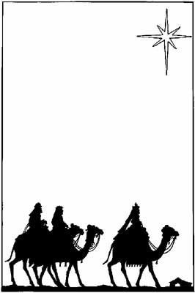
Read about the visit of the magi in Matthew 2:1-12, https://bible.usccb.org/bible/matthew/2. Imagine that you are traveling with them, and then reach the stable where Jesus was born, meeting Him for the first time. Picture the scene, thinking about how you would feel if you were there.
What do you see? ________________________________
_______________________________________________
What do you hear? _______________________________
_______________________________________________
What do you feel? _______________________________
_______________________________________________
Why does being with Jesus bring us peace? ____________
_______________________________________________
_______________________________________________
_______________________________________________
How can you be like the magi (the Three Kings) and follow Jesus? ___________________________________________
________________________________________________

Grade 5- “Christ the King, Prince of Peace”

We celebrate Epiphany on January 6, remembering the journey of the Three Kings to greet the Baby Jesus, and praise Him. They knew that Jesus is God, the greatest King. God rules over Heaven and Earth.
Jesus forgave and blessed people, healed and helped, listened and taught. Jesus showed us how to pray, such as by saying the “Our Father,” and how to build up His Kingdom. We are part of His Kingdom on Earth. When we do good things out of love for God, treating others kindly to honor Him, we are working towards the Kingdom of Heaven.
Because Jesus was so close to His Father in Heaven, nothing was impossible for Him. He was willing to do anything to help bring us closer to His Father, so that we could know how loved we are by Him. He could do anything, because the love of God made Him strong. This is how He could perform miracles, like walking on water (Mark 6:45-52). We hear about these miracles in the Gospel readings at Mass. These are part of the Propers, which change each week.
The Three Kings followed the Star to find where Jesus was born in the stable. We can follow the light of God by listening to what He calls us to do: to love Him, and the people He puts in our path.
See activity continued on next page
Grade 5- “Christ the King, Prince of Peace” Reflection Questions
1. Think about other kings you have learned about and read in stories. How is Jesus different from those kings? What words would you use to describe the kind of King that Jesus is? Write down your ideas in the circles and boxes below.
*

_________________________________________________________________________________
_________________________________________________________________________________
*
2. What does Jesus do for the people in His Kingdom? What does this show about Him?
__________________________________________________________________________________________________________________________________________________________________________________________________________________________________________
3. What can you do to build up God’s Kingdom? How can you follow the example of Jesus to be a good leader? Draw your response in the spaces below, showing how you can be like Jesus.

Jesus Me

See questions continued on next page
4. Jesus is called the “Prince of Peace” (Isaiah 9:6). What do you think this means?
__________________________________________________________________________________________________________________________________________________________________________________________________________________________________________
5. Jesus showed He is King in His power over nature, how He ruled the land. Read the story of Jesus calming the storm in Mark 4:35-41 (here: https://bible.usccb.org/bible/mark/4). How does Jesus help us to be calm when we face storms in our lives?
________________________________________________________________________________________________________________________________________________________________________________________________________________________________________________________________________________________________________________________

Grade 6- “Epiphany Reflection Journal: St. Augustine and Peace”

St. Augustine was a bishop and scholar from Africa who lived from 354 A.D.-430 A.D.). Before he pursued a life of holiness and became a bishop, he struggled with temptations. His mother, St. Monica, prayed for him to become closer to Jesus. God worked in St. Augustine’s heart, and gave him spiritual visions, telling him to “take and read” the Bible. This led St. Augustine to devote his life completely to God. St. Augustine’s total change of heart is called metanoia, meaning to “turn away” from sin.
We celebrate Epiphany this month, remembering how the Three Kings traveled to meet the newborn Jesus in Bethlehem. In the busyness of the world, we might find ourselves seeking peace, searching, just like the wisemen did as they looked to the Star to guide them. St. Augustine says “our hearts are restless until they rest in You, O Lord.”
What do you think St. Augustine means by this? Why do you think true peace comes from God? And what could we do to turn closer to God so that we can bring peace into our hearts, and our communities? Journal about your thoughts on the lines below:
________________________________________________________________________________________________________________________________________________________________________________________________________________________________________________________________________________________________________________________________________________________________________________________________________________________________________________________________________________________________________________________________________________________________________________________________________________________________________________________________________________________________________________________________________________________________________________________________________________________________________________________________________________________________

Week 2
Grade 3- “Prayer Corner Design: A Place for Peace”
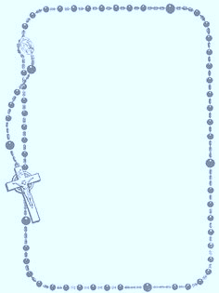
As we prepared for Christmas during the Advent season, we were very busy. It’s good for us to be involved in activities, and to connect with our community. When we are very busy, it’s important that we also take time to pray and be with God. God can help us to do our best and share His love with other people.
God is our friend. Our friends make us happy. If we are worried, they help us to feel better. Talking with God in prayer helps us to feel peaceful inside. God wants to bless us, to do good things to make us happy, and praying helps us to open our hearts to loving God more, so that we can receive His many blessings.
Sacramentals are holy items that remind us of the sacraments, and of God’s love for us. Priests bless them. Examples of sacramentals are statues of saints, pictures of Jesus and Mary, rosaries, crucifixes (crosses with Jesus), candles, and holy water. We can use sacramentals to focus our minds on God and inspire our prayers.
In the space below, draw a picture of a place in your house you can go to pray. If you could create your own prayer corner, what would you put in it to remind you of God and help you feel peaceful? Then, answer the reflection question on the next page.

Grade 3- “Prayer Corner Design: A Place for Peace” Reflection Question
What did you decide to put in your prayer corner, and why? Which sacramental helps you to feel most peaceful?
______________________________________________________________________________
______________________________________________________________________________
______________________________________________________________________________
______________________________________________________________________________
______________________________________________________________________________
______________________________________________________________________________

Grade 4- “Prayers of Peace”
This month, we learned about Epiphany, the Feast of the Three Kings. Jesus is the greatest King, because He serves others, always being present to help and heal. Talking with Jesus in prayer helps us to feel peaceful inside. God wants to bless us, to do good things to make us happy, and praying helps us to open our hearts to loving God more, so that we can receive His many blessings. A blessing is also called a benediction. When we pray, we can petition God, asking Him to help us, our families, and others. We can ask God to bless us, the people we meet, and the things we do. Prayers can be used to thank God, and to tell Him how much we love Him.
When we are very busy, it’s important that we also take time to pray and be with God. You can create a prayer corner in your house, finding a quiet area to go to pray. Think about why peace is important, and how God brings you peace. What do you want to talk to God about? How can you use your prayer to help someone, sharing God’s peace? On the lines below, write a prayer you can put in your prayer corner to pray, or share with others to bless them.

______________________________________________________
______________________________________________________
______________________________________________________
______________________________________________________
______________________________________________________
______________________________________________________
______________________________________________________
______________________________________________________
______________________________________________________
______________________________________________________
______________________________________________________

Grade 5- “Peace in Jesus’ Presence”
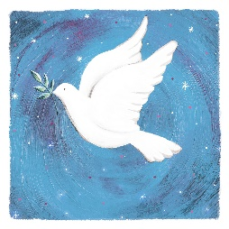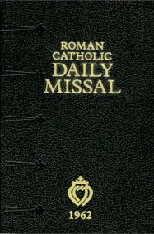
God is always with us. At Christmas, we celebrated the birth of Christ. During Advent, we sang “O Come, O Come, Emmanuel” as we prepared for Christ’s coming. “Emmanuel” means “God with us.” When we go to Mass, we experience the Real Presence of Christ in the Eucharist. This means that in the Eucharist, we receive Christ’s Body. It is not a symbol, but Real. It is truly Christ Who comes into our hearts when we receive the Eucharist. Through the sacraments, we experience God’s presence on a deeper level. The sacraments were given to us so that we could see signs of God’s love, but more than that, they have a real effect, an impact, on us. Graces God gives us out of love change us, making us stronger.
Last week, we learned about Epiphany. The Three Kings went to see Jesus after He was born because they knew He was the visible God- not a symbol far away, but a real Being, here, with us in the world. They wanted to see Jesus and honor Him, to thank God the Father for bringing His Son to walk among us so that we could know Him personally. Jesus came to be with us, taking on human form, out of love. He is God, but humbled Himself as a human so that we could know Him. When we celebrate Epiphany, we are celebrating the presence of God in our world. Knowing God is with us, we can be peaceful.
We can honor God’s Presence through respectfully participating in the Mass. One way we can do this is by using the Roman Catholic Missal, the book that holds the Mass prayers, songs, and readings. It is a guide that helps us to understand what happens at the Mass, because it includes the parts of the Mass that change each week, like Gospel readings, and the parts that are unchanging. The Missal tells us how we can show our love for God.
- Find the readings for this Sunday (January 14) here: https://bible.usccb.org/readings/calendar. Read the Gospel reading. What did John say the Holy Spirit was like?
______________________________________________________________________________
- Why do you think John used this image to represent the Holy Spirit? What did this teach you about true peace- where does true peace come from?
__________________________________________________________________________________________________________________________________________________________________________________________________________________________________________
- Why does the Mass bring us peace? How do we come to know God through the Mass?
________________________________________________________________________________________________________________________________________________________________________________________________________________________________________________________________________________________________________________________
- How can you use the Roman Catholic Missal to find deeper peace at the Mass in this new year? Is there a certain part of the Missal you want to focus on learning more about?
________________________________________________________________________________________________________________________________________________________________________________________________________________________________________________________________________________________________________________________

Think about what makes you feel peaceful. It could be a memory of a peaceful place you’ve been to, like the ocean or the mountains. Draw what you see when you think of “peace.”

How do you see God’s presence here? What about your memories/thoughts of what “peace” is remind you of God? __________________________________________________________________________________________________________________________________________________________________________________________________________________________________________

Grade 6- “Hearts of Peace”
___________________________________________________
___________________________________________________
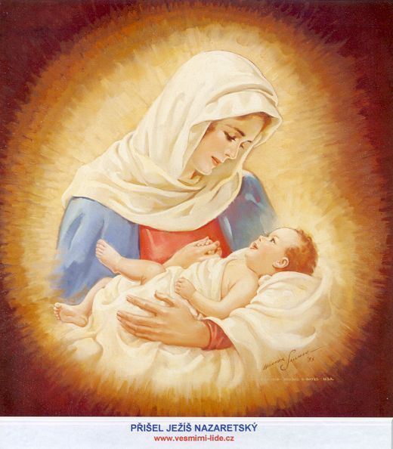
On January 1, we celebrated the Solemnity of Mary, Mother of God, and on January 24, we celebrate Our Lady of Peace. Both of these feast days in January remind us of Mother Mary’s great faith and peace as we think about the miracle of Mary bringing God into the world: Jesus, the Prince of Peace. Mary trusted in God the Father, which we see in how She said “yes” to God’s plan for Her to be Jesus’ Mother. Her peaceful Heart is what could allow for Jesus to come into the world. God’s plan for Mary was so much bigger than Herself, but She had faith that He would carry Her through it: She knew it was a gift to carry His light into the world, illuminating His love and goodness for others. Mary reflected the peace of God in Her acceptance of His will, which She followed, saying, “Be it done to me according to Your Word.” Accepting God the Father’s plan for Him to carry the Cross, bearing the weight of our sins, Her Son, Jesus, would one day say “Thy will be done” as well.
Mary knew that She would be the Mother of the Messiah, the Savior. Songs of the Old Testament (psalms) said that the Messiah would be a “suffering servant.” Knowing that Her Son would suffer, and that She would suffer seeing His sorrow, Mary could have followed Her own will, saying “no” to this future, but She believed in God’s mercy, seeing that it was greater than any challenge She would face, capable of bringing good from every situation. Mary’s peace came from Her love. She loves God, and She loves us, so She followed God’s will for Her to bring Jesus into the world to save us. When the Three Kings went to visit the Christ Child (which we celebrate on January 6, Epiphany), they not only would have seen Jesus, but His Mother caring for Him. Honoring Jesus would mean honoring Mary. Finding peace in Christ would mean reaching Him through Mary, His loving Mother.
- Reflect on the words of the Serenity Prayer. How do you think Mother Mary represents “serenity”?
__________________________________________________________________________________________________________________________________________________________________________________________________________________________________________
- Why is it important to know Mary in order to know Jesus? How do Mary and Jesus give us peace?
__________________________________________________________________________________________________________________________________________________________________________________________________________________________________________
- What can you do to better know Mary? How could you dedicate time to honoring Her?
__________________________________________________________________________________________________________________________________________________________________________________________________________________________________________
- Mary received so many blessings from God. She kept them in Her Heart, treasuring the signs God gave Her of His love (Luke 2:19). Because She kept God’s love in Her heart, She could trust in His faithfulness, knowing that His love would always be with Her, so there was no need to fear the future.
In the heart above (on the left of the picture of Mary), write what you treasure (what is close to your heart). What are some signs of God’s presence in the world around you that make you feel blessed and peaceful?
In the heart to the right of Mary’s picture, write qualities of Mother Mary that you admire, and want to apply to your own spiritual life in the new year. Think about what could bring you greater peace this year.

- What is something you could do to bring peace to someone else, to carry light into the world?
__________________________________________________________________________________________________________________________________________________________________________________________________________________________________________

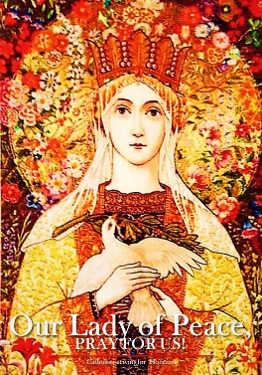

Week 3
Grade 3- “Peace and the Rosary”
In Week 2, we learned about sacramentals. One sacramental is the Rosary. The Rosary is a blessed string of beads. It is called the “Rosary” because it is like a garland of roses. Roses are beautiful and smell sweet. The prayers we send to God from our hearts are like roses that are beautiful and sweet to Him. Mother Mary asks us to pray the Rosary, telling us that when we do as She asks, there will be peace. We remember Our Lady of Peace on January 24. Praying the Rosary brings us closer to Mary, and when we become closer to Her, She leads us to know Her Son, Jesus, better. Mother Mary is called the “Mystical Rose,” because the holy love for God She has in Her Heart is like the most beautiful rose. She shows us how our love for God can grow like a rose, especially when we pray the Rosary, offering our prayers to Him.
Each bead in the Rosary stands for a prayer. As we count the beads, we pray the prayers that go with each bead. First, we make the Sign of the Cross (“saying, “In the name of the Father, and of the Son, and of the Holy Spirit”), and kiss the crucifix (Jesus on the Cross), which is how we can tell Jesus that we love Him. Then, we pray the Apostle’s Creed, a prayer that says what we believe. We can say our intentions (what we want to pray for), and be thinking about what we want God to help us with as we continue to pray. After we say our Apostle’s Creed prayer and intentions, we say the “Our Father.” All of the biggest beads on the Rosary are for the “Our Father” prayer. There are six of these large beads, so we say the “Our Father” six times: one time before we pray the Mysteries, and one time for each of the Five Mysteries we pray.*
In between the crucifix, 2 large beads, and heart bead at the start of the Rosary, there are three small beads. On these beads, we pray the “Hail Mary” prayer. On all of the medium beads in between the “Our Father” prayers, we pray the “Hail Mary.” There are a total of 53 medium beads: 5 sets of 10 “Hail Mary” prayers, 10 for each Mystery (50 total), and the 3 at the beginning. Whenever we reach the spaces between the Hail Mary and Our Father beads, we pray the “Glory Be” and “Fatima” prayers.
After the first three “Hail Mary” prayers, we say another “Our Father,” and pray the first Mystery. Then, on the heart bead, we say the “Hail, Holy Queen” prayer. From there, we keep following the pattern of praying our Hail Mary prayers on the sets of 10 medium beads in a row, the Glory Be and Fatima prayers after the 10th bead in each set, and then the “Our Father” prayers on the larger beads, which stand for each new Mystery. When we finish praying all of these prayers, we make the Sign of the Cross again, thanking God.
*On Mondays and Thursdays during the year (and Sundays in Advent), we pray the Joyful Mysteries. For each new “Our Father” bead we reach, we pray about one of the Mysteries; for example, saying, “The First Joyful Mystery is the Annunciation.” For the next Our Father bead, we’d say “The Second Joyful Mystery is the Visitation,” and so on, thinking about each of these mysteries as we pray, asking for graces from each. On Tuesdays and Fridays during the year (and Sundays in Lent), we pray the Sorrowful Mysteries. Finally, on Wednesdays and Saturdays during the year (and Sundays in the Pentecost season), we pray the Glorious Mysteries.
Label the spaces in the boxes with the prayer you say for each bead the lines are pointing to. Practice praying the Rosary together as a family. Then, answer the reflection question.
What prayer is said on the large beads?
____________
____________
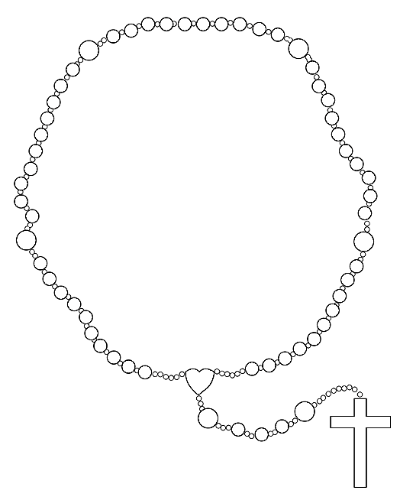
What prayer is said on the medium beads?
_____________
_____________

What 2 prayers do we say in between the medium and large beads?
1. _________________
_________________
2. _________________
_________________
_________________
What prayer do we say on the heart bead?
_______________________
_______________________
_______________________
What 2 prayers do we say at the beginning of the Rosary?
1.______________________________________________
2. _____________________________________________

Grade 3- “Peace and the Rosary” Reflection Question
Think about what you prayed for while you said the Rosary. Why did praying the Rosary help you to feel peaceful?
______________________________________________________________________________
______________________________________________________________________________
______________________________________________________________________________
______________________________________________________________________________
______________________________________________________________________________
______________________________________________________________________________

If you would like, you may draw a picture of you praying the Rosary in the space below! How will you represent “peace” in this picture?



Grade 4- “A Recipe for Peace”

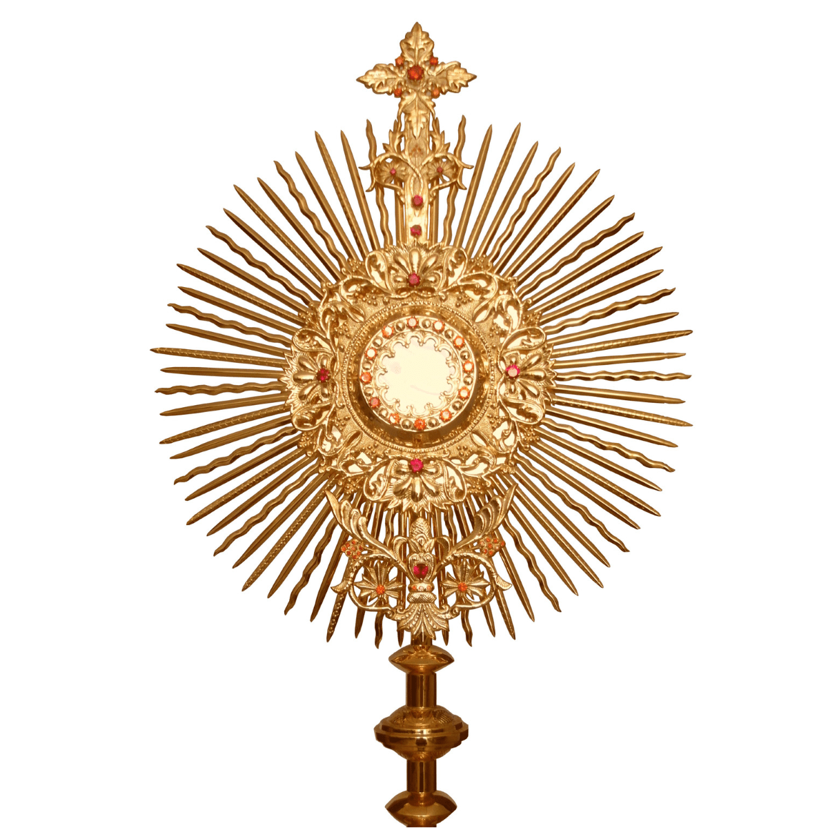
Monstrance with Eucharist
On January 6, we celebrated Epiphany. One way people celebrate Epiphany is by making Epiphany cake, which is baked in a special crown-shaped pan. Sometimes these cakes have many ingredients mixed in, which each symbolize something different. For example, getting a slice of cake with chocolate in it means you’re sweet. But the main ingredient we need for a peaceful life is Jesus, because God is love, and peace comes from love.
We don’t know what the new year will bring for us, but we know that Jesus will be with us, giving us blessings that will help us become stronger. Bringing the sacraments into our lives is important. In addition to going to Mass, we can continue to celebrate the gift of the Eucharist through Adoration. We can always adore Christ, but this is another special way to show our devotion, our love for Jesus and faith in Him. The halo of rays around the monstrance, which holds the Eucharist, is like a crown. Every time we go to Eucharistic Adoration, we can learn something about Jesus we didn’t notice before. There are always epiphanies, things to discover, in store from Christ the King.
God’s rules for living a good life, the 10 Commandments (also called the “Decalogue”), help us to live in peace, because they show us how to love each other. The first three Commandments are about loving God, and the rest are about loving others. When we love God, we can learn how to love each other even more. The order of the Commandments shows us that all peace comes from putting God first, keeping Christ as King of our lives.

Grade 4- “A Recipe for Peace” Reflection Questions
- Going to Eucharistic Adoration is one way to know God by being with Him, in the Presence of the Eucharist. At Adoration, we look upon Jesus in the Eucharist and pray. Why do you think praying is important for us to be peaceful?
______________________________________________________________________________
______________________________________________________________________________
______________________________________________________________________________
- Why is it important to follow the 10 Commandments (God’s rules)? How does following God’s rules help us to bring peace?
______________________________________________________________________________
______________________________________________________________________________
______________________________________________________________________________
______________________________________________________________________________
- At the start of a new year, we can make New Year’s resolutions. We can write down what we plan to do to make it a good year. What is something you can do this year to adore (love and praise) Jesus?
______________________________________________________________________________
______________________________________________________________________________
______________________________________________________________________________
- Match the words in the word bank to their definitions in the recipe card below. Then, write your own ideas about how to complete the recipe for living a sweet life by honoring God, keeping peace in your heart by keeping Christ as King.

For a Sweet Life
Word Bank:
- Benediction
- Decalogue
- Adoration
- Praise of God: __________________________
- 10 Commandments: __________________________
- Blessing: _________________
- __________________________
- __________________________

Grade 5- “Prayers for the New Year”
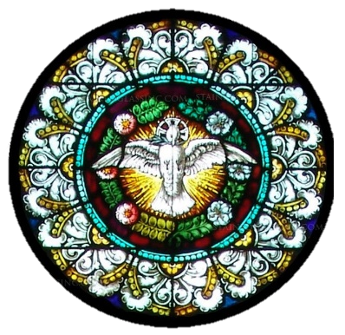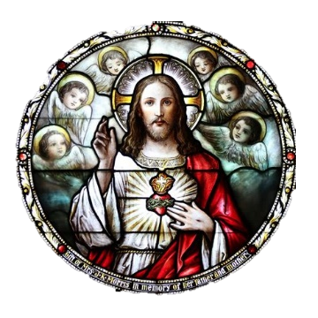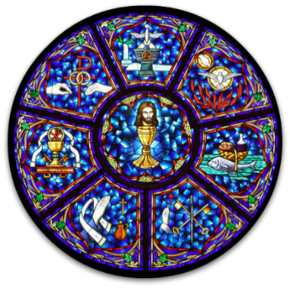
As we welcome in a new year, we look forward to what God will bring into our lives. Sometimes, we feel unsure of what to expect, but if we are worried about change, we can always pray to God. He will give us what you need and show us what He wants us to do. We can rely on God to help us, because He is always with us. Last week, we learned about the Missal, and readings of the Mass that change. The ordinaries are parts of the Mass that don’t change, like the consecration. The priest blesses and breaks the Bread. The Bread becomes Christ’s Body, which He broke on the Cross to save us from our sins. At every Mass, we remember Jesus’ Sacrifice. At the heart of it all is His love, which lasts forever, never changing.
On the lines below, write a prayer for peace, thinking about your hopes for the new year. You could write about how you would like God to help you grow in your faith this year, or reflect on how one of the sacraments, such as Communion or Confession, brings you peace.

____________________________________________________________________________________________________________________________________________________________________________________________________________________________________________________________________________________________________________________________________________________________________________________________________________________________________________________________________________________________
____________________________________________________________________________________________________________________________________________________________________________________________________________________________________________________________________________________________________________________________________________________________________________________________________________________________________________________________________________________________

Grade 6- “Jesus the King: Then, Now, and Forever”

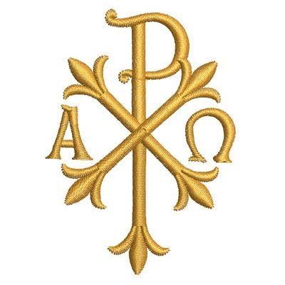
When we read the New Testament in the Bible, we learn about the events in Jesus’ life. But if we look back at the Old Testament, we see stories that foreshadow, or tell ahead of time, that Jesus would be the Messiah, our Savior. The people of the Old Testament had waited for the Messiah for a long time, knowing He would save them. Jesus’ birth brought hope into the world that the Messiah had finally come, the King who would set things right in the world.
In the New Testament, we see how Jesus did everything that the prophets from the Old Testament (people who gave messages from God about what would happen) said the Savior would do. We see that God kept His promises. Even when situations seemed impossible, God did what He said He would, sending His only Son to free us from sin. Knowing that God does what He promises when the time is right, working everything out for our good, we can have peace in our hearts, trusting that He will lead and guide us, because Jesus is a King Who serves His people with love.
Read these verses from Daniel, an Old Testament prophet. Then read the verses from Luke, the New Testament Gospel writer:
- OT: Daniel 7:13-14 https://bible.usccb.org/bible/daniel/7
  - NT: Luke 1:31-33 https://bible.usccb.org/bible/luke/1
See next page for reflection questions
Grade 6- “Jesus the King: Then, Now, and Forever” Reflection Questions
- How was the reading from Daniel in the Old Testament similar to the reading from Luke in the New Testament (how did they reflect each other)? What evidence did you see of the Old Testament predicting what would happen in the New Testament- how was the prophecy fulfilled?
______________________________________________________________________________________________________________________________________________________________________________________________________________________________________________________________________________________________________________________________________________________________________________________________________
- Jesus is called the “alpha and the omega” (Revelation 1:8). “Alpha” is the first letter of the Greek alphabet, and “omega” is the last. This means that Jesus is the beginning and the end. What do you think this means?
________________________________________________________________________________________________________________________________________________________________________________________________________________________________________________________________________________________________________________________
- What does it mean that God’s Kingdom is “eternal”? Why can we have peace knowing that God’s Kingdom is eternal?
______________________________________________________________________________________________________________________________________________________________________________________________________________________________________________________________________________________________________________________________________________________________________________________________________
- Draw a banner that tells of Jesus’ kingship, of God’s Kingdom. Think about how you would describe Christ the King to someone who has not learned about His life. What kinds of symbols can you use to show that Christ is King?

January 2024 3-6 Review
Use this review sheet as a reference to track progress and check that learning goals are met.
Recap: What did we learn?
All Grades
- Peace comes from God
- God is love, and peace grows from love
- Jesus is the greatest King
- We can pray the Serenity Prayer for peace
Grade 3
- The wisemen show us how to be peaceful by trusting in God
- The wisemen remind us to continue learning about and looking for God
- Sacramentals are blessed objects that remind us of the sacraments
- Rosaries are sacramentals
- Praying the Rosary can bring us many graces, helping us to be peaceful
Grade 4
- The magi (wisemen) followed the star to reach the Christ Child and honor Him
- We can adore Christ like the wisemen did
- A balance of prayer and devotions like Adoration can help us to live a peaceful life out of love for God
- The Ten Commandments are God’s rules that show us how to love God and each other
- Following the Ten Commandments helps us to live peacefully
Grade 5
- We remember God’s presence among us on feasts such as Epiphany
- At the Mass, we experience the Real Presence of Christ
- The Eucharist is not a symbol, but is truly the Body of Christ
- The sacraments make an impact on us
- We use the Roman Missal to guide us in praying the Mass
- The Ordinary (unchanging) & Proper (changing) parts of the Mass are in the Missal
Grade 6
- St. Augustine is an example of peace, because he dedicated His life to loving God, turning away from sin to follow God’s plan
- Mother Mary is another example of peace, because of Her trust and faith in God
- In the New Testament, we see how Jesus fulfilled Old Testament prophecies
- The Bible shows us how God keeps His promises
What vocabulary words did we practice?
Grade 3
Week 1
Pilgrimage
Week 2
Sacramental
Week 3
Rosary
Grade 4
Week 1
Adoration
Week 2
Benediction
Week 3
Decalogue
Grade 5
Week 1
Propers
Week 2
Roman Missal
Week 3
Ordinaries
Grade 6
Week 1
Metanoia
Week 2
Psalm
Week 3
Prophet
What prayers did we practice?
Grade 3
Serenity Prayer
Grade 4
Serenity Prayer
Grade 5
Serenity Prayer
Grade 6
Serenity Prayer
Checklist: Activity Completion
Grade 3
Week 1: “The Wisemen and Peace”
Week 2: “Prayer Corner Design: A Place for Peace”
Week 3: “Peace and the Rosary”
Grade 4
Week 1: “Imagining the Visit of the Magi”
Week 2: “Prayers of Peace”
Week 3: “A Recipe for Peace”
Grade 5
Week 1: “Christ the King, Prince of Peace”
Week 2: “Peace in Jesus’ Presence”
Week 3: “Prayers for the New Year”
Grade 6
Week 1: “Epiphany Reflection Journal: St. Augustine and Peace”
Week 2: “Hearts of Peace”
Week 3: “Jesus the King: Then, Now, and Forever”
Quick Check:
Did your child fully answer all of the questions (in spoken discussion or in writing)?
Did your child demonstrate their understanding of concepts through their artistic response (i.e. drawings)?
Did your child use their vocabulary words in spoken discussion or in writing?
Did your child practice saying their prayers and applying their knowledge, such as by making the Sign of the Cross or helping to say grace at a meal?
Did you and your child work on the monthly challenge to put our theme into practice?
Did you use the thematic guiding questions to discuss concepts related to the theme?
Tell us about your experience with these activities this month! Our January 2024 Google Form for Grades 3-6 is available here: https://forms.gle/ZLVrNtWGmScY2ucb6

