Our Lady of the Valley Religious Education

October 2023 Activity Packet

Grades 7-9

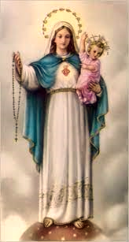
Name: ________________________________________
Materials Included in Packet
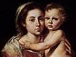
Overview…………………………………………………………………………………………3
Standards………………………………………………………………………………………...5
Pacing Guide……………………………………………………………………………………12
Activities………………………………………………………………………………………...18
Week 1…………………………………………………………………………………………..18
Grade 7……………………………………………………………………………….…18
Grade 8………………………………………………………………………………….20
Grade 9………………………………………………………………………….............22
Week 2…………………………………………………………………………………………..24
Grade 7……………………………………………………………………………….…24
Grade 8………………………………………………………………………………….26
Grade 9………………………………………………………………………….............28
Week 3…………………………………………………………………………………………..30
Grade 7……………………………………………………………………………….…30
Grade 8………………………………………………………………………………….32
Grade 9……..…………………………………………………………………………...34
Review………………………………………………………………………………………….36

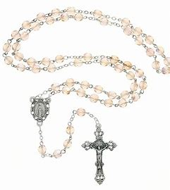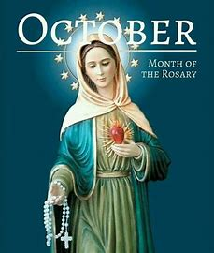
October 2023 Overview: Grades 7-9
Theme: Month of the Holy Rosary
Monthly Prayer/Invocation: Queen of the Most Holy Rosary, pray for us.
Thematic Guiding Questions, 7-9: What is the Rosary? Why and how do we pray it?
- Why do you think all of the Mysteries of the Rosary are needed (Joyful, Sorrowful, and Glorious)?
- What do they show us about Jesus’ life?
Saint of the Month: St. Therese of Lisieux was a Carmelite nun who prayed faithfully. She was called the “Little Flower,” using everything she did out of love from God, from the smallest tasks like sweeping the floor, to praying the Rosary. She teaches us that everyone can use what they do to honor God, no matter how “little” the way may seem, because what we do out of love has a bigger impact than we can imagine.
Monthly Challenge: Pray the Rosary. Choose one Mystery to focus on. Start by praying a decade a day. Talk about how you relate to the Mystery you chose.
Overall Learning Goals: This month, our goal is to learn more about how we can grow in our faith through the Rosary, and to identify how we can further integrate the spirit and prayers of the Rosary into our lives. Our goal is to more deeply appreciate the significance and deeper meanings of the Rosary Mysteries, as well as to increase our love for the Rosary as a liturgical devotion, a sacramental that draws us back to the Heart of Christ at the center of every sacrament. Ultimately, it is our overall learning goal to relate our studies of the Rosary to our understanding of eternity, recognizing the impactful role that sacramentals and devotions in the Church have in our spiritual development, our journey to reach Heaven.
Summary of Activities: This month, we will center our exploration of the Rosary on inspiring followers of Christ who lived out the spirit of the Mysteries, and stories from the Bible that are focal points for the Rosary, so as to better understand how we might meditate on the Rosary’s truths, including through praying a scriptural Rosary. We will identify how we can connect the Mysteries of the Rosary and the religious devotions of the saints to our lives, so that we, too, can live out our faith, with the Rosary as a guide. Our activities will explore devotions to Jesus and Mary, October feast days, types of prayer, and virtues, using art, design, and spiritual reflection to guide us in our journey to Christ and His Mother through the Rosary.
Additional Enrichment Ideas:
- Visit the St. Therese Shrine in Nasonville, Rhode Island, in honor of St. Therese of Lisieux’s feast day this month. Receive an indulgence for visiting the shrine in honor of the shrine’s 100th anniversary. Go to the shrine’s website for more information about the shrine, including its history, St. Therese’s biography, event dates, and a novena to St. Therese:
  - https://burrillvillecatholic.org/novena-to-st-therese
  - https://burrillvillecatholic.org/the-life-of-st-therese
  - https://burrillvillecatholic.org/anniversary-%26-feast-days
  - https://burrillvillecatholic.org/history-of-the-shrine
- Visit the Museum of Family Prayer, operated by Holy Cross Family Ministries in Easton, MA (Stonehill College), to learn more about the ministry of Fr. Patrick Peyton, the rosary priest. See their website for listings of upcoming events and additional prayer resources: https://www.museumoffamilyprayer.org/events-and-programs.
- Hold a Sacred Heart enthronement ceremony in your home in honor of St. Margaret Mary Alacoque’s feast day, as well as the Feast of Christ the King, this month. Place a blessed image of Jesus’ Sacred Heart in a central location, and consecrate your home to Him. Learn more about enthronement ceremonies, and registering yours, at these sites:
  - https://welcomehisheart.com/
  - https://www.catholiccompany.com/content/sacred-heart-jesus-enthronement-ceremony

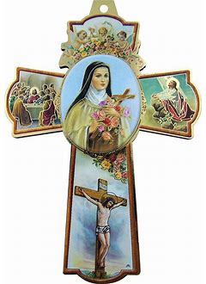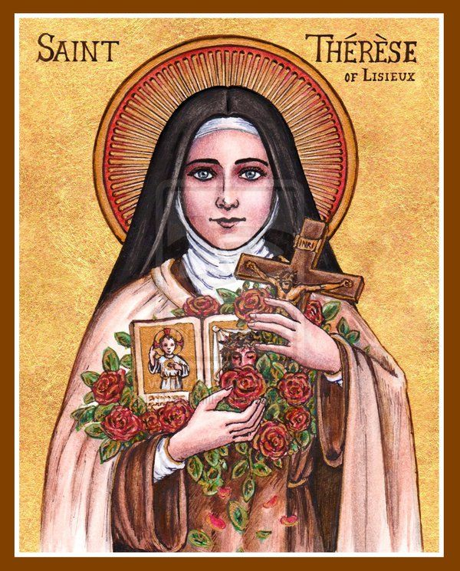
Standards
Grade Level | Week | Activities | Learning Standards
Grade 7 | 1 | “Building Faith: One Bead at a Time” | 7.1 Prayers are integral to our growth, as they allow us to connect with God, guiding us forward with faith and hope. When we pray, we are taking a constructive step to address worry in our lives… Active and passive prayer (regular and mystical) are two forms of mental prayer that we see exercised in the lives of the saints, and that we can practice in our spiritual lives as well.
Grade 7 | 2 | “Good Deed Beads: Living on Prayer like St. Therese” | 7.1 Prayers are integral to our growth, as they allow us to connect with God, guiding us forward with faith and hope. When we pray, we are taking a constructive step to address worry in our lives…  7.3 There are seven “contrary virtues” counteracting the seven deadly sins: humility, liberality, chastity, meekness, temperance, brotherly love, and diligence.  7.10 Throughout Church history, there have been a variety of religious and secular orders founded by saints that have allowed for clergy and laypeople to live out their faith according to special charisms that deepen their relationships with God. Members of religious orders (first, second, and third) fulfill vows of poverty, chastity, and obedience to God, dedicating their lives to honoring Him, whether cloistered, or in the world.
Grade 7 | 3 | “At Home in the Sacred Heart: Finding Christ’s Peace with the Rosary” | 7.7 The examen is an Ignatian spiritual practice that is akin to a daily examination of conscience. This practice involves one in spiritual reflection on the events of the day, a mental review of what was done, what could have been done differently, and what will be done going forward. The examen ends on a hopeful note, looking to the future. It can instill gratitude, develop intrinsic motivation, and cultivate an attitude of continual improvement, encouraging one to avoid occasions of sin, redirecting their attention and behavior so that it is oriented towards Christ. Through the examen, one can gradually turn away from sin, noticing patterns of thought and behavior, and determining how to go the extra mile to do good works centered on love for Christ rather than yielding to temptation.
Grade 8 | 1 | “The First Good News: Sharing Prayers like Our Lady” | 8.2 Mary, the Mother of Jesus, was conceived without sin. This phenomenon is called the Immaculate Conception. Both  Mary and Jesus are without sin. As a sinless human being, Mary was chosen to bring Jesus into the world (the means to the Incarnation).  8.3 Mary’s “yes” to God is known as the “fiat.” Her openness to God’s plan for her (“Be it done to me according to Your Word”) is an example of strong faith in God. The fiat foreshadowed Jesus’ own willingness to fulfill the Father’s plan for Him (“Thy will be done”). In the Old Testament, Abraham is also an example of faith, because he was willing to give his only son when God asked him to. This foreshadowed how Jesus, God’s only Son, would be offered for our salvation.  8.5 We rely on Sacred Scripture and Sacred Tradition to help us know and follow Christ.
Grade 8 | 2 | “Wearing Our Hearts on Our Sleeves: Bringing Jesus’ Love into the World” | 8.1 Jesus is both fully human and fully divine, a phenomenon known as the hypostatic union. The Incarnation is when Jesus took on flesh, becoming man to be among us. This emphasizes his humanity (Christology from below), while the Transfiguration emphasizes his divinity (Christology from above).
Grade 8 | 3 | “Full Circle: The Rosary, the Eucharist, and Christ’s Presence” | 8.6 Sacraments, and the infinite graces flowing from them, are free gifts from God… Because sacraments are efficacious, meaning that they have real effects that impact us, they impart graces that we can receive. At the Mass, the transubstantiation takes place, meaning at the consecration, the substance of the bread and wine change, becoming the Body and Blood of Christ. When we receive the Body of Christ, we are receiving an efficacious sacrament (made real, more than symbolic, through His Sacrifice), engaging in a personal encounter with Christ. He truly works within us as we open our hearts to receive Him. The degree of grace we receive in the sacraments depends on our degree of faith, hope, and love, our receptivity to God.  8.8 The Rosary shows us the sacraments’ layers of meaning by commemorating the events of Jesus’ and Mary’s lives, helping us to better understand their roles in salvation history… The Rosary reminds us that Christ has won salvation for each of us, and that there is a place for each of us in His family to serve and honor Him in a ministry that illuminates Christ’s light in the world, making Christ visible to others.
Grade 9 | 1 | “The Spirit of the Rosary: Prayer as the Golden Key” | S3.3 To receive the sacrament of Confirmation is to be sent forth, much like the apostles at Pentecost, to pursue God’s call.  9.4 Christ has achieved our salvation objectively, but to be saved subjectively, we must live out a life of faith and good works, in accordance with the Gospels, using our free will to follow Christ, recognizing Him as our Savior.  S3.4 It is the responsibility of the Catholic to evangelize, sharing the gifts given them by God with others.  S3.9 Confirmation gives us a fuller outpouring of graces helping us to make discernments about how we can use our gifts to serve God in the future.
Grade 9 | 2 | “Christ the King and the Queen of Heaven: The Crowning Glory of the Rosary” | 9.2 Suffering is an inevitable part of life, due to the fallen nature of man. Adam and Eve brought suffering into the world through their sin of pride against God, using their free will for the wrong purposes. However, God makes meaning of suffering, using it for our good, to become closer for us. He does not abandon us or stop loving us through our challenges. Without the Cross, there is no salvation…  9.3 Free will was given to us by God, because He loves us.
Grade 9 | 3 | “Filled with the Spirit: Opening Our Hearts to God’s Gifts” | S3.8 To be confirmed is to make a deeper commitment to Christ.  9.9 The Holy Spirit transforms what is entrusted to His power, as we see through sacraments such as Confirmation. The Gifts of the Holy Spirit have the power to transform us. If we offer ourselves to the Holy Spirit, He will move our hearts, stirring our souls, so that we can put faith into action.

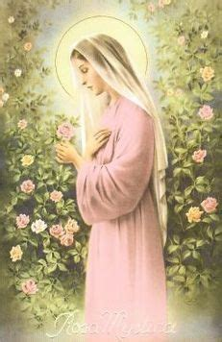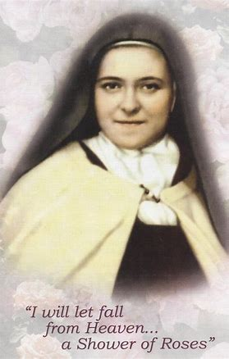
October 2023 Pacing Guide (Suggested Schedule)
Grades 7-9
Week Number/Date | Grade Level | Activities
Week 1  (October 2, 2023 – October 6, 2023) | Grade 7 | “Building Faith: One Bead at a Time”
Week 1  (October 2, 2023 – October 6, 2023) | Grade 8 | “The First Good News: Sharing Prayers like Our Lady”
Week 1  (October 2, 2023 – October 6, 2023) | Grade 9 | “The Spirit of the Rosary: Prayer as the Golden Key”
Week 2  (October 9, 2023 – October 13, 2023) | Grade 7 | “Good Deed Beads: Living on Prayer like St. Therese”
Week 2  (October 9, 2023 – October 13, 2023) | Grade 8 | “Wearing Our Hearts on Our Sleeves: Bringing Jesus’ Love into the World”
Week 2  (October 9, 2023 – October 13, 2023) | Grade 9 | “Christ the King and the Queen of Heaven: The Crowning Glory of the Rosary”
Week 3  (October 16, 2023 – October 20, 2023) | Grade 7 | “At Home in the Sacred Heart: Finding Christ’s Peace with the Rosary”
Week 3  (October 16, 2023 – October 20, 2023) | Grade 8 | “Full Circle: The Rosary, the Eucharist, and Christ’s Presence”
Week 3  (October 16, 2023 – October 20, 2023) | Grade 9 | “Filled with the Spirit: Opening Our Hearts to God’s Gifts”

Week Number/Date | Grade Level | Words to Practice | Definitions
Week 1  (October 2, 2023 – October 6, 2023) | Grade 7 | Franciscan | Someone who follows the Rule of St. Francis of Assisi. St. Francis of Assisi founded the first and third (secular) orders in the 1200s, and St. Clare founded the Poor Clares (women’s order, the second order) in 1212. Franciscans live out the vow of poverty in the fullest possible way. Some Franciscan orders are “discalced,” or shoeless, orders.
Week 1  (October 2, 2023 – October 6, 2023) | Grade 7 | Mental prayer | When one puts their mind to prayer, focusing their thoughts on God. Mental prayer helps a person to unite their heart and mind with God.
Week 1  (October 2, 2023 – October 6, 2023) | Grade 8 | Protoevangelium | The beginning of the Old Testament; the creation story of Genesis, which tells of Adam and Eve. “Proto” is a root word used to refer to the “first” of something, an early version. The protoevangelium is the story of creation before Christ’s coming, the “good news” to be shared.
Week 1  (October 2, 2023 – October 6, 2023) | Grade 9 | Meditation | Christian meditation involves fixing the mind on God, focusing on a specific mystery in the Catholic tradition to focus on. To meditate, a person turns their thoughts and prayers to God, thinking about His greatness. There are five core steps to Christian meditation: preparation, selection of material, consideration, conversation, and thanksgiving.
Week 2  (October 9, 2023 – October 13, 2023) | Grade 7 | Acquired virtue | A virtue a person gains over time through regularly practicing good habits that help them to become holier. In this way, the virtue, the holy quality, is acquired.
Week 2  (October 9, 2023 – October 13, 2023) | Grade 7 | Carmelite | Members of the Order of the Brothers of Our Lady of Mount Carmel, the religious order founded on Mount Carmel in the 1100s, are called Carmelites. St. Theresa of Avila and St. Therese of Lisieux were Carmelite sisters.
Week 2  (October 9, 2023 – October 13, 2023) | Grade 8 | Cassock | A long black garment worn by the priest. During the Mass, the cassock is worn under outer vestments like the alb and chasuble.
Week 2  (October 9, 2023 – October 13, 2023) | Grade 9 | Papal Coronation | Before Vatican Council II in the 1960s, when a new pope was elected, they were coronated. A coronation is an official ceremony when someone is crowned. Royalty have coronation ceremonies where they are officially crowned as kings or queens when they begin their rule. The papal coronation kept with the traditional view of the papacy as a kind of monarchy honoring Christ the King, and the pope serving Him as the Church’s leader.
Week 3  (October 16, 2023 – October 20, 2023) | Grade 7 | Jesuit | A member of the Society of Jesus, a religious order founded in 1539 by St. Ignatius Loyola, is called a “Jesuit.” Ignatian spirituality focuses on finding God in all things. Jesuits put a special emphasis on service in the world, care for people and the environment.
Week 3  (October 16, 2023 – October 20, 2023) | Grade 8 | Cope | A cloak worn by the priest outside of saying the Mass, such as during a Eucharistic procession.
Week 3  (October 16, 2023 – October 20, 2023) | Grade 9 | Disposition | A person’s inner state, their leanings, thoughts, or feelings towards something that cause them to act in a certain way. Having the right disposition means being detached from sin (wanting to stay away from it), and being willing to open oneself up to God’s grace. Before we receive the sacraments, we must have the right disposition.
Week 3  (October 16, 2023 – October 20, 2023) | Grade 9 | Proximal preparation for sacraments | Immediate preparation for sacraments. “Proximal” means “close.” Proximal actions taken in preparation for receiving a sacrament is what we do to prepare ourselves, to ready our souls, right before receiving it.
Week 3  (October 16, 2023 – October 20, 2023) | Grade 9 | Remote preparation for sacraments | Something we do further ahead of time to prepare for receiving a sacrament, not immediately prior. “Remote” means “distant,” or “far away.”

Week Number/Date | Grade Level | Prayers to Practice | Text of Prayers
Week 1  (October 2, 2023 – October 6, 2023) | Grade 7 | Prayer to the Sacred Heart for Inner Peace | Holy Heart of Jesus, Sweet Sanctuary of rest, bring peace to my soul and settle my spirit, especially in the matter of [state your intention here]. I vow to place all of my worries and fears into the wound of Your Sacred Heart there to be tended to in accordance with Your perfect will, which desires only the best and the highest good. Your love alone is enough, and I surrender to it, clinging to the hope of a swift resolution and trusting with confidence in all of Your promises. Amen.
Week 1  (October 2, 2023 – October 6, 2023) |  | St. Francis of Assisi Prayer (Prayer for Peace) | Lord, make me an instrument of your peace:  Where there is hatred, let me sow love;  Where there is injury, pardon;  Where there is doubt, faith;  Where there is despair, hope;  Where there is darkness, light;  Where there is sadness, joy.  O divine Master, grant that I may not so much seek  To be consoled as to console,  To be understood as to understand,  To be loved as to love.  For it is in giving that we receive,  It is in pardoning that we are pardoned,  And it is in dying that we are born to eternal life.
Week 1  (October 2, 2023 – October 6, 2023) | Grade 8 | Petition to Our Lady of the Rosary | O Virgin Mary, grant that the recitation of Thy Rosary may be for me each day, in the midst of my manifold duties, a bond of unity in my actions, a tribute of filial piety, a sweet refreshment, an encouragement to walk joyfully along the path of duty. Grant, above all, O Virgin Mary, that the study of thy fifteen mysteries may form in my soul, little by little, a luminous atmosphere, pure, strengthening, and fragrant, which may penetrate my understanding, my will, my heart, my memory, my imagination, my whole being. So shall I acquire the habit of praying while I work, without the aid of formal prayers, by interior acts of admiration and of supplication, or by aspirations of love. I ask this of thee, O Queen of the holy Rosary, through Saint Dominic, thy son of predilection, the renowned preacher of thy mysteries, and the faithful imitator of thy virtues. Amen.
Week 1  (October 2, 2023 – October 6, 2023) | Grade 9 | Petition for Light | O Holy Spirit, Spirit of truth, come into our hearts; shed the brightness of Thy light upon the nations, that they may please Thee in unity of faith.
Week 2  (October 9, 2023 – October 13, 2023) | Grade 7 | Prayer to the Sacred Heart for Inner Peace | Holy Heart of Jesus, Sweet Sanctuary of rest, bring peace to my soul and settle my spirit, especially in the matter of [state your intention here]. I vow to place all of my worries and fears into the wound of Your Sacred Heart there to be tended to in accordance with Your perfect will, which desires only the best and the highest good. Your love alone is enough, and I surrender to it, clinging to the hope of a swift resolution and trusting with confidence in all of Your promises. Amen.
Week 2  (October 9, 2023 – October 13, 2023) | Grade 8 | Petition to Our Lady of the Rosary | O Virgin Mary, grant that the recitation of Thy Rosary may be for me each day, in the midst of my manifold duties, a bond of unity in my actions, a tribute of filial piety, a sweet refreshment, an encouragement to walk joyfully along the path of duty. Grant, above all, O Virgin Mary, that the study of thy fifteen mysteries may form in my soul, little by little, a luminous atmosphere, pure, strengthening, and fragrant, which may penetrate my understanding, my will, my heart, my memory, my imagination, my whole being. So shall I acquire the habit of praying while I work, without the aid of formal prayers, by interior acts of admiration and of supplication, or by aspirations of love. I ask this of thee, O Queen of the holy Rosary, through Saint Dominic, thy son of predilection, the renowned preacher of thy mysteries, and the faithful imitator of thy virtues. Amen.
Week 2  (October 9, 2023 – October 13, 2023) | Grade 9 | Petition for Light | O Holy Spirit, Spirit of truth, come into our hearts; shed the brightness of Thy light upon the nations, that they may please Thee in unity of faith.
Week 3  (October 16, 2023 – October 20, 2023) | Grade 7 | Prayer to the Sacred Heart for Inner Peace | Holy Heart of Jesus, Sweet Sanctuary of rest, bring peace to my soul and settle my spirit, especially in the matter of [state your intention here]. I vow to place all of my worries and fears into the wound of Your Sacred Heart there to be tended to in accordance with Your perfect will, which desires only the best and the highest good. Your love alone is enough, and I surrender to it, clinging to the hope of a swift resolution and trusting with confidence in all of Your promises. Amen.
Week 3  (October 16, 2023 – October 20, 2023) | Grade 8 | Petition to Our Lady of the Rosary | O Virgin Mary, grant that the recitation of Thy Rosary may be for me each day, in the midst of my manifold duties, a bond of unity in my actions, a tribute of filial piety, a sweet refreshment, an encouragement to walk joyfully along the path of duty. Grant, above all, O Virgin Mary, that the study of thy fifteen mysteries may form in my soul, little by little, a luminous atmosphere, pure, strengthening, and fragrant, which may penetrate my understanding, my will, my heart, my memory, my imagination, my whole being. So shall I acquire the habit of praying while I work, without the aid of formal prayers, by interior acts of admiration and of supplication, or by aspirations of love. I ask this of thee, O Queen of the holy Rosary, through Saint Dominic, thy son of predilection, the renowned preacher of thy mysteries, and the faithful imitator of thy virtues. Amen.
Week 3  (October 16, 2023 – October 20, 2023) | Grade 9 | Petition for Light | O Holy Spirit, Spirit of truth, come into our hearts; shed the brightness of Thy light upon the nations, that they may please Thee in unity of faith.

October 2023 7-9 Activities
Week 1
Grade 7- “Building Faith: One Bead at a Time”
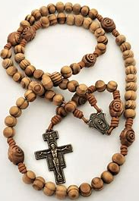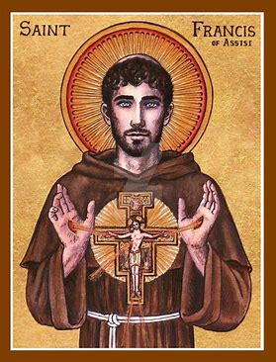
At the beginning of October, we celebrate the feast days of some very special saints. October 4 is the feast day of St. Francis of Assisi, an Italian monk. St. Francis began the Franciscan order, and inspired St. Clare, foundress of the Poor Clares, the Franciscan order for women.
We know St. Francis as the saint who loved animals, preaching sermons to the birds, and leading animals like wolves to become completely gentle and calm. St. Francis did not pray to the animals, but prayed to God, thanking Him for the world He created. St. Francis was also a saint who had the wounds of Christ, marks from the nails on his hands, feet, and side. He is also the saint who began the tradition of nativity scenes to honor Jesus’ Birth on Christmas Day.
God called St. Francis to build the Church. At first, St. Francis took God’s message to him literally. He thought God wanted him to rebuild a local church that needed repairs. God was really asking St. Francis to help build up the Church by bringing more people to Jesus. St. Francis humbly lived among the poor, giving up everything he owned. He chose this way of life to understand Jesus, Who also lived in humble conditions.
St. Francis not only cared for the land and the animals, but about all of the people God created. He put his faith into action, keeping God first in his life. He was compassionate towards everyone in God’s family. St. Francis lived out his prayer for peace. The wounds of Christ St. Francis had were reminders to him to live like Christ, which he did through his kindness to others, including people who were sick. St. Francis, like St. Therese of Lisieux, was willing to challenge himself to grow better each day, to overcome his fears to be more like Jesus.
Mental prayer is how we talk to God, giving our minds and hearts to thoughts about God. St. Francis brought the prayers of his mind and heart to life. He shows us that we each have special knowledge and talents to use in building the Church. We can build faith in each other as we treat each other with kindness and care like St. Francis. When we pray the Rosary, we pray in our hearts and minds, but in this month of the Holy Rosary, we can also live out the Mysteries of the Rosary, the stories of Jesus’ and Mary’s lives, by living with the love they had in their Hearts. We can build up the Church through our prayers, which help other souls.
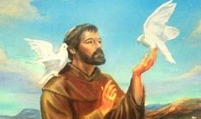
- Pray St. Francis’ “Prayer for Peace.” Then pray the “Prayer to the Sacred Heart for Inner Peace.” What gives us peace? How can we bring peace to the world around us like St. Francis?
__________________________________________________________________________________________________________________________________________________________________________________________________________________________________________
- What are three examples of how St. Francis of Assisi helped to build the Church?
St. Francis of Assisi
- St. Francis is the patron saint of ecology, the environment. In his honor, spend some time outside. Find a peaceful place to pray. Keep a “nature notebook” to write down what you see and hear. How did spending time in nature help you to appreciate the world God has made? What does it mean to you to care for God’s creation like St. Francis did?

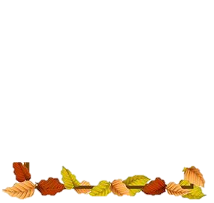
__________________________________________________________________________
__________________________________________________________________________
__________________________________________________________________________
__________________________________________________________________________
__________________________________________________________________________
__________________________________________________________________________
__________________________________________________________________________
__________________________________________________________________________
__________________________________________________________________________
Grade 8- “The First Good News: Sharing Prayers like Our Lady”
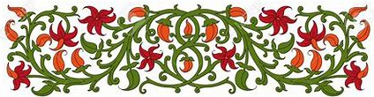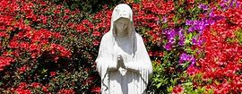
Angels are God’s messengers. They bring news from God in Heaven to people on Earth. We celebrate the Feast of the Guardian Angels on October 2 every year. When we read the Old Testament, we see hints of the best news, the news of the coming of Jesus, Our Savior. The Protoevangelium is the story of God’s creation in the book of Genesis (a word that translates to “creation”), the first book of the Old Testament. “Protoevangelium” means “first good news.” Just like how a prototype is an early version, the first design, of a product or invention, the “protoevangelium” is the first hint we receive of the lives of Jesus and Mary that are to come.
In the Protoevangelium, we read the story of Adam and Eve. Adam and Eve are our first parents, the first man and woman created by God. Adam and Eve were told by God not to eat the fruit from the Tree of the Knowledge of Good and Evil. They thought that eating the fruit would not harm them. Unsure of why God would tell them not to eat the fruit, they trusted in their own knowledge instead of God’s. They listened to the snake (Satan) who tempted them to eat the fruit, instead of listening to God.
God does everything for our good. Knowing this, we can trust in the wisdom of His plan. Adam and Eve, the first human parents, may not have listened to God, but God would send us spiritual parents who would save us from sin: Jesus and Mother Mary, the New Adam and the New Eve. Jesus and Mary listened to God the Father, putting Him first. Mary trusted in God’s plan for Her to be Jesus’ Mother. Jesus trusted in God the Father’s plan, giving His life on the Cross for us, then rising from the dead to give us new life in Heaven. He gives us new life from the Eucharist, the spiritual food that forgives the sin brought into the world through the forbidden fruit Adam and Eve ate. Adam and Eve had to leave the beautiful garden of Eden for their sin, but Jesus and Mary opened the gates of Heaven to us so that we can be face-to-face with God. Mother Mary said Her “Heart will triumph.” She and Jesus defeat Satan. Jesus triumphed over the Cross. Mother Mary triumphs through the Rosary (the prayer this month is dedicated to), which helps us to overcome our crosses, too. Mother Mary and Jesus guard us with the angels.
While we might not think of the story of Adam and Eve as the first good news, it gives us hope to look back, and know that Jesus and Mary would come to heal. The news of Jesus and Mary is truly good news, news that gives us hope for what they have in store for us, a special plan for each of us to bring good into the world in our own ways. When we look back at our own lives, we can see how God was working in our lives, connecting events that helped us grow in faith, just like how looking back at the Old Testament shows us how things would come together, planting seeds for what would happen in the New Testament, when Jesus was born.

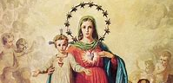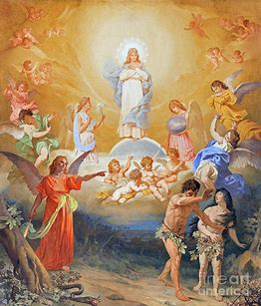
- Why is the Protoevangelium the “first good news”? What future events was it hinting at?
__________________________________________________________________________________________________________________________________________________________________________________________________________________________________________
- Compare and contrast: how is Jesus the “New Adam,” and Mother Mary the “New Eve”?
Adam | New Adam (Jesus)

Eve | New Eve (Mother Mary)

- When you make your Confirmation, you will be anointed, receiving a special blessing. God uniquely sets you apart as someone who goes into the world and serves Him. Like the angels who are messengers, or the evangelists who wrote the stories of Jesus in the Bible, how can we share the good news of Jesus? Why is it important that we share these messages with others?
__________________________________________________________________________________________________________________________________________________________________________________________________________________________________________
______________________________________________________________________________
Grade 9- “The Spirit of the Rosary: Prayer as the Golden Key”
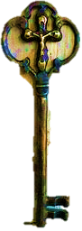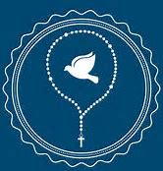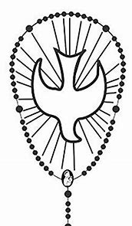
The autumn is a beautiful season of harvest. The seeds that were planted long ago have grown, and the fruits of the earth are ready. The seasons of nature are like the seasons of the Church, and the seasons in our lives. Prayer plants the seeds we need to harvest the Gifts of the Holy Spirit, and to produce good fruits, good works that honor God. The Gifts of the Holy Spirit help us to bring the goodness of God into the world. Fruits of the Holy Spirit, like joy and peace, are what we bring from using our gifts. We can use the Gift of Knowledge, for example, to teach what we know. Sharing our knowledge opens up another person’s mind and heart. It brings joy to learn new things, and it brings us joy to share what we have learned to help someone else.
Prayer helps our hearts become ready to receive the Gifts of the Holy Spirit in the sacrament of Confirmation. If we unwrap a gift before we are ready, we may not be able to appreciate the gift as much. But if we take time to pray and know God more, we can fully love and use the gifts He gives us well. We will have a better understanding of what to do with them. Mother Mary had a Heart of grace, free of sin. She had all of the Gifts of the Holy Spirit, and lived them well, because She prayed always, treasuring God’s love in Her Heart. As Jesus’ Mother, Mary helps us to know Jesus’ Heart.
In this month of the Holy Rosary, we can come to know Jesus better by praying the Rosary. The Rosary is the story of Jesus’ life, a form of prayer we can use in meditation. When we meditate, we take time to think about Jesus, focusing our minds and hearts on Him. The Joyful Mysteries start with Mother Mary learning that She was chosen to be Jesus’ Mother, and follow the events in Jesus’ and Mary’s life through Jesus’ childhood. The Sorrowful Mysteries tell us of Jesus’ suffering and death, but the Glorious Mysteries tell us of Jesus rising from the dead, following the events after His Resurrection, such as when He went to Heaven, when He sent the His Spirit, the Holy Ghost, to the apostles, and when Mother Mary went to Heaven.
Staying close to God in seasons of joy and sadness ultimately brings us to Heaven, as we see from the stories we think about while we pray the Rosary. The “Mysteries” of the Rosary are mysteries of faith, because they are heavenly things. Heavenly things are of God, and things of God cannot always be described in earthly, human ways, because they are so great. This is the beauty of the mysteries. The Holy Spirit can shed light on the Mysteries, helping us to better understand them, so we know how to live like Jesus and Mary in all seasons of life. In the Mysteries of the Rosary, we see Jesus’ and Mary’s love for God the Father and for us, the Two Hearts of Mother and Son joined together. As we celebrate Our Lady of the Rosary on October 7, we can pray for a grace-filled heart like Mother Mary’s, which will help us to use God’s gifts. Like Mary, as you open your heart to receiving God, He will fill your heart with the love in His Heart, making your heart more like His.
- In chapter 8 of your Devotion to the Holy Spirit book (pages 41-47), why do you think prayer is called the “golden key”? What does prayer do for us? How does it affect our relationship with the Holy Spirit?
_____________________________________________________________________________
_____________________________________________________________________________
_____________________________________________________________________________
_____________________________________________________________________________
- Meditate on the Third Glorious Mystery of the Rosary, the Descent of the Holy Ghost (Pentecost). Pentecost, when the Holy Spirit came, is the event in the Church we remember at Confirmation. You can see a guide to meditating on this Mystery here (scroll down to the Third Mystery): https://rosarycenter.org/the-glorious-mysteries-scripturally-based. Talk to God about your thoughts on this Mystery. Ask the Holy Spirit to inspire you, and guide your meditation. Meditation (contemplation) leads to action. Prayer can show us how God wants us to serve. Write down what you learned from meditating on this mystery. How did meditation help guide you to know how to act?
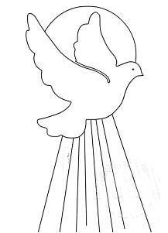
Going forward, how might you serve the Church like the apostles? Where might the Holy Spirit be leading you?
How did praying this Mystery impact you? How might you use prayer going forward to prepare for Confirmation?
What did you learn about the Third Glorious Mystery, Pentecost?

- How can the Rosary help us to know Jesus, and unlock the spiritual treasure of His Heart? _________________________________________________________________
___________________________________________________________________________
- Research a saint whose feast day we celebrate in October, like St. Francis of Assisi, St. Margaret Mary Alacoque, or St. Jude. Which Gift of the Holy Spirit did you see them use, and how did it help them produce good fruit, a Fruit of the Holy Spirit?
Name of Saint | Gift of the Holy Spirit | Fruit of the Holy Spirit
Week 2
Grade 7- “Good Deed Beads: Living on Prayer like St. Therese”
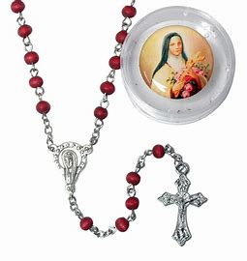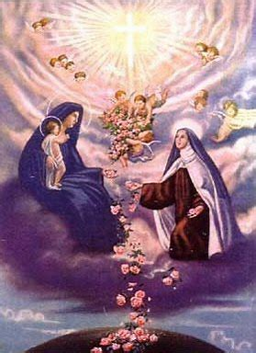
October 3 is the traditional feast day of St. Therese of Lisieux. St. Therese was a French Carmelite nun, a nun with a special devotion to Our Lady of Mount Carmel. Our Lady of Mount Carmel gave the brown scapular to St. Simon Stock. The scapular is a special devotional item that Mother Mary promised would protect its wearers. It is two pieces of cloth blessed by a priest that are joined together by a string, which is worn over the shoulders, like a long necklace.
St. Therese’s favorite form of prayer was mental prayer. Mental prayer is when a person puts their mind on God, focusing on uniting their heart with Jesus’ Heart. Mental prayer may not always mean saying written, formal prayers, but may be a personal conversation with God. Regular mental prayer is when a person talks to God, actively putting their minds on praying. Mystical mental prayer is listening to God, receiving His words into the heart, and being present; it is more about being rather than doing.
In her pocket, St. Therese always kept a rosary to pray. Mother Mary first gave the Rosary to St. Dominic. She called them her “sacrifice beads.” Throughout the day, she used the beads to count how many things she had offered up to God, good deeds that could help her and others get to Heaven. She challenged herself to grow in her faith, to do more for God. St. Therese wanted to offer up every small thing she did with love. She did not focus on greatness and success in the world. She was a living prayer who did all things humbly, for God. Offering her heart to God, she opened herself up to many blessings, but was always thinking of how she could bless others. She is still helping people from Heaven. Like Mother Mary, St. Therese listened to God’s plan for her, and was loyal to Him. Mother Mary is our most powerful intercessor, one who helps us. She triumphs through the Rosary and scapular, which she uses to save us, bringing us to Heaven. St. Therese also responds to our prayers, bringing them to Mother Mary.
St. Therese shows us how we can become holier over time by continuing to practice good habits each day, like praying the Rosary. She would build up gradually, never giving up. An acquired virtue is a virtue, a holy quality, we acquire, or earn, from practicing our faith. Virtues include faith, hope, and love. Our good habits help to make us more faithful, hopeful, and loving. They give us graces that lead us away from sin.
St. Therese said that after she went to Heaven, she would let a “shower of roses” fall. She would continue to bring people blessings on Earth, many more than she could have on Earth. It is like she is still counting the beads on her rosary, doing good deeds for us. It is said that when you pray to St. Therese, when your prayer is answered, you will smell the scent of roses. This holy fragrance reminds us of how sweet our faith and good works are to God.
- Design your own Rosary “good deed” beads. Research symbols of Mary you can draw on the beads. Why did you choose this/these symbols? Next to the Rosary, write something you would offer to God, a good deed you can do in honor of Our Lady this month.

__________________
__________________
__________________
__________________
__________________
__________________
__________________
__________________
__________________
__________________
__________________
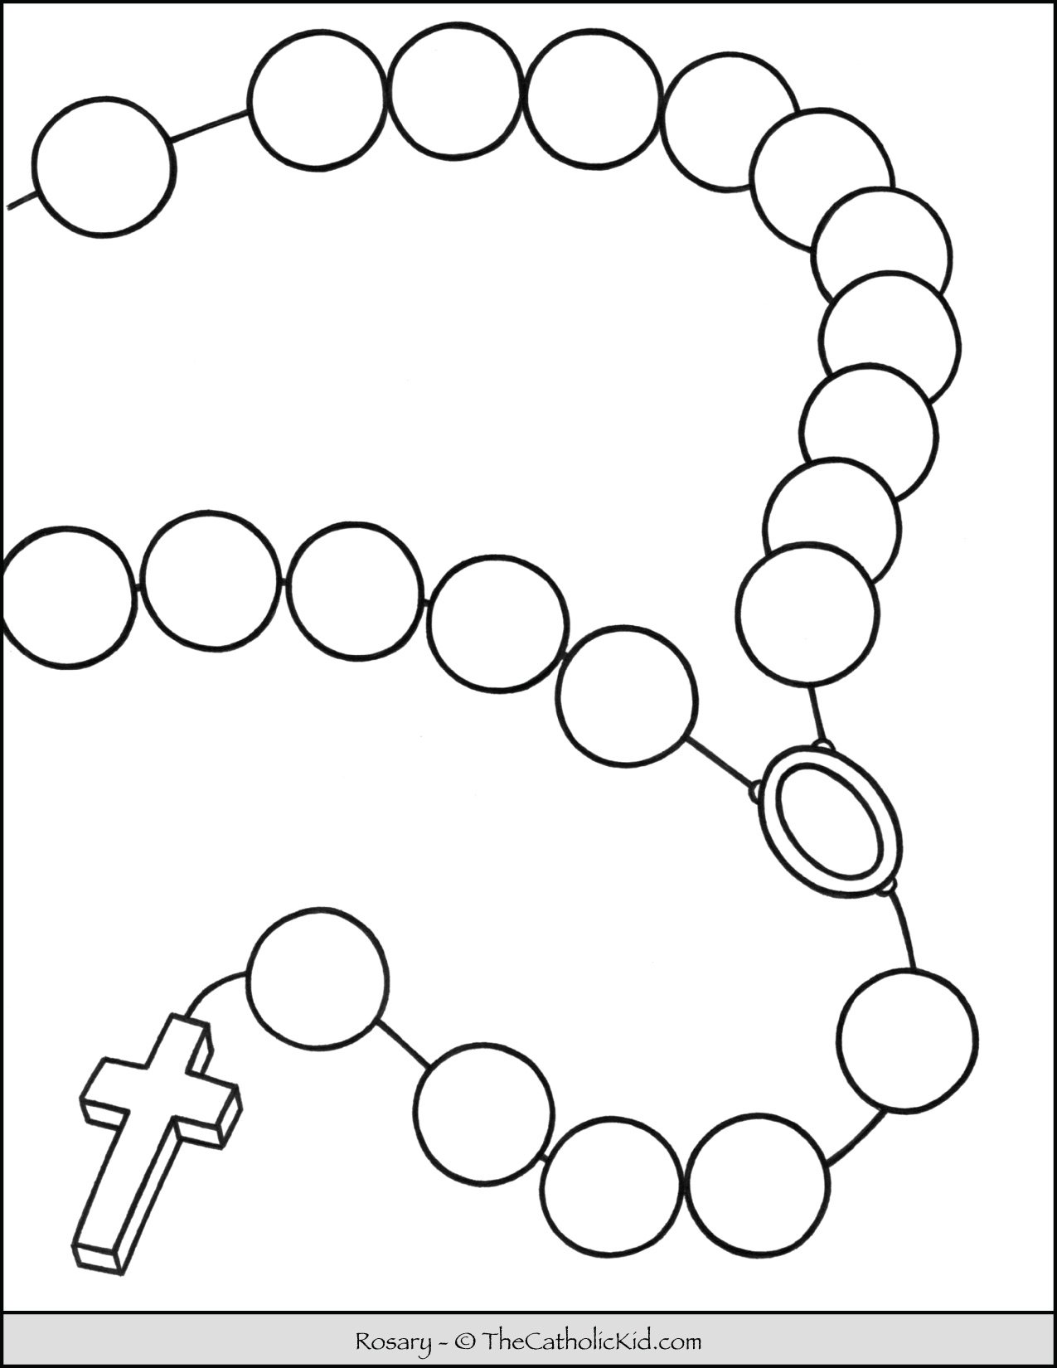
- October is the Month of the Holy Rosary, with the feast of Our Lady of the Rosary being on October 7. How do you think St. Therese lived like Mother Mary?
______________________________________________________________________________
______________________________________________________________________________
______________________________________________________________________________
- Compare the Rosary and the scapular. What is different about these devotions? What is one of Mother Mary’s promises to people who pray the Rosary? What is one of Her promises to people who wear the scapular?
Rosary | Scapular
- Our lady’s promise: | - OUR LADY’S PROMISE:

Grade 8- “Wearing Our Hearts on Our Sleeves: Bringing Jesus’ Love into the World”
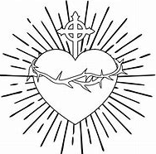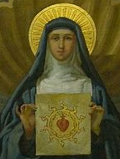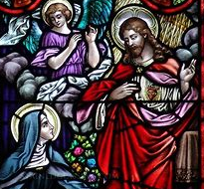
On October 17, we celebrate the traditional feast day of St. Margaret Mary Alacoque. St. Margaret Mary is the saint of the Sacred Heart of Jesus. Jesus came from Heaven to give St. Margaret Mary a special message. He told her to teach other people about His Sacred Heart. Jesus’ Heart is sacred, holy, because of the love He has for us. This is the love that led Him to give His life for us. At every Mass, we remember Jesus’ Sacrifice, and prepare to receive Him in our hearts at Communion.
St. Margaret Mary taught people about the Sacred Heart, including the First Friday tradition. Fridays are dedicated to Jesus, because Friday is the day He died on the Cross. This is why, traditionally, Catholics would not eat meat on any Friday during the year, not only during Lent. Jesus promised St. Margaret Mary that on the First Friday of every month, if people go to Mass and pray to His Sacred Heart in a special way, He will give them special blessings. God’s plan was for St. Margaret Mary to share Jesus’ message about the Sacred Heart in order to bring more people to Jesus. Becoming closer to the Sacred Heart, we open ourselves to receiving more of God’s love, more graces that help us in our lives.
Every time we receive the Eucharist, Jesus’ Body, we receive His Heart. When miracles of the Eucharist have happened (such as Hosts beginning to bleed, glowing with light, or showing images of Jesus’ face), the miraculous Hosts were sent to labs to be analyzed. Scientists would find that the Hosts were flesh from the human heart: Jesus’ Heart. Jesus is Really with us in the Eucharist. The Eucharist is how we come to know Jesus as He shows us His love. The Eucharist helps us to make our hearts more and more like Jesus’, full of kindness and care for others. Like St. Margaret Mary, we all can bring a heart like this into the world in the unique ways God calls us to use our talents.
There is an expression that we might “wear our hearts on our sleeves.” People who do this are showing what is in their hearts, sharing their thoughts and feelings openly. Jesus does this, sharing His Heart, and so do His priests and lay disciples. The clothes priests wear are symbols of Jesus, such as the cassock, a long black garment with the Roman collar. The white of the collar is a symbol of purity, a clean heart with love for Jesus. Black is a reminder of Christ dying for us, and is a color of mourning, of sadness, for people who do not yet know Christ. But sharing His love, visibly showing others what Jesus is like, can help to bring people to Jesus.
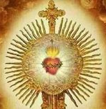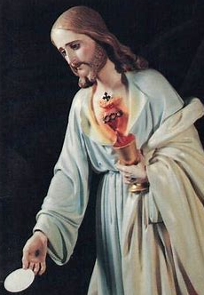
- How is the cassock the priest wears a reminder of Jesus’ life? What is the priest called to do? ____________________________________________________________
______________________________________________________________________________
______________________________________________________________________________
______________________________________________________________________________
- How did St. Margaret Mary Alacoque “wear her heart on her sleeve” to show people God’s love? What can you do to show others Jesus’ Heart, His kindness? As you prepare for Confirmation next year, think about ways you might choose to serve Jesus in the future.

Me
St. Margaret Mary
- What is the First Friday devotion? Why and how do we honor Fridays in the Church? _______________________________________________________________
_____________________________________________________________________________
_____________________________________________________________________________
- How do we see Jesus’ love at Communion? When we receive the Eucharist, what are we receiving, and how does this affect us? ___________________________________
_____________________________________________________________________________
_____________________________________________________________________________
______________________________________________________________________________
______________________________________________________________________________
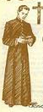
Grade 9- “Christ the King and the Queen of Heaven: The Crowning Glory of the Rosary”
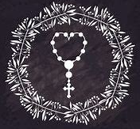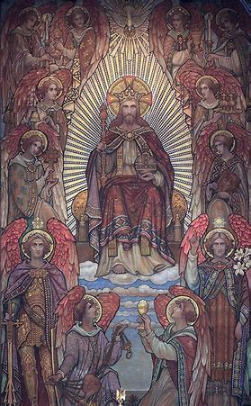
The Rosary is known as a “chaplet,” a little crown. Mother Mary, the Queen of Heaven, first gave the Rosary to St. Dominic to teach people how to pray. When we pray the Mysteries of the Rosary, we think of the joys, sorrows, and glories of Jesus’ and Mary’s lives. We see how Jesus’ suffering, which He went through willingly out of love for God the Father and for us, made His crown of thorns into a heavenly crown, a crown of roses. Through carrying His Cross, Jesus triumphed over death. He shows us that, through following Him, we can also overcome sin, suffering, and death to live forever with Him in Heaven.
Crowning royalty shows respect. Everything we do in the Church is to show respect for the holiness of God. A past tradition of the Church was the papal coronation. When a new pope was chosen to lead the Church forward, he was crowned in a special ceremony. The pope’s crowning represented how he was being prepared by Jesus to lead His Church. At Confirmation, it is like we are crowned by the Holy Spirit, prepared to lead lives that honor Jesus.
Confirmation is usually celebrated by the bishop, whose vestments are like royal garments, with his mitre, his hat, like a tall crown. Only bishops can give all of the sacraments. They celebrate the sacrament of Holy Orders to ordain new priests, giving them powers from Jesus. They pass down the Holy Spirit’s gifts from the apostles to us, and we pass on God’s love to others as we go into the world as Jesus’ followers. At Confirmation, it is like we are crowned with the graces and Gifts of the Holy Spirit. Our foreheads are anointed, blessed, with holy oil. In the past, headbands, like crowns, were worn at Confirmation. Three days after Confirmation, the forehead would be washed to show respect for the holy oil.
The Rosary is like the Bible, the story of God. Praying the Rosary helps us to get to Heaven, where we will one day be crowned with the angels and saints. Heaven is ruled by Christ the King. We celebrate the traditional feast day of Christ the King on October 29 this year. Christ the King is the leader of the Church, and He wants to reign over our hearts, too. When we pray the Rosary, we can focus our minds and hearts on loving Jesus.
Jesus is the Way. The Way he gives us is the Way to Heaven. We can be comforted in knowing that when we go through challenges, God is giving us what we need to help us become stronger, to get to Heaven. Jesus gives crosses to His friends. He wants you to know Him. We come to know Jesus through prayer, and when we go through challenges, we can understand more of what it was like for Jesus to carry His Cross. This helps us to open our hearts to greater love and compassion for others. When our hearts are open, Jesus can give us more of the love from His Heart. Jesus will reward you in Heaven for your kindness, and for not giving up. God sees what we can become. He gives us what we need to keep growing, and knows we are capable of more than we might believe. We all can use our talents to become leaders.
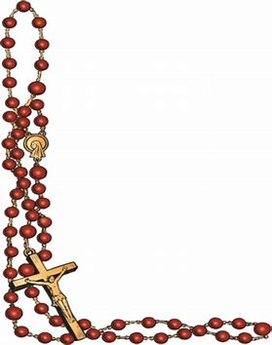
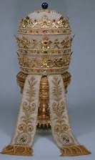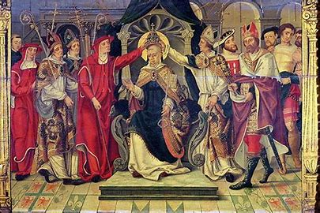
- Confirmation makes us soldiers for Christ, people who live for Jesus. The Bible tells us to “Put on the armor of God so that you may be able to stand firm” (Ephesians 6:11). Design a Confirmation headband. Research symbols of Christ and of Confirmation, and choose some to draw on your headband (the two pieces can be connected to form one headband).


Why did you choose the symbols that you did? What is their meaning?
____________________________________________________________________________________________________________________________________________________________
______________________________________________________________________________
- How can praying the Rosary help us to get to Heaven? _________________________
______________________________________________________________________________
______________________________________________________________________________
- Why is the crown an important symbol in the Church? What are some examples?
______________________________________________________________________________
______________________________________________________________________________
- How is Confirmation like a crowning? ______________________________________
______________________________________________________________________________
______________________________________________________________________________
- How can you honor Jesus on the Christ the King feast day this year?
______________________________________________________________________________
______________________________________________________________________________
Week 3
Grade 7- “At Home in the Sacred Heart: Finding Christ’s Peace with the Rosary”
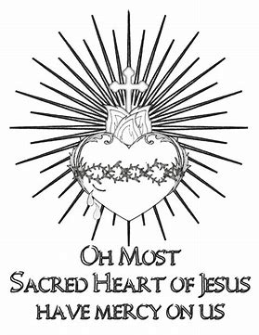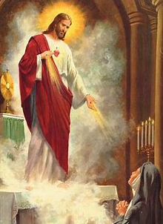
October is filled with feast days of saints who show us how to find peace in Jesus’ Heart. These saints lead us to Jesus through prayers and devotions like the Rosary. October 17 is the traditional feast day of St. Margaret Mary Alacoque, the saint of the Sacred Heart. St. Margaret Mary Alacoque, a French nun who lived in the 1600s, was visited by Jesus. She received visions that helped her to understand more about the Sacred Heart. She had the honor of putting her head on Jesus’ Heart. From being close to Jesus, she could see how much love Jesus has for all of us.
God had a special purpose for St. Margaret Mary. Her calling was to help other people come to love the Sacred Heart of Jesus as she did. To bring people closer to Jesus’ Heart, she taught people about going to Mass and praying to the Sacred Heart on First Fridays. She taught people about praying to make up for sins in the world, so that people can come to know Jesus and turn away from things that do not bring them closer to Him.
To reach Jesus’ Heart, we go to the Heart of His Mother. Mother Mary gave us the Rosary to become closer to Jesus. While praying the Rosary, we can offer up worries or petitions (prayer requests) to Mother Mary. She brings them to Jesus. He helps us carry our crosses. In this way, we find love and peace in Jesus’ Sacred Heart, and in Mother Mary’s Immaculate Heart. Making our home in Jesus’ Heart, and allowing Jesus to stay in our hearts, means that we can live with love, and do not have to fear. We have peace in knowing that Christ the King, Whose feast day we celebrate on October 29, is watching over everyone in His Kingdom, His Church. Christ is the greatest King, because no other king could love us like Jesus, Who gave His life for us.
Each Mystery of the Rosary shows us something of Jesus’ Heart, and Mother Mary’s Heart. The First Joyful Mystery, for example, is the Annunciation. This is when the Angel Gabriel announced to Mother Mary that She was chosen by God to be the Mother of Jesus, Our Savior, God’s only Son. Mother Mary said “yes” to God’s plan. She was not afraid of what a big or overwhelming plan this may have seemed to be. Instead, Her love for God won out, so She had the courage, faith, and hope in Her Heart to do what God was asking of Her. With a heart like Jesus’, we can see things with the love that God does. St. Ignatius, a Spanish priest, began the Jesuit order, the Society of Jesus. St. Ignatius created prayers of self-reflection that people can use to think about how they followed Jesus each day. St. Ignatius taught people to see God in all things, just as Jesus can see the goodness in each person. The Rosary also helps us to think about our actions, and how we can connect them to the way Jesus and Mary lived.
- How does the Rosary help us to know the Hearts of Jesus and Mary?
____________________________________________________________________________________________________________________________________________________________
- Research one of the Marian Mysteries of the Rosary in honor of Our Lady of the Rosary. Choose from one of the Joyful Mysteries: The Annunciation or the Visitation; or choose from one of the Glorious Mysteries: The Assumption or the Coronation.
Name of Rosary Mystery:
Feast Date (what day we celebrate this Mystery in the Church):
- What happened in this event from Mary’s life?

- How does this event show Mother Mary’s holiness? What did you learn about Mother Mary’s Heart from this Mystery?

- Why do you think the Rosary includes this Mystery honoring Mary?

- Why does the Sacred Heart of Jesus bring us peace? ___________________________
______________________________________________________________________________
- In October, we celebrate the feast day of St. Margaret Mary Alacoque, the saint of the Sacred Heart, and we also celebrate Christ the King’s feast day. How do you think these feast days are connected?
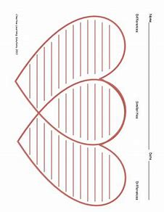
St. Margaret Mary Feast Day
Christ the King

Bonus: Visit the Sacred Heart enthronement site, https://welcomehisheart.com/. What happens at a Sacred Heart enthronement ceremony? ____________________________________________
_____________________________________________________________________________
Grade 8- “Full Circle: The Rosary, the Eucharist, and Christ’s Presence”
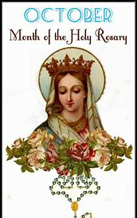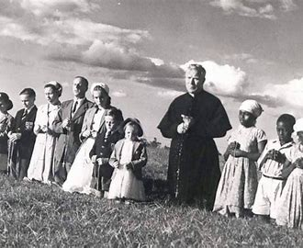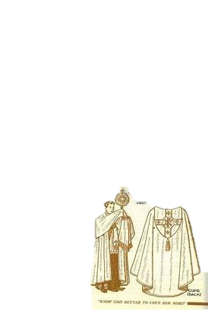
To bring the story of Jesus into the world, and pray for special blessings that will bring the world together under the protection of Jesus and Mary, sometimes people in the Church go on rosary processions. A procession is a walk, a parade of people. In Eucharistic processions, people follow a priest who carries the Eucharist. Everyone looks to the Eucharist, and is joined together as a community focused on God’s love. They show that they all follow Jesus. People are joined together in prayer on Rosary processions, and it is as though they are one voice speaking for Jesus. Whenever he processes with the Eucharist, the priest wears a type of clothing called the “cope,” which is like a cape he wears on his shoulders over the cassock. It is a symbol of the priest wrapping himself in the power of the Eucharist, surrounding Himself with the Presence of Jesus. The cope also reminds us of how we, like the priest, may carry a cross over our shoulders, like Jesus did. Jesus helps us to cope, to overcome challenges and become our best selves, giving us shelter and peace. His Mother, Mary, also takes us under Her wing, comforting us. As the Glorious Mysteries of the Rosary (about Jesus’ Resurrection) remind us, the Cross did not defeat Jesus, but transformed Him. He rose again, and went up to Heaven.
Father Patrick Peyton, an Irish priest who lived in recent times, is a wonderful example of how to live with joy and hope in Jesus. Fr. Peyton was inspired to teach people about the Rosary because of how it helped him in his life. As a child, he prayed the Rosary with his family every night. Growing up, he knew that he wanted to become a priest, but when he applied to the seminary, he was rejected. Fr. Peyton never gave up, and finally, was ordained a priest. Then, when he became seriously ill, and needed surgery, he prayed the Rosary, asking for Mother Mary’s guidance. The surgery would be risky, and he worried that, either way, whether he went through with the surgery or not, his health would be in danger. Miraculously, Fr. Peyton was healed, and did not need surgery. God had a special purpose for him.
Fr. Peyton stayed close to Jesus, keeping himself wrapped up in the beautiful mysteries of the Rosary, like a priest wrapping himself in the cope to carry the Eucharist. He brought Jesus into the world by sharing the beautiful prayers of the Rosary with families. He came back to where he began, with the family rosary, helping people to grow in their faith, just as the Rosary helped him to grow in his faith. Fr. Peyton is called the “rosary priest” because of how he went on TV and radio to speak about the Rosary, making people around the world aware of its power. The Rosary is a crown of prayers that forms a circle, just like the Eucharist. Jesus is the beginning and the end, bringing everything full-circle. He is our starting point, and our goal, as we journey towards Heaven. Christ is the King. He has us covered, helping us. Through Jesus in the Eucharist, and Mother Mary’s help through the Rosary, we can one day wear our crowns in Heaven. As messengers and guardians, the angels also help us to pray, and always respect Jesus’ Presence within us and around us.
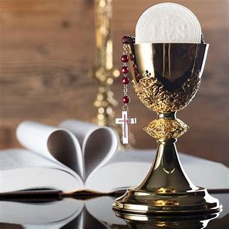
- Why do priests wear a garment called the “cope”? What is it a reminder of?
___________________________________________________________________________
___________________________________________________________________________

- How are the Rosary and the Eucharist connected?
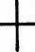
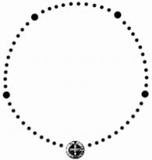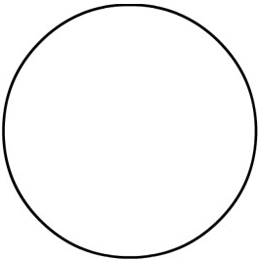
___________________________
___________________________
___________________________
___________________________
___________________________
________________________
________________________
________________________
________________________
________________________
- How did God bring things full-circle for Fr. Peyton?
____________________________________________________________________________________________________________________________________________________________
- How was Fr. Peyton a messenger for Jesus and Mother Mary?
____________________________________________________________________________________________________________________________________________________________

- After reading about Fr. Peyton, what example(s) did you see of Mother Mary and the guardian angels helping Fr. Peyton?
____________________________________________________________________________________________________________________________________________________________
- How does Fr. Peyton inspire you to live your faith?
____________________________________________________________________________________________________________________________________________________________

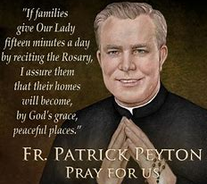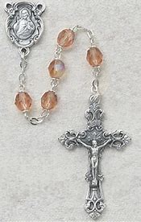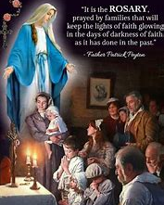
Grade 9- “Filled with the Spirit: Opening Our Hearts to God’s Gifts”
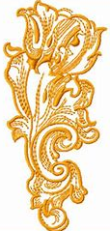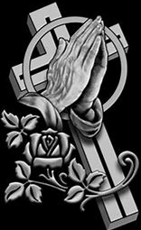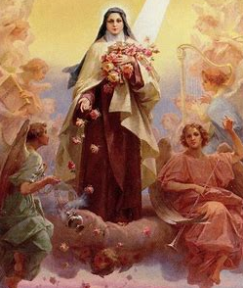
October 3 is the traditional feast day of St. Therese of Lisieux. St. Therese was a French nun who entered religious life at a very young age. She asked the Pope for permission to become a nun earlier than the typical age. In her short life, St. Therese made an incredible impact, and she continues to impact us in eternal life. When she first became a nun, St. Therese faced challenges in adapting to community life. She preferred to pray and reflect on God by herself, rather than praying aloud as a group. She loved the quiet and peace of contemplation, of thinking about God, but she used all of her actions to honor God as well. Some may have doubted St. Therese because she was young, but she proved that everyone has wisdom and love to share. We all can learn from each other, and see Jesus in each other, through acts of kindness.
St. Therese was only in her early twenties when she became very sick. Illness was a new cross to carry, but St. Therese did this cheerfully. She found strength from the Holy Spirit, Who inspired her to offer up to God even the smallest task or challenge she was facing. She trusted in God instead of losing hope, letting her heart be open to what God wanted for her, so that it could be filled with His love, with the Holy Spirit. St. Therese kept going, continuing to pray and work for God, knowing that God brings good out of everything. St. Therese’s habits of holiness, like praying the Rosary, helped her to move forward. Every small act of love adds up, making a big difference. Each good deed is a step on our way to Heaven, one rosary bead at a time. St. Therese is a patron of soldiers. At Confirmation, we become soldiers for Christ, making St. Therese a perfect patron for Confirmation candidates. Ask her to help you as you prepare.
As we prepare for Confirmation, we can start new holy habits that help us to make our hearts ready to receive the Gifts of the Holy Spirit. We make sure that we are in the right disposition, the right spirit or mindset, to make Confirmation. Both proximal and remote preparation for Confirmation is needed to put us in the right disposition. “Proximal” means “close,” so proximal preparation is what we do to prepare right before Confirmation, when we become close to the day of the Confirmation Mass. Going to Confession right before Confirmation helps us to have the right disposition, because it wipes our hearts clean of sin. “Remote” means “far,” so remote preparation is what we can start doing now, further ahead of Confirmation, to prepare, like praying the Rosary to the Holy Spirit. This October, we will honor Christ the King. Jesus is the King, because He conquered sin and death. As we prepare for Confirmation, our sins wiped away and forgiven at Confession, our hearts have room for the gifts, the blessings, God wants to give us. We receive what we need from God to help us achieve our goals, and become our best selves, as God envisioned us being.
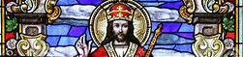
- Write down some remote and proximal actions you can take to prepare for Confirmation.
Proximal preparation | remote preparation
How can these steps help you to become closer to God, and prepare your heart to receive the Gifts of the Holy Spirit at Confirmation? _______________________________________
______________________________________________________________________________
______________________________________________________________________________
- St. Therese and St. Philip Neri were both saints devoted to the Holy Spirit, and responded to Him in unique ways. In chapter five of your Devotion to the Holy Spirit book (pages 23-24), what did you learn St. Philip Neri, the saint of joy, did every day? How do you think St. Therese lived out joy? Compare and contrast, writing your responses below.
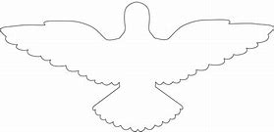
St. Philip Neri
St. Therese
- How can we be like St. Philip Neri and St. Therese as we prepare for Confirmation?
____________________________________________________________________________________________________________________________________________________________
- After reading about St. Therese, how did you see examples of the Holy Spirit working in her life?_______________________________________________________
______________________________________________________________________________
- It’s no coincidence that the saint of joy, St. Philip Neri, is also the saint of Confirmation. How do you think the sacrament of Confirmation brings joy?
______________________________________________________________________________
______________________________________________________________________________
October 2023 7-9 Review
Use this review sheet as a reference to track progress and check that learning goals are met.
Recap: What did I learn?
All Grades
- October is the month of the Holy Rosary
- We can grow in our relationship with Jesus through Mother Mary
- The Rosary, a gift from Mother Mary, helps us to better know and love Jesus and Mary
- The Joyful, Sorrowful, and Glorious Mysteries tell the stories of Jesus’ and Mary’s life. They reflect the stories of the Bible, helping us to focus our hearts and minds on Jesus and Mary as we pray
- The Mysteries show us the faith, hope, and love of Jesus and Mary. In the example set by Jesus, Mary, and the saints, we see how we, too, can live out virtues
- Praying the Rosary is a powerful spiritual practice that we can continue to honor throughout the year, not only in October
Grade 7
- Mental prayer is when we lift up our minds and hearts to God, focusing on Him
- When we pray the Rosary, we can take part in mental prayer as we reflect on the Mysteries of the Rosary, thinking about the lives of Jesus and Mary
- St. Francis of Assisi brought his faith into action, living out his prayers to God
- St. Francis served God through his vocation. He began the Franciscan order, and built up the Church
- We all can use our talents in building up the Church, especially through praying the Rosary
- St. Therese of Lisieux, a Carmelite nun, lived out her faith by doing everything in love for God
- She used the Rosary to keep track of good deeds she had done, and to challenge herself to keep growing in her love for God and others
- St. Therese shows us how we can become more virtuous, more full of faith, hope, and love, through holy habits we do every day. One of these habits that can help us is praying the Rosary
- St. Margaret Mary Alacoque lived out her calling from God to teach people about the love in Jesus’ Sacred Heart
- We grow closer to the Sacred Heart by coming to know and love Jesus more. The Rosary helps us to do this
- St. Ignatius, founder of the Jesuit order, teaches us to see God in all things. As we become closer to Jesus’ Heart, we can see with the eyes of our hearts, looking at things with love, as Jesus does, so that we want to care for God’s creation, as St. Francis did
Grade 8
- The Protoevangelium is the “first good news,” the story of God creating the world at the beginning of the Old Testament
- In the Protoevangelium, we read of Adam and Eve, the first man and woman God created, our first parents
- In the story of Adam and Eve, we see an example of disobedience to God, but the hope of the story is in how it hints at the New Adam and Eve to come: Jesus and Mary
- Jesus and Mother Mary reversed the sin of Adam and Eve with their sinlessness. They redeemed us, the descendants of Adam and Eve, from sin through their obedience to God
- We all can share the good news of Jesus and Mary, using our unique talents given by God
- St. Margaret Mary Alacoque brought Jesus’ message of love into the world by teaching people about the Sacred Heart
- She taught people about how to better love the Sacred Heart by going to Mass and praying for God’s forgiveness on the First Friday of every month
- We all can make Jesus’ love visible to others in how we live. Priests wear visible symbols of their faith. Vestments like the cassock and cope are reminders of Jesus’ humility and purity, His clean Heart, and constant Presence in our lives
- God brings everything full-circle, using all of our experiences to help us grow, and to share our faith so that others can thrive
- Jesus will help us to carry our crosses. Praying the Rosary carries us through our challenges by reminding us of the glory to come with Jesus
- Fr. Patrick Peyton, the rosary priest, brought people together by spreading the family rosary devotion. He faced challenges, but was brought closer to Jesus and Mary through the Rosary, and shared his faith by talking about the power of prayer to people around the world
Grade 9
- Prayer is the key to better knowing and loving God. God listens to our prayers, and works in us through our prayers
- The Holy Spirit gives us Gifts we receive at Confirmation. Through prayer, we learn how to use these Gifts to serve God
- Prayers plant seeds of faith that continue to grow as we keep working on learning about God. Meditation is a form of prayer that helps us clear our minds of distraction and focus on God
- Through meditating on the Mysteries of the Rosary, we can open our hearts to listening to what God is calling us to do. The Holy Spirit inspires us, helping us to understand
- We honor royalty with respect. In the same way, we honor holy things with great love
- Popes used to be crowned in papal coronations once they were elected to begin leading the Church. Through devotion to Christ the King, we can one day be crowned in Heaven
- Christ is King, since He has the greatest love, a love that overcame sin and death
- We can keep Christ as king of our lives by praying the Rosary, a “little crown” of prayers
- Praying the Rosary strengthened St. Therese of Lisieux. She lived out the “Little Way,” doing small things with great love, and offering up everything to God in faith
- Although she faced big adversities, St. Therese kept taking gradual steps to get to Heaven, helping people as much as possible on Earth. Now, she helps people in Heaven
- The saints show us how we can take proximal and remote steps to prepare to receive the sacraments with holiness, so that we have the right disposition
- To have the right disposition, or spirit, to receive a sacrament means to truly want to receive it out of love for God, with a clean heart
- To have the right disposition before Confirmation, one can go to Confession beforehand, keeping a spirit of love for God, and keeping away from sin
- Remote actions are things we do far ahead of time to get ready for a sacrament
- Proximal actions are done right before a sacrament to prepare to receive it
- We need remote and proximal actions to prepare for the sacraments
What vocabulary words did I practice?
Grade 7
Week 1
Franciscan
Mental prayer
Week 2
Acquired virtue
Carmelite
Week 3
Jesuit
Grade 8
Week 1
Protoevangelium
Week 2
Cassock
Week 3
Cope
Grade 9
Week 1
Meditation
Week 2
Papal coronation
Week 3
Disposition
Proximal preparation for the sacraments
Remote preparation for the sacraments
What prayers did I practice?
Grade 7
Prayer to the Sacred Heart for Inner Peace
Grade 8
Petition to Our Lady of the Rosary
Grade 9
Petition for Light
Checklist: Activity Completion
Grade 7
Week 1: “At Home in the Sacred Heart: Finding Christ’s Peace with the Rosary”
Week 2: “Good Deed Beads: Living on Prayer like St. Therese”
Week 3: “Building Faith: One Bead at a Time”
Grade 8
Week 1: “The First Good News: Sharing Prayers like Our Lady”
Week 2: “Wearing Our Hearts on Our Sleeves: Bringing Jesus’ Love into the World”
Week 3: “Full Circle: The Rosary, the Eucharist, and Christ’s Presence”
Grade 9
Week 1: “The Spirit of the Rosary: Prayer as the Golden Key”
Week 2: “Christ the King and the Queen of Heaven: The Crowning Glory of the Rosary”
Week 3: “Filled with the Spirit: Opening Our Hearts to God’s Gifts”
Quick Check:
Tell us about your experience with these activities this month! Our October 2023 Google Form for Grades 7-9 is available here: https://forms.gle/cT2Nv9ABVAsQEAAW8

