Our Lady of the Valley Religious Education

September 2023 Activity Packet

Grades 7-9

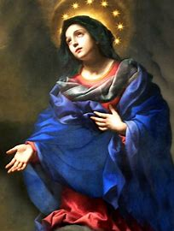
Name: ________________________________________
Materials Included in Packet
Overview…………………………………………………………………………………………3
Standards………………………………………………………………………………………...5
Pacing Guide……………………………………………………………………………………12
Activities…………………………………………………………………………………………17
Week 1…………………………………………………………………………………………...17
Grade 7……………………………………………………………………………….….17
Grade 8…………………………………………………………………………………..19
Grade 9…………………………………………………………………………..............21
Week 2…………………………………………………………………………………………...23
Grade 7……………………………………………………………………………….….23
Grade 8…………………………………………………………………………………..25
Grade 9…………………………………………………………………………..............27
Week 3…………………………………………………………………………………………..29
Grade 7……………………………………………………………………………….…29
Grade 8………………………………………………………………………………….31
Grade 9……..…………………………………………………………………………...33
Review………………………………………………………………………………………….35

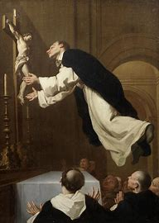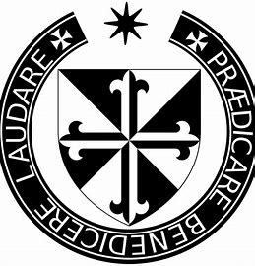
September 2023 Overview: Grades 7-9
Theme: Month of Our Lady’s Nativity (Birthday)
Monthly Prayer/Invocation: Mary, Mother of Christians, pray for us.
Thematic Guiding Questions, 7-9: What does it mean that we celebrate Our Lady’s “Nativity”? Why do we celebrate this?
- Throughout the Church year, we celebrate birth. Feast days are usually the days on which saints passed into the next life, also called their “birthdays in Heaven.”
How does Mother Mary help us find the way to Heaven?
- How are we reborn in Jesus (for example, how do the sacraments give us life in Christ)?
Saint of the Month: St. Teresa of Calcutta, the foundress of the Missionaries of Charity, devoted her life to caring for the poor and sick. Living in Calcutta, she used her ministry to treat all people with loving respect, tending to people who were suffering in body and soul. Just as Mother Mary brought hope and joy when She was born, and when She brought Her Son, Jesus, into the world, Mother Teresa brought hope. She taught her order of sisters to serve people with gladness, keeping smiles on their faces to reflect Jesus’ joy. St. Teresa of Calcutta reminds us that when we help others, we are serving Jesus.
Monthly Challenge: Choose something special that you can do as a gift to Our Lady for Her birthday. Have a “birthday party” to honor Mother Mary. Sing songs dedicated to Mother Mary, like “Immaculate Mary.” Honor Mother Mary like the saints did: read or watch a video about Mother Teresa, and talk about things you can do to help others like she did.
Overall Learning Goals: Our goal this month is to learn about the significance of Mother Mary’s role in salvation history. As we cultivate a deeper devotion to Mother Mary, we seek to further appreciate the ways in which grace has operated in Her soul, and how, through Her intercession, these graces are channeled from Mary to us, helping us to grow in our faith, so that we may be a loving servant to God like Her.
Summary of Activities: Our activities this month will center around the birthday of Mother Mary, looking broadly at how growth in our faith allows us to experience new hope in everything, so that, in Christ, we are continually reborn. To meet our learning goals of further connecting to Jesus through Mother Mary, we will use prayer, spiritual reflection, art, as well as studies of Catholic culture, liturgical traditions, Church history, and the beauty of the liturgical year. We will identify how we can keep reigniting our faith as we start a new year of growth. In reflecting on the Church year, we will explore how all feast days are interconnected, especially in the month of September, as we celebrate special days such as Priesthood Sunday, the Holy Name of Mary, the Exaltation of the Cross, and the Feast of the Archangels.
Additional Enrichment Ideas:
- Celebrate the birthday of Mother Mary on September 8. Decorate a home shrine table for Mother Mary with flowers. Have flower seeds blessed by a priest (a tradition on September 8). Listen to Marian hymns together or pray the Rosary as a family.
  - Come to our annual parish picnic on Sunday, September 17, beginning at 2:00 p.m., at the Sacred Heart campus (33 Franklin St., Easthampton) in honor of Our Lady’s Nativity
- Visit the monastery of the Dominican nuns in West Springfield, MA, in honor of the Dominican jubilee continuing this year. Join the prayer list and send your prayer requests to the nuns: https://vocationws.com/contact
- Pray before a crucifix on the Exaltation of the Cross feast day (September 14). Have crosses blessed in honor of this day
- Pray for priests on Priesthood Sunday (September 24). Write a thank-you card to give to a priest
- Have a Michaelmas feast. In honor of the Feast of the Archangels on September 29, eat meals with blackberries. Desserts with blackberries, or bannock breads with raisins, are eaten in honor of St. Michael. Legend has it that when St. Michael battled Satan, Satan fell in a blackberry bush, defeated. People eat blackberries on Michaelmas to celebrate the victory of St. Michael, and the triumph of God’s goodness. Other traditional harvest foods, such as carrots, are incorporated into Michaelmas meals. (Angel food cake is another popular choice, naturally! ) Michaelmas is the Catholic thanksgiving.
  - Say the St. Michael the Archangel Prayer.

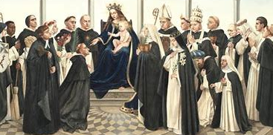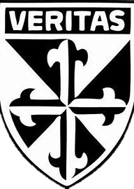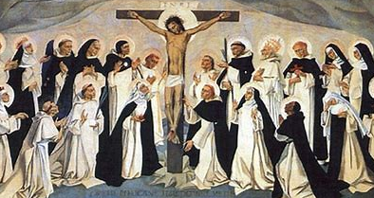
Standards
Grade Level | Week | Activities | Learning Standards
Grade 7 | 1 | “Graces and Gifts from Our Lady” | 7.1 Prayers are integral to our growth, as they allow us to connect with God, guiding us forward with faith and hope. When we pray, we are taking a constructive step to address worry in our lives…  Active and passive prayer (regular and mystical) are two forms of mental prayer that we see exercised in the lives of the saints, and that we can practice in our spiritual lives as well.
Grade 7 | 2 | “Order of the Soul: Honoring Mother Mary’s Holiness” | 7.3 There are seven “contrary virtues” counteracting the seven deadly sins: humility, liberality, chastity, meekness, temperance, brotherly love, and diligence.  7.6 There are different types of prayer, and distinct purposes for praying, but all prayer is meant to draw us closer to God…  7.10 Throughout Church history, there have been a variety of religious and secular orders founded by saints that have allowed for clergy and laypeople to live out their faith according to special charisms that deepen their relationships with God. Members of religious orders (first, second, and third) fulfill vows of poverty, chastity, and obedience to God, dedicating their lives to honoring Him, whether cloistered, or in the world.
Grade 7 | 3 | “Priesthood Sunday and Michaelmas: Giving Thanks for Our Priests” | 7.3 There are seven “contrary virtues” counteracting the seven deadly sins: humility, liberality, chastity, meekness, temperance, brotherly love, and diligence.  7.10 Throughout Church history, there have been a variety of religious and secular orders founded by saints that have allowed for clergy and laypeople to live out their faith according to special charisms that deepen their relationships with God. Members of religious orders (first, second, and third) fulfill vows of poverty, chastity, and obedience to God, dedicating their lives to honoring Him, whether cloistered, or in the world.
Grade 8 | 1 | “The Church and the Cross: Mary, Mother of the Church” | 8.1 Jesus is both fully human and fully divine, a phenomenon known as the hypostatic union. The Incarnation is when Jesus took on flesh, becoming man to be among us.  8.5 We rely on Sacred Scripture and Sacred Tradition to help us know and follow Christ.  8.7 Before Jesus’ Death, rituals like baptism were purely symbolic, but after He died, the sacraments became efficacious. They took on real weight, allowing us to know Christ while living our earthly lives. Our Mass is not merely a feast, but a sacrifice commemorating Jesus’ life, His self-gift. We can have a role in salvation history and live new life because of Christ’s sacrifice.  8.9 Mother Mary continues to shape history, working with us now, serving as a channel of grace, a mediator between ourselves and Her Son.
Grade 8 | 2 | “Mother Teresa, Mother Mary, and Finding Our Ministries” | 8.8 The Rosary shows us the sacraments’ layers of meaning by commemorating the events of Jesus’ and Mary’s lives, helping us to better understand their roles in salvation history… The Rosary reminds us that Christ has won salvation for each of us, and that there is a place for each of us in His family to serve and honor Him in a ministry that illuminates Christ’s light in the world, making Christ visible to others.
Grade 8 | 3 | “Standing by Jesus: Praying to Know Our Vocation” | 8.6 Sacraments, and the infinite graces flowing from them, are free gifts from God that must be freely accepted. God is personal and loving, giving us free will as an extension of His love… Receiving the sacraments, especially the Eucharist, gives us the graces we need to obediently serve God and answer the unique call He has for each of us.
Grade 9 | 1 | “A Graceful Dance: The Rhythms of the Church Year” | Jesus is the Bridegroom of the Church. The Church is Bride of Christ. Wed to the Church, Jesus is with us, never to abandon the faithful in the global body of the Church. Apostolic succession (the continuous line of Christ’s apostles, stemming from Peter) preserves this tradition through the priesthood. The priest becomes an “alter Christus,” another Christ, wed to the Church. Mary is wed to the Holy Spirit. The Holy Spirit overshadowed Her, allowing Her to naturally give birth to Jesus while preserving Her purity. Mary is the “New Eve” since She counteracted the disobedience of Eve with Her faithfulness; She brought hope into the world to counteract the suffering Adam and Eve brought with their sin.  9.8 Jesus instituted seven sacraments that align with major life stages. The spiritual life cycle of the sacraments mirrors the natural life cycle of the body. Baptism is birth, Confirmation is maturation, and the Eucharist is strengthening. Holy Orders and Marriage are lifelong service. Confession and Extreme Unction are preparation for transition into the next life, opportunities to make repairs, to restore, before death. These stages remind us of why the sacraments are essential to our growth, our wellbeing and strength, throughout the lifespan. The liturgical seasons are also representative of Christ’s life cycle of dying and rising, following two overlapping calendars: the Sanctoral and Temporal Cycles. While the Sanctoral Cycle tends towards set, unchanging dates for feast days of saints (that aren’t necessarily closely connected to the liturgical season), the Temporal Cycle is more likely to have moveable (changing) feast dates, because they are connected to the seasons tracing the rhythms of Christ’s life on Earth. Ultimately, everything circles back to the Sacrifice of Jesus, and the love of God that compelled it. At the heart of the Mass is the Sacrifice, the Eucharist, from which everything else flows.
Grade 9 | 2 | “Celebrating Our Mother: The Birthday of Mary and the Birthday of the Church” | S3.7 Confirmation marks not an end to catechesis, but a new beginning. Confirmation has real effects that allow us to grow as members of Christ’s family, exercising our roles as His children more fully and intentionally. There are five core effects of Confirmation, which helps us to: associate more fully with the mission of Mother Church, strengthen our bond with the Church, root ourselves more deeply in divine sonship, bear witness to Christ in word and deed, and perfect baptismal grace.
Grade 9 | 3 | “The Spirit of Christ: The Past, Present, and Future Church” | 9.7 When we receive the sacraments, we are more fully participating in the life of Christ, the life of the Church, and living out our purpose as Christians to love, living for God. All sacraments are meant to create a closer union between the soul and Christ. When we assist at the Mass, we more deeply unite our hearts with Christ, which prepares us for the Sacrifice, and the reception of Christ. The two forms of the Mass, the Extraordinary and Ordinary Forms, differently emphasize and respond to aspects of Christ’s life and Presence in the Eucharist, but we can always participate in the liturgy (worship of God) through inward and outward gestures of prayerfulness and reverence for God that express our love for Him, helping us to strengthen our relationship with Him.

September 2023 Pacing Guide (Suggested Schedule)
Grades 7-9
Week Number/Date | Grade Level | Activities
Week 1  (September 11, 2023 – September 15, 2023) | Grade 7 | “Graces and Gifts from Our Lady”
Week 1  (September 11, 2023 – September 15, 2023) | Grade 8 | “The Church and the Cross: Mary, Mother of the Church”
Week 1  (September 11, 2023 – September 15, 2023) | Grade 9 | “A Graceful Dance: The Rhythms of the Church Year”
Week 2  (September 18, 2023 – September 22, 2023) | Grade 7 | “Order of the Soul: Honoring Mother Mary’s Holiness”
Week 2  (September 18, 2023 – September 22, 2023) | Grade 8 | “Mother Teresa, Mother Mary, and Finding Our Ministries”
Week 2  (September 18, 2023 – September 22, 2023) | Grade 9 | “Celebrating Our Mother: The Birthday of Mary and the Birthday of the Church”
Week 3  (September 25, 2023 – September 29, 2023) | Grade 7 | “Priesthood Sunday and Michaelmas: Giving Thanks for Our Priests”
Week 3  (September 25, 2023 – September 29, 2023) | Grade 8 | “Standing by Jesus: Praying to Know Our Vocation”
Week 3  (September 25, 2023 – September 29, 2023) | Grade 9 | “The Spirit of Christ: The Past, Present, and Future Church”

Week Number/Date | Grade Level | Words to Practice | Definitions
Week 1  (September 11, 2023 – September 15, 2023) | Grade 7 | Cloistered | Separated from the worldly, whether in a monastery or convent of a religious order.
Week 1  (September 11, 2023 – September 15, 2023) | Grade 7 | Dominican | Members of the Order of Preachers religious order, called Dominicans, follow the Rule of St. Dominic, who began the order in 1216. The Dominican Order is known as the Order of Preachers for its emphasis on preaching the word of God and teaching.
Week 1  (September 11, 2023 – September 15, 2023) | Grade 8 | Ark of the Covenant | The wooden chest, or box, containing three sacred objects carried by the Hebrews when they wandered in the desert. The Ark held signs of God’s love, of His promise to provide for His people: Aaron’s staff, manna from Heaven, and the 10 Commandments tablets.
Week 1  (September 11, 2023 – September 15, 2023) | Grade 8 | Christology | The study of Jesus Christ.
Week 1  (September 11, 2023 – September 15, 2023) | Grade 9 | Moveable feast | A feast day that moves each year in the liturgical calendar. Moveable feasts do not have fixed (unchanging) dates. They have new dates each year in the Church, based on when other feast days fall.
Week 2  (September 18, 2023 – September 22, 2023) | Grade 7 | Benedictine | A member of the Order of St. Benedict, the religious order founded in 529 A.D. by St. Benedict of Nursia, is called a Benedictine. Benedictines live out the Rule of St. Benedict.
Week 2  (September 18, 2023 – September 22, 2023) | Grade 8 | Ministry | A special practice a person takes part in to serve God; the pathway they choose to honor Him, and share His love with others. Ministries allow people to contribute their God-given gifts and talents to building the Church. Examples of ministries include music ministry or campus ministry.
Week 2  (September 18, 2023 – September 22, 2023) | Grade 9 | Ecclesiology | The study of the Church.
Week 3  (September 25, 2023 – September 29, 2023) | Grade 7 | Tonsure | The practice of shaving one’s head among some religious orders, and the hairstyle itself; some or all of the hair is cut, but usually, just the top is shaved. When we see the tonsure of religious brothers at a monastery, we see a visible symbol of humility.
Week 3  (September 25, 2023 – September 29, 2023) | Grade 8 | Third order | When someone joins a religious order as a layperson, rather than as a consecrated priest or nun, they are entering the third order. They live out the promises and spirit of an order, but not as clergy.
Week 3  (September 25, 2023 – September 29, 2023) | Grade 9 | Extraordinary Form of the Mass | The Traditional Form of the Mass said before the New Mass instituted by the Vatican II Council in the early 1960s. The Extraordinary Form is in Latin, and emphasizes the Sacrifice of the Mass.
Week 3  (September 25, 2023 – September 29, 2023) | Grade 9 | Ordinary Form of the Mass | The Ordinary Form of the Mass instituted by the Vatican II Council (1962-5), and celebrated currently. The New Mass is said in the common language rather than in Latin. It emphasizes the Church as a community, focusing on the Mass as a Eucharistic meal, and the common, or baptismal, priesthood of the people.

Week Number/Date | Grade Level | Prayers to Practice | Text of Prayers
Week 1  (September 11, 2023 – September 15, 2023) | Grade 7 | St. Michael Prayer | St. Michael, the Archangel, defend us in battle; be our protection against the wickedness and snares of the devil. May God rebuke him, we humbly pray; and do thou, O Prince of the heavenly host, by the power of God, cast into Hell Satan and all the evil spirits, who roam through the world, seeking the ruin of souls. Amen.
Week 1  (September 11, 2023 – September 15, 2023) | Grade 8 | Act of Thanksgiving (St. Paul of the Cross) | Lord, I give Thee thanks for that Thou didst die upon the Cross for my sins.
Week 1  (September 11, 2023 – September 15, 2023) | Grade 9 | Petition to Know our Vocation | My Lord Jesus Christ, who didst die for my salvation, I implore Thee, through the merits of Thy passion, to give me light and strength to choose that state of life which is best for my salvation. Speak, Lord, for Thy servant heareth. Let me know what Thou wishest from me, and I will do all; and let me especially know in what state Thou wishest me to serve Thee: make Thou known to me the way in which I should walk, in order to reach Heaven. And Thou, my loving Mother Mary, obtain this grace for me through thy powerful intercession.
Week 2  (September 18, 2023 – September 22, 2023) | Grade 7 | St. Michael Prayer | St. Michael, the Archangel, defend us in battle; be our protection against the wickedness and snares of the devil. May God rebuke him, we humbly pray; and do thou, O Prince of the heavenly host, by the power of God, cast into Hell Satan and all the evil spirits, who roam through the world, seeking the ruin of souls. Amen.
Week 2  (September 18, 2023 – September 22, 2023) | Grade 8 | Petition to Know our Vocation | My Lord Jesus Christ, who didst die for my salvation, I implore Thee, through the merits of Thy passion, to give me light and strength to choose that state of life which is best for my salvation. Speak, Lord, for Thy servant heareth. Let me know what Thou wishest from me, and I will do all; and let me especially know in what state Thou wishest me to serve Thee: make Thou known to me the way in which I should walk, in order to reach Heaven. And Thou, my loving Mother Mary, obtain this grace for me through thy powerful intercession.
Week 2  (September 18, 2023 – September 22, 2023) | Grade 9 | Petition to Know our Vocation | My Lord Jesus Christ, who didst die for my salvation, I implore Thee, through the merits of Thy passion, to give me light and strength to choose that state of life which is best for my salvation. Speak, Lord, for Thy servant heareth. Let me know what Thou wishest from me, and I will do all; and let me especially know in what state Thou wishest me to serve Thee: make Thou known to me the way in which I should walk, in order to reach Heaven. And Thou, my loving Mother Mary, obtain this grace for me through thy powerful intercession.
Week 3  (September 25, 2023 – September 29, 2023) | Grade 7 | St. Michael Prayer | St. Michael, the Archangel, defend us in battle; be our protection against the wickedness and snares of the devil. May God rebuke him, we humbly pray; and do thou, O Prince of the heavenly host, by the power of God, cast into Hell Satan and all the evil spirits, who roam through the world, seeking the ruin of souls. Amen.
Week 3  (September 25, 2023 – September 29, 2023) | Grade 8 | Act of Thanksgiving (St. Paul of the Cross) | Lord, I give Thee thanks for that Thou didst die upon the Cross for my sins.
Week 3  (September 25, 2023 – September 29, 2023) | Grade 9 | Petition to Know our Vocation | My Lord Jesus Christ, who didst die for my salvation, I implore Thee, through the merits of Thy passion, to give me light and strength to choose that state of life which is best for my salvation. Speak, Lord, for Thy servant heareth. Let me know what Thou wishest from me, and I will do all; and let me especially know in what state Thou wishest me to serve Thee: make Thou known to me the way in which I should walk, in order to reach Heaven. And Thou, my loving Mother Mary, obtain this grace for me through thy powerful intercession.

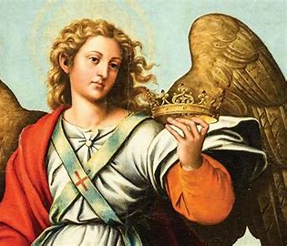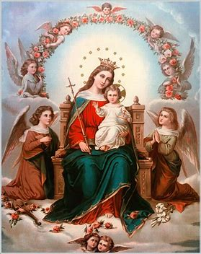
September 2023 7-9 Activities
Week 1, Grade 7- “Graces and Gifts from Our Lady”
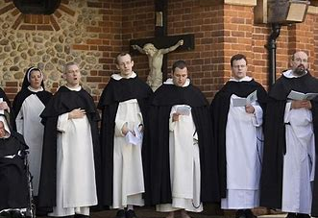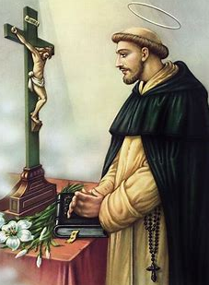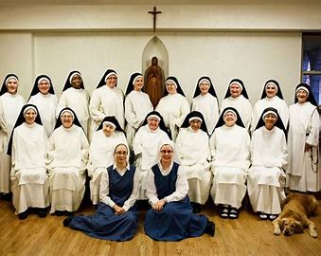
September 8 is the birthday of Mother Mary. Mother Mary has given us many gifts, and using them is how we can honor Her on Her birthday. One of the gifts Mother Mary has given us to help our souls is the Rosary. She gave the Spanish priest St. Dominic the Rosary to use in teaching others, and to spread devotion to Her. Before, people would say the prayers of the Rosary using a book called a psalter. There were 150 prayers.
The rosary beads that Mother Mary gave St. Dominic helped people to keep track of their prayers by counting the beads. The 150 prayers are broken up in a simpler way when using rosary beads. There are 5 decades of small beads representing the “Hail Mary” prayers. The root word “dec” in “decade,” means “10.” This means there are 10 “Hail Mary” prayers for each of the 5 Joyful Mysteries, each of the 5 Sorrowful Mysteries, and each of the 5 Glorious Mysteries, for a total of 150. Many people choose to pray one decade a day (10 “Hail Mary” prayers), or to focus on one of the Mystery categories per day, such as praying just the Joyful Mysteries (a total of 50 “Hail Mary” prayers). Others might pray all of the Mysteries throughout the day. For each decade of “Hail Mary” prayers, there is also an “Our Father,” “Glory Be,” and “Fatima Prayer.”
In addition to being known as the rosary saint, St. Dominic is also known for starting a religious order called the Dominicans. The monks and nuns in the Dominican order are known for their preaching and teaching. When you see the letters “O.P.” after someone’s name, you know they are a member of the “Order of Preachers,” the Dominicans. The Dominican mission is to “praise, bless, and preach.” They live out the word “veritas,” which is Latin for “truth.” The goal of the Dominicans is to teach people the truth by teaching them about Jesus, Who is the Way, the Truth, and the Life. We can trust what the Bible says. What God said would happen has happened. He promised to send a Savior, and Jesus came to us. The truth sets us free.
Some Dominican monks and nuns are cloistered, meaning they live away from the world in monasteries and convents. They do this to focus their lives completely on prayer, giving themselves to God. We may not be cloistered, but we can grow in faith through prayer, too. Mother Mary gave all people the Rosary as a way to get to Heaven. Praying the Rosary helps us to focus on Jesus and Mary as we reflect on the events of their lives, and how, no matter what they were going through, they had faith in God the Father. St. Dominic received great blessings, gifts and graces, from Mother Mary and Jesus, like the Rosary, because of his deep prayer life. Sometimes he would be so deep in prayer, so full of joy for God, that when he said Mass, he would float above the ground. Prayer might not cause us to levitate like St. Dominic, but we can lift up our minds and hearts in love to Jesus. When we read the Bible and pray, we can hear Jesus’ love for us in the words he says to the people He meets. Because Jesus rose from the dead, our hearts can be lifted in joy and hope.
- What is the saying the Dominicans live by? What does this saying mean to you, and how do you think you can live it out?
________________________________________________________________________________________________________________________________________________________________________________________________________________________________________________________________________________________________________________________
- St. Dominic was given the Rosary by Mother Mary. Why is the Rosary a gift to us, to our souls?
__________________________________________________________________________________________________________________________________________________________________________________________________________________________________________
- Another famous Dominican monk was St. Thomas Aquinas, whose 800th birthday anniversary will happen in 2025. Through January 28, 2025, people can gain special blessings from visiting churches connected to the Dominican order.
Research the Dominican Monastery of the Mother of God, which is in nearby West Springfield, MA. You can visit their website here: https://vocationws.com/
Write your own “newspaper article” to share what you learned about the Dominican nuns. In your article, answer these questions:
- How do the nuns live out the spirit of the Dominican order?
- What are some of the prayers or devotions the nuns take part in each day?
- How do you see the nuns’ love for Mother Mary?

Grade 8- “The Church and the Cross: Mary, Mother of the Church”
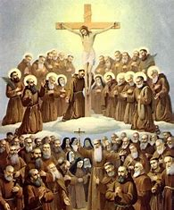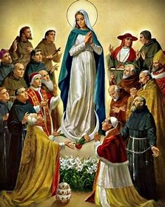
September 14 is the Exaltation of the Cross. If we “exalt” something, we lift it up. We praise it and honor it. The Cross was redeemed by Jesus. He made it into a symbol of victory over death, which is why we also refer to this feast day as the “Triumph” of the True Cross. Jesus helps us to carry crosses, the heavy things we have in life, to make them feel lighter. September is the month of Mother Mary’s birth as well. If She had not been born, Jesus would not have been born, and saved us through the Cross. Mother Mary was with Jesus from the beginning, and was with Him until the end, standing by the Cross. She is with us, too.
Christology is the study of Jesus Christ. To know Jesus, we learn about the Cross, because God is love. We know Jesus by knowing His love, and it is His love that allowed Him to overcome the Cross. We “exalt” the Cross, lifting it up, knowing that Jesus has already won the biggest battle for us by overcoming the Cross. We can lift our crosses because Jesus did. Saints like Paul of the Cross have prayers of thanksgiving for the Cross. We thank God for the Cross, because while it seemed like something impossible to carry at first, God brought so much good out of it, more than if Jesus had never gone through with it. Through the challenges, the greatest good came, as Jesus saved all people, and rose again.
On September 14, we remember when St. Helen, the mother of the emperor Constantine, found the True Cross. St. Helen traveled to Jerusalem, where Jesus died years after Jesus’ Death and Resurrection. There, she found three crosses. When she touched a piece of one of the crosses to someone who was sick, the person was healed. This is how she knew it was really Jesus’ Cross. By Jesus’ Sacrifice on the Cross, we all were saved, and continue to be healed by Jesus. When St. Helen’s son, Constantine, was going to battle, he saw an image of the Cross appear in the sky. He won the battle, and became emperor. Seeing how Jesus was with Him through His battle, He was inspired to become a Christian, making him the first Christian emperor.
This year, the Exaltation of the Cross falls on a Thursday. Thursday is the day of the week specially dedicated to the Eucharist. Jesus gives us new life in the Eucharist. He gives us the hope of Heaven, gained for us through His Sacrifice on the Cross. At every Mass, we remember Jesus’ Sacrifice. We focus not only on His dying, but most of all, on His rising. Every Communion is like a birthday in Christ. As we celebrate Mother Mary’ s birthday this month, we can remember that Mother Mary also had Her Crosses. When She learned that She was chosen to be the Mother of the Savior, She knew what was to come. The Old Testament Scriptures said the Savior would be a suffering servant. But Mother Mary trusted in God, saying “yes” to His plan. She planted seeds of faith by saying “yes” to God. Jesus was born, grew, and became the Bread of Life. Now, the Church continues to grow. One “yes” to God, one person’s faith, helped bring so much growth. It is no wonder that on Mother Mary’s birthday September 8, seeds are blessed.
1. How are the Cross and the Eucharist connected? _________________________________
_____________________________________________________________________________
_____________________________________________________________________________
2. How can you honor, or “exalt,” Jesus’ Cross? Below, write some ideas for devotions or traditions you can practice. If you like, research past traditions in the Church for celebrating the Exaltation feast day on September 14.
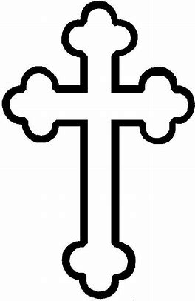

______________________________
______________________________
______________________________
______________________________
______________________________
______________________________
______________________________
______________________________
______________________________
3. It is special that September is the month of both Mother Mary’s birthday, and the Exaltation of the Cross. How did Jesus and Mary both show faith in how they carried their Crosses?
__________________________________________________________________________________________________________________________________________________________________________________________________________________________________________
- What is the Cross a symbol of? How did the symbol of the Cross help Constantine?
__________________________________________________________________________________________________________________________________________________________________________________________________________________________________________
______________________________________________________________________________

Grade 9- “A Graceful Dance: The Rhythms of the Church Year”
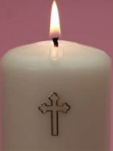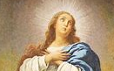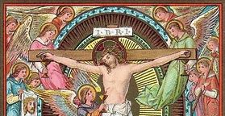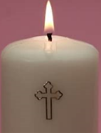
Time is holy in the Church. Our time is a gift from God. He gives us the time we need to do what He has called us to do. Time on Earth measures things that change. In Heaven, we are with God, Who never changes. God is love, and God’s love is forever, so Heaven is changeless. Time is not measured the same way in Heaven. God’s time is different than our time, but God’s time is always the right time. We can trust that God has the perfect plan for how our time should be used. He knows how to use time to prepare us so that we are ready to become our best selves, and experience the things that will help us grow. Every hour of the day is holy, every day of the week is holy, and every month of the year is holy. As you prepare for receiving more of the Holy Spirit’s graces at Confirmation, we will focus on the Holy Spirit’s special times. 9:00 a.m. is the hour of the Holy Spirit, and Monday is the day of the week specially dedicated to the Holy Spirit.
Our Church year is organized by feast days, including moveable feasts, feast dates that change each year, according to the other dates in the calendar. Pentecost, the day we celebrate the Holy Spirit coming down to the apostles, is a moveable feast. It falls on a different day every year, because its date is based on when Easter is. Easter is based on when Lent starts, and Lent starts on a different date every year. All days in the Church are connected. Nothing in the Church stands alone. The more we learn about the Church, the more we see how God planned for everyone and everything to work together for His glory. The Church year is like a graceful dance to the music of God, with every step coordinated perfectly, in harmony. We join this dance by coming to Mass, praying, and learning about God. We participate by celebrating God with joy, remembering that Jesus won every battle for us, and will help us through our crosses, too.
In September, we celebrate feast days dedicated to Mother Mary that do not change, such as Her birthday on September 8. December 8 is the Immaculate Conception, when Mary was created by God in the womb. December 8 through September 8 marks the time leading up to Her birth. God made Mother Mary a sinless person, an “immaculate” person clean of heart. The Holy Spirit was always working in Mother Mary. Through the Holy Spirit, She could be born a sinless human being, and then give birth to the Son of God, another sinless human being. Mother Mary is considered to be the Bride of the Holy Spirit. By the Holy Spirit, She was given every grace. God originally planned for every person to be full of grace, but when Adam and Eve sinned, these graces were lost, and the people after Adam and Eve were born with sin, except for Mother Mary and Jesus. Mother Mary is an example of how the soul is made perfect by grace.
We receive the sacraments for graces to be restored in us. Participating in the life of the Church year-round by going to Mass, receiving Communion, and going to Confession gives us special graces, which you will receive even more of at Confirmation. Every feast day, we remember the lives of Jesus, Mary, and the saints who lived with God’s love, just like them. The Church year reflects the cycle of dying and rising in Jesus’ life. The sacraments we receive commemorate Jesus’ dying and rising. At Confession and Communion, we die to sin, and accept new life in Christ, Who gives us the food we need for our souls to live forever. As the Church year starts again, we remember that with God, there are no endings. Everything comes back to the center, where it all begins: with God. Through the graces of the Holy Spirit, like Mother Mary, we can help to build up the Church and inspire other people to turn to Jesus, Who saves us.
- Read chapter 7 (pages 38-40) in your Devotion to the Holy Spirit book. Why should we seek grace from God through Mother Mary? ______________________________
______________________________________________________________________________
- How does the Church calendar inspire us to live like Jesus and Mary year-round?
____________________________________________________________________________________________________________________________________________________________
- Mother Mary needed special graces from the Holy Spirit to guide all of us as Her spiritual daughters and sons. Why do you think we need graces from the Holy Spirit at Confirmation? ________________________________________________________
______________________________________________________________________________
- As you plan your time to prepare for Confirmation, make a calendar of your favorite feast days/holy days in the Church. Choose 3 that inspire you to become closer to God, that make you want to learn more about Him. If you like, focus on feast days in September to learn about how you can honor Jesus and Mother Mary in this month.
Name of Feast Day | Date in 2024 (Moveable or Fixed?) | What event in the Church does this celebrate (what happened on this day)? | What is a special tradition connected to this feast day?

In general, why are these feast days special to you? What do they teach you about God, or reveal to you about how the Holy Spirit works in our lives? __________________________
_____________________________________________________________________________
_____________________________________________________________________________
____________________________________________________________________________________________________________________________________________________________
Week 2
Grade 7- “Order of the Soul: Honoring Mother Mary’s Holiness”
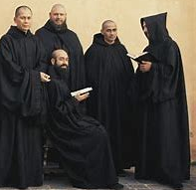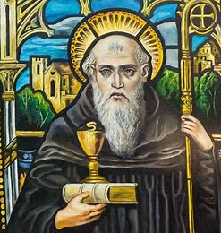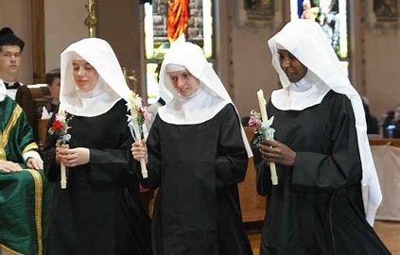
Benedictine monks St. Benedict Benedictine nuns
On September 12, just a few days after Mother Mary’s birthday, we celebrate the feast day of Her Holy Name. Mother Mary’s Name is holy, because when we say it, we are reminded of Her perfect harmony, the balance of every good, holy quality, of faith, hope, and love, in Her Heart. Piety, or holiness, is said to be the order of the soul. When things are in good order, they go smoothly. We have balance and peace. Holiness is what helps our hearts and souls to be full of peace and balance. The more we practice holiness in our lives, the more good order we can have. This month of September, we celebrate the birthday of Mother Mary. Mother Mary is a beautiful example of holiness. She had peace in Her soul from trusting in God, listening to His plan, even when it seemed so much bigger than Her, or hard to fully understand. Everything turned out for the good, since She followed God’s plan. She gave birth to Jesus, the human example of God’s holiness and peace, which come from His love. Mary and Jesus brought order into the world by starting with peace in their own souls.
In Mother Mary, there is perfect balance. She was born without sin so that She could give birth to Jesus, the sinless Son of God. From not listening to God’s plan, Adam and Eve brought suffering, labor, and death into the world, but Mary brought life, hope, and healing into the world through listening to God and giving birth to Jesus. She had all of God’s graces in Her soul, all of the graces God had planned for every human being to have, before the sin of Adam and Eve. When we stay close to Mary, She helps us to have balance and peace, too. She helps to lead us to Jesus, Who gives us special graces in sacraments like the Eucharist. The Eucharist is what will bring us to Heaven and restores our souls, perfecting us, so that we are freed, brought back to life.
“Order” has another meaning in the Church. An order is also a religious group a monk or nun may belong to. Some monks and nuns choose to live out their promises to God by living away from the world. They live in communities dedicated to praying, going to Mass, and growing in their faith in God every day. The Benedictines belong to a religious order started by St. Benedict. The Benedictines live out the Latin saying “ora and labora,” which means “prayer and work.” They believe in making the work they do into a prayer they offer up to God. Everything they do, whether working on the monastery farm, or singing chants (religious hymns), is done for God out of love, lifted up as a prayer. Balancing prayer and work brings peace. The St. Benedict medal even has the Latin word “pax,” meaning “peace.” To live in harmony as a community, making work go smoothly, the members of the Benedictine order stay focused on God, working together to honor Him through their prayers and service. Not all of us are called to be monks or nuns, but we are called to do things in love for God, as they do.
- Compare and contrast the Dominicans and the Benedictines. How do they live out the virtues of faith, hope, and love uniquely?

Benedictines
Dominicans

- Which order’s mission or spirit do you most connect with, and why?
____________________________________________________________________________________________________________________________________________________________
- How is Mother Mary an example of perfect balance?
____________________________________________________________________________________________________________________________________________________________
- How do Benedictines keep harmony in their communities?
____________________________________________________________________________________________________________________________________________________________
- Thinking of the religious orders we have learned about, and the example of Mother Mary, how can we, too, bring harmony to our Church and community?
____________________________________________________________________________________________________________________________________________________________
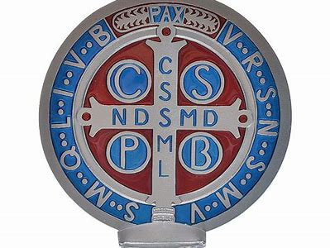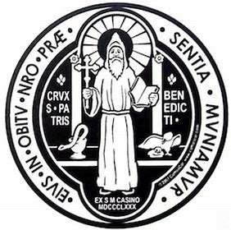
Grade 8- “Mother Teresa, Mother Mary, and Finding Our Ministries”
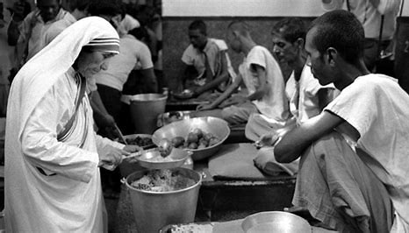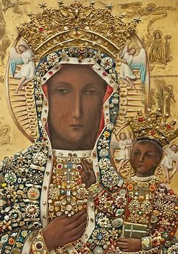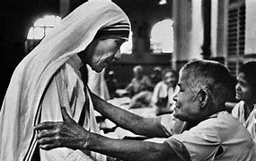
September 12 is the feast day of the Holy Name of Mary. As the Mother of Jesus, Mary is holy. Just as we respect the Name of Her Son, Our Savior, we honor the Name of Mary. The Name “Mary” comes from the Latin word for “sea.” Mother Mary is known as “Stella Maris,” the “Star of the Sea.” Mother Mary is the star that leads us to Jesus, the light that shows us the way as we travel. When you look at Madonna and Child paintings (portraits of Mary holding the baby Jesus), you will often see Her pointing to Jesus. The image of Our Lady of Czestochowa, the Polish Madonna, is an example of this, as Mary points to Her Son, reminding us that He is the Way. Through Mary, we reach Jesus, the Way to Heaven. We all can be holy like Mary through loving God, which we can do by caring for His creation, His people.
Mary and Her Name are holy, because of Mother Mary’s love for God. Mother Mary shows us how to minister to others. She cared for Jesus with gentleness. Mother Mary ministered to Her cousin, Elizabeth, going to help her when Elizabeth was preparing to have her son, John the Baptist. Jesus ministered to people by teaching and healing them, showing them the love of God the Father. We each have a special calling from God. There is a ministry for each of us, a way for us to share our faith. When we use our talents to share our faith, we grow in holiness, and live out our beliefs. In our church, there are many ministries to become involved in to help others and serve Jesus. Music ministry is a powerful way to share love for God by singing in the church choir. Helping with the sandwich ministry, you can prepare food to be shared with people in need. You might also assist with the gardening ministry, helping to care for the church grounds.
St. Teresa of Calcutta, better known as Mother Teresa, had a ministry inspired by her love for Mother Mary. She went into the streets of Calcutta, helping the poorest of the poor. Many were sick or dying, left to care for themselves alone. It seemed they had nothing, but they did have Mother Teresa. She cared for them, giving them food, shelter, medicine, and true kindness. Mother Teresa’s ministry was challenging. She saw suffering, but prayed for Mother Mary’s guidance. This helped her to never lose hope. Around the world, Mother Teresa was honored for her holiness. She pointed the way to Jesus, giving people a visible example of His love. She was humble, saying, “I am not called to be successful, I am called to be faithful.” She showed people that they are never alone, that God will not abandon them, because His love is forever. Novena prayers are said for nine days in a row, but when in need, Mother Teresa would take a few minutes to pray a “flying novena”, saying 9 “Memorare” prayers in a row. She let Mother Mary guide her, which helped her to be faithful in her ministry. She heard God’s call, and listened to it. To be successful, Mother Teresa shows, is to be faithful to God, to trust that He will create truly beautiful results from our efforts, more than we could imagine. Our work for God makes a deep impact. Things of the world fade, but things from God last forever.

- List some additional examples of church ministries in the chart below. You can research more about our church organizations on our parish’s website (https://olveasthampton.org/), or check the bulletin. Take note of what each ministry does to serve the Church, and how it reminds you of Jesus’ service.
Church Ministry | How do people serve Jesus and others in this ministry? | How does this ministry reflect Jesus’ spirit/ His service to others?
Music ministry
Sandwich ministry/
Take and Eat
Gardening ministry

What do these ministries have in common? ________________________________________
- As you prepare for Confirmation next year, thinking about how you might want to serve Jesus in the future, write down some ministries that you are interested in helping with. Which ministry do you connect most with, and why?
__________________________________________________________________________________________________________________________________________________________________________________________________________________________________________
- We learned that this month, we celebrate the feast day of Mother Mary’s Holy Name. After learning about types of ministries, what do you think it means to be “holy”? How was Mother Teresa an example of holiness like Mother Mary?
__________________________________________________________________________________________________________________________________________________________________________________________________________________________________________
- How can you be like Mother Teresa, serving God in your own ministry?
____________________________________________________________________________________________________________________________________________________________
- What does Mother Teresa’s quote about being “called to be faithful, not successful” mean to you? What do you think it means to have true success?
____________________________________________________________________________________________________________________________________________________________
Grade 9- “Celebrating Our Mother: The Birthday of Mary and the Birthday of the Church”
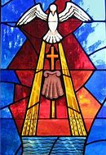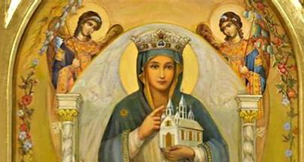
We call our Church “Mother Church.” The Church is the Bride of Christ. Jesus gave His life to the Church out of love. We are members of Jesus’ family, the Church. He sacrificed His life to save us. Jesus’ Mother, Mary, is the Mother of the Church, since Jesus is united with the Church.
When we celebrate Mother Mary’s birthday this month, we can be thinking of the birthday of the Church as well. Because Mother Mary gave birth to Jesus, Who built the Church, Mother Mary is our Mother in Heaven, too. Her birthday is linked to the birthday of the Church. We call Pentecost the official birthday of the Church. This is when the Holy Spirit came to the apostles, like Peter, to bring them the gifts they would need to keep Jesus’ Church going, once Jesus went to Heaven. The apostles baptized many new Catholics, and baptism is like a second birthday for us, as we become children of God for life. Every Confirmation is a remembrance of Pentecost, since we receive the Gifts of the Holy Spirit. We choose a Confirmation saint name, and it is like we are reborn again, growing in our faith even more. Mother Church welcomes us at Confirmation. We receive the gifts we need to better love the Church, and serve Jesus in the Church, as a community of people who share their love for Him.
As we prepare for Confirmation, we learn more about the Church. The study of the Church is called ecclesiology. Learning about the Church helps us understand more about what God is calling us to do in the Church. We learn about our Church traditions, and why we celebrate them. When we understand where we came from, we know where we can go in the future. The more we learn, the more we know. The more we know something, the more we can love it.
Confirmation is not symbolic, but is real. It leaves a special mark on the soul for life. We have more of the graces we need to be faithful to God in how we live our lives. God positively transforms our souls. One of the effects of Confirmation, something the sacrament does for us, is to help us to more fully live out the mission of the Church. The Church’s mission is to continue Jesus’ work of teaching and loving others, to ultimately help lead them to the Truth, the path to Heaven. Through the graces of Confirmation, we are made stronger friends of Christ in the Church. The changes in our souls after Confirmation happen because of the Holy Spirit.
Jesus sent the Holy Spirit to be with His people after He went to Heaven, so that we would always have a friend, an advocate, to help us. The Holy Spirit works in us so we can do good things for God, things that are better than if we tried to work alone, on our own strength. There is no limit to what God can do. Letting God work in us, any of our dreams are possible.
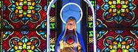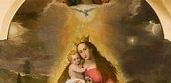
- On our birthdays, we celebrate growth. Birthday candles are a symbol of hope and light for our new year. When the Holy Spirit came to give the apostles Gifts they needed to grow in faith, He came as “flames,” a holy fire that inspired the apostles.
Read chapter 3 (pages 9-14) in your Devotion to the Holy Spirit book. Next to each of the candles, write something that the Holy Spirit does for our souls.

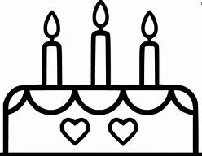
How do you think the Holy Spirit will help you to grow as a follower of Christ in the Church? _____________________________________________________________________
_____________________________________________________________________________
- Why do we need the Holy Spirit to do this for our souls, rather than doing things on our own strength?
____________________________________________________________________________________________________________________________________________________________
- Why do we call the Church “Mother” Church?
____________________________________________________________________________________________________________________________________________________________
- How does Confirmation affect our relationship to the Church?
____________________________________________________________________________________________________________________________________________________________
- What is something you can do to serve Jesus and Mary in the Church this month, in honor of Our Lady?
______________________________________________________________________________
______________________________________________________________________________
______________________________________________________________________________
Week 3
Grade 7- “Priesthood Sunday and Michaelmas: Giving Thanks for Our Priests”
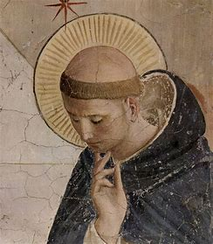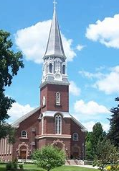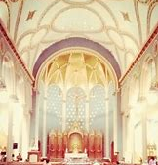
St. Michael’s Cathedral
We start the month of September off strong with Mother Mary’s birthday, and we end it strong with feast days that celebrate our priests and angels (the categories often overlap!). September 24 is Priesthood Sunday this year. Priests have a special role in our Church. Monks and parish priests are our spiritual brothers and fathers. They pray for, guide, and watch over people, living like St. Joseph, who guarded Jesus and Mary as a loving father. Priests are examples of how to be strong in our faith, not give up, and be brave as we share our faith by using the talents God has given us. Parish priests serve people in their churches, bringing them the sacraments. Monks may live away from the world, but they share their love for God’s creation through the prayers they offer for the world. They make sacrifices to help the souls of people living in the world.
Priests bring the prayers inside their hearts outside, into the world, showing their love for God not only in the words they preach, but through their actions. The vestments priests wear are symbols of Jesus and His service to others. Some monks in religious orders take part in the practice of tonsure, shaving parts of their head. They do this out of humbleness. It marks them as someone who has given themselves to God to live in a religious community. The hairstyle also makes the monk look they have a halo around their head, a sign of holiness.
We often see saints and angels with haloes in paintings. Like priests, angels watch over us, protecting us and bringing us messages from God. Angels are not human beings with bodies, but spiritual beings. They sing and praise God in Heaven. September 29, also called “Michaelmas,” is the Feast of the Archangels. The Archangels are the leaders of the angels: St. Michael, St. Raphael, and St. Gabriel. St. Michael is the angel known for battling evil. Our diocese’s patron is St. Michael, the namesake of our cathedral. We say special prayers for St. Michael to watch over us. St. Gabriel is the angel who brought messages, such as when he told Mother Mary She was chosen by God to be the Mother of Jesus. St. Raphael is the healing angel.
All of the angels pray for us, much like our priests who say Masses for us, and teach us to pray. Angels and priests show reverence, respect, for heavenly things, and model to us how to be holy. They humbly serve God, helping people to win each battle, to overcome their challenges, so they can get to Heaven. When priests say the Mass, they celebrate Jesus winning the battle against sin and death, conquering the Cross. Michaelmas is the Catholic Thanksgiving, the perfect time to give thanks for our priests, and for the holy angels who inspire them.
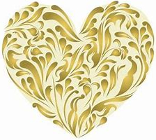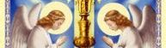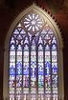
- Take a virtual tour of St. Michael’s Cathedral. Visit the cathedral’s website: https://stmichaelscathedralspfld.org/. Share an interesting fact you learned about the cathedral.
____________________________________________________________________________________________________________________________________________________________

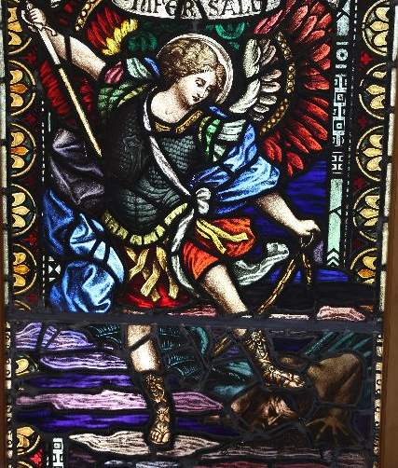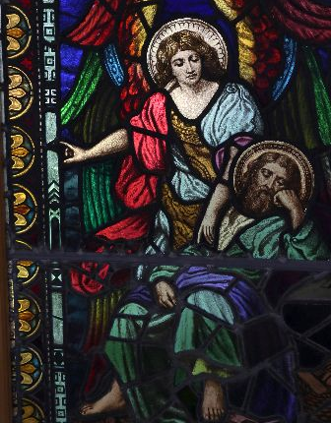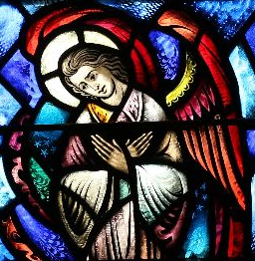
- Look at the pictures of the stained glass from St. Michael’s Cathedral above. These pictures all show different roles of the angels. How do you think this art honors the angels? How do they represent what the angels do for us, and for God?
Image 1 | Image 2 | Image 3

____________________________________________________________________________________________________________________________________________________________

- How are priests like angels in how they serve God? How are angels different from humans?
__________________________________________________________________________________________________________________________________________________________________________________________________________________________________________
- Michaelmas, the Feast of the Archangels, is known as the Catholic Thanksgiving. What are you thankful to our priests for? How have they shown you through their actions what it means to live like Jesus?
__________________________________________________________________________________________________________________________________________________________________________________________________________________________________________

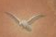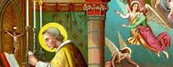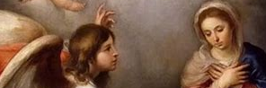
Grade 8- “Standing by Jesus: Praying to Know Our Vocation”
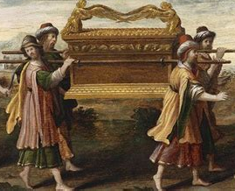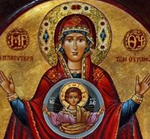
Priesthood Sunday is on the last Sunday of the month of September (the 24th this year). It is special that Priesthood Sunday happens in September, the month of Mother Mary’s birthday. If Mary had not first been born, Her Son, Jesus, the greatest priest, could not have been born and saved us. Mother Mary is known as the living Ark of the Covenant.
The Ark of the Covenant was a treasure chest the Israelites, the Jewish people of the Old Testament, carried with them through the desert. When they left Egypt, they were left without a home, wandering through the desert, lost. There were days they felt hungry and hopeless, but the things they carried with them reminded them that God was with them. The things they carried in the box, or ark, were all reminders that God was keeping His promises to them. God made a covenant, an agreement, with the Jewish people, promising He would send them a Savior. When they suffered in Egypt, and finally escaped to the desert, they had faith that God would save them. In the treasure chest, they had manna from Heaven, bread God sent from Heaven to feed them. There were also the Ten Commandments written on the stone tablets, and Aaron’s staff. Aaron was the brother of Moses. Moses received the Ten Commandments from God and led the Jewish people out of Egypt.
All of these items hinted that Jesus, the priest, prophet, and king, would come to save God’s people. Jesus is the Bread of Heaven Who gives His life to feed our souls (through the Eucharist). He gives the new law, the commandment to love each other, showing us how to live the 10 Commandments. As a prophet, a person who brings a message from God, He told us what we need to do to follow God and go to Heaven. Jesus is the King, just as the staff, a sign of leadership, reminds us of royalty who carry scepters.
Mother Mary is the New Ark of the Covenant, because She carried Jesus, the priest, prophet, and king, just like the Jewish people carrying the box with signs that the Savior would come. Mother Mary gave birth to the Savior, showing that God kept His promise. Mother Mary was loyal to God the Father, saying “yes” to His plan for Her to be Mother of His only Son, Jesus. She kept Her promises to God. Mother Mary stood by Jesus, staying by the Cross, praying faithfully, even when others left, afraid to stand by Jesus. Priests promise to be loyal to God and His Church, too.
At Confirmation next year, you will renew your promises from Baptism to be faithful to God as His child, a member of His family, the Church. All of us have Jesus in our hearts. Even if we do not have a religious vocation (to become a priest or nun), our vocation is to share God with others. Some of us may choose to join a third order. Men and women in some religious orders live away from the world to carry out their formal vows, promises to God, but people in the third order can live out the mission of a religious order while still living in the world as a layperson. Every order has its own spirit and mission. The Dominicans preach and teach, the Franciscans serve the poor, and Benedictines pray and work. Whichever ministry we may have, we can carry God’s goodness into the world.
- Compare and contrast the mission and spirit of each of the religious orders using the Venn diagram below.
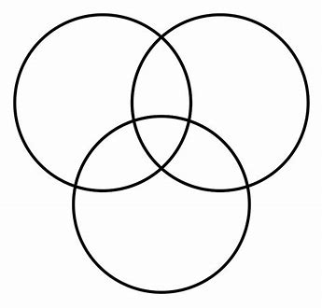
Benedictine
Franciscan
Dominican
- Which order’s charism (mission and spirit) speaks the most to you, and why?
____________________________________________________________________________________________________________________________________________________________
- How do you think living out this mission as a layperson in the third order can help to deepen someone’s relationship with God? Why is it important that we have both faithful priests and laypeople in the Church?
__________________________________________________________________________________________________________________________________________________________________________________________________________________________________________
- What vocation do we all have, as people in the Church? How do we bring Jesus into the world, continuing His ministry and carrying His mission forward? ___________
______________________________________________________________________________
______________________________________________________________________________
- Pray the “Petition to Know Our Vocation.” How can you stand by Jesus?
_____________________________________________________________________________
_____________________________________________________________________________
- Mary is the Ark of the New Covenant, because She carried Jesus. How did each item in the Ark of the Covenant represent Jesus?
Ark of the Covenant | Ark of the New Covenant
- Manna from heaven: | - Jesus:
- Ten Commandments: | - Jesus:
- Aaron’s staff: | - Jesus:
Grade 9- “The Spirit of Christ: The Past, Present, and Future Church”
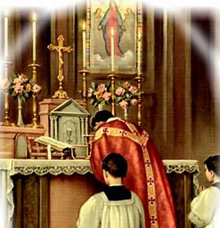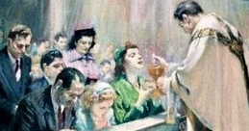
At the Last Supper, Jesus instituted the Eucharist. He began the Sacred Tradition, the sacrament, of Communion, and also, of Holy Orders. He made His apostles, like Peter, priests who would continue His mission of bringing God’s love to all people. Jesus showed them how to break and bless the bread in His Name, so that it would become His Body. He was showing them how to say Mass in His memory, His honor, as one Church family. After Jesus’ Death and Resurrection, He sent the Holy Spirit. The Holy Spirit gave the apostles the graces and holy gifts they needed to carry out the mission Jesus had planned for them. They would need strength, wisdom, and holiness to build up the Church. The Spirit that came into their hearts gave them these gifts they needed to reach their full potential, and to help others reach theirs, as God planned. Going to Mass is how we serve as Jesus’ disciples. Not everyone is called to be a priest (a direct apostle of Christ, someone sent out to share the sacraments on Jesus’ behalf) or nun, but we all are learners, followers of Christ. We spend our entire lives growing and learning, so there is a new possibility that awaits us each day. Jesus makes everything new, bringing hope, just like the rising sun.
Being with Jesus at Mass, giving Him honor, and receiving the Eucharist with reverence, great love and respect, prepares us to do good works, bringing Jesus out into the world. The Holy Spirit is with us at Mass, as we receive special graces from Communion. We receive more of these graces at Confirmation. Before the 1960s, the Mass was said in Latin. Latin is the language of the Church, the language that allows us all to speak the language of God, as One Church. We also speak our love for God through our actions. At the Extraordinary Form of the Mass, there are many gestures, movements, of reverence that are made to show respect for God’s holiness. The Extraordinary Form of the Mass is the Traditional Latin Mass, the older form of the Mass passed down for hundreds of years.
Everything the people at the Latin Mass do is directed to God. The priest faces the east, where the sun rises, since Jesus is the risen God, the Son Who shows us the light, the Way to Heaven. Everyone at the Mass faces the same way, showing that they all honor Christ together. People kneel, bow, and genuflect frequently throughout the Extraordinary Form of the Mass to outwardly show the love in their hearts for God. They also receive Communion kneeling and on the tongue to help ensure that Jesus in the Eucharist is respected, and particles of the Eucharist do not fall on the ground. At the Latin Mass, there is also the use of incense, and the ringing of handbells, to remind people of God’s holy presence. The rising smoke of the incense, sweet-smelling frankincense, is a reminder to lift prayers up to God, while the bells are a signal to people that something new is beginning, whether the start of the Mass, or the consecration (when the bread and wine are changed into the Body and Blood of Christ). The music of the bells call people to honor God’s holiness and greet His Presence together.
In the Ordinary Form of the Mass, the priest says Mass facing the people. He speaks in the language most commonly used in the area, whether English, Spanish, French, Polish, or another. There are fewer outward gestures than at the Latin Mass, and a greater emphasis on the readings of the Bible as the preparation for the Eucharistic feast, a meal shared as one family in Christ. At the Latin Mass, there is a one-year cycle of readings, but the newer (Ordinary Form) Mass draws from many more books of the Bible, using a three-year cycle of readings that repeats. The Word of God feeds our souls as we prepare to receive the Eucharist, the Bread of Heaven. Understanding the past traditions of the Church, we can understand how to honor God in the present, and build a future Church that will continue to glorify Him.
The Holy Spirit works at every Mass, inspiring us, as we learn how to be better servants of God. When we receive Communion, we receive the Holy Spirit. Whether at the Ordinary Form of the Mass or the Extraordinary Form, we are called to participate in the Mass by praying and bringing our hearts to God. At the Mass, the bread changed into Christ’s Body that we receive also transforms our hearts: God’s love changes us forever. When we receive the love of God, it makes us want to share it, so that everyone can be transformed by hope. Mass is a prayer. We participate at Mass not only in what we do, or say on the outside, but by thinking of God, and listening to Him with our hearts, praying on the inside. Our purpose at the Mass is to love God with all our souls, which we express through inward and outward gestures.
- Read some of the prayers of the Holy Spirit, starting on page 50 in your Devotion to the Holy Spirit book. Which one makes you feel most connected to the Holy Spirit, and why? How can you integrate this prayer into your life to prepare for Confirmation?
__________________________________________________________________________________________________________________________________________________________________________________________________________________________________________
- Compare and contrast the Ordinary and Extraordinary Forms of the Mass. To learn more about the Extraordinary Form, visit the parish website’s Latin Mass page at https://olveasthampton.org/traditional-latin-mass/, where you can watch a video of parts of the Latin Mass at Our Lady of the Valley (starting at the 4-minute mark).
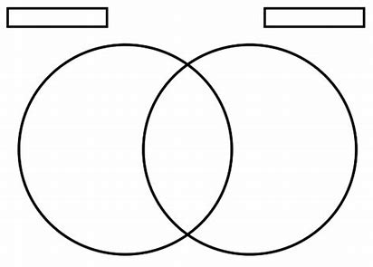
Extraordinary Form
Ordinary Form
What is something you learned about the traditions of the Latin Mass that inspires you?
____________________________________________________________________________________________________________________________________________________________
- Why is it important that we show respect for God’s Presence in how we pray the Mass? At every Mass, how can we honor God?
__________________________________________________________________________________________________________________________________________________________________________________________________________________________________________
- How do you think the Mass will help to prepare you for receiving more of God’s graces at Confirmation?
____________________________________________________________________________________________________________________________________________________________
______________________________________________________________________________
September 2023 7-9 Review
Use this review sheet as a reference to track progress and check that learning goals are met.
Recap: What did I learn?
All Grades
- Mother Mary’s birthday on September 8 is a day to honor our Mother in Heaven
- Through Mary’s birth, the birth of Christ could come about. In Mary, we see an example of faith, hope, and love, every virtue and grace from God, come to life
- Mother Mary is the Immaculate Conception. Through Her sinlessness, She could give birth to the sinless Son of God
- We have hope because of Jesus and Mary, who help to give us the graces we need for growth, so that we can build up Christ’s Church, using our gifts and talents to honor God
Grade 7
- Mother Mary gives us graces through gifts that help our souls
- She gave St. Dominic the Rosary, because this prayer helps us grow closer to Jesus
- When we pray the Rosary, we reflect on the lives of Jesus and Mary
- St. Dominic founded the Dominican order. The Dominicans have a special ministry of preaching and teaching
- We all can honor Mother Mary and Jesus uniquely. The Rosary helps us to call on Mother Mary, and to model our lives after Her, as we find our own special ministries
- September 12 is the feast day of the Holy Name of Mary. Mary’s Name is Holy, because She is holy. Mary is holy, because of Her faithfulness to God
- The Benedictines, the order started by St. Benedict, have a ministry of praying and working
- Everything we do can be lifted up to God in prayer. What we do to honor Mother Mary, in Her Holy Name, is a special prayer
- The tonsure, a shaved head, is an outward sign that monks in religious orders wear to show their humble faith in God
- Besides the tonsure, there are many ways to outwardly share and show our faith. We all can show Jesus’ love to others like monks and nuns in religious orders do
- Priesthood Sunday is on September 24. We celebrate our priests in prayer and thanks
- The Feast of the Archangels, St. Michael, St. Gabriel, and St. Raphael, is September 29
- Priests are like angels in how they guide and protect us, helping us grow closer to God. They praise God’s holiness and show us how to honor Him with great respect
Grade 8
- Christology is the study of Jesus Christ. To know Jesus, we learn of His love. We see His love in how He Sacrificed His life on the Cross for us
- The Cross is a symbol of Jesus’ victory over death that inspires us to walk with Jesus as we carry our own crosses
- The Feast of the Exaltation of the Cross on September 14 is a day to celebrate Jesus’ triumph over the Cross. Without the Cross, there would be no salvation, no new life
- Mother Mary also had Crosses in life, suffering as She watched Her Son suffer, but Her faith carried Her through
- Through believing in God the Father’s bigger plan, and putting Him first, Mother Mary and Jesus brought about greater good, as people were saved through their faith
- We each have a special purpose God has given us. In the Church, there are ministries we can take part in that allow us to glorify God by using our talents as we help His Church
- Mother Teresa used her ministry of caring for the poor to bring Jesus’ love into the world
- Mother Teresa and Mother Mary both pointed people to Jesus, the Way, the Truth, and the Life. Mother Mary leads us to Jesus, the Way to Heaven
- Mother Mary is the Mother of us all, including priests. She is the Mother of Jesus, the ultimate priest
- Mother Mary is the Ark of the New Covenant, because She carried Jesus, the fulfillment of God the Father’s promise to send His people someone to save them. Jesus is the Savior
- The Ark of the Covenant was originally the box the Israelites carried through the desert to help them never lose faith. The box held all things God had given them as signs of His promise: bread from Heaven, the 10 Commandments, and Aaron’s staff
- These symbolized that Jesus would be Priest, Prophet, and King, one to heal, teach, and lead God’s people
- We all have a vocation to serve Jesus, though not all of us may be called to be priests or nuns. Some may be called to the third order, to live as laypeople carrying out a religious order’s special mission
Grade 9
- Moveable feasts in the Church are feast days whose dates change from year to year
- The whole Church calendar is a reminder of God’s perfect order, His harmonious plan
- The feast days of the Church help prepare us to receive God’s graces with love and respect
- All feast days are connected, each being centered around the death and life of Jesus, from Whom we receive new life
- Participating in the life of the Church by going to Mass, receiving Communion, and going to Confession help us to keep Jesus at the center
- Ecclesiology is the study of the Church. Mary is the Mother of the Church
- We study the Church to better understand how we can serve Christ in His Church
- The Church is the Bride of Christ, and all priests are wed to the Church, as they are Christ’s representatives. Jesus gave His life to the Church, His family, and so do priests
- Confirmation has real effects on us, making a mark on our souls forever. This is because Confirmation is from Christ, Whose Death made the sacraments real, not just symbolic
- Confirmation is when we receive the Gifts of the Holy Spirit we need to continue Christ’s mission and keep building the Church up
- One of the effects of Confirmation is to help strengthen our bond with the Church so we can grow closer to Christ
- The Mass is where we remember Jesus’ Sacrifice and experience God’s love as One Church family, honoring Him through our prayers
- We pray the Mass by keeping our love for God as the focus of our minds and hearts. Participating in the Mass is not only about what we do, or how we outwardly show our love, but also, about what we pray inside, and how we inwardly turn our hearts to Jesus
- The Extraordinary Form of the Mass is the Mass that was said before the Vatican II Council changes in the 1960s. The traditional Mass is said in Latin, as the priest faces the east, where the sun rises, to remember Jesus’ rising
- People kneel, genuflect, and bow frequently throughout the Latin Mass. They receive by tongue to show respect for Christ’s Presence in the Eucharist, as a way to ensure that no particles of the Host fall to the floor
- The Ordinary Form of the Mass is the newer Mass, which is currently used. This Mass puts a greater emphasis on the readings as a type of spiritual food, a means to prepare the soul inwardly for receiving Jesus through the ultimate feast, the Eucharist. The Ordinary Form of the Mass is said facing the people
- The Ordinary Form of the Mass is said in the language of the area, while the Latin Mass is said in the language of the whole Church
What vocabulary words did I practice?
Grade 7
Week 1
Cloistered
Dominican
Week 2
Benedictine
Week 3
Tonsure
Grade 8
Week 1
Ark of the Covenant
Christology
Week 2
Ministry
Week 3
Third order
Grade 9
Week 1
Moveable feast
Week 2
Ecclesiology
Week 3
Extraordinary Form of the Mass
Ordinary Form of the Mass
What prayers did I practice?
Grade 7
St. Michael Prayer
Grade 8
Act of Thanksgiving (St. Paul of the Cross)
Petition to Know our Vocation
Grade 9
Petition to Know our Vocation
Checklist: Activity Completion
Grade 7
Week 1: “Graces and Gifts from Our Lady”
Week 2: “Order of the Soul: Honoring Mother Mary’s Holiness”
Week 3: “Priesthood Sunday and Michaelmas: Giving Thanks for Our Priests”
Grade 8
Week 1: “The Church and the Cross: Mary, Mother of the Church”
Week 2: “Mother Teresa, Mother Mary, and Finding Our Ministries”
Week 3: “Standing by Jesus: Praying to Know Our Vocation”
Grade 9
Week 1: “A Graceful Dance: The Rhythms of the Church Year”
Week 2: “Celebrating Our Mother: The Birthday of Mary and the Birthday of the Church”
Week 3: “The Spirit of Christ: The Past, Present, and Future Church”
Quick Check:
Tell us about your experience with these activities this month! Our September 2023 Google Form for Grades 7-9 is available here: https://forms.gle/XPZ3rNEmiDhSysjY9

