Our Lady of the Valley Religious Education

September 2023 Activity Packet

Grades Pre-K-2

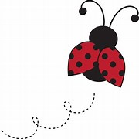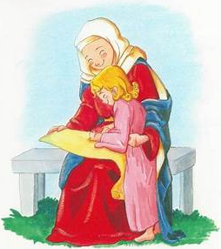

Name: ________________________________________
Materials Included in Packet
Overview………………………………………………………………………………………….3
Standards………………………………………………………………………………………....5
Pacing Guide……………………………………………………………………………………11
Activities………………………………………………………………………………………....15
Week 1…………………………………………………………………………………………...15
Pre-K/Kindergarten…………………………………………………………………….15
Grade 1…………………………………………………………………………………..17
Grade 2…………………………………………………………………………..............19
Week 2…………………………………………………………………………………………...21
Pre-K/Kindergarten…………………………………………………………………….21
Grade 1…………………………………………………………………………………..23
Grade 2…………………………………………………………………………..............25
Week 3…………………………………………………………………………………………...27
Pre-K/Kindergarten…………………………………………………………………….27
Grade 1…………………………………………………………………………………..29
Grade 2…………………………………………………………………………..............31
Review…………………………………………………………………………………………...35

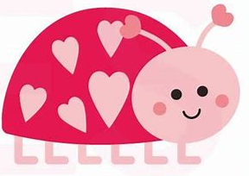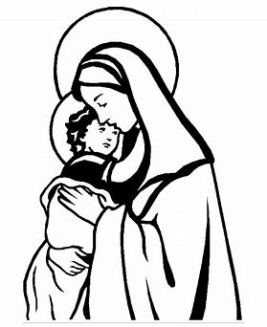
September 2023 Overview: Grades Pre-K-2
Theme: Month of Our Lady’s Nativity (Birthday)
Monthly Prayer/Invocation: Mary, Mother of Christians, pray for us.
Thematic Guiding Questions, Pre-K-2: What does it mean that we celebrate Our Lady’s “Nativity”? Why do we celebrate this?
- When we celebrate birthdays, we celebrate people we love! God made us all special. Birthday celebrations are one way we show other people that we love the special things about them.
What is special about Mother Mary, and how can we celebrate Her birthday this month?
Saint of the Month: St. Teresa of Calcutta, the foundress of the Missionaries of Charity, devoted her life to caring for the poor and sick. Living in Calcutta, she used her ministry to treat all people with loving respect, tending to people who were suffering in body and soul. Just as Mother Mary brought hope and joy when She was born, and when She brought Her Son, Jesus, into the world, Mother Teresa brought hope. She taught her order of sisters to serve people with gladness, keeping smiles on their faces to reflect Jesus’ joy. St. Teresa of Calcutta reminds us that when we help others, we are serving Jesus.
Monthly Challenge: Choose something special that you can do as a gift to Our Lady for Her birthday. Have a “birthday party” to honor Mother Mary. Sing songs dedicated to Mother Mary, like “Immaculate Mary.” Honor Mother Mary like the saints did: read or watch a video about Mother Teresa, and talk about things you can do to help others like she did.
Overall Learning Goals: As we celebrate Mother Mary’s birthday this month, our goal is to identify how we can honor Jesus through honoring His Mother. We will explore how we can grow in closeness to God through learning about the examples of priests, angels, and saints such as Mother Mary, all of whom we remember in a special way in September.
Summary of Activities: Our activities will help us to apply our learning about Jesus, Mother Mary, the angels, and priests in our Church as we use art, music, and reflection to consider how we can come together as a Church to praise God, contributing our unique talents to building the Church, One Body in Christ.
Additional Enrichment Ideas:
- Celebrate the birthday of Mother Mary on September 8. Decorate a home shrine table for Mother Mary with flowers. Have flower seeds blessed by a priest (a tradition on September 8). Sing Marian hymns together, enjoy a birthday cake dedicated to Mother Mary, make party decorations inspired by Mother Mary (such as with the Marian monogram, Her initials) together, or pray the Rosary as a family
- Visit the Museum of Family Prayer, operated by Holy Cross Family Ministries in Easton, MA. See their website for listings of upcoming events and additional prayer resources: https://www.museumoffamilyprayer.org/events-and-programs
- Have a Michaelmas feast. In honor of the Feast of the Archangels on September 29, eat meals with blackberries. Desserts with blackberries, or bannock breads with raisins, are eaten in honor of St. Michael. Legend has it that when St. Michael battled Satan, Satan fell in a blackberry bush, defeated. People eat blackberries on Michaelmas to celebrate the victory of St. Michael, and the triumph of God’s goodness. Other traditional harvest foods, such as carrots, are incorporated into Michaelmas meals. (Angel food cake is another popular choice, naturally! ) Michaelmas is the Catholic thanksgiving
  - Sing songs of thanks and pray together as a family to share your gratitude to God. Say the St. Michael the Archangel Prayer. Listen to “Christ, Fair Glory of the Holy Angels” here: https://www.youtube.com/watch?v=NTK4dE-_OP4
- As a family, complete the total consecration of your hearts to Jesus through Mary. Go to the Holy Heroes website for Marian Consecration Adventure signups. You will receive free daily prayer emails from Holy Heroes that walk you through the total consecration process during the consecration timeframe: https://holyheroes.com/pages/marian-consecration?goal=0_1190290075-8373cd25c6-82048155&mc_cid=8373cd25c6&mc_eid=8b187f230d

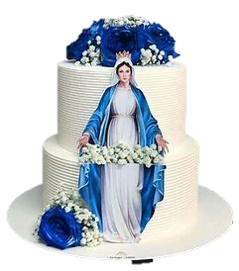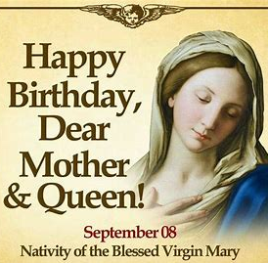
Standards
Grade Level | Week | Activities | Learning Standards
Pre-K, Kindergarten | 1 | “God Made Mother Mary: Celebrating Our Lady” | K.1 God is love. He wants all of us to be loving to each other, so we use kind words and do kind things to show our love.  K.3 We were created in God’s image, out of His love. We are made to be like Christ, loving and forgiving, but we need God to help us.  K.9 Mary, the Mother of Jesus, is our Mother, too- She is always with us. We can pray for Her to help us to get to know Jesus better, because as His Mother, Mary is very close to Jesus.
Pre-K, Kindergarten | 2 | “God Made You: The Goodness of God’s Creation” | K.3 We were created in God’s image, out of His love. We are made to be like Christ, loving and forgiving, but we need God to help us.
Pre-K, Kindergarten | 3 | “God Made the Church: Praying Together as God’s Family” | K.4 We talk to God through prayer. We pray every day to help us do the right things. Praying helps us to know God.  K.6 We acknowledge God’s holy presence with respect, such as when we enter a church, pray, and go to Mass. In front of the tabernacle, we make the Sign of the Cross, which reminds us of how Jesus went onto the Cross out of love for us, to save us from sin.  K.7 When we go to church, we are in God’s house. It is a holy place where we experience God’s love, so we are respectful. We attend Mass at church and pray, following the priest as he celebrates the sacrament. In addition to attending Mass on Sundays, we attend for special holidays during the seasons, including Advent and Lent. At church, we show our love for God.
Grade 1 | 1 | “A Song for Mary: Honoring Mary with the Angels” | 1.1 Jesus and Mary are examples of full faith in God the Father. Their lives were lived without sin, and with total love. We can follow their example in our daily lives, especially as we prepare to receive the sacraments that will bring us into closer union with God.  1.9 In addition to expressing our belief through gestures of reverence, we use our words to communicate our belief, including by saying “Amen,” which means “I believe.”
Grade 1 | 2 | “Lifting Every Voice: Praising the Holy Names of Mary and Jesus” | 1.10 Our churches are places where we come together as God’s family to pray, sing, and share our love for God. The angels and saints in Heaven are with us at the Mass, singing and listening to our prayers. We share our love for God with each other. As one big Church community, we share our talents to give God our love, and prepare our hearts to receive Jesus. Our beautiful churches are made to remind us of Heaven, and how great God is, so that we will be inspired to pray and use our gifts for God. We are in communion with Christ.
Grade 1 | 3 | “Prayers for Priests: Priesthood Sunday and Mary, Mother of the Church” | 1.10 Our churches are places where we come together as God’s family to pray, sing, and share our love for God. The angels and saints in Heaven are with us at the Mass, singing and listening to our prayers. We share our love for God with each other. As one big Church community, we share our talents to give God our love, and prepare our hearts to receive Jesus. Our beautiful churches are made to remind us of Heaven, and how great God is, so that we will be inspired to pray and use our gifts for God. We are in communion with Christ.
Grade 2 | 1 | “Happy Birthday, Mother Mary: A Celebration for the Blessed Mother” | 2.4 The saints are people in Heaven, including Mother Mary. They teach us how to be like Jesus. We can ask them to help us be holy. The saints loved God in their lives on Earth, exemplifying how to receive God’s graces reverently through the sacraments, and how to use them to become holier.
Grade 2 | 2 | “Baptized into God’s Family: Our Birthdays in the Church” | S2.4 Jesus Christ is Really and Truly Present in the Eucharist.  2.5 There are seven sacraments: Baptism, Confession (Reconciliation), Communion (Eucharist), Confirmation, Matrimony (Marriage), Holy Orders, Extreme Unction (Last Rites/Anointing of the Sick).  2.6 The sacraments are special celebrations of God’s love, signs of His Presence. Some sacraments are received only once, including Baptism, Confirmation, and Holy Orders, because they leave marks on the soul for life, but other sacraments are received regularly, these being Communion and Confession. While some sacraments are received at specific junctures in life, and others are consistent, God is always part of our lives, and when we encounter Christ in the sacraments, our connection to Him is made stronger.  S2.6 All other sacraments are directed towards the Eucharist, providing graces that enrich the experience of receiving Communion.  S1.9 Sacraments such as Confession allow us to encounter God in our earthly lives, receiving a foretaste of Heaven through experiencing His merciful love.
Grade 2 | 3 | “Jesus the Priest: Honoring Our Lord on Priesthood Sunday” | 2.3 Jesus is the Son of God. As the Second Person of the Trinity, He is God, the same nature as the Father, as well as the Holy Spirit.  S2.3 The Eucharist is the source and summit of Christian life.  S2.5 The Eucharist is not merely a symbol, but is efficacious.

September 2023 Pacing Guide (Suggested Schedule)
Grades Pre-K-2
Week Number/Date | Grade Level | Activities
Week 1  (September 11, 2023 – September 15, 2023) | Pre-K, Kindergarten | “God Made Mother Mary: Celebrating Our Lady”
Week 1  (September 11, 2023 – September 15, 2023) | Grade 1 | “A Song for Mary: Honoring Mary with the Angels”
Week 1  (September 11, 2023 – September 15, 2023) | Grade 2 | “Happy Birthday, Mother Mary: A Celebration for the Blessed Mother”
Week 2  (September 18, 2023 – September 22, 2023) | Pre-K, Kindergarten | “God Made You: The Goodness of God’s Creation”
Week 2  (September 18, 2023 – September 22, 2023) | Grade 1 | “Lifting Every Voice: Praising the Holy Names of Mary and Jesus”
Week 2  (September 18, 2023 – September 22, 2023) | Grade 2 | “Baptized into God’s Family: Our Birthdays in the Church”
Week 3  (September 25, 2023 – September 29, 2023) | Pre-K, Kindergarten | “God Made the Church: Praying Together as God’s Family”
Week 3  (September 25, 2023 – September 29, 2023) | Grade 1 | “Prayers for Priests: Priesthood Sunday and Mary, Mother of the Church”
Week 3  (September 25, 2023 – September 29, 2023) | Grade 2 | “Jesus the Priest: Honoring Our Lord on Priesthood Sunday”

Week Number/Date | Grade Level | Words to Practice | Definitions
Week 1  (September 11, 2023 – September 15, 2023) | Pre-K, Kindergarten | God | God made the whole world. He made each person, every living thing. God is love. He made everything out of love. God made us to be kind people who are loving like Him.
Week 1  (September 11, 2023 – September 15, 2023) | Grade 1 | Cantor | A singer. A person who chants, or sings hymns, at the Mass. Choirs are made up of many cantors.
Week 1  (September 11, 2023 – September 15, 2023) | Grade 1 | Gregorian chants | Special songs for the Mass that were collected when St. Gregory was the pope. Gregorian chants are still sung at the Latin Mass. Monks and nuns may use these chants to pray the liturgy of the hours, the prayers they say throughout the hours of the day.
Week 1  (September 11, 2023 – September 15, 2023) | Grade 2 | Nativity | Birth. Usually, this refers to the Birth of Christ (the third Joyful Mystery of the Rosary), celebrated on December 25, Christmas Day. It is also used when talking about feasts like the Birthday of Our Lady on September 8.
Week 1  (September 11, 2023 – September 15, 2023) | Grade 2 | Parable | A story Jesus told to teach people about God the Father and the Kingdom of Heaven. Jesus told stories that helped people to understand how great God is, and how we can love Him in our everyday lives. Jesus used comparisons, showing how things we see around us are reminders of God.
Week 2  (September 18, 2023 – September 22, 2023) | Pre-K, Kindergarten | Creation | What God made. God created the world. He made the land, the sea, the sky, the moon, the sun, the stars, animals, and people. These are examples of God’s creation.
Week 2  (September 18, 2023 – September 22, 2023) | Grade 1 | Choir | A group of several people singing hymns at the Mass. This word can also be used when talking about “choirs,” or groups, of angels in Heaven.
Week 2  (September 18, 2023 – September 22, 2023) | Grade 1 | Choir loft | The part of the church where the choir, the group of singers, sings. Usually, the choir loft is in the back of the church, in an area like a balcony that is above where the people in the church are sitting and praying. The church organ used to play music at the Mass is kept in the choir loft.
Week 2  (September 18, 2023 – September 22, 2023) | Grade 2 | Baptism | One of the seven sacraments, Baptism is how original sin, the sin that was passed on to us by Adam and Eve, our first parents, is forgiven by God.
Week 2  (September 18, 2023 – September 22, 2023) | Grade 2 | Baptismal font | The basin (container) of holy water used for baptizing. Baptismal fonts are much larger than the small holy water fonts (bowls) by the church doors that people use to bless themselves when they come into or out of the church.
Week 2  (September 18, 2023 – September 22, 2023) | Grade 2 | Baptismal promises | Promises to follow God and stay away from sin. When babies are baptized, their parents promise to raise them in the Church, to help them live out the promise to love God as a member of His Church family. When baptized children grow older, they make these promises again, saying they will keep following Jesus, loving others and following the 10 Commandments like He asks them to do. Baptismal promises are made again at Easter.
Week 3  (September 25, 2023 – September 29, 2023) | Pre-K, Kindergarten | Laity/laypeople | People practicing the Catholic faith who have not taken religious vows through the sacrament of Holy Orders. Laypeople are people who are not priests or nuns. Priests and nuns make special promises to God that are different from baptismal promises that everyone in the Church makes. Priests and nuns give their whole lives to serving God, in a different way than laypeople who are serving God in the world.
Week 3  (September 25, 2023 – September 29, 2023) | Grade 1 | Cathedral | The official church that is like the headquarters of a diocese. This is a large church where the bishop, the priest who is the leader of a diocese, has his “throne,” a special chair like what a king would sit in.
Week 3  (September 25, 2023 – September 29, 2023) | Grade 2 | IHS | Sometimes called Jesus’ “initials,” these are the first three letters of His name in Greek.

Week Number/Date | Grade Level | Prayers to Practice | Text of Prayers
Week 1  (September 11, 2023 – September 15, 2023) | Pre-K, Kindergarten | Sign of the Cross | In the name of the Father,  And of the Son,  And of the Holy Spirit. Amen.
Week 1  (September 11, 2023 – September 15, 2023) | Grade 1 | Guardian Angel Prayer | Angel of God, my Guardian dear,  To whom His love commits me here,  Ever this day be at my side,  To light and guard, rule and guide. Amen.
Week 1  (September 11, 2023 – September 15, 2023) | Grade 2 | Hail Mary | Hail, Mary, full of grace,  The Lord is with thee;  Blessed art thou among women,  And blessed is the fruit of thy womb, Jesus.  Holy Mary, Mother of God,  Pray for us sinners,  Now and at the hour of our death. Amen.
Week 2  (September 18, 2023 – September 22, 2023) | Pre-K, Kindergarten | Sign of the Cross | In the name of the Father,  And of the Son,  And of the Holy Spirit. Amen.
Week 2  (September 18, 2023 – September 22, 2023) | Grade 1 | Guardian Angel Prayer | Angel of God, my Guardian dear,  To whom His love commits me here,  Ever this day be at my side,  To light and guard, rule and guide. Amen.
Week 2  (September 18, 2023 – September 22, 2023) | Grade 2 | Hail Mary | Hail, Mary, full of grace,  The Lord is with thee;  Blessed art thou among women,  And blessed is the fruit of thy womb, Jesus.  Holy Mary, Mother of God,  Pray for us sinners,  Now and at the hour of our death. Amen.
Week 3  (September 25, 2023 – September 29, 2023) | Pre-K, Kindergarten | Sign of the Cross | In the name of the Father,  And of the Son,  And of the Holy Spirit. Amen.
Week 3  (September 25, 2023 – September 29, 2023) | Grade 1 | Guardian Angel Prayer | Angel of God, my Guardian dear,  To whom His love commits me here,  Ever this day be at my side,  To light and guard, rule and guide. Amen.
Week 3  (September 25, 2023 – September 29, 2023) | Grade 2 | Hail Mary | Hail, Mary, full of grace,  The Lord is with thee;  Blessed art thou among women,  And blessed is the fruit of thy womb, Jesus.  Holy Mary, Mother of God,  Pray for us sinners,  Now and at the hour of our death. Amen.

September 2023 Pre-K-2 Activities
Week 1
Pre-K/Kindergarten- “God Made Mother Mary: Celebrating Our Lady”
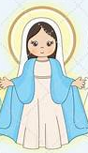
September 8 is the birthday of Mother Mary! Mother Mary is the Mother of Jesus. We celebrate Jesus’ birthday on Christmas Day, December 25. God chose Mary to be Jesus’ Mother. This was a very special gift, for Mary to have Jesus as Her Son. Jesus is the Son of God. He came to save people. Jesus has a Heart of love, and so does Mother Mary.
Mother Mary was made by God. She was born so that one day, Jesus would be born. We are all born with special gifts that God gives us to use in helping others and loving Him throughout our lives. God loves all of us. God made the whole world, and He cares for the world every day, helping everything to keep going.
Mother Mary is called “Our Lady.” She is a kind and beautiful lady, because She has a beautiful Heart that loves God. Ladybugs were named after Our Lady. Seeing a ladybug is said to bring good luck. But when we pray for Mother Mary to help us, She brings us something better. She goes to Jesus, Her Son, and brings us blessings, good and holy things in our lives that help us. We are lucky, truly blessed, to have Mother Mary!
Mother Mary loves us and cares for us. It may be Her birthday, but Mother Mary gives us gifts. She gave us the Rosary (prayer beads) to pray so that we can talk to Her, and the scapular (pieces of cloth the priest blesses, and that we wear on a string like a necklace) to remind us She is watching over us, keeping us safe. Mother Mary always helps us and prays for us. We can give Mother Mary the gift of our love by praying the Rosary, wearing the scapular, and treating Her Son, Jesus, with love.
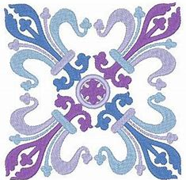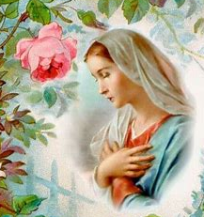
Let’s celebrate Our Lady on Her birthday! When we go to birthday parties, we bring presents. We give gifts to tell people we love them. Giving them a present is a way to say that they are a gift to us, and we are blessed to have them in our lives to share the love in our hearts with. Our Lady gave us Her Son, Jesus, Who saved us. She listens to our prayers, and lets us know She loves us.
Draw a picture of a gift you can give to Mother Mary from your heart. What is something you can do to celebrate Her birthday and share your love with Her?


______________________________________________________________________________
Grade 1- “A Song for Mary: Honoring Mary with the Angels”
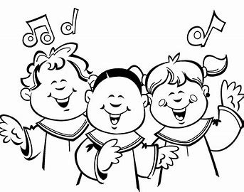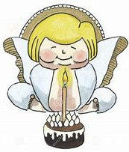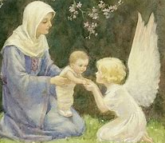
In September, we celebrate Mother Mary and the angels. September 29 is the feast day of the Archangels. The archangels are God’s very special angels, the leaders of all of the angels in Heaven. The archangels’ names are St. Michael, St. Gabriel, and St. Raphael. Angels bring messages from God in Heaven. They tell people on Earth about God’s plans for them. St. Gabriel was the angel who came to Mother Mary to tell Her that God chose Her to be Jesus’ Mother.
Angels in Heaven are always singing to God to show their love for Him. They create beautiful music, because God is good, and they want to honor Him for all of the beautiful things He has made and done. The angels watch over us. They are with us at Mass. We are like the angels in Heaven when we lift up our hearts, minds, and voices to pray to God with the songs we sing. God is very happy when we share our joy by singing.
The person who is the singer at Mass, the leader of the music, is called a cantor. We see the root word “cant” in the word “canticle,” or “chant,” both of which are types of song. At Mass, we may hear the cantor sing in Latin, which is the language of the Church. They sing Latin songs for God called the Gregorian chants, because they are from St. Gregory’s time.
All of us can share the special song that God gave us in our hearts. When you have a song in your heart, you have love in your heart for God. September 12 is the feast day of Mother Mary’s Holy Name. She is holy, because She is faithful to God, listening to Him. Listening to God is as important as singing and praying to Him. When we listen, we hear God’s beautiful song for us. We hear what He wants us to do to use our talents and bring joy to the world. There are many songs for Mother Mary we can sing, like “Ave Maria,” which means “Hail Mary” in Latin. Singing Mother Mary’s name is a wonderful way to show our love for Her and Her Holy Name.
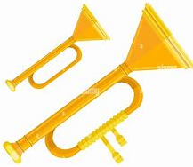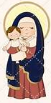
Our Lady of the Angels
Angels give God’s messages to people. What would you tell a friend about God to share your love for Him?
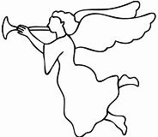

___________________________________

___________________________________

__________________________________

__________________________________

___________________________________

Imagine you are the cantor at Mass. Choose a song you would sing for Mary, and draw a picture of you sharing this song at Mass.

Grade 2- “Happy Birthday, Mother Mary: A Celebration for the Blessed Mother”
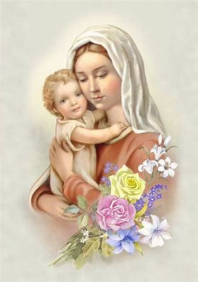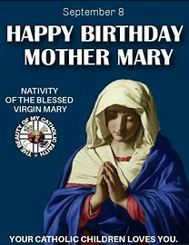
September 8 is Mother Mary’s birthday. Mother Mary’s birthday is called the Nativity of Mary. “Nativity” means “birth.” We call Jesus’ birthday, Christmas, the “Nativity” of Our Lord. Nativity scenes show when Jesus was born in the manger. God chose Mother Mary to be Jesus’ Mother. Mother Mary had a special mission from God to be the Mother of His only Son. Because Mother Mary was born, Jesus could one day be born, when it was time for Him to go on His mission from God to save the people in the world.
Mother Mary cared for Jesus from the time He was born. He grew into a teacher Who taught people about God the Father. Jesus helped people to learn about what they needed to do to get to Heaven to be with His Father. The stories He told to teach people are called parables. Parables teach us a lesson that shows us how to be loving and holy. One of the stories Jesus told was the parable of the mustard seed. A mustard seed is very small. It might not look like it would grow very much. But when we plant mustard seeds and care for them, giving them the things they need, like sunlight and water, they grow into very big, tall, and strong plants. Jesus told this story to show that when we start out with a little bit of faith, and have hope in God, God helps us to grow. He gives us what we need to become very strong, and to share His love with other people.
Mother Mary gave us the gifts of the Rosary and the scapular to help our love for God to grow. Seeds are blessed by priests on Mother Mary’s birthday, because She helps us to grow closer to God. The prayers of the Rosary, like the “Our Father,” “Hail Mary,” and “Glory Be,” are what we use to talk to God, ask Him to help us, and tell Him that we love Him. He listens and helps us. Mother Mary protects us when we wear the scapular, small pieces of wool that a priest blesses and gives us to wear like a necklace to remind us that Mother Mary is keeping us safe. The scapular and Rosary both remind us that Mother Mary wants us to pray to ask for Her help to love Jesus more. Like Mother Mary and Jesus, we were born with special missions God gave us to share His love with other people and make the world a better place. Receiving Jesus at Communion makes us strong so that we can do the special mission God has for us.
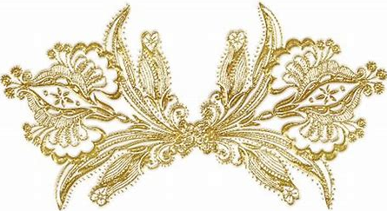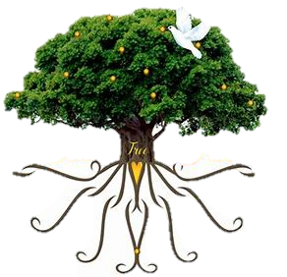
Read more about Mother Mary on pages 21 and 22 as part of Lesson 4 in your St. Joseph’s First Communion Catechism book.
It’s Mother Mary’s birthday, and we need a birthday cake to celebrate. When we bake, we use ingredients like baking powder and baking soda to help cakes and breads to rise. There are many ingredients, foods we need, to make a cake taste delicious, like vanilla. Cakes start out as batter, but when we put them in the oven, they rise. Jesus rose after giving His life on the Cross for us. We lift up our hearts to God when we pray. God gives us Communion, Jesus’ Body, the Eucharist, so that we have the food we need to become stronger, and for our souls to rise to Heaven someday. The gifts God gives us make our lives joyful.
Just as we make cakes with love, we put love into honoring Jesus and Mary. What do we need to do to grow closer to Jesus? What gifts has Mother Mary given us that can help us prepare for Communion? What “ingredients” from God do we need to help our faith, the love in our hearts for Jesus, to grow? Write and draw your ideas on each layer of the cake.
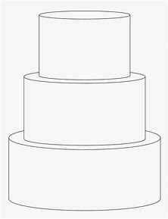

How can we treat God with love like Mother Mary?

______________________________________________________________________________

Week 2
Pre-K/Kindergarten- “God Made You: The Goodness of God’s Creation”
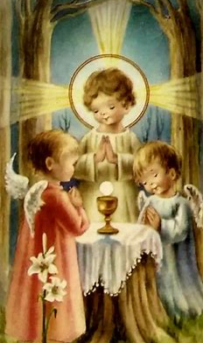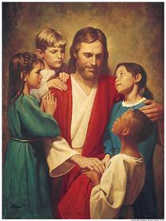
God is our Father in Heaven. He made the world, and everyone in the world. God made you! God made you, because He loves you. God loves each person He has made. God is good, and everything He made is good. You are good, because you are from God. After everything He made, from the sun and moon, the stars and ocean, the mountains and animals, to the first man and woman, Adam and Eve, God said, “It is good.”
Adam and Eve lived in a beautiful garden God made called Eden. Adam and Eve had everything they needed in the garden. It was a good place where they could be close to God. Adam and Eve did not listen to God, and had to leave the beautiful garden. But years later, God made Mother Mary. Mother Mary did listen to God. She is holy. She had a Son, Jesus, Who also listened to God the Father, because He loved His Father in Heaven very much. Jesus saved us. Jesus and Mary love everyone. They did what God made them to do. Because of Jesus, we can one day go to Heaven, a place even more beautiful and good than Eden, to be with God.
When we go to Mass, we can see a little bit of what Heaven will be like, because Jesus is with us. We hear beautiful singing like the music of the angels in Heaven. In Heaven, we see Jesus face to face. Sharing our love for God with our church family at Mass is how we can care for God’s creation, the people He made, or created. We pray for each other.
God made us to love Him, and to love each other. Since God made each one of us, He wants us to love each other. We are all children of God. We can see God’s goodness in other people, and we can show other people God’s love when we are kind, gentle, and caring. God made each of us for a special reason. He chose each of us to do something good that will bring His love and joy to the world He made, just like Jesus and Mary.
In the frame below, draw a picture of you with Jesus. What are some other things God made in the world that you can draw? How can you show Jesus your love? How can you treat God’s creation with love?
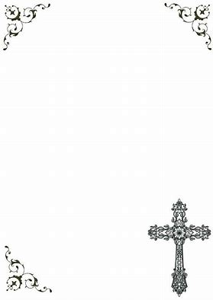

The art you make is called a “creation.” We can create things that honor God. When you finish your drawing, share your art creation with a friend or family member. How did it make you feel to share?

______________________________________________________________________________
Grade 1- “Lifting Every Voice: Praising the Holy Names of Mary and Jesus”
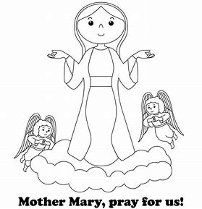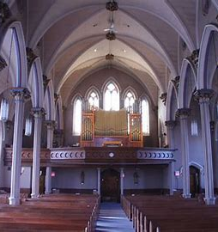
Choir Loft, Our Lady of the Valley
When we say the Holy Name of Jesus at Mass, we bow our heads to show respect for Jesus. Jesus is the Son of God. He is holy, because of the love He has for God the Father and for all of us. Jesus gave His life on the Cross to save us. He loves us so much, that He gives Himself to care for us and help us. When we say Jesus’ Name with love, we are respecting His holiness.
Our songs at Mass are sung out of love for Jesus and Mary. Our music is most beautiful when we sing together. We all are special, because we were made by God, and He made each of us unique. Everyone has a different talent to offer, and a unique voice to share the story of God’s love.
A cantor is one singer. A group of cantors is called a choir. The people in a choir sing at Mass together. When a cantor sings alone, they are singing a solo. Mostly, we hear everyone singing together as one choir, one group. The choir sings in a part of our church called the choir loft. The choir loft is above the pews, the benches where people sit during Mass. We have to look up to see the choir. When we look up, we remember to look up to God in Heaven. We remember that God wants us to get to Heaven so that we can be with Him. We get to Heaven by loving Him and others. We share our love by using our talents, such as by singing, to honor God. The choir loft is like the part of Heaven where the angels are, above the Earth.
All of our voices are needed to create the most beautiful song to honor God. God made you, because He wants you to share His story, and show other people His love. God wants all of us to work together as His family. All of us are needed to bring kindness and love into the world in our own special way.
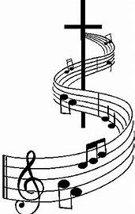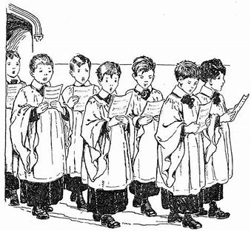
In the church below, draw the part of the church where the choir sings. What is it called?

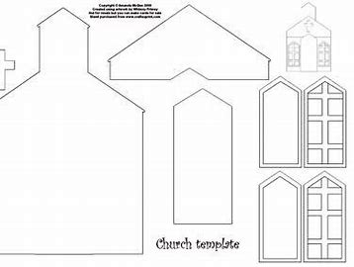
______________________________________________________________________________

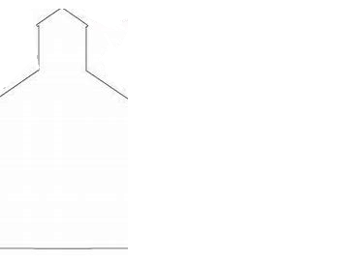

How can we share our love for God together as a Church family?

______________________________________________________________________________
Grade 2- “Baptized into God’s Family: Our Birthdays in the Church”
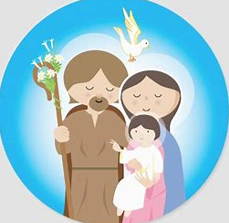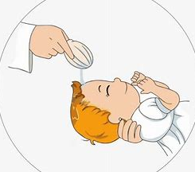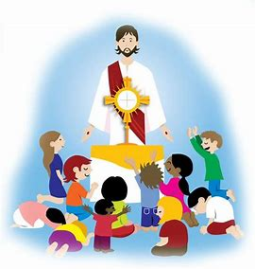
September 12 is the feast day of the Holy Name of Mary. In our Church, we show our love for holy things, things that are from God. Mother Mary’s name is holy, because She is the Mother of Jesus. When we say Her Name, we are saying the Name of the Queen of Heaven. You are preparing to make a sacrament called “Holy Communion,” when you will receive the bread changed into Jesus’ Body by the priest. Communion is holy, because we receive Jesus, the Son of God. He gives us new life. He makes our souls strong. You have received one sacrament in the Church already. It is called “Holy Baptism.” Baptism is like our birthday in the Church. God adopts us as His children. We become part of His family, the Church, forever. This means we only need to be baptized once.
When you were baptized, the priest blessed you with holy water from the baptismal font, a container of holy water. It is called a “font” because it looks like a fountain. When babies are baptized, their parents promise to raise them to love God. They make promises for the baby to follow Jesus. These are called baptismal promises. Every Easter, we make our baptismal promises again by saying that we will stay close to Jesus, and do our best to stay away from sin.
A sin is something a person does that does not follow God’s rules to love Him and other people. When people sin, they choose not to listen to God. Adam and Eve were the first people God made. They did not listen to God, so all of the people born after Adam and Eve were born with original sin, sin that comes from God’s first people. Baptism cleans our souls of original sin. Before going to Communion, we go to Confession to ask God to forgive us for times we did not listen to Him ever since we were baptized. Jesus is with us at Baptism, and He is with us at Communion, when we show God our love for Him as His children. It helps us to go to Communion as often as we can, as long as we have been to Confession, because Communion keeps us strong, so that we can stay away from sin.
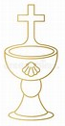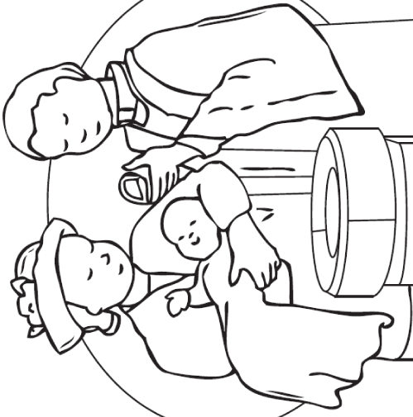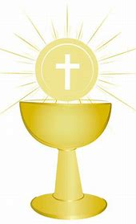
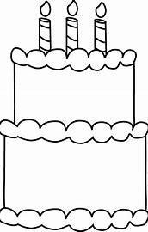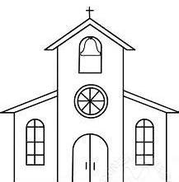
Read more about Holy Baptism in Lesson 8 of your St. Joseph’s First Communion Catechism book (pages 35-37). You can also read the story of Adam and Eve in lesson 1, pages, 7-10.
Draw pictures comparing Holy Baptism and First Holy Communion.

What happens at Baptism? What happens at Communion?

What is one difference between Baptism and Communion?

______________________________________________________________________________

______________________________________________________________________________

What do Baptism and Communion have in common?

______________________________________________________________________________

______________________________________________________________________________
Week 3
Pre-K/Kindergarten- “God Made the Church: Praying Together as God’s Family”
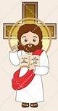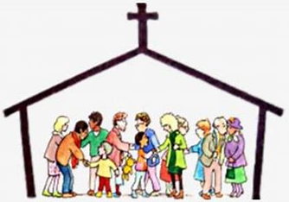
God made Mother Mary, and He made you. God has made our whole world, and each person in it. God made the Church. Jesus went on the Cross for us. He gave His life for us. After Jesus went to Heaven, His helpers kept the Church, His family, going. When we go to church, we share our love for God as one family. We talk to God when we say our prayers and make the Sign of the Cross to remind us of Jesus going on the Cross, because He loved us, and wanted to save us by giving His life. The priest, Jesus’ helper, says the Mass. He helps us to remember Jesus’ love for us, and to live like Jesus. Priests give their lives to God. They change the bread at Mass into Jesus’ Body, the Eucharist. They bring Jesus to everyone in the Church. Only priests have the power to do this in the special way that Jesus gave them.
The people who go to Mass, and are part of God’s family, but are not priests, are called laity, or laypeople. God made the Church so that we could pray together and love each other. Jesus is with us at Mass. During Mass, we think of Him going on the Cross. He wants us to be His friend by being friends with the people He sends us to know. Laypeople and priests pray at the Mass. The priest is the leader. He stands at the altar, the table where the bread is changed into Jesus’ Body, and prays, while laypeople sit in their seats and pray. Priests and laypeople all have special talents they use to help their family, the Church. God loves priests and laypeople. September 29 is a special day to remember God’s angels. God’s holy angels watch over everyone in the Church from Heaven. They sing and pray with us from Heaven while we are at Mass. We can pray for our angels to keep us safe and help us. We can be like the angels by loving God.
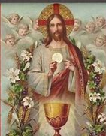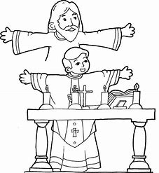
Draw and label people in the church. What is the name of Jesus’ helper who says the Mass? Where does he go? Where do the people go at Mass, and what is a special name for them?
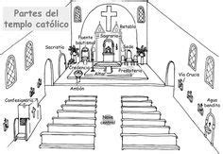
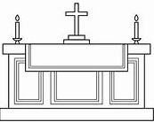
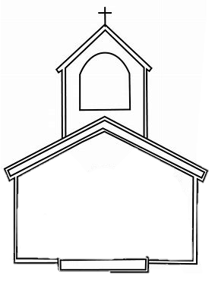
The
_________________
sit here and pray.
The

__________________
says the Mass.
Grade 1- “Prayers for Priests: Priesthood Sunday and Mary, Mother of the Church”
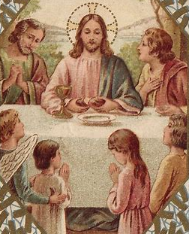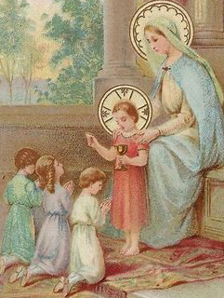
September 24 is Priesthood Sunday this year. Priesthood Sunday is a special day to pray for our priests, who are part of our Church family. Priests change the bread into Jesus’ Body at Mass. They give us Communion to bring us Jesus into our hearts. Priests help us to become closer to Jesus so that we can know how to love Him, and one day be with Him in Heaven where we can love Him forever.
Priests care for us in our churches. In our churches, we pray for God to help and bless us and the people in our church family. We pray as one family in Christ when we go to church, sharing our love for God with each other. One special kind of church is a cathedral. Cathedrals are the bishop’s big churches. Bishops watch over the priests and all of the churches in an area. There are many cathedrals that are named after Mother Mary. In September, we also celebrate the Holy Name of Mother Mary. Jesus and His churches are holy, because they are where we show our love for Him and for His Mother, Mary. Jesus is in each church, and in our hearts. We can make our hearts like churches, holy places, for Jesus by praying, talking to God with love.
Mother Mary is the Mother of the Catholic Church, because She is the Mother of Jesus, and the Church is Jesus’ Church. Mother Mary watches over all of the priests and the people they help. Mother Mary is the Mother of Jesus, Who was a priest. She is our Mother in Heaven, the Mother of all priests. Priests give their lives to serving Jesus and His Church. They help us to get ready for receiving sacraments like Communion. When you ask Mother Mary to help you prepare for your First Communion, She will also pray for you. As members of Jesus’ family, we can all pray for each other.
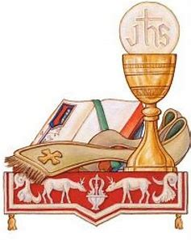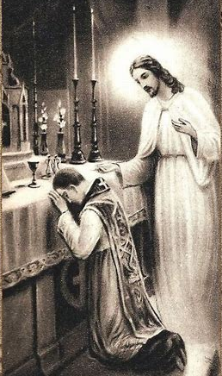
What do we do when we go to church? Who is the leader who serves our church? Who can you pray for at church? Draw a picture to show your answers. Write your thoughts or label your picture on the lines below.
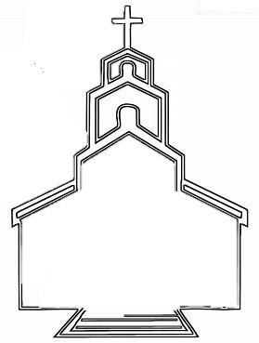
______________________________________________________________________________
______________________________________________________________________________
Grade 2- “Jesus the Priest: Honoring Our Lord on Priesthood Sunday”
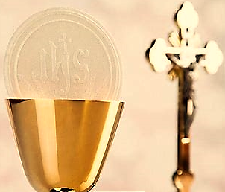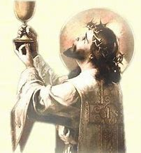
When we go to Mass, we see the priest. He is the leader of our church who says the Mass. Priests are chosen by God to be His servants, Jesus’ helpers on Earth. Jesus is in Heaven. The priests give us the sacraments, such as Communion, which help us to know Jesus. Jesus comes down from Heaven to us in the sacraments. We call the Eucharist the “Bread of Heaven,” or the “Heavenly Host,” because it is Jesus’ Body.
On the Host, you will see Jesus’ initials, “IHS.” Sometimes the “I” looks like a “J.” These are the first letters of His Holy Name in the language known as Greek. Jesus’ Name is holy. When the priest gives us the Eucharist, He tells us It is Christ. We know we are not receiving regular food, but the food of Heaven, the greatest gift God can give us as we prepare to go to Heaven to be with Him someday. Even the angels, who are with us watching over us at Mass, cannot receive Communion. Only we can, on Earth.
Saying Jesus’ Name is a prayer. Living like Jesus, with love, is another way we pray. Priests live like Jesus in a special way, because Jesus was a priest. They give people the sacraments, just like Jesus did. Jesus created the sacraments. He told His helpers to bless the bread and give it to people to save their souls. The priest changes the bread at Mass into Jesus’ Body to give to people to help their souls. We can all live like Jesus, treating people with kindness, and sharing God’s love. Only men who are priests can share God’s love by saying the Mass, changing the bread into Jesus’ Body, and giving people all of the sacraments.
In September, we celebrate Priesthood Sunday and the Feast of the Archangels (Gabriel, Michael, and Raphael, the leaders of the angels). Angels bring messages from God, and help keep us safe. Jesus is the Good Shepherd, because He watches over us from Heaven like a shepherd watches his sheep. Priests are His helpers, shepherds who watch over us in their churches on Earth. Priests remind us of what God tells us: to pray, go to Mass and respectfully receive the Eucharist with clean hearts, and treat others with love. They show us how to do these things, honoring God and His Holy Name. These are ways we show our love for God.
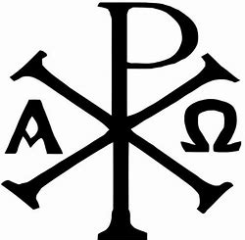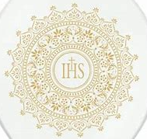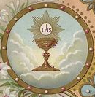

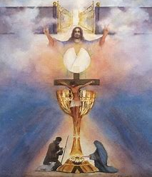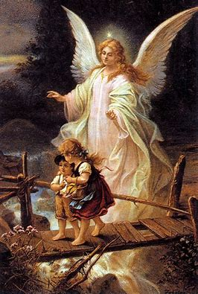
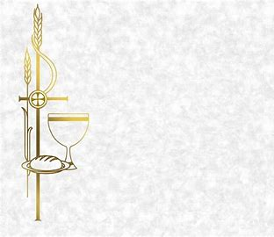
Read “Signs or Symbols” on page 46 in Lesson 10 of your St. Joseph’s First Communion Catechism book. You learned about IHS, Jesus’ initials. What is another symbol (picture) we see in church? What does it stand for, or remind us of?

_____________________________________________________

_____________________________________________________

_____________________________________________________

_____________________________________________________

_____________________________________________________

_____________________________________________________

Choose a patron saint or archangel you can ask to help you as you get ready for your First Communion. Write the name of the saint or archangel you will pray to here:

______________________________________________________________________________
Symbols, pictures we see in the church like the Cross, remind us of Jesus. Priests remind us of Jesus by living out His love. Write a thank-you note to give to a priest. What does the priest do that is like Jesus? How does he remind us of Jesus, showing us what Jesus is like?
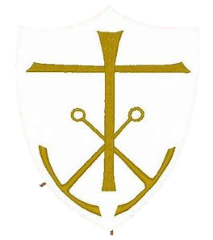
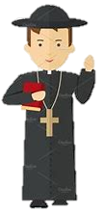
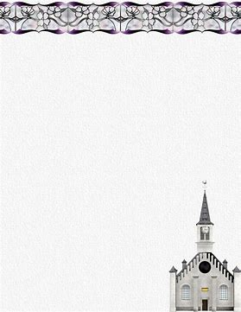

__________________________________

__________________________________

__________________________________

___________________________________________________________________________

___________________________________________________________________________

___________________________________________________________________________

___________________________________________________________________________

___________________________________________________________________________

September 2023 Pre-K-2 Review
Use this review sheet as a reference to track progress and check that learning goals are met.
Recap: What did we learn?
All Grades
- September 8 is Mother Mary’s birthday
- Mother Mary is the Mother of Jesus. Since Mother Mary was born, Jesus could one day be born
- September is a special month to celebrate Mother Mary, the angels, and our priests in the Church. Mother Mary, the angels, and priests show us how to love God, because they listen to Him
- Listening to God is how we show our love for God and follow His special plan for each of us
- Priests are Jesus’ helpers who share God’s love for us. They give their lives to God out of love for Him, and watch over us in our churches on Earth
- Angels are God’s messengers who watch over us from Heaven
- Jesus and Mother Mary are holy, because they are full of love for God the Father and for us. The Names of Jesus and Mary are holy, because of their holiness
Pre-K/Kindergarten
- God is our Father in Heaven. He made everything. He made the world, He made people, and He made the Church
- Everything God made, or created, is called His “creation”
- God made Mother Mary, the Mother of His only Son, Jesus
- Mother Mary brings us blessings from Jesus. She prays for us, and wants us to talk with Her in prayer so that She can help us to better know and love Her and Her Son
- God is good. Everything He made is good
- God made you out of love. He made you to love Him. He made you special
- God made the Church, His family, so that we can share our love for Him together. He wants us to love each other. We can learn about God’s love through our kindness to each other
- Priests say Mass at the altar, the table where they change the bread into Jesus’ Body. Only priests can say the Mass. Priests pray to God in a special way at the Mass
- People who go to Mass to pray, but who are not priests, are called the laity, or laypeople
Grade 1
- A special way for us to honor the Holy Names of Mother Mary and Jesus is by singing. Singing is how we can share our love for God at Mass
- Cantors are singers at the Mass. A group of cantors who sing together is called a choir
- The choir sings in the choir loft, which is above the pews where people sit in the church
- Latin songs sung at the Mass are called “Gregorian chants”
- There are special songs for Mother Mary, like “Ave Maria,” Latin for “Hail Mary”
- The angels sing in Heaven to honor God. Singing at the Mass makes the Church on Earth feel like Heaven. We can see how beautiful and happy it will be to be with Jesus
- Churches are where we go to share our love for God. We are all part of one big Church family
- Priests are part of our Church family. They teach us about Jesus, and how to live like Jesus, in how they live like Him
- The bishop’s big church is called a cathedral. Some cathedrals are dedicated to Mother Mary
- Mother Mary is the Mother of the Church, because She is the Mother of Jesus, and the Church is Jesus’ Church
- Priests give their lives to serving God and His people in His Church. Mother Mary is Mother to us all, and She is the Mother of the priests
- Everyone in our Church family is needed to share Jesus’ love. Only priests can share Jesus through giving the sacraments to people, but we can all be loving like Jesus
Grade 2
- God gave us all a special mission to share His love
- Mother Mary’s special mission was to be Jesus’ Mother. She loved and cared for Him, giving Him what He needed to grow so that He would be ready for His special mission from God, to save people from sin
- Mother Mary’s birthday is called Her “nativity”
- Jesus told stories called “parables” to teach people about God’s love. He showed us that God’s love helps our faith to grow. Praying helps us plant the seeds we need for our faith to grow, because when we pray, we can talk to God and share our love for Him
- The first sacrament we receive in the Church is Baptism. When we are baptized, the priest blesses us with holy water. We are adopted into God’s family
- At baptism, we become children of God. Baptismal promises are promises we make to follow God and stay away from sin. Baptism forgives the first sin of Adam and Eve
- We keep going to Confession before receiving Communion so that we will be forgiven of other times we have sinned
- Baptism and Communion are both sacraments. Jesus is with us in the sacraments, and we feel His love when we receive them. At Communion, we receive Jesus in the Eucharist
- We can only be baptized once, because Baptism makes us God’s children forever, but we need to keep receiving Communion to stay strong and close to God
- Baptism is like our birthday in the Church. Every time we go to Communion is like a birthday for our souls, because Jesus gives us new life. The sacraments help us to start fresh, and to keep becoming better friends of God
- Jesus’ initials are IHS in Greek. We see His initials on the Eucharist, the Host
- There are many signs and symbols in the Church that remind us of Jesus
- Jesus is with us at Mass, and always in our hearts. Jesus comes into our hearts in a special way at Communion
- Jesus was a priest. Priests today share Jesus with us by changing the bread at Mass into Jesus’ Body. Only priests have the power from Jesus to do this
What vocabulary words did we practice?
Pre-K/Kindergarten
Week 1
God
Week 2
Creation
Week 3
Laity/laypeople
Grade 1
Week 1
Cantor
Gregorian chants
Week 2
Choir
Choir loft
Week 3
Cathedral
Grade 2
Week 1
Nativity
Parable
Week 2
Baptism
Baptismal font
Baptismal promises
Week 3
IHS
What prayers did we practice?
Pre-K/Kindergarten
Sign of the Cross
Grade 1
Guardian Angel Prayer
Grade 2
Hail Mary
Checklist: Activity Completion
Pre-K/Kindergarten
Week 1: “God Made Mother Mary: Celebrating Our Lady”
Week 2: “God Made You: The Goodness of God’s Creation”
Week 3: “God Made the Church: Praying Together as God’s Family”
Grade 1
Week 1: “A Song for Mary: Honoring Mary with the Angels”
Week 2: “Lifting Every Voice: Praising the Holy Names of Mary and Jesus”
Week 3: “Prayers for Priests: Priesthood Sunday and Mary, Mother of the Church”
Grade 2
Week 1: “Happy Birthday, Mother Mary: A Celebration for the Blessed Mother”
Week 2: “Baptized into God’s Family: Our Birthdays in the Church”
Week 3: “Jesus the Priest: Honoring Our Lord on Priesthood Sunday”
Quick Check:
Tell us about your experience with these activities this month! Our September 2023 Google Form for Grades Pre-K-2 is available here: https://forms.gle/8BZzo2DGdGLAqpBw6

