Our Lady of the Valley Religious Education

April 2023 Activity Packet

Grades 7-9/10-12

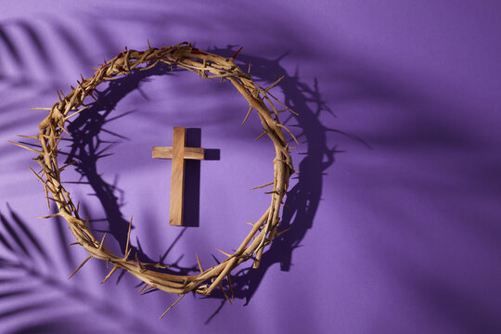

Name: ________________________________________
Materials Included in Packet
Overview…………………………………………………………………………………………3
Standards………………………………………………………………………………………...5
Pacing Guide……………………………………………………………………………………..8
Activities…………………………………………………………………………………………12
Week 1…………………………………………………………………………………………...12
Grade 7……………………………………………………………………………….….12
Grade 8…………………………………………………………………………………..14
Grade 9/10-12…………………………………………………………………………...16
Week 2…………………………………………………………………………………………...18
Grade 7……………………………………………………………………………….….18
Grade 8…………………………………………………………………………………..20
Grade 9/10-12…………………………………………………………………………...22
Week 3…………………………………………………………………………………………..24
Grade 7……………………………………………………………………………….…24
Grade 8………………………………………………………………………………….26
Grade 9/10-12…………………………………………………………………………...28
Review…………………………………………………………………………………………...30

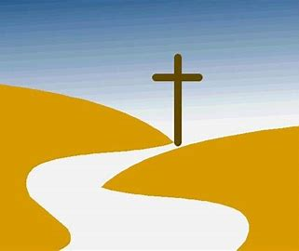
April 2023 Overview: Grades 7-9/10-12
Theme: Faith (Fides)
Thematic Guiding Questions, 7-9/10-12:
- Why do you think that faith is a journey, a process of seeking?
- How do the liturgical seasons, especially our Lenten walk through the desert, reflect the ongoing search for God?
Monthly Challenge: Reduce screen time. Take 15 minutes you would normally be on your phone/social media, and use that time to pray instead. Read a Bible passage, meditate, etc. How did you feel? If you made this part of your daily schedule, what kinds of effects did you see over the long-term in your faith life?
Overall Learning Goals: This month, our overall goal is to learn about what it means to practice our faith every day, to live out our beliefs and put our trust in God. Our goal is to learn about how we personally grow in the virtue of faith, and how we can continue to deepen our understanding of the Catholic Faith, as well as how to share that understanding with others.
Summary of Activities: To fulfill our learning goals, we will read examples from the Bible of people who have demonstrated their faith in God. We will also see examples from Scripture of how God has been faithful to His followers, keeping His promises. Using music, art, journaling, and reflection, our activities will allow for exploration of how we live our faith through Sacred Scripture and Sacred Tradition (the sacraments, and the liturgy of the Mass/sacramentals), how we share our faith, and how we have kept our faith alive through the ages, with a special focus on how Holy Week and the Easter season illuminate our faith.
Additional Enrichment Ideas:
- Deepen devotion to Jesus by praying before an image of the Holy Face. Meditate on St. Veronica’s compassion towards Christ in His suffering, thinking about seeing the face of Christ in everyone
- Attend the OLV Good Friday talk (April 7, 2023, at 6:00 p.m.) on the Seven Last Words of Jesus, which connects with our activities this month about Jesus’ words on the Cross
- On the Second Sunday of Easter, April 16, attend a Divine Mercy service with readings from St. Faustina’s diary, praying of the Divine Mercy chaplet, Benediction, Adoration, Divine Praises, and singing of the Litany of Divine Mercy. It is also a tradition to go to Confession on Divine Mercy Sunday. Join us at OLV to celebrate this special day
- Visit the Shrine of Divine Mercy in nearby Stockbridge, MA. Pray the outdoor Stations of the Cross, pray the Divine Mercy chaplet in the church, and learn more about the devotion of Saints Faustina and Pope John Paul II to our merciful God. You can see the chaplet prayed live at 3:00 each day online: https://www.shrineofdivinemercy.org/watch-national-shrine
- April 30 is World Day of Prayer for Vocations. Pray for an increase in vocations for men and women religious, and for everyone who is discerning their future. Pray that each person will be given the clarity to know where God is guiding them to use their gifts.
  - Take part in praying on the 27th of every month for the seminarians at St. John’s in Brighton, MA. Sign up for email reminders here: https://www.sjs.edu/27
  - You can also download Sadlier’s prayer for vocations, and cut out the prayer card to keep at home: https://95641.fs1.hubspotusercontent-na1.net/hubfs/95641/00_Redesign_2019/Religion_2019/03_Rel_Downloads/Rel_Download_PDFs/REL_DL_QuiltActivity_Vocations.pdf
Bible Affirmation
Cut out this card to remind you that God is faithful to His promises, always there to help you.
May the God of hope fill you with all joy and peace in believing, so that you may abound in hope by the power of the Holy Spirit. (Romans 15:13)

Standards
Grade Level | Week | Activities | Learning Standards
Grade 7 | 1 | “Holy Week and the Light of Faith” | 7.1 Prayers are integral to our growth, as they allow us to connect with God, guiding us forward with faith and hope. When we pray, we are taking a constructive step to address worry in our lives… prayers help us to increase our sense of peace as we put faith in God, trusting in Him to protect and heal us.
Grade 7 | 2 | “The Road to Emmaus and Faith in the Real Presence” | 7.4 God reveals Who He is to us, reminding us of His presence, so that we need not worry, instead remembering His goodness all around us, all the beautiful and true signs of God that lead us to virtue.
Grade 7 | 3 | “Faith Road Map: Lenten Resolutions Reflection” | 7.6 There are different types of prayer, and distinct purposes for praying, but all prayer is meant to draw us closer to God.
Grade 8 | 1 | “The Light of Christ: Faith in Jesus at Holy Week and Beyond” | 8.5 We rely on Sacred Scripture and Sacred Tradition to help us know and follow Christ.
Grade 8 | 2 | “The Rosary and the Glory of our Faith” | 8.8 The Rosary shows us the sacraments’ layers of meaning by commemorating the events of Jesus’ and Mary’s lives, helping us to better understand their roles in salvation history.
Grade 8 | 3 | “The Treasure of our Faith” | 8.6 Sacraments, and the infinite graces flowing from them, are free gifts from God that must be freely accepted… Avoiding sin allows us to fully receive grace needed to further perfect our souls. Because sacraments are efficacious, meaning that they have real effects that impact us, they impart graces that we can receive. At the Mass… the substance of the bread and wine change, becoming the Body and Blood of Christ. When we receive the Body of Christ, we are receiving an efficacious sacrament (made real, more than symbolic, through His Sacrifice), engaging in a personal encounter with Christ. He truly works within us as we open our hearts to receive Him. The degree of grace we receive in the sacraments depends on our degree of faith, hope, and love, our receptivity to God. Praying the Act of Faith, Act of Hope, and Act of Love before and after receiving Communion can help us to open our hearts more fully to God, to prayerfully welcome His graces.
Grade 9 (& 10-12) | 1 | “Our Faith and the Chrism Mass” | 9.10 God has a special plan for each person, a distinct purpose He created them for, which the Gifts of the Holy Spirit give us the clarity to discern. We are all called to love, which is ultimately how we all can serve God, though we all live out this vocation in a unique way.
Grade 9 (& 10-12) | 2 | “The Art of Easter” | 9.8 Jesus instituted seven sacraments that align with major life stages. The spiritual life cycle of the sacraments mirrors the natural life cycle of the body. Baptism is birth, Confirmation is maturation, and the Eucharist is strengthening… These stages remind us that the sacraments are essential to our growth.
Grade 9 (& 10-12) | 3 | “Pentecost and Faith in the Holy Spirit” | 9.9 The Holy Spirit transforms what is entrusted to His power, as we see through sacraments such as Confirmation. The Gifts of the Holy Spirit have the power to transform us. If we offer ourselves to the Holy Spirit, He will move our hearts, stirring our souls, so that we can put faith into action.

April 2023 Pacing Guide (Suggested Schedule)
Grades 7-9/10-12
Week Number/Date | Grade Level | Activities
Week 1  (April 3-7, 2023: triduum, correlation with Holy Week) | Grade 7 | “Holy Week and the Light of Faith”
 | Grade 8 | “The Light of Christ: Faith in Jesus at Holy Week and Beyond”
 | Grade 9 (& 10-12) | “Our Faith and the Chrism Mass”
Week 2  (April 10-14, 2023) | Grade 7 | “The Road to Emmaus and Faith in the Real Presence”
Week 2  (April 10-14, 2023) | Grade 8 | “The Rosary and the Glory of our Faith”
Week 2  (April 10-14, 2023) | Grade 9 (& 10-12) | “The Art of Easter”
Week 3  (April 24-26, 2023) | Grade 7 | “Faith Road Map: Lenten Resolutions Reflection”
Week 3  (April 24-26, 2023) | Grade 8 | “The Treasure of our Faith”
Week 3  (April 24-26, 2023) | Grade 9 (& 10-12) | “Pentecost and Faith in the Holy Spirit”

Week Number/Date | Grade Level | Words to Practice | Definitions
Week 1  (April 3-7, 2023: triduum, correlation with Holy Week) | Grade 7 | Tenebrae | From the Latin “tenebris,” meaning “darkness.” Tenebrae services held during Holy Week incorporate music and prayerful reflection on Christ’s suffering.
 | Grade 8 | Last Supper | When Christ broke bread with the apostles, instituting the sacrament of the Eucharist, on what would be His last night before dying on the Cross. Every Mass commemorates these events of Christ’s life, but on Holy Thursday specifically, this eve of Christ’s Death is remembered.
 | Grade 9 (& 10-12) | Chrism | A holy oil blessed by the bishop every year at a special Mass, to be used in sacraments such as Confirmation. Confirmandi are anointed with chrism oil to signify that they are being “sent” forth to continue Christ’s mission, drawing upon the Gifts of the Holy Spirit to live it out.
Week 2  (April 10-14, 2023) | Grade 7 | Real Presence | The True Presence of Jesus in the Blessed Sacrament (the Eucharist); believing that the bread is not simply bread, a symbol of the Body, but really the Body of Christ Itself; Christ is there, alive in the Sacred Host.
Week 2  (April 10-14, 2023) | Grade 8 | Ascension | Jesus rose (ascended) into Heaven 40 days after the Resurrection (when Jesus rose from the dead).
Week 2  (April 10-14, 2023) | Grade 9 (& 10-12) | Redemption | Salvation. Christ redeemed us from sin. His Sacrifice freed us from our debt of sin, giving us new life, another chance.
Week 3  (April 24-26, 2023) | Grade 7 | Sacred Tradition | The sacraments. Liturgical traditions in the Church passed down. Practices to live out the Faith.
Week 3  (April 24-26, 2023) | Grade 8 | Pneumatology | The study of the Holy Spirit. “Pneuma” translates to “breath” or “air” in Latin. The Holy Spirit breathes life into us through the spiritual gifts of fortitude, wisdom, counsel, fear of the Lord, piety, understanding, and knowledge. On Pentecost, the Holy Spirit came down on the apostles like wind to bestow these Gifts.
Week 3  (April 24-26, 2023) | Grade 9 (& 10-12) | Pentecost | When the Holy Spirit came down to the apostles after Jesus’ Ascension, giving them the gifts they needed to continue Jesus’ mission. This day is celebrated 50 days after Easter Sunday.

Week Number/Date | Grade Level | Prayers to Practice | Text of Prayers
Week 1  (April 3-7, 2023: triduum, correlation with Holy Week) | Grade 7 | Jesus Prayer | Lord Jesus Christ, Son of the Living God, have mercy on me, a sinner. Amen.
 | Grade 8 | Anima Christi | Soul of Christ, be my sanctification.  Body of Christ, be my salvation.  Blood of Christ, fill all my veins.  Water of Christ’s side, wash out my stains.  Passion of Christ, my comfort be.  O good Jesus, listen to me.  In Thy wounds I fain would hide,  Never to be parted from Thy side.  Guard me should the foe assail me.  Call me when my life shall fail me.  Bid me come to Thee above,  With Thy saints to sing Thy love  World without end. Amen.
 | Grade 9 (& 10-12) | Prayer to the Holy Face | Holy Face of Jesus, Be my joy.  Holy Face of Jesus, Be my strength.  Holy Face of Jesus, Be my health.  Holy Face of Jesus, Be my courage.  Holy Face of Jesus, Be my wisdom.  Holy Face of Jesus, Image of the Father, Provide for me.  Holy Face of Jesus, Mirror of Thy Priestly Heart, Be my zeal.  Holy Face of Jesus, Gift of the Spirit, Show me Thy love.  Holy Face of Jesus, saddened by sorrow, Grant my requests through Thy merits. Amen.
Week 2  (April 10-14, 2023) | Grade 7 | Jesus Prayer | Lord Jesus Christ, Son of the Living God, have mercy on me, a sinner. Amen.
Week 2  (April 10-14, 2023) | Grade 8 | Anima Christi | Soul of Christ, be my sanctification.  Body of Christ, be my salvation.  Blood of Christ, fill all my veins.  Water of Christ’s side, wash out my stains.  Passion of Christ, my comfort be.  O good Jesus, listen to me.  In Thy wounds I fain would hide,  Never to be parted from Thy side.  Guard me should the foe assail me.  Call me when my life shall fail me.  Bid me come to Thee above,  With Thy saints to sing Thy love  World without end. Amen.
Week 2  (April 10-14, 2023) | Grade 9 (& 10-12) | Prayer to the Holy Face | Holy Face of Jesus, Be my joy.  Holy Face of Jesus, Be my strength.  Holy Face of Jesus, Be my health.  Holy Face of Jesus, Be my courage.  Holy Face of Jesus, Be my wisdom.  Holy Face of Jesus, Image of the Father, Provide for me.  Holy Face of Jesus, Mirror of Thy Priestly Heart, Be my zeal.  Holy Face of Jesus, Gift of the Spirit, Show me Thy love.  Holy Face of Jesus, saddened by sorrow, Grant my requests through Thy merits. Amen.
Week 3  (April 24-26, 2023) | Grade 7 | Jesus Prayer | Lord Jesus Christ, Son of the Living God, have mercy on me, a sinner. Amen.
Week 3  (April 24-26, 2023) | Grade 8 | Anima Christi | Soul of Christ, be my sanctification.  Body of Christ, be my salvation.  Blood of Christ, fill all my veins.  Water of Christ’s side, wash out my stains.  Passion of Christ, my comfort be.  O good Jesus, listen to me.  In Thy wounds I fain would hide,  Never to be parted from Thy side.  Guard me should the foe assail me.  Call me when my life shall fail me.  Bid me come to Thee above,  With Thy saints to sing Thy love  World without end. Amen.
Week 3  (April 24-26, 2023) | Grade 9 (& 10-12) | Prayer to the Holy Face | Holy Face of Jesus, Be my joy.  Holy Face of Jesus, Be my strength.  Holy Face of Jesus, Be my health.  Holy Face of Jesus, Be my courage.  Holy Face of Jesus, Be my wisdom.  Holy Face of Jesus, Image of the Father, Provide for me.  Holy Face of Jesus, Mirror of Thy Priestly Heart, Be my zeal.  Holy Face of Jesus, Gift of the Spirit, Show me Thy love.  Holy Face of Jesus, saddened by sorrow, Grant my requests through Thy merits. Amen.

April 2023 7-9/10-12 Activities
Week 1
Grade 7- “Holy Week and the Light of Faith”
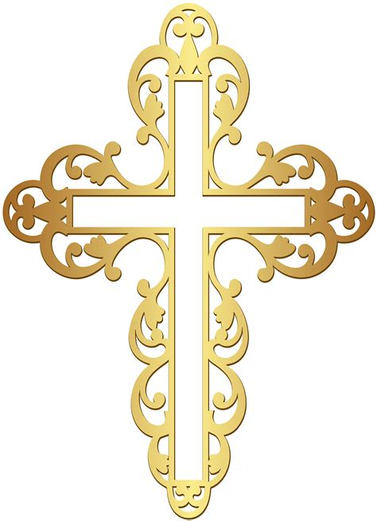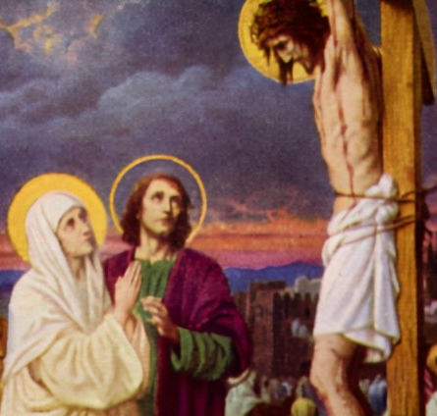
This year, Holy Week takes place in the first week of April, when we observe the Easter Triduum. These are three days when we remember Jesus’ Passion, Death, and Resurrection. The night of Holy Thursday to the night of Good Friday makes up one day in the Triduum. From the night of Good Friday to the night of Holy Saturday, we observe the second day of the Triduum. The Triduum ends with the third day, from the night of the vigil to the night of Easter Sunday.
On Holy Thursday, we remember the Last Supper, the night before Jesus died, when He introduced the sacraments of the Eucharist and Holy Orders. Jesus prepared the apostles to carry on His mission after He died, so He taught them how to celebrate the Mass as priests by breaking the bread and blessing it, so that other people can receive Christ’s Body. This is how they would pass on the Faith. At many Holy Thursday Masses, there is a symbolic washing of feet, which honors when Jesus washed the feet of the 12 apostles. He was teaching them about caring for others with love, and also, about cleansing away sin. On Good Friday, we remember when Jesus died. This is the only day of the year when no Masses are celebrated, but there are services on Good Friday. At a Good Friday service, people can receive Communion (Hosts consecrated at the Holy Thursday Mass). They also venerate the Cross, usually by kissing a crucifix, to honor Jesus for dying for us on the Cross.
During Holy Week, you can go to Tenebrae services also. “Tenebrae” means “darkness” in Latin: the darkness of Christ’s Passion and Death. Songs of sadness are sung, like how at the Stations of the Cross, as we go to each Station and reflect on Jesus’ suffering (His Passion), we sing the “Stabat Mater.” The Easter Vigil on Holy Saturday is the welcoming of new life, of Christ’s rising. We await the joy of His Resurrection on Easter Sunday; this hope is present at the vigil. We see the contrast between darkness and light, seeing that Jesus drives out darkness, as we light candles that shine in the dark church. Then, on Easter, we can sing the joyful “Alleluia” again, after not singing it during Lent, as we celebrate Jesus overcoming death.
- Which of the Triduum liturgies (Holy Thursday, Good Friday, Holy Saturday, Easter Sunday) is your favorite, and why? Which speaks most to you, and boosts your faith?
______________________________________________________________________________
__________________________________________________________________________________________________________________________________________________________________________________________________________________________________________
- How are Tenebrae and the Easter vigil similar, and how are they different?

- Listen to the “Stabat Mater” song from the Stations of the Cross, or read the English translation of the Latin lyrics: https://www.preces-latinae.org/thesaurus/BVM/SMDolorosa.html. Reflect on how this song made you feel. When you think about Jesus’ suffering through the eyes of Mary, His Mother, how do you see it differently? How is Mary an example of faith in how She responded to Jesus’ suffering (consider the meaning of the song’s title, too)?
________________________________________________________________________________________________________________________________________________________________________________________________________________________________________________________________________________________________________________________
- Why do you think music is such a large part of how we express our faith during Holy Week?
____________________________________________________________________________________________________________________________________________________________
- One of Jesus’ last words on the Cross was “Behold your Mother.” Jesus gave us His Mother to be our spiritual mother, and He gave us to Her to be Her spiritual children. Faith is loyalty. Jesus did not leave His Mother alone, and He did not leave us alone. Why is it important that we venerate (honor) Mother Mary to be faithful to Jesus?
________________________________________________________________________________________________________________________________________________________________________________________________________________________________________________________________________________________________________________________
Grade 8- “The Light of Christ: Faith in Jesus at Holy Week and Beyond”
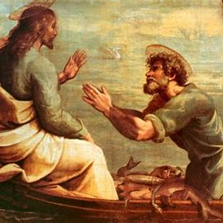
During Holy Week, we observe the Easter Triduum, three days commemorating the Paschal Mystery: Jesus’ Passion, Death, and Resurrection. Day one of the Triduum is from the night of Holy Thursday to the night of Good Friday. Making up the second day is the night of Good Friday to the night of Holy Saturday, and from Holy Saturday night to the night of Easter Sunday, we celebrate the third day of the Triduum. We prepare ourselves spiritually to celebrate Jesus’ triumph over death, so that we can share in the joy of His Resurrection, and look forward to new life in Christ. (In fact, traditionally, Holy Week was a time for spring cleaning as well- to wash away the past dust from the house, and to cleanse the soul of past sins, too!)
We think of the Last Supper, which we remember on Holy Thursday, as being the first Mass. Jesus introduced the sacrament of the Eucharist, breaking and blessing the bread. He prepared His apostles to do the same in His memory, as priests celebrating future Masses. In this way, the sacrament would be passed on, and generations after could know Jesus in His Presence in the Eucharist. But on Good Friday, the day Jesus died on the Cross, we have the heart of the Mass, because at every Mass, we relive Jesus’ Sacrifice, remembering God’s great love, a love that led the Father to give us His Son, and the Son to give us His life so that we would be saved.
Holy Week is about light overcoming darkness, life overcoming death, which is possible through God’s love. Peter and Judas both denied Jesus in different ways. Sin shadowed their relationships with God. Judas never asked for God to forgive him after he betrayed Jesus. He lost hope, and gave in to darkness. In Peter, though, we see the light of hope. Peter believed God’s mercy was greater than His sin of lying and rejecting Christ by acting as though he had never known Him. Peter asked for Jesus’ forgiveness. For each of the three times Peter denied Jesus, he told Jesus that he loved Him. Like Penance after Confession, this was an expression of His commitment to loyally follow Christ and heal his relationship with Him, sharing His faith rather than hiding it. In the light, nothing is hidden. We see what is true. Jesus is the Way, the Truth, and the Life. Sharing our faith, we show God’s love to others, bringing it into the light.
- Read Luke 22:54-62 (https://bible.usccb.org/bible/luke/22) and John 21:15-25 (https://bible.usccb.org/bible/john/21). How do these stories of Peter and Jesus show us the importance of Confession? What contrast do you see between darkness and light?
____________________________________________________________________________________________________________________________________________________________
____________________________________________________________________________________________________________________________________________________________
- When Jesus looked at Peter after Peter denied Jesus for the third time, why do you think Peter reacted the way he did? How do these stories demonstrate God’s love for, and faithfulness to, us?
__________________________________________________________________________________________________________________________________________________________________________________________________________________________________________
- How are darkness and light contrasted during Holy Week? Of the Triduum liturgies, pick two to compare: Holy Thursday, Good Friday, Holy Saturday, and Easter Sunday. Research traditions associated with each day. Start by watching videos of past Holy Week liturgies, like the Holy Saturday Easter vigil at OLV: https://vimeo.com/700219496. You can also read excerpts from the “Holy Week” reflection by the Catholic writer/singer Maria von Trapp (of Sound of Music fame), about Holy Week traditions, on page 34 of this packet.

- Before the Vatican Council II changes in the 1960s, at the end of every Mass, the first chapter of the Gospel of John was read. John writes that he came to “testify to the light.” His purpose was to bring others to Jesus, the Light of the World, “so that all might believe through Him.” Light helps us to find our way. At Lent, we fast and pray, discerning how we can draw nearer to God. We continue this process of seeking God, the Truth, after Lent. Ask Jesus to help you discern your future path, to shed light, so that you can see what He is calling you to do. How can you share your faith, giving testimony to the light (telling about/showing others the Light of Christ)?
________________________________________________________________________________________________________________________________________________________________________________________________________________________________________________________________________________________________________________________
Grade 9 (& 10-12)- “Our Faith and the Chrism Mass”
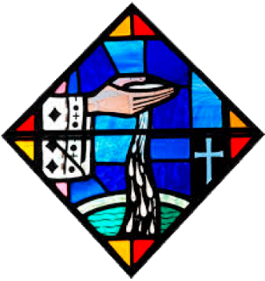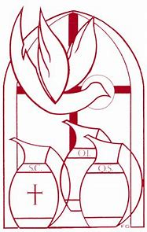
This year, Holy Week will take place in the first week of April. We start off the Triduum, the three days leading up to Easter Sunday, with Holy Thursday. On Holy Thursday, we remember the Last Supper. During the Last Supper, Jesus broke the bread and blessed it, sharing it with His apostles. In doing so, He introduced the sacrament of the Eucharist. At every Mass, the priest blesses and breaks the bread, which becomes Christ’s Body, offered up for us. The night of the Last Supper, Jesus also introduced the sacrament of Holy Orders, because He was teaching His apostles to be priests. He was preparing them to be sent out on a special mission: to share the sacraments with the world, and build our Church, passing on the Church’s traditions.
Now, it is common for the Chrism Mass to be celebrated on Holy Thursday. Chrism oil, which is used for anointings in sacraments like Confirmation, is blessed at this Mass. Made from balsam, the chrism oil represents joy, health, prosperity, and cleansing. Jesus was called “the Anointed One,” because He was set apart. When we are anointed, we receive a special blessing before we are sent out to do what God is calling us to do. Besides being used in the sacraments of Baptism and Confirmation, oil is used to anoint priests receiving the sacrament of Holy Orders. They are made priests for life. Their hands are anointed in preparation for blessing and breaking the Bread. It is a sign of the holy power they are given through God to act on behalf of Christ, to be His hands and feet working in the world, walking with Him and serving His family, the Church. Priests also renew their ordination vows, the promises they made to God when they were ordained as priests, at the Chrism Mass.
Confirmation helps us to be loyal to God, to keep our faith. Living out what we believe means keeping our promises to God, striving to uphold His Commandments every day. At Confirmation, we accept God’s gifts, making the decision to use them for Him. During Holy Week, we remember Jesus rising. Confirmation helps us to rise to greater heights with Jesus. Working with God, and each other in the Church, we can achieve more than we can alone.
- Watch parts of the 2021 Diocese of Springfield Chrism Mass here: https://www.youtube.com/watch?v=ko7AK5RVo-I. You can see the chrism oil being blessed at the 1-hour mark. The bishop said, “May all who are blessed by this oil be inwardly transformed.” How is the chrism oil a symbol of our transformation? How do we bring our inner spiritual transformation to the world outside?
______________________________________________________________________________
__________________________________________________________________________________________________________________________________________________________________________________________________________________________________________
- Why is it appropriate that the Chrism Mass takes place during Holy Week? Why do you think this Mass is celebrated on Holy Thursday, rather than on another holy day in the Church year?
________________________________________________________________________________________________________________________________________________________________________________________________________________________________________________________________________________________________________________________
- What are some similarities between Holy Orders and Confirmation, two of the sacraments involving anointings with holy oil?
Confirmation | Holy Orders

- How can the gifts of the Holy Spirit help us to be loyal to God, and live out the faith we have inside? Choose one of the gifts of the Holy Spirit to focus on: fear of the Lord, piety, wisdom, knowledge, counsel, understanding, or fortitude.

Chrism Oil
______________________________________________________
______________________________________________________
______________________________________________________
______________________________________________________
How do you think God is setting you apart to use this gift? What unique purpose do you think has He given you? _________________________________________________
_________________________________________________
_________________________________________________
_________________________________________________
Gift:
________________________

Week 2
Grade 7- “The Road to Emmaus and Faith in the Real Presence”
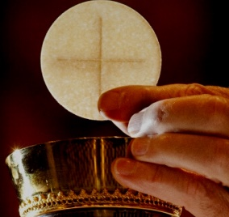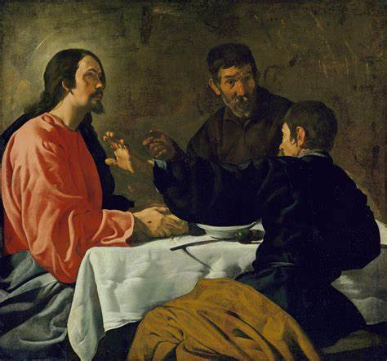
In the story of the “Road to Emmaus” in Luke 24:13-35, we read about two men who are walking to the village of Emmaus, talking on the way there. They are heartbroken about Jesus dying on the Cross. They had believed He was the Savior, the One Who would free people from sin, but now, it seemed they had been left alone. Another traveler walks up to the men and asks what they are talking about. The men tell him of their disappointment about Jesus, but the traveler quotes Scripture, telling them they are wrong to lose hope.
When the men invite him to eat dinner with them, instead of continuing to travel through the evening, the traveler sits with them at the table, breaking and blessing the bread. Then, the men realize that the traveler is not a stranger, but Jesus Himself. They hadn’t recognized Him before, but now that they do, they are filled with joy, knowing for sure that what they heard about the empty tomb was true: Jesus really did rise from the dead. He truly was the Savior!
Easter is a season of welcoming: we meet the Risen Jesus, Who welcomes us into friendship with Him. We meet Jesus in the Eucharist, and when we receive Communion, we welcome Him into our hearts and souls. The Emmaus story is about the Real Presence of Jesus. When Jesus breaks the bread, they finally see Him for Who He is, because Jesus is the Bread of Life. At Mass, the bread is changed into Christ’s Body. Jesus is in the Eucharist. It is His resurrected Body, not a symbol, but real.
We also meet Jesus in other people Who witness to His love, too, the people around us who shine Jesus’ light. In the consecrated religious men and women we know, like priests and nuns, and in the lay faithful, we can see examples of what it means to be like Christ: kind, thoughtful, welcoming, humble. At first, the men walking to Emmaus didn’t know the traveler they met was Jesus, but they remind us that we should see the face of Christ in everyone we meet, remembering that they are made in God’s image, too. When we serve others, we are serving God, since He calls us to love each other.
- What caused the men to recognize Jesus?
____________________________________________________________________________________________________________________________________________________________
- How did Jesus use both Sacred Scripture (the Bible) and Sacred Tradition (the sacraments) to teach the men about Him?
________________________________________________________________________________________________________________________________________________________________________________________________________________________________________________________________________________________________________________________
- How did the men change once they recognized Jesus? What were their emotions at the start of the story compared to the end? Why did they come to feel this way?
__________________________________________________________________________________________________________________________________________________________________________________________________________________________________________
- At first, the men only saw what was around them. They were distracted by their worries and sadness, not seeing Jesus right in front of them, with them through it all. They didn’t look with eyes of faith, from their souls. How do you think the Bible and the sacraments can help us to see with eyes of faith?
__________________________________________________________________________________________________________________________________________________________________________________________________________________________________________
- When was a time you felt like you met Christ in someone else? How can others meet Christ in you?
________________________________________________________________________________________________________________________________________________________________________________________________________________________________________________________________________________________________________________________
Having faith means persevering. When you have faith, you keep going, not giving up, but continuing to pray. Think about what gives you hope in Jesus. Write your own prayer of faith you can use to talk with Jesus as you walk with Him on your faith journey.
____________________________________________________________________________________________________________________________________________________________________________________________________________________________________________________________________________________________________________________________________________________________________________________________________________________________________________________________________________________

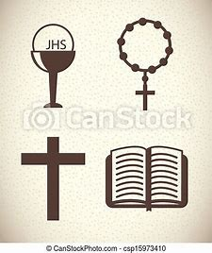

Grade 8- “The Rosary and the Glory of our Faith”
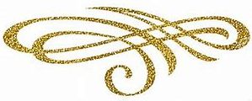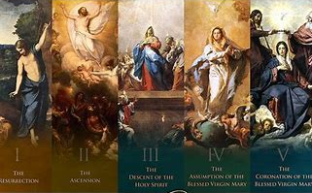
Easter Sunday has gone by, but we continue the Easter season for 50 days, until Pentecost. The root word of Pentecost, “Pente,” means “5,” for “50.” Jesus went up to Heaven 40 days after Easter (when He rose from the dead, and walked among His apostles and disciples), and He sent the Holy Spirit 10 days later, when we celebrate Pentecost. Jesus had promised the apostles that He would send them the Holy Spirit to help them after He went to Heaven, and was no longer with them on Earth. The Holy Spirit gave them the knowledge and talents they needed to keep the Church going, and bring more people to Jesus by planting seeds of faith and hope in them.
During Advent, we focus on the Joyful Mysteries of the Rosary, reflecting on the joy of Jesus being born. We reflect on Mother Mary’s joy to be bringing new life into the world, the Son of God, our Savior. At Lent, we focus on the Sorrowful Mysteries of the Rosary as we remember Jesus’ suffering and death on the Cross. When we pray the Joyful Mysteries, we think about the beginning of Jesus’ life, while the Sorrowful Mysteries lead us to think about the rest of Jesus’ earthly life. We see how God’s plan unfolded, how Jesus did what His Father asked of Him. Now, in the Easter season, as we prepare for the season of Pentecost, we focus on the Glorious Mysteries. We celebrate new life in Jesus, all the possibility and hope that resulted from Jesus rising again, showing us that death is not the end. With God, life goes on. Our souls live forever.
The Glorious Mysteries of the Rosary are the Resurrection, the Ascension of our Lord (when Jesus went up to Heaven), Pentecost, the Assumption of Mary (when Mary went to Heaven), and the Coronation (crowning) of Mary as Queen of Heaven. All the Mysteries help us to better know our Faith, because they tell the story of the lives of Jesus and Mary. In each of the Mysteries, we see God working. We see miracles He brought about. We see how Jesus and Mary were faithful to God the Father, living out true loyalty to, and love for, Him. When we pray the Rosary, we put our trust in God to help us use both our joys and sorrows to become more like Jesus and Mary, truly glorious, so that we can be in Heaven with them someday, too. Praying the Rosary is how we can affirm what we believe in, saying that, yes, we are followers of Christ, and have faith that God can do even what seems impossible, like rising to new life after dying.
- At Pentecost, the Holy Spirit gave the apostles spiritual gifts they needed, like wisdom and bravery, to continue Jesus’ mission, and spread the Catholic Faith around the world. Which gifts can you use to spread faith in God, and give glory to Him?
____________________________________________________________________________________________________________________________________________________________
- Research the 7 Gifts of the Holy Spirit. Which gift do you most want to grow in to keep building your faith, and why? How can you work on growing in this gift?
__________________________________________________________________________________________________________________________________________________________________________________________________________________________________________
- What does it mean to be “glorious”? What is true glory, and why do we need both joy and sorrow, like Jesus and Mary, to reach true glory?
____________________________________________________________________________________________________________________________________________________________
- Which of the Glorious Mysteries most inspires you, and why? How does it boost your faith in God, your belief that He keeps His promises?
__________________________________________________________________________________________________________________________________________________________________________________________________________________________________________
As you pray and reflect on the Glorious Mysteries, write down what comes to mind about each Mystery. Write how you relate to each Mystery personally, something that stands out to you about it, how it makes you feel, or what God is speaking into your heart about each Mystery.
(3) Pentecost:
(4) Assumption:

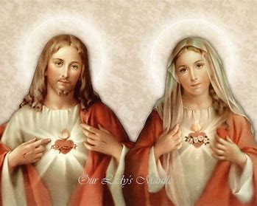

(1) Resurrection:
(2) Ascension:
(5) Coronation:

Grade 9 (& 10-12)- “The Art of Easter”
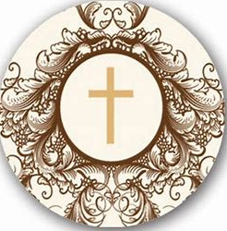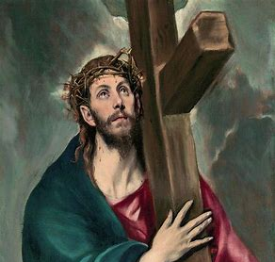
“Christ Carrying the Cross” (1580) by El Greco
On the Cross, Jesus spoke to God the Father, Mother Mary, John, and to a thief on a cross next to Him. Jesus was crucified with criminals being punished for stealing. Jesus had never taken anything; He had only given. He was willing to be treated like a criminal, even though He was innocent, to complete His Father’s plan for our redemption. Like His Mother Who said “yes” to God’s plan for Her to give birth to the Son of God, Jesus was willing to say “yes” to God’s plan for Him to die in order to save us. It might have seemed that the thieves on the two crosses next to Jesus had no hope. But one, known as the “good thief,” showed that there is always hope when we put our faith in Jesus. God can make a hopeless situation good. One thief was laughing at Jesus, saying that if He were truly God, He would be able to get down from the Cross.
But the good thief defended Jesus. He knew that Jesus was God, because only God would have so much love for us, that He would go through such pain and indignity patiently and faithfully. The good thief was rewarded for his faith. Jesus told the good thief that he would soon be with Him in Heaven. Before, the good thief sinned by stealing, but before dying on his own cross, he decided to turn his heart to Jesus. He cared more about putting faith in Jesus, and sharing his belief in Jesus with everyone present by defending Him, than anything else. As a result, the good thief was shown God’s mercy, and went to Heaven. Loving God meant that he would go on to experience the love of God forever in Heaven. Faith in Christ redeems us, bringing us out of the darkness of sorrow and sin, into the light of joy and hope. It is truly never too late to turn to Christ. Our journey of learning more about God and growing in our faith lasts our whole lives. When we trust in Jesus to help us carry our crosses, they are much lighter. He can help us overcome any challenge, because He has already overcome suffering and death. From the challenges Jesus faced came the miracle of His Resurrection.
- When you look at the expression on Jesus’ face as He carries His Cross in El Greco’s painting, what emotions do you see? Is there hope or sadness? What does this tell you about Who Jesus is, what His faith in the Father is?
__________________________________________________________________________________________________________________________________________________________________________________________________________________________________________
- One of Jesus’ Seven Last Words was “Father, into Thy hands I commend my Spirit.” Jesus gave His Spirit, His life, over to God the Father. Jesus said, “Thy will be done.” Jesus wanted what God the Father wanted for Him, because of His love for His Father. He trusted in His plan, and chose to follow through with it. Why is it ultimately better to let “Thy will be done,” instead of saying “my will be done”?
__________________________________________________________________________________________________________________________________________________________________________________________________________________________________________
- It can be challenging sometimes to place all of our trust in God. We like to know what to expect, and to have control over what happens in life. Putting faith in the things of the world to give us happiness can disappoint us, but we don’t have to fear putting our faith in God. God wants us to be happy. His love is perfect, because it is selfless. We see this in how Jesus gave all of Himself, dying on the Cross for us. How can we overcome the challenge of putting full trust in God? What might it look like for you to put your future into God’s hands, to offer your dreams and talents to Him?
________________________________________________________________________________________________________________________________________________________________________________________________________________________________________________________________________________________________________________________
- Say a prayer before a crucifix. You can do this at home, or at church. When you were praying, what came to mind? What do you feel Jesus is speaking into your heart?
________________________________________________________________________________________________________________________________________________________________________________________________________________________________________________________________________________________________________________________
- Jesus said, “Behold your Mother,” while on the Cross. He wasn’t focused on His pain, but was thinking about the peace and happiness of others. He was telling us to look to Mary to help us become closer to Him, as She is a faith role model for us. He gave us Mary to be our spiritual mother, to care for us. Mary is known as “Co-Redemptrix.” How was Mary part of our redemption (salvation)? How did Her faith help save us?
________________________________________________________________________________________________________________________________________________________________________________________________________________________________________________________________________________________________________________________

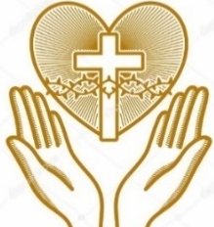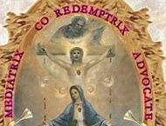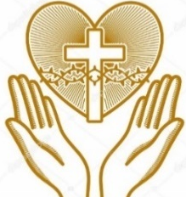
Week 3
Grade 7- “Faith Road Map: Lenten Resolutions Reflection”
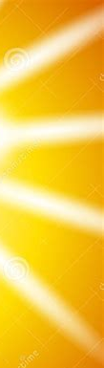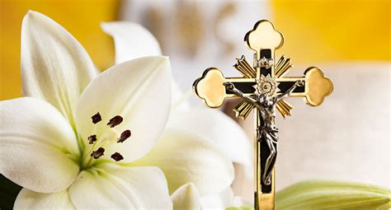
In Sacred Scripture, the Bible, we have the Word of God. When we read the Bible, we read written records of people of faith. We come to understand our beliefs when we read the Bible, because in the stories of the Bible, we see how God has revealed Who He is. We know what Jesus has taught. From the Bible, we learn that we can put our faith in Jesus, because, as He says, “I am the Way, and the Truth, and the Life” (John 14:6). Knowing that Jesus is the Truth, we know that we can believe what He says, because He is telling the truth. He is God. God, in His perfection, cannot lie. What comes from God is true, because it is eternal: forever.
When we put our faith in Jesus, trusting in where He is guiding us, we can reach Heaven. It is through Jesus that we deepen our hope in, and love for, God. Jesus models to us how to be faithful to God when we see how He listened to God the Father. Jesus overcame Satan’s temptations in the desert, because He stayed focused on God, quoting the Old Testament to fight Satan’s lies. Jesus went on the Cross to fulfill His Father’s plan for people to be saved, showing the strongest faith in God’s plan. He knew that good would ultimately come from His suffering.
Sacred Scripture comes alive as we practice our Faith. Sacred Tradition is how we live out what we believe, how we stand up for the truth God communicates to us in the Bible. How we live our lives is a prayer. What we offer to God, how we lift our minds and hearts to Him, is prayer. We carry on our faith tradition through the sacraments, but most especially, Holy Communion. We can offer our Holy Communion for souls to be saved, remembering all of the members of our Church family, including the souls in Purgatory. We can be role models who show the people around us what it means to be a follower of Christ, to have faith in Him. We can pass down our beliefs as we receive the sacraments with love, and share with others our love for God, which is at the heart of Sacred Tradition: God’s love, which we see in Jesus’ Sacrifice, is the reason why we believe, why we continue to receive the sacraments and live our faith.
- How did you live out your Faith during Lent?
____________________________________________________________________________________________________________________________________________________________
- Why do you think Sacred Tradition is equally important to Sacred Scripture?
____________________________________________________________________________________________________________________________________________________________
- God can reshape our plans, bringing out something better than what we had originally imagined. Sometimes He answers prayers in unexpected ways. Did you find that your plan for what to sacrifice, or add for spiritual enrichment in your life, changed during Lent? Were you surprised by how you saw God working this Lent?
__________________________________________________________________________________________________________________________________________________________________________________________________________________________________________
- On TV and the internet, we see so many ads telling us what things we need to be happy, what brands we should be loyal to. Media outlets compete for our attention. The world tries to pull our focus away from God. How did your Lenten practice help you to be faithful to God? How did you see God’s faithfulness to you during Lent?
__________________________________________________________________________________________________________________________________________________________________________________________________________________________________________
- Thinking about how you would like to grow in your faith in the future, what is something you did for God during Lent that you want to continue doing? Make a faith road map.

Which sign of God’s love and faithfulness will you focus on? Choose a story from the Bible. _________________________________________________________________________________________________________
After the Easter season, I will continue living my faith by ____________________________________________________________
During the Easter season (until May 28), I will keep working on growing in my faith by ________________________________________________________________________________






Jesus is your copilot on the road from here to Heaven!
Grade 8- “The Treasure of our Faith”
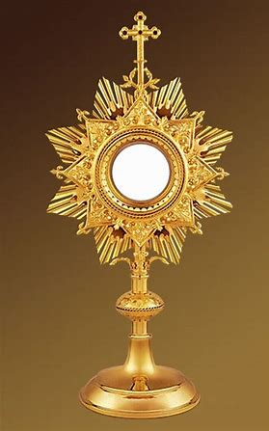
When you go into church, you will see many beautiful sacred objects made to honor God. Monstrances are gold containers for the Eucharist that are used at Adoration, when the Host is exposed on the altar, and people come to pray before it. Monstrances are different from the tabernacle, which is also a beautiful container for the Eucharist. Tabernacles hold all the consecrated Hosts, and look like small palaces or churches, decorated shrines. Monstrances have a long base like a candlestick, and at the top, there are rays around the glass where the Eucharist is contained, making the top of the monstrance look like the sun. They are made to look this way to remind us of Jesus’ glory. When we look at the Host in the monstrance, we are reminded that Jesus is truly Present with us, shining His light.
One night in 1345, in Krakow, Poland, thieves went into a Catholic church, and stole a monstrance holding the Sacred Host. They thought the monstrance was made of gold. When they found it wasn’t, they left it in a swampy area. When the priest of the church saw the monstrance was gone, realizing thieves had broken in, he went to look for it in the area around the church with parishioners. They saw light glowing from the marsh, and went to tell the bishop what they saw. The bishop told them to fast and pray for three days. On the third day, they went to retrieve the monstrance, which was still glowing brightly. Inside, the Host had not been broken.
We were made in God’s image. We were made to be like God, with qualities like wisdom and creativity. As humans, we need God to keep growing in these good qualities. The Holy Spirit is within us. When you receive a greater outpouring of the Gifts of the Holy Spirit at Confirmation, you will be given special graces from God to help you keep growing in your knowledge, talents, and holiness. Pneumatology is the study of the Holy Spirit. Learning about the Holy Spirit helps us to better know God and ourselves. In praying, reading about God, receiving the sacraments, and keeping our eyes open to God’s presence around us, we can see how the Holy Spirit is leading us, how He is illuminating (shining light in) our minds, hearts, and souls. God is always with us; when we receive the Eucharist, we are receiving Jesus in our hearts, which He shines from, just as the Host in the monstrance was shining. As we build our trust in God, and our understanding of Who He is, we can honor Him by becoming who He calls us to be, people with hearts of faith, hope, and love, who shine their light for God.
- The thieves in the story of the Krakow Eucharistic miracle thought the monstrance with the Host had no value since it wasn’t made of an expensive metal like gold. Why is our Faith a treasure? How can we treasure the Eucharist? _________________________
____________________________________________________________________________________________________________________________________________________________
- What similarities do you see between this Eucharistic miracle story, and to the story of the Resurrection? What does the Eucharistic miracle story teach us about the spirit of Easter, its true meaning?
__________________________________________________________________________________________________________________________________________________________________________________________________________________________________________
- Why do we need the sacraments to grow in our faith, and shine Christ’s light?
__________________________________________________________________________________________________________________________________________________________________________________________________________________________________________
- Listen to the song “Anima Christi”: https://www.youtube.com/watch?v=JRgT5mwMEMw.“Anima” means “soul” in Latin. If you “animate” something, you give it life. You give it soul, like how animated movies bring drawings to life. Jesus gives life to our souls. What do you think it means to have a soul of Christ, to be like Jesus?
____________________________________________________________________________________________________________________________________________________________
- At Lent, we walk through the desert with Jesus. We look for water to refresh us. At first, it may seem there is no change, but if we keep faith, continuing to practice it each day, we find our way through the desert, and are given new life. Journal about your Lent, and look ahead to your plans for growth in the Easter season. Think about these questions as you jot down your thoughts. Choose 1 to focus a short reflection on:
- Did you find it challenging to keep your Lenten resolution (a sacrifice or an addition, something you brought into your life for spiritual enrichment)? How did God help you through the challenge, to stay true to your spiritual goals?
- What helped you to follow the plan you made to honor God during Lent? Was there a prayer you said, or a Bible verse you kept in mind?
- How did you see the Holy Spirit working in you during Lent? Looking back, how do you think you have grown since Lent?
- What did you do during Lent that you can continue with during the Easter season?

____________________________________________________________________________________________________________________________________________________________________________________________________________________________________________________________________________________________________________________________________________________________________________________________________________________________________________________________________________________________________________________________________________________________________________________________________________________________________________________________________________________________________________________________________________________________________________
Grade 9 (& 10-12)- “Pentecost and Faith in the Holy Spirit”
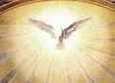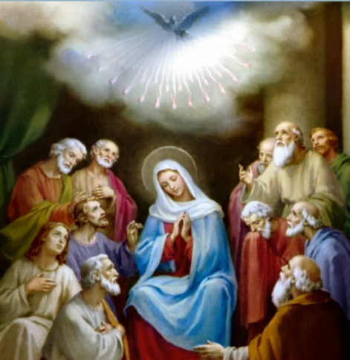
Though Easter Sunday has passed by, we still are celebrating the Easter season, which extends to Pentecost. The prefix “pente” means “5,” because Pentecost is always 50 days after Easter Sunday. This year, it will fall on May 28. On Pentecost, the Holy Spirit came down to the apostles. Jesus had promised the apostles that after He went up to Heaven, He would send the Holy Spirit to help them. Jesus ascended into Heaven 40 days after Easter Sunday (this is called the Ascension, which is on May 18 this year). Jesus was faithful to His promise- He kept it. When the Holy Spirit came, the apostles were given the knowledge and talents they would need to serve the Church as priests who would grow the faith of other people. We remember Pentecost at Confirmation, because the sacrament of Confirmation gives us more of the graces we need to keep serving Jesus. Confirmation helps us to keep growing in our faith.
At Baptism, we are given special graces that are deepened at Confirmation. On Pentecost, the apostles baptized thousands of people. They brought them into Jesus’ family, the Church, just as you were made a member of Christ’s family when you were baptized. You received an indelible mark, a mark on your soul that can never be erased: you were made a child of God for life. Now, at Confirmation, you will confirm your faith, making a commitment to continue living it out as you grow. This is like how we renew our baptismal promises at Easter, confirming that we will follow Jesus. You will receive another indelible mark: you will become a soldier for Christ for life, someone who keeps our Faith going, who stays true to the beliefs of our Church and is a light shining for Jesus. We are given the amazing gift of our Faith to share. We are given the Gifts of the Holy Spirit, from wisdom and knowledge to fortitude and counsel, to inspire other people to know Jesus. They can first be introduced to Him through us. This is another gift to us, that we can have the happiness of bringing Jesus into the world, of making other people joyful.
- Pope St. John Paul II said we are the “Easter people.” It is our calling to bring the Easter spirit out into the world. How can we keep the spirit of Easter alive in our hearts? How do we share the good news of the Resurrection, Jesus overcoming death, whether in words or actions?
__________________________________________________________________________________________________________________________________________________________________________________________________________________________________________
- “Easter” comes from a word meaning “dawn,” the sunrise. Jesus is the Son of God Who would rise from the dead. Before changes to the Mass were made in the 1960s, the priest would say Mass facing the east, where the sun rises. We can count on the sun to rise, and we can count on Jesus to keep His promises. Why is it important that we keep renewing our promises to God, like at Easter, and at Confirmation?
__________________________________________________________________________________________________________________________________________________________________________________________________________________________________________
- As you prepare to affirm your faith at Confirmation, what does it mean to you to be part of the Catholic Church, the “Easter people?”
______________________________________________________________________________
____________________________________________________________________________________________________________________________________________________________
- Lent is about becoming more open to God by letting go of things that distract us from Him in the world around us. It’s not only about what we do, but about our readiness to receive God into our hearts, to be open to how He wants to bless us and work through us. How do you think Lent helped you to prepare for Confirmation? What changes did you see in your spiritual life during this season?
__________________________________________________________________________________________________________________________________________________________________________________________________________________________________________
- John was the only apostle to stay with Jesus at the Cross when Jesus was crucified. He was loyal, like Mother Mary, Who also stayed. Their faith was greater than fear. Before Pentecost, another apostle, Peter, had denied Jesus, pretending he didn’t know Him. Peter feared the consequences of admitting he was a follower of Christ. But after Pentecost, he was preaching, teaching, and bringing the sacraments to people in the world. (See Chapter 2 of Acts of the Apostles, https://bible.usccb.org/bible/acts/2). How do you think the Holy Spirit changed the apostles? How do you think Confirmation will change you? Listen to “Veni Creator Spiritus,” “Come, Holy Spirit, the Creator,” for inspiration: https://www.youtube.com/watch?v=5GrQJGQWfd8.
________________________________________________________________________________________________________________________________________________________________________________________________________________________________________________________________________________________________________________________
- The Holy Spirit is described as coming down like “flames” or “fire.” Why do you think the Holy Spirit is described this way? How is faith like a holy fire, sanctum ignis?
__________________________________________________________________________________________________________________________________________________________________________________________________________________________________________
April 2023 7-9/10-12 Review
Use this review sheet as a reference to track progress and check that learning goals are met.
Recap: What did I learn?
All Grades
- Faith is about loyalty to God: to our belief in Him, and how we live out our belief
- Our faith is a two-way street. Faith is the foundation on which we build a relationship with God
- God is faithful to us. He keeps His promises, because He loves us. God’s love is perfect
- God may answer our prayers in unexpected ways, but we never have to doubt that He will carry through with what He says. We see this in the miracle of Jesus’ Resurrection, as Jesus fulfilled the prophecies of the Old Testament
- The Easter Triduum refers to the three days of Holy Week when we remember Jesus’ Passion, Death, and Resurrection
Grade 7
- Mother Mary is an example of faith in how She stayed with Jesus until the end, and accepted God’s plan for Her, even though She would suffer as She watched Jesus suffer
- Jesus gave us His Mother out of faithfulness to us, and to Her. He ensured that Mary would have spiritual children to care for, and that we would have a spiritual mother
- Holy Week reminds us that our faith is a light. We celebrate our faith in Jesus, our belief that He is our Savior, Who overcame suffering and death to live again
- Looking with eyes of faith, we can see that Jesus is with us down every road we go
- Sometimes we are distracted by worry, but hope refocuses us. God’s revelation in the Bible and the sacraments is the foundation of our faith, and as we engage more deeply with the Bible and the sacraments, we can continue to grow in our faith
- Putting our faith in Jesus, we can be nourished spiritually. Jesus’ Real Presence in the Eucharist sustains us, giving us what we need to keep going, and build our faith
- We need both Sacred Scripture (the Bible) and Sacred Tradition (the sacraments) to grow in our faith
- The Bible is the Word of God, containing the truths on which we build our lives. We live out what God is calling us to do through Sacred Tradition
- We can live out our faith by passing down our traditions, sharing our love for God with others. We can remain faithful to God through prayer
- The stories of the Bible show us how God has been faithful to people throughout time, most especially in the story of Jesus dying on the Cross out of love for us.
- Jesus shows us the way forward, because He is an example of faith to God the Father. We can put our faith in Jesus, because He is the Truth. Faith is belief in what we hold as true, and we believe that what Jesus tells us is true
Grade 8
- At the Last Supper, Jesus instituted the sacraments of the Eucharist and Holy Orders
- Good Friday, the day Jesus died, is when we commemorate the Sacrifice Jesus made, His self-gift given out of love. This is at the heart of every Mass, when we relive the Paschal Mystery
- During Holy Week, we observe the Easter Triduum, recalling Jesus’ Passion, Death, and Resurrection from Holy Thursday to Easter Sunday
- The battle between light and darkness is a common thread connecting the days of the Triduum, as we ultimately celebrate Jesus overcoming darkness and death with His life, shining the light of God’s love
- When we pray the Rosary, reflecting on each of the Mysteries, we are connecting our lives to the lives of Jesus and Mary. We come to understand the foundations of what we believe, as these beliefs are reflected in the Mysteries of the Rosary
- Each Mystery of the Rosary highlights the heart of a different liturgical season: the Joyful Mysteries are emphasized at Advent, the Sorrowful at Lent, and the Glorious at Easter and Pentecost.
- Joyful, sorrowful, and glorious experiences are all part of life. They each contribute to our growth in the virtue of faith, helping us to better know Jesus and Mary, and to believe in God’s faithfulness to us as He walks with us in each experience
- As we learn more about our Catholic Faith, we can appreciate its beauty. Our Faith is a treasure, and the personal faith we nurture in our hearts allows us to better love God
- Eucharistic miracles attest to the greatness of God. We can have faith in God, knowing that He can do what would otherwise seem impossible, out of love for us
- Jesus is with us in the Eucharist. Knowing God is Present among us, we see that He has been faithful, never leaving us, but giving us what we need to be fed each day
Grade 9 (& 10-12)
- The chrism oil used in anointing confirmandi at Confirmation is blessed at the Chrism Mass, which is celebrated during Holy Week, usually on Holy Thursday
- Chrism oil is also used in sacraments such as Baptism and Holy Orders, which are closely connected, since they confirm our commitment to serving God
- Jesus is known as the “Anointed One.” He was set apart, chosen to be our Savior. We are also uniquely set apart when we are anointed as soldiers for Christ who will carry on His mission of building the Church and sharing the good news of God’s love
- To live out our faith means to renew our promises to God every day, to keep doing what He has called us to do. Confirming our faith is not a one-time event when we make a new sacrament, but part of how we live each day
- Jesus showed His faith in God the Father by accepting the Father’s plan for Him to die on the Cross and redeem us from sin, which saved us
- The good thief who turned to Jesus shows us that it is never too late to choose faith, and follow God
- At Confirmation, we remember Pentecost, when the Holy Spirit came to the apostles
- The Holy Spirit gave the apostles the gifts they needed to keep building Jesus’ Church family, and bring other people hope by welcoming them into the Faith
- At Confirmation, the Holy Spirit gives us even more graces, expanding upon the graces we received at Baptism. We receive gifts we need to keep growing in our faith and to share it with others out in the world
What vocabulary words did I practice?
Grade 7
Week 1
Tenebrae
Week 2
Real Presence
Week 3
Sacred Tradition
Grade 8
Week 1
Last Supper
Week 2
Ascension
Week 3
Pneumatology
Grade 9 (& 10-12)
Week 1
Chrism
Week 2
Redemption
Week 3
Pentecost
What prayers did I practice?
Grade 7
Jesus Prayer
Grade 8
Anima Christi
Grade 9 (& 10-12)
Prayer to the Holy Face
Checklist: Activity Completion
Grade 7
Week 1: “Holy Week and the Light of Faith”
Week 2: “The Road to Emmaus and Faith in the Real Presence”
Week 3: “Faith Road Map: Lenten Resolutions Reflection”
Grade 8
Week 1: “The Light of Christ: Faith in Jesus at Holy Week and Beyond”
Week 2: “The Rosary and the Glory of our Faith”
Week 3: “The Treasure of our Faith”
Grade 9 (& 10-12)
Week 1: “Our Faith and the Chrism Mass”
Week 2: “The Art of Easter”
Week 3: “Pentecost and Faith in the Holy Spirit”
Quick Check:
Tell us about your experience with these activities this month! Our April 2023 Google Form for Grades 7-9/10-12 is available here: https://forms.gle/mQy5yNvEk3fBCv167

Gr. 8, Activity Week 1: Maria von Trapp: “Holy Week” Story (reference)
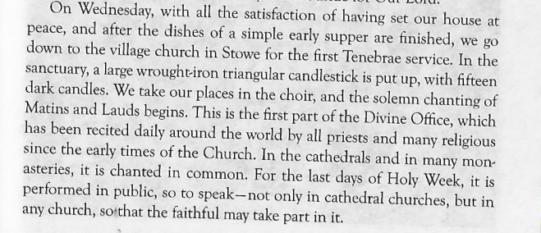
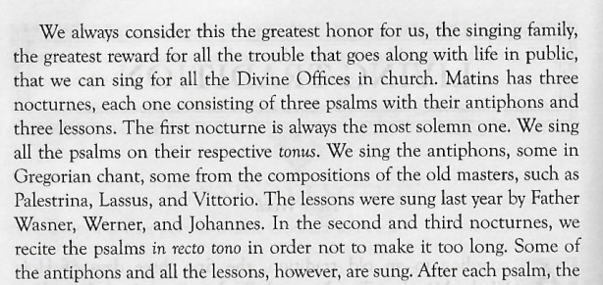
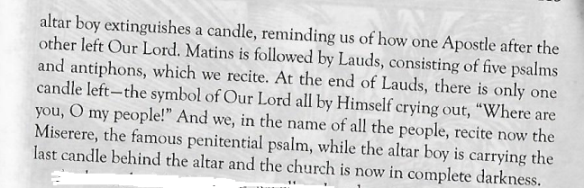

(“Holy Week” story continued)
