Our Lady of the Valley Religious Education

April 2023 Activity Packet

Grades 3-6



Name: ________________________________________

Materials Included in Packet
Overview…………………………………………………………………………………………3
Standards………………………………………………………………………………………...5
Pacing Guide……………………………………………………………………………………10
Activities………………………………………………………………………………………...13
Week 1…………………………………………………………………………………………..13
Grade 3………………………………………………………………………………….13
Grade 4………………………………………………………………………………….15
Grade 5………………………………………………………………………….............17
Grade 6………………………………………………………………………………….19
Week 2…………………………………………………………………………………………..21
Grade 3……………………………………………………………………………….…21
Grade 4………………………………………………………………………………….23
Grade 5………………………………………………………………………….............25
Grade 6………………………………………………………………………………….26
Week 3…………………………………………………………………………………………..28
Grade 3……………………………………………………………………………….…28
Grade 4………………………………………………………………………………….30
Grade 5………………………………………………………………………….............32
Grade 6………………………………………………………………………………….34
Review…………………………………………………………………………………………...36

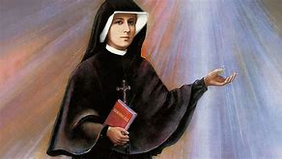
April 2023 Overview: Grades 3-6
Theme: Faith (Fides)
Thematic Guiding Questions, 3-6:
- What does the life of Jesus, and the lives of those who knew Him, teach us about having faith?
- How did Jesus show faith in His Father’s plan, and how did God faithfully fulfill His promises to us?
Monthly Challenge: Reduce screen time. Take 15 minutes you would normally be on your phone/social media, and use that time to pray instead. Read a Bible passage, meditate, etc. How did you feel? If you made this part of your daily schedule, what kinds of effects did you see over the long-term in your faith life?
Overall Learning Goals: This month, we will be learning about how we live out our faith, personally, and as a Church family. Our goal is to identify ways in which we can continue to grow in our faith, and uniquely express what our faith means to us in order to deepen the faith of the people God sends us.
Summary of Activities: Activities will encompass studies of Catholic culture, especially surrounding Lent and Easter seasons traditions, to hone understanding of how we grow in faith throughout the liturgical year, emulating Jesus and Mary as we observe holy days celebrating their faith in God the Father. We will explore how the saints, biblical figures, and leaders in the Church have lived out their faith in Christ, becoming who God called them to be. In reflecting on how we can be like the saints, we will discern ways to apply our what we have learned about our Faith in our communities. Through visual art, music, reflective writing, and prayer, we will follow where the light of Christ is leading us, deepening love for our risen Lord and Savior.
Suggested Mealtime Prayer: At this Easter table, we pray to God with joy, for Jesus has brought us new life. Lord, bless our family, friends, and food. Thank You for all You have given us. Amen.
Suggested Prayer Starters: Jesus, help me to be like you in my faith.
Jesus, I praise you for the gift of your life.
Additional Enrichment Ideas:
- Send Easter cards, a tradition similar to sending Christmas cards, wishing blessings to others in the Easter season; or create your own Easter cards to exchange as a family
- Have food for your Easter meal blessed by a priest. Blessings of Easter food will be offered at OLV on April 8 at 11:00 a.m. in the parish hall
- Watch The Ten Commandments. Read the story from Exodus about Moses and the parting of the Red Sea (Exodus 14:23-31, https://bible.usccb.org/bible/exodus/14)
- Celebrate the Easter Triduum: take part in Holy Thursday Mass, Good Friday services, and the Easter vigil on Holy Saturday
- Attend Divine Mercy services on April 16, or go to Confession for Divine Mercy Sunday
  - Divine Mercy services often include a sermon, readings of the Bible and excerpts from St. Faustina’s diary, chanting of the Divine Mercy chaplet, singing of the Litany of Divine Mercy, Benediction, Adoration, and Divine Praises
  - Our Lady of the Valley will hold a Divine Mercy service- we hope you will join us for this special day!
- Pray the Divine Mercy chaplet together as a family. 3:00 p.m. is the hour of divine mercy
- If possible, plan a visit to the Divine Mercy Shrine in nearby Stockbridge, MA for the month of April, or visit their website for more Divine Mercy resources: https://www.shrineofdivinemercy.org/
- April 30 is the World Day of Prayer for Vocations. Pray together as a family for religious vocations, and that each person will discover where God is uniquely calling them to use their talents to serve Him with love.
Scripture Memory Card
---------------------------------------------------------------------------------------------------------------------

We walk by faith, 
not by sight.
(2 Corinthians 5:7)

---------------------------------------------------------------------------------------------------------------------

Standards
Grade Level | Week | Activities | Learning Standards
Grade 3 | 1 | “Holy Week Bulletins: Sharing the Good News of Easter” | 3.2 God is at the center of life. All of the sacraments point back to Him as the source of all love, all virtue.
Grade 3 | 2 | “New Life in Jesus: New You, New Virtue” | 3.1 The theological virtues are faith, hope, and charity (love).
Grade 3 | 3 | “The Light of Faith: Seeing and Believing” | 3.6 A disciple is one who learns, a student of Christ who listens and follows Him, living out the virtues. An apostle is one who is “sent” by Christ out into the world as a leader of the Church to preach and teach...  3.7 Jesus chose 12 men to be His original apostles, whose mission is distinct from that of disciples: Bartholomew, Andrew, Peter, Philip, Thaddeus, Thomas, John, James the Greater, James the Lesser, Judas (replaced by Matthias), Simon, and Matthew. Today, apostolic succession in the Church continues the tradition of ordaining men to be priests, apostles of Christ who act on His behalf.
Grade 4 | 1 | “Triduum Triptych” | 4.4 The Church year is called the liturgical year, because it organizes our celebration of the liturgy, the public worship of God (namely, through the Mass). The liturgical seasons reflect Christ’s life: Advent and Lent memorialize His birth, dying, and rising.
Grade 4 | 2 | “Faith like St. Gemma” | 4.6 Regularly attending Mass helps us to live out our calling and follow Christ… we respond in the second part when we receive Communion, allowing Christ to enter our hearts.  4.8 Doing good works is an essential part of the Christian life, as Christ was Himself a servant who lived to care for others, tending to their physical and spiritual ailments.
Grade 4 | 3 | “Faith in God’s Mercy” | 4.5 There are eight Beatitudes (blessings) Jesus gave in the Sermon on the Mount: Blessed are the poor in spirit, for theirs is the kingdom of heaven; Blessed are the meek, for they will inherit the earth; Blessed are they that mourn, for they will be comforted; Blessed are they that hunger and thirst for righteousness, for they shall be filled; Blessed are the merciful, for they shall obtain mercy; Blessed are the clean of heart, for they shall see God; Blessed are the peacemakers, for they shall be called the children of God; Blessed are they that suffer persecution for justice’s sake, for theirs is the kingdom of Heaven.  4.7 Adoration and Benediction are both powerful devotions in which we honor the Real Presence of Christ in the Eucharist, glorifying God. In Eucharistic Adoration, the Sacred Host is removed from the tabernacle, and placed in the monstrance. It is exposed on the altar, so that people can look upon it and pray, adoring the Presence of Jesus. Benediction takes place after a time of Adoration, when the priest blesses people with the Eucharist in the monstrance.
Grade 5 | 1 | “The Sweetness of Faith” | 5.4 We each have a different calling, something that God is asking us to do, by using the special talents and personalities He gave us. We are all made in God’s image, but are completely unique. There is no one else like you. Some are called to Holy Orders, and others serve God in different ways, but all of us can live out our callings to do good things in love for God.
Grade 5 | 2 | “Faith like Pope Benedict” | 5.2 The Church has… a chain of leadership to guide it forward. The Pope is the overall leader of the Church.
Grade 5 | 3 | “Eucharistic Miracles and Faith in Jesus” | 5.8 Sacraments such as the Eucharist are visible signs of God’s love we can encounter today. Throughout His life, Jesus did miraculous things to show us that He is God, and that He will do amazing things out of love for us, to bring us closer to Him. We can read about these miracles in Scripture.
Grade 6 | 1 | “Faith in Jesus’ Promises: The Story of Lazarus” | 6.7 In the… Bible… Jesus’ life is the focus of the New Testament, which shows how He fulfilled the Jewish prophecies of the Old Testament.
Grade 6 | 2 | “Faith like St. Faustina” | 6.4 A variety of saints have faithfully lived out God’s will for them throughout history, even when it was difficult, leading to the point of martyrdom. Saints & martyrs offered their lives up for Christ, joyfully and humbly, which provides an example of how we, too, can lift up the crosses we carry with hope, knowing they will be used for the good.
Grade 6 | 3 | “Eucharistic Miracles: Renewing our Faith in Christ” | 6.1 Catholics throughout history have used their talents to glorify God, turning away from sin to pursue virtue and make a positive impact on the world, attesting to the greatness of God.



April 2023 Pacing Guide (Suggested Schedule)
Grades 3-6
Week Number/Date | Grade Level | Activities
Week 1  (April 3-7, 2023: triduum, correlation with Holy Week) | Grade 3 | “Holy Week Bulletins: Sharing the Good News of Easter”
 | Grade 4 | “Triduum Triptych”
 | Grade 5 | “The Sweetness of Faith”
 | Grade 6 | “Faith in Jesus’ Promises: The Story of Lazarus”
Week 2  (April 10-14, 2023) | Grade 3 | “New Life in Jesus: New You, New Virtue”
Week 2  (April 10-14, 2023) | Grade 4 | “Faith like St. Gemma”
Week 2  (April 10-14, 2023) | Grade 5 | “Faith like Pope Benedict”
Week 2  (April 10-14, 2023) | Grade 6 | “Faith like St. Faustina”
Week 3  (April 16-24 for Divine Mercy;  or April 24-26, 2023) | Grade 3 | “The Light of Faith: Seeing and Believing”
 | Grade 4 | “Faith in God’s Mercy”
 | Grade 5 | “Eucharistic Miracles and Faith in Jesus”
 | Grade 6 | “Eucharistic Miracles: Renewing our Faith in Christ”

Week Number/Date | Grade Level | Words to Practice | Definitions
Week 1  (April 3-7, 2023: Holy Week) | Grade 3 | Resurrection | When Jesus rose from the dead, coming back to life. He showed that His love could never be defeated by sin or death, but would go on forever.
Week 1  (April 3-7, 2023: Holy Week) | Grade 4 | Triduum | Three days during Holy Week, the days leading up to Easter, when we celebrate Jesus’ Resurrection from the dead. The Triduum is made up of Holy Thursday (the night of the Last Supper), Good Friday (the day Jesus died), and Holy Saturday (the Easter vigil- the night before Easter). The night of Holy Thursday to the night of Good Friday, the night of Good Friday to the night of Holy Saturday, and the night of Holy Saturday to Easter Sunday make up three full days.
Week 1  (April 3-7, 2023: Holy Week) | Grade 5 | Vestments | The sacred garments (clothes) worn by the priest saying the Mass.
Week 1  (April 3-7, 2023: Holy Week) | Grade 6 | Sacred Scripture | The Bible; the inspired word of God.
Week 2  (April 10-14, 2023) | Grade 3 | Virtue | A holy quality; something that leads us to greater holiness.
Week 2  (April 10-14, 2023) | Grade 4 | Liturgy | Public worship of God, including the Mass (and all sacraments), Divine Office (liturgy of the hours), and sacramentals.
Week 2  (April 10-14, 2023) | Grade 5 | Pope | The leader of the Catholic Church.
Week 2  (April 10-14, 2023) | Grade 6 | Psalm | A song sung to God. The Book of Psalms is part of the Wisdom literature of the Old Testament.
Week 3  (April 16-24 for Divine Mercy;  or April 24-26, 2023) | Grade 3 | Faith | Believing in God. Having faith means not giving up, not letting go of belief, even in hard times.
 | Grade 4 | Adoration | Praise and love of God. Eucharistic Adoration is when we see the Host on the altar, outside of the tabernacle, in a vessel called the monstrance. We then lift up our hearts to pray to God, and share our love for Him, thanking Jesus for the gift of His life, of the Eucharist that allows us to be so close to Him on Earth.
 | Grade 5 | Corporal | The linen on which the chalice (cup of wine) is placed on the altar at Mass.
 | Grade 6 | Metanoia | The Greek term for turning away from sin, choosing to follow God instead; a spiritual conversion.

Week Number/Date | Grade Level | Prayers to Practice | Text of Prayers
Week 1  (April 3-7, 2023: Holy Week) | Grade 3 | Divine Mercy Chaplet Prayers | Holy God, Holy Mighty One, Holy Immortal One, have mercy on us and on the whole world.
Week 1  (April 3-7, 2023: Holy Week) | Grade 4 | Divine Mercy Chaplet Prayers | Holy God, Holy Mighty One, Holy Immortal One, have mercy on us and on the whole world.
Week 1  (April 3-7, 2023: Holy Week) | Grade 5 | Divine Mercy Chaplet Prayers | O Blood and Water, which gushed forth from the Heart of Jesus as a fount of mercy for us, I trust in You!
Week 1  (April 3-7, 2023: Holy Week) | Grade 6 | Divine Mercy Chaplet Prayers | O Blood and Water, which gushed forth from the Heart of Jesus as a fount of mercy for us, I trust in You!
Week 2  (April 10-14, 2023) | Grade 3 | Divine Mercy Chaplet Prayers | Holy God, Holy Mighty One, Holy Immortal One, have mercy on us and on the whole world.
Week 2  (April 10-14, 2023) | Grade 4 | Divine Mercy Chaplet Prayers | Holy God, Holy Mighty One, Holy Immortal One, have mercy on us and on the whole world.
Week 2  (April 10-14, 2023) | Grade 5 | Divine Mercy Chaplet Prayers | O Blood and Water, which gushed forth from the Heart of Jesus as a fount of mercy for us, I trust in You!
Week 2  (April 10-14, 2023) | Grade 6 | Divine Mercy Chaplet Prayers | O Blood and Water, which gushed forth from the Heart of Jesus as a fount of mercy for us, I trust in You!
Week 3  (April 16-24 for Divine Mercy;  or April 24-26, 2023) | Grade 3 | Divine Mercy Chaplet Prayers | Holy God, Holy Mighty One, Holy Immortal One, have mercy on us and on the whole world.
 | Grade 4 | Divine Mercy Chaplet Prayers | Holy God, Holy Mighty One, Holy Immortal One, have mercy on us and on the whole world.
 | Grade 5 | Divine Mercy Chaplet Prayers | O Blood and Water, which gushed forth from the Heart of Jesus as a fount of mercy for us, I trust in You!
 | Grade 6 | Divine Mercy Chaplet Prayers | O Blood and Water, which gushed forth from the Heart of Jesus as a fount of mercy for us, I trust in You!

April 2023 3-6 Activities
Week 1
Grade 3- “Holy Week Bulletins: Sharing the Good News of Easter”
This week is Holy Week. On the days of Holy Week, we remember the parts of Jesus’ life called His Passion, Death, and Resurrection. Jesus is very holy, because He is filled with love for God the Father, His Father in Heaven. His Heart is holy, because all of the love in His heart makes it clean and good. All the love means there is no room for sin in His Heart. We think about Jesus’ love during Holy Week. Jesus went on the Cross to save people from their sins, the things they did that went against God’s rules. He offered up His sinless Heart to make up for the sins of other people. When there are sins in our hearts, they have to be cleaned away before we can be with God in Heaven. This is why we go to Confession, so that our hearts can stay clean, and we can keep getting ourselves ready to be in Heaven someday.
Jesus’ “Passion” is what we call His suffering. It hurt Jesus to be on the Cross, but what hurt Him most was sadness. Jesus was sad for people who did not love Him, because Jesus wants everyone to go to Heaven, and be with Him someday. People who love God on Earth, and are kind and loving to other people, can go to Heaven someday, where they can love God forever. Jesus died on a Friday at 3:00 in the afternoon. This is what we remember on Good Friday, but at every Mass, Jesus gives His life to us again when we receive the Host, His Body.
The day after Good Friday is Holy Saturday, the Easter vigil. A vigil is when we keep watch, waiting. We have faith, we believe, that Jesus will come to be with us again. We wait to celebrate the Resurrection of Jesus on Easter Sunday, the day after Holy Saturday. The Resurrection is what we call Jesus’ coming back to life after dying on the Cross. On Sunday, the third day, Jesus rose again. This is why we celebrate Jesus’ Resurrection on Easter Sunday. People around the world in our Church family go to Mass and sing “Alleluia” to share joy.
Every time we receive Communion at Mass, we are receiving Jesus’ resurrected Body. We have new life, new hope, because of Jesus’ Resurrection. During Lent, we prepared for Easter. We got stronger as we took steps to get closer to Jesus. After Easter, we can keep growing, and let Jesus make us even stronger through the blessings we receive from Him in Communion. We can keep thanking God the Father for sending us His Son, Jesus, and we can thank Jesus for giving His life to save us. No one might have thought that a man could come back from the dead, but Jesus is not only man, He is God, the Son, and can do amazing things out of love for us. We can trust in Jesus, listening to Him, because He has shown us that He can do anything to help us.
When you go to church, look for the church bulletin. This is like a newspaper that tells you about what is happening in our church, and about how much Jesus loves us. When we learn about how our friends at church are serving God, we see how God is working in them, and how they are sharing their talents to love God. We can think about things we can do to share our love for God. We also read the Bible to hear the good news of God’s love. On Easter, we can share the good news of Jesus coming back from the dead. We can share our faith, our love and trust in God, with other people.
Make your own church bulletin. On the cover of the bulletin, draw a picture of what happened on Easter Sunday. What did Jesus do on this day? How do we celebrate Easter as a Church family? Think about how you will share the good news through your bulletin.
Our Lady of the Valley Bulletin, Vol. 1, No. 1
9 April 2023


On Easter, we celebrate the _________________________________________of Jesus.
I can share the good news by _____________________________________________________.
Grade 4- “Triduum Triptych”
It is Holy Week, a special time to prepare to open up our hearts to Jesus on Easter. Three days during Holy Week are known as the Triduum. Holy Thursday, Good Friday, and Holy Saturday are the days before Easter. Remember that the root word “tri” in “triduum” means three, just like in “Trinity” (the Holy Trinity is the Three Persons of God: Father, Son, and Holy Spirit). Counting the time leading up to Easter Sunday, the night of Holy Thursday to the night of Good Friday makes up one full day of the Triduum. Then, the night of Good Friday to the night of Holy Saturday is the second day. From the Holy Saturday vigil to Easter Sunday, we have another full day, the third day. Jesus rose again on the third day.
We remember the Last Supper on Holy Thursday, which is on April 6 this year. This was the night before Jesus died. At the Last Supper, Jesus brought the sacrament of the Eucharist. He shared bread with the 12 apostles at the dinner feast, and told them that He would give His life to save everyone. After He died, they would share the Bread, the Eucharist, with everyone, so that they could have new life in Jesus. The apostles would be priests who would consecrate the Bread: it would become Christ’s Body, through the power Jesus gave them to bless the Bread.

On Good Friday, the day after Holy Thursday (April 7 this year), we remember when Jesus died on the Cross. When Jesus died at 3:00 on Friday, there was an earthquake, and the skies turned completely dark. The whole world was sad. There are Masses every day of the year, including on Holy Thursday, Holy Saturday, and Easter Sunday, but no Masses are said on Good Friday. Instead, there is a service on Good Friday. At Good Friday services, we hear stories from the Bible about Jesus’ death, and people can still receive Communion, but the Hosts they receive were consecrated at Masses before Good Friday, usually, from the Holy Thursday Mass.
Holy Saturday, the day after Good Friday (April 8 this year), is when we wait for Easter. The Easter vigil is held on Holy Saturday. A vigil is when we watch and wait. If we stay “vigilant,” it means that we are keeping focused. Our eyes are open, looking carefully at everything around us, and our ears are listening closely. At the Easter vigil, we are listening and watching for God. We are listening in our hearts for what God is telling us, and we are seeing God in the people and places around us, because God’s beautiful creations remind us of Him. We light candles at the Easter vigil. The shining lights remind us of when Jesus came back from the dead, bringing His light back into the world. Jesus’ light shines, because He is full of love. We remember to shine the light of Christ in our hearts, to be ready for the joy of Easter Sunday. We look and listen for ways that we can be kind and loving to others, sharing our faith in Jesus.
Holy Saturday welcomes in Easter Sunday (April 9 this year), the day Jesus rose back to life. Jesus’ love allowed Him to win victory over death. Jesus gives us hope that our souls can live forever, and one day be with Him in Heaven. We can have faith in Jesus, believing and trusting in Him, knowing that He can do anything, including resurrecting: rising from the dead. On Easter Sunday, we go to Mass, and receive new life in Jesus when we receive the Host, the resurrected Body of Jesus, and we sing “Alleluia” to thank God and joyfully tell Him we love Him.
Here is a third “tri” word to try: “Triptych.” A triptych has three pieces that are connected, like in the picture below. You might have even seen some picture frames that have three connecting pieces, where you can put a picture in each one, opening and closing the two side panels over the middle frame. These are “triptychs.”
Make your own Triduum Triptych. On each of the frames below, draw the parts of Jesus’ life we remember on the three days of the Triduum. Label your pictures with the names of the days.

_____________________ _______________________________ _________________

How will you honor Jesus on these days? How can you practice your faith, showing your love for God, during Holy Week?
______________________________________________________________________________
______________________________________________________________________________
______________________________________________________________________________

Grade 5- “The Sweetness of Faith”
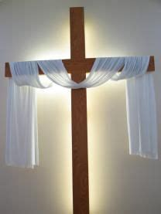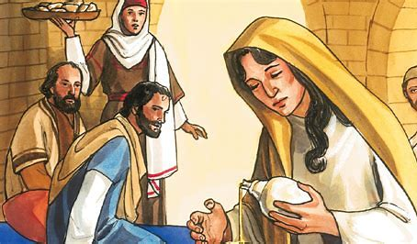
Mary Magdalene was a friend and follower of Jesus. When Jesus came to the house where Mary, her brother, Lazarus, and her sister, Martha, lived, Mary poured out her bottle of perfume on Jesus’ feet. Perfume was very expensive and valuable. Mary wanted to share the most special thing she owned with Jesus, to pour out all she had out of love for Our Lord, just like how Jesus would give His life as a gift to everyone when He died on the Cross on Good Friday. Jesus poured out His life as gift so that we could one day be in Heaven with Him. Pouring out the sweet perfume was a sign of Mary’s faith in Jesus, a sign of cleansing and healing in her soul. She was showing her belief that Jesus was the Savior, God’s Son Who came to save us all. She wanted to give glory, honor, to God. Mary turned away from sin and chose to follow Jesus.
Mary’s sister, Martha, was focused on preparing a meal for Jesus’ visit. She was so busy with getting ready for the feast, that she didn’t spend time with Jesus, but Mary took time to be present with Him. Not everyone understood why Mary poured out her perfume. They thought she was wasting the expensive perfume, pouring it all out on His feet like she had, but Mary knew that giving everything to Jesus was not a waste. It was a gift, and she was happy to share her love for Jesus. Mary was the first to see Jesus after He rose from the dead. She was chosen to bring the message that He had risen, to share her joy with everyone, just as she joyfully shared her love for Jesus by pouring out her perfume.
Jesus can do amazing things with even the smallest things we give Him. We still hear the Bible story of Mary Magdalene pouring out her perfume, because Jesus used her faith to teach other people about how to follow Him with love. Jesus hears every prayer. Sometimes, we can’t see how our prayers change the world around us, but they do! Jesus takes everything we offer Him, and makes it all so much bigger and more powerful than we could imagine.
*You can read the story in John 12:1-11 here: https://bible.usccb.org/bible/john/12
- On Easter Sunday, the priest wears white vestments. The color of the clothing is like fresh snow, new and clean. It’s also like the wool of a lamb. Jesus is called the “Lamb of God.” How does Easter make us new? How does Jesus give us new life?
____________________________________________________________________________________________________________________________________________________________
- “Thou shalt sprinkle me, O Lord, with hyssop, and I shall be cleansed. Thou shalt wash me, and I shall become whiter than snow. Have mercy on me, O God.” Hyssop is a mint plant. Plants were used in oils and perfumes like Mary would have had, for healing and cleansing. Before the Mass was changed in the 1960s, this Latin chant was sung at the beginning of the Mass, and the people were sprinkled with holy water. It reminds us to keep our hearts and souls clean in order to receive Jesus’ resurrected Body in the Eucharist at Mass. You can listen to the “Asperges Me” chant here: https://www.youtube.com/watch?v=Da6QgUPwCl8. How do you think Lent helped you get ready for Easter, to receive Jesus with a clean heart?
____________________________________________________________________________________________________________________________________________________________
- White Easter lilies also remind us of pureness, like Jesus’ innocent Heart, full of love for us. Lilies have a sweet smell like Mary’s perfume. Every good thing we do for God is sweet to Him, lifted up like a prayer, or the sweet-smelling incense that is used at Mass. Below the perfume bottle, write your ideas about how you can share the gift of faith with others, and how you can offer your faith to God as a gift. You can also draw your ideas.

Like Mary, I can be a messenger. I can share my faith in God by _________________________ _____________________________________________________________________________.
During Easter, I can be like Mary and be present for Jesus. I can spend time with Jesus by ___________________________________________________________________________________________________________________________________________________________.
Grade 6- “Faith in Jesus’ Promises: The Story of Lazarus”
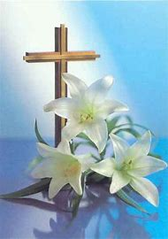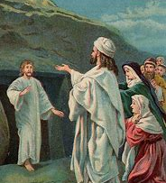
Sacred Scripture, the Bible, is one story of God keeping His promises to people of faith following Him. We see this in the New Testament stories of Jesus. Many people doubted Jesus, thinking He was not the Savior He said He was. Others saw His miracles, and came to believe in Him, knowing that only God, so full of love and mercy, could do such amazing things. In one story, Mary Magdalene and Martha were sad and frustrated. Their brother, Lazarus, had died. Lazarus was Jesus’ friend, but even after they sent a message to Jesus to come to their house to see Lazarus and help him before he died, Jesus still hadn’t come in time. Why had Jesus taken so long to come see them when He was told that His friend, Lazarus, was dying? If He hadn’t come so late, then Lazarus could have been healed, and saved from death, Mary and Martha thought. If He was really their friend, wouldn’t Jesus have been there?
But Jesus did what they had not expected. He showed that everything happens in His time. If they had trusted in Him, they would have seen that He had a plan, and that He was going to help them. He had not forgotten about them or left them behind. He was going to make a miracle happen to give people hope and faith, to show that they could trust in Him, no matter what. When Jesus got to Mary and Martha’s house, it had been three nights since Lazarus died. Jesus raised Lazarus up from the dead. Lazarus walked out of the house, alive.
Jesus really was their friend, and He is our friend, too. Jesus had cried when Lazarus died. His Heart goes out to us, too. He feels sad for us when we’re sad, joyful when we’re joyful. He wants us to be happy. He wants us to trust in Him, because when we trust in Him, we can have full peace and happiness, not having to worry about what will happen. God has it all in His hands.
Lazarus’ resurrection was how Jesus prepared people for His own Resurrection that would soon happen. Some may have lost hope when they saw Jesus die, thinking that maybe He had not been the Savior they thought. Would they ever be saved? Would they have to keep waiting many more years? Why hadn’t Jesus kept His promises? But, after three days, Jesus returned. He showed us that we can always put our faith in Him, believing in His power and goodness. He will never let us down. He will keep His promises. He can make what seems unbelievable, possible.

- Think of a time when God answered your prayers after you waited. Did He answer your prayers in a different way than you expected? How did this give you faith in God being with you, and keeping His promises, like He did at Easter?
__________________________________________________________________________________________________________________________________________________________________________________________________________________________________________
- Read the stories of Lazarus’ (John 11:1-44, https://bible.usccb.org/bible/john/11) and Jesus’ (John 20:1-18, https://bible.usccb.org/bible/john/20) resurrections in the Bible. What similarities are there between the story of Lazarus being raised up from the dead, and Jesus rising from the dead? What differences do you see?
Lazarus’ resurrection | JESUS’ RESURRECTION
- Similarity: | - SIMILARITY:
- DIFFERENCE: | - DIFFERENCE:
- SIMILARITY: | - SIMILARITY:
- DIFFERENCE: | - DIFFERENCE:

- Faith is our belief in God. When we have faith, we also have hope. We trust that God will do what He says, what we believe. How does Jesus give us new hope at Easter? How do the story of Lazarus and Jesus give you faith in God’s greatness?
__________________________________________________________________________________________________________________________________________________________________________________________________________________________________________
- Jesus is our friend. We can be good friends to Jesus by bringing new friends into His Church family, and sharing our friendship in Christ with other people. Mary Magdalene, sister of Lazarus, had seen Jesus’ miracles. She saw Lazarus raised from the dead, and she was the first to learn of Jesus’ Resurrection and share this good news with others. How can you share your faith and hope in Jesus this Easter?
Write your ideas next to the lily. Lilies look like trumpets used to announce the good news of life in Jesus. They remind us to share our faith and sing out our praise to God.
________________________________________________________________________________________________________________________________________________________________________________________________

Week 2
Grade 3- “New Life in Jesus: New You, New Virtue”
Easter Sunday has gone by, but it’s still the Easter season until Pentecost, May 28 this year. God fills our lives with good things, giving us what we need. Let’s fill our hearts with love for God, just like filling a basket with Easter eggs. When you go on an Easter egg hunt, you look everywhere for the eggs. Sometimes the eggs are hidden where you don’t expect, but when you find those surprise Easter eggs, you’re joyful. Every day, we can collect virtues, seeing God all around us, helping us to grow holier. We can find God’s love all around us. He created the sun that rises every day to give us warmth and light. He gives us people to pray for, people to help and teach us. There is always something new to learn every day, something to look forward to, and something kind we can do to love God and the people He sends us. Faith, hope, and love are virtues we can work on growing in every day. Each day, we can look around us at what God has given us: the hope He brings, the love He shares with us. We can think about how to become even more full of virtues, these good things that fill our hearts and make us happy.
God is listening. He wants to help us, because He loves us. We can have faith in God, believing He will answer us, when we think of Bible stories about prayers He answered. When Moses was walking with the Hebrew people out of Egypt, taking them where they could be free, they didn’t know how they would cross the deep ocean in time without a boat. But God helped them get through. He moved the ocean waves aside. A sandy path opened up for the people to walk on. God is faithful to us, always near. He keeps His promises. He can work miracles. When we see His goodness, how He acts with love for us, we can be inspired to have faith, hope, and love, too.
Write about signs of God’s faith, hope, and love that you have seen. You can also draw them in the Easter eggs. Then, you can cut out the eggs and put them in the basket to remind you of how God is filling your heart with virtues of faith, hope, and love.
What is something you saw today, or recently, that filled you with love for God? ______________________________________________________________________________
What is something you hope that God will do to help? ______________________________________________________________________________
What is something God helped has you with before, showing He is with you? ____________________________________________________________________________
What is something you will do to show your faith in God? ____________________________________________________________________________

We can put our faith, our trust, in God, because ____________________________________
______________________________________________________________________________
Grade 4- “Faith like St. Gemma”
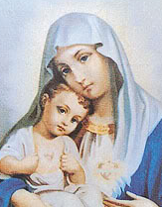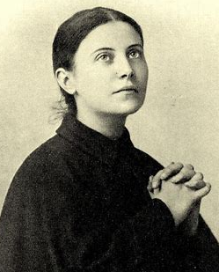
St. Gemma Galgani & Our Lady of the Sacred Heart
Gemma Galgani is an Italian saint who was born in 1878. St. Gemma had amazing faith in God. She was very sick, but kept praying novenas (nine days in a row of prayer) for healing. She was so close to Jesus, that she was given the stigmata, the wounds Jesus had on His hands, feet, and side from being on the Cross. St. Gemma felt His pain, and offered it up out of love for Him. She was also very close to her guardian angels. She prayed to them often to help protect her, and even sent them to deliver messages for her!
The closer St. Gemma became as a friend to Jesus, the more He wanted to bless her. He helped her heart become more pure, strong, and holy, just like His Sacred Heart. St. Gemma put her love and trust in Jesus’ Heart, knowing His Heart is filled with love for us. She had made her First Communion on the Feast of the Sacred Heart of Jesus. St. Gemma was joyful to receive the Eucharist, the Body of Christ, which she knew is a gift from God helping us to know Him better.
Jesus allowed St. Gemma to overcome difficult challenges, crosses to carry, just like He had. St. Gemma believed Jesus would help her through all that she was going through, and that He would help her get to Heaven. He did. Now, we remember St. Gemma’s beautiful faith on her feast day, April 11. April 11 is the day St. Gemma went to Heaven, in 1903 (which was on Holy Saturday that year, the day before Easter). Feast days are birthdays in Heaven, the day a saint is “born” in Heaven, into new life, after life on Earth. This is why we celebrate feast days of our friends in Jesus, the saints, just like we celebrate the special gift of the lives God gave us on our birthdays.
- Why is St. Gemma an example of faith in Jesus? How did she show faith in Him?
______________________________________________________________________________
______________________________________________________________________________
- How can you celebrate St. Gemma’s feast day (her birthday in Heaven), and practice growing in your faith like her?
______________________________________________________________________________
______________________________________________________________________________
- The liturgy is public worship of God. Going to Mass and sharing our love for God together at our parish is an example of how we experience the liturgy, how we live out our faith. On Easter, we remember Jesus rising again after dying on the Cross. We celebrate Jesus giving us new life. How is every Mass like Easter, a time to celebrate new life?
______________________________________________________________________________
______________________________________________________________________________
- Write a prayer to tell about your faith and trust in Jesus. Use the words of your prayer to share your love for Him, how He gives you hope, and to thank Him for the signs of new life you see.
______________________________________________________________________________
______________________________________________________________________________
______________________________________________________________________________
______________________________________________________________________________

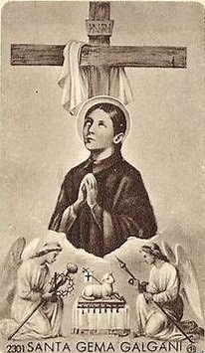

Grade 5- “Faith like Pope Benedict”
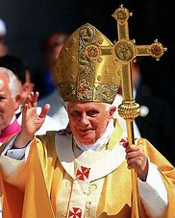
As pope, Pope Benedict XVI (16) led people to Jesus. He had an amazing mind, sharing his wisdom in what he spoke and wrote. His heart was gentle and kind like Jesus. Pope Benedict was also compassionate to animals. When he was growing up in Germany, he would rescue and feed stray cats. Pope Benedict shared what Jesus taught with Catholics around the world. Jesus teaches us to love God and each other with all our hearts, minds, and souls. Pope Benedict faithfully lived out what Jesus taught in how he treated God’s creation and guided the Church, loyally looking to Jesus as the King and greatest leader. Pope Benedict died in January 2023. His birthday was on April 16, which is Divine Mercy Sunday this year, the Sunday after Easter celebrating God’s forgiveness. We can remember Pope Benedict when we pray on this special day, thinking about his new life in Heaven with Jesus, our loving and merciful friend, Who saved us and gives us the food we need to live through the Eucharist, His resurrected Body.
At the Easter vigil Mass on Holy Saturday, the night before Easter, we heard the creation story read. Easter is the end of Lent. At the beginning of Lent, on Ash Wednesday, we also remembered the creation story when we received ashes on our foreheads, a reminder of where we came from: dust. We remember that we return to dust, too, that life on Earth comes to an end. Through Jesus, our souls can live forever. Jesus is the end and the beginning. Everything comes back to Him. Jesus overcame death when He rose again on Easter. Easter is about light over darkness, just like how the Easter vigil candles shine in the dark. Jesus is the Way, the Truth, and the Life. If we follow Him, believing and listening to what He tells us, we are on our way to new life in the Eucharist, and can live forever in Heaven with Him. He is the light leading us there.
- In Pope Benedict’s 2012 Easter vigil Mass sermon (reflection), he said, “Faith reveals [shows] God’s light to us.” What does it mean to have faith? How is it a light for us?
____________________________________________________________________________________________________________________________________________________________
- How did you see the light of God this Easter, and how did it make you feel?
____________________________________________________________________________________________________________________________________________________________
- How was Pope Benedict a light for Christ, and how can we be like him?
____________________________________________________________________________________________________________________________________________________________
Grade 6- “Faith like St. Faustina”
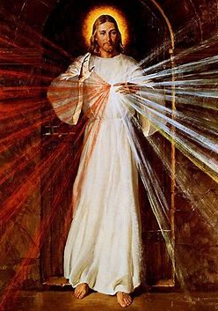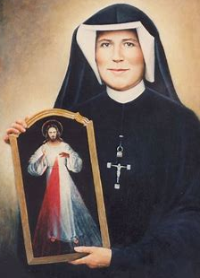
St. Faustina was born in the early 1900s in Poland, the third of ten children. Growing up, she knew that God was calling her to become a nun. Before she could become a nun, St. Faustina worked as a housekeeper to help her family, because they were very poor. She did not give up, having faith that God’s plan for her would be fulfilled, completed in His time.
After becoming a nun, St. Faustina was visited by Jesus. She had visions of Jesus appearing with light shining from His Heart, like white and red rays of sun. Jesus told St. Faustina that her special calling was to be an example of His mercy to other people. He also asked her to share what she had seen with other people. St. Faustina could not paint, but found an artist to create an image of Jesus with the light shining from His Heart, just like what she had seen, so that the image could be printed on prayer cards. She also wrote down what Jesus told her in a diary that was published for people around the world to read. In everything she did, St. Faustina showed her trust in God, doing all in love for Him. On the outside, her life seemed quiet. She cooked, tended gardens, and cleaned. But inside, she had great faith in Jesus, doing all He asked, as she prayed and cared for other souls, living out the great plans God had for her with a humble heart.
St. Faustina introduced people to the Divine Mercy chaplet, a beaded sacramental like the Rosary, for people to pray, asking for God’s mercy on them, while showing mercy to others by praying for souls in need, like the souls in Purgatory, who are waiting to go to Heaven as their souls are being cleansed of sins. St. Faustina shared her faith, reminding us that we can trust in God, because His forgiving, loving Heart is bigger than anything we face. In prayer, we can aways go to Jesus, Who can heal us. In His mercy, He can do great things to help us.
- Music has long been used to express faith in God. In the Old Testament, the books of the Bible from before Jesus’ birth, we have the psalms, songs of sadness, joy, and hope. During Lent, in the weeks leading up to Easter, we ask God to forgive us. We don’t sing the joyful “Alleluia” song at Mass again until Easter to celebrate Jesus rising from the dead. On Divine Mercy Sunday, the Sunday after Easter (April 16 this year), the chaplet of Divine Mercy is often sung in special during a special service.
Why do you think music is used to share our faith? How can it bring us closer to God?
____________________________________________________________________________________________________________________________________________________________
- How is St. Faustina an example of living out faith in Jesus?
____________________________________________________________________________________________________________________________________________________________
- St. Faustina said, “O Lord, I want to be completely transformed into Your mercy and to be Your living reflection. May the greatest of all divine attributes, that of Your unfathomable mercy, pass through my heart and soul to my neighbor.” What does it mean to be a living reflection of God? How do we reflect God to others?
__________________________________________________________________________________________________________________________________________________________________________________________________________________________________________
- In Stockbridge, Massachusetts (local to us, in the Berkshires), we are blessed to have the
Shrine of Divine Mercy. You can watch the chaplet being prayed at the Shrine online. The chaplet is prayed at 3:00 p.m. every day, the hour when Jesus died, which is also known as the hour of divine mercy: https://www.thedivinemercy.org/DailyChaplet
Why do you think the hour Jesus died is known as the hour of God’s mercy?
____________________________________________________________________________________________________________________________________________________________
- In the Divine Mercy image of Jesus, we see rays of light reaching from His Heart out to us, asking us to welcome His love into our hearts. Easter is a special time to celebrate how the light of the risen Christ leads us to a stronger faith. How can you reach back to God with love in this Easter season (the 50 days going up to Pentecost, May 28 this year), living out your faith in Him? Write your ideas around the chaplet. Or, you can write your own prayer for God’s mercy to express your faith.
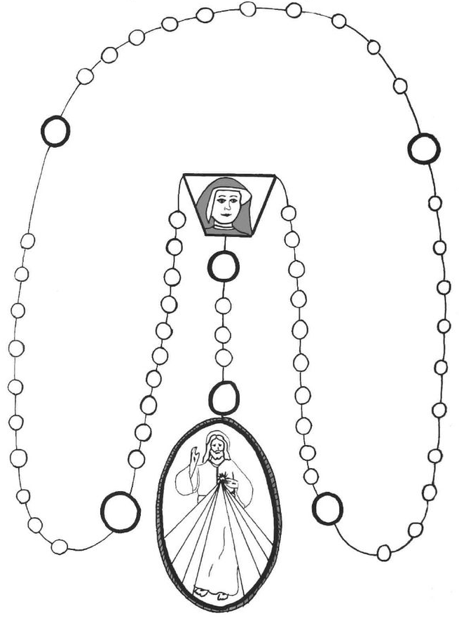
___________________________________________________________________________________________________________________________________________________________________________________________________________________________________________________________________________________________________________________________________________________________________________________________________________________________________________________________________________________________________________________________________________________________
Week 3
Grade 3- “The Light of Faith: Seeing and Believing”
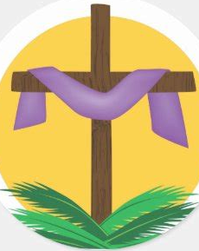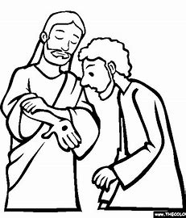
The story of St. Thomas is read on the Sunday after Easter, Divine Mercy Sunday. St. Thomas was one of Jesus’ apostles who would be sent to continue Jesus’ work of teaching and bringing the sacraments to people after He went to Heaven. In the Bible, we hear the story of Mary Magdalene telling the apostles that Jesus was alive again. He had come back after dying on the Cross. She told them to come see Jesus, but St. Thomas had a hard time believing what he was hearing. He wasn’t sure if it was true. How could such an amazing thing really happen?
St. Thomas said it wasn’t enough for him to see. He had to touch Jesus’ wounds to know that it was really Him, that He had truly come back. Jesus had gotten cuts from the nails of the Cross on His hands, feet, and side. St. Thomas knew if these wounds were there, then it really was Jesus walking among them again. When Jesus came to visit St. Thomas, Thomas could see and touch Jesus’ wounds. Then, he knew for sure that it all was real. It was Jesus: He had risen!
Jesus has mercy on us. He forgives. He wasn’t angry with St. Thomas for not believing at first. He still loved Thomas. St. Thomas needed time, but he came to have faith in Jesus, to trust in Him. He saw that Jesus was the answer to all of his questions. Then, he wanted to share his faith in Jesus with everyone. Seeing how Jesus loved him and was merciful to him, St. Thomas believed in Jesus’ mercy and goodness, seeing He really was God. Only Jesus could have so much love in His Heart that He was able to overcome death on the Cross to bring us new life.
*You can read this story in John 20:24-29: https://bible.usccb.org/bible/john/20
We see by the light. Faith is like a light that shows us the way. Without light, we wouldn’t be able to see where we are going. When we believe in Jesus, we believe in what He taught. We want to follow Him and listen to Him, so we want to love Him and other people, because that is what He teaches us to do. Knowing that this is what we believe, we know what to do: we know how to live out our faith, to show what we believe, by doing loving and kind things. We know where to go and what to do when we learn from Jesus, seeing how He helped and loved other people in the Bible, like St. Thomas. Sharing our faith, our trust and love for God, is how we can help other people to see Jesus’ light, and believe in Him, too.

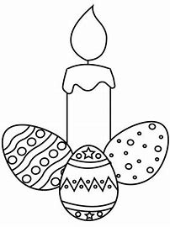
At Advent, we lit a candle in the Advent wreath each week before Christmas. On Holy Saturday, the day before Easter, the Easter Candle is lit, which is like the candles in the Advent wreath. Jesus brought light, hope, and joy into the world when He was born. When He died and then came back from the dead, it was like He was born again, bringing hope, joy, and light back to us. During the 50 days of the Easter season, which is until Pentecost (May 28 this year- “Pente” means “5,” for the 50 days), you can see the Easter Candle shining in our church, reminding each of us to be a light shining for Jesus, doing good things that teach other people to have faith in God and His love.
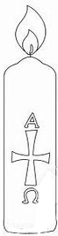
How can you show Jesus’ light to other people in this Easter season? How can you share your faith, helping people to see Jesus’ love, like St. Thomas did, when He came to believe in Jesus? How can we live out our faith throughout the year?
Color in the candle, and then draw or write your ideas here.
3
2
0
2

What is one way that Lent is like Advent, or Christmas like Easter?
______________________________________________________________________________
Grade 4- “Faith in God’s Mercy”
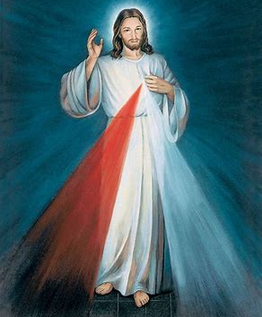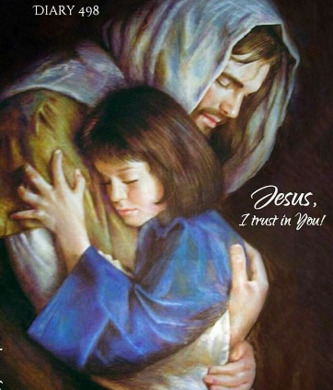
Divine Mercy Sunday is the Sunday after Easter. This year, it is April 16. On Divine Mercy Sunday, we think of St. Faustina, a Polish nun who lived from 1905-1938. St. Faustina had a special faith in Jesus, just like another saint friend of ours, St. Gemma. Her heart was so close to Jesus, so filled with love for Him, that He visited her, and she spoke with Him. She saw Jesus appear with light shining very brightly from His Sacred Heart. He told her to share an image of this light with other people, so that they could see how much love and mercy are shining like light from His heart. He asked her to share her faith, her trust in Him, with other people, so that they could learn to trust in Him, too. St. Faustina wrote down what Jesus told her, and published her writing in a book that people from all over the world would read to learn about Jesus. She made sure that a painting of Jesus was made, the Divine Mercy image, that is now printed on holy cards everywhere. St. Faustina was gentle and humble, like Jesus. She showed other people His gentleness and mercy, how kind and forgiving He is. St. Faustina lived out her faith.
On Divine Mercy Sunday, there are many beautiful ways that churches celebrate Jesus’ love and mercy. The Easter season is the perfect time to think about God’s forgiveness, because we are remembering Jesus dying and rising for us. Jesus came to forgive us and save us from sins. This is why Divine Mercy Sunday is a day when many people go to Confession, to receive Jesus’ love and forgiveness in their hearts by saying they are sorry for their sins, and will make better choices out of love for Jesus. At Divine Mercy church services, people pray the Divine Mercy chaplet (which is like the Rosary), sing, and read St. Faustina’s writings about Jesus. There is also Adoration, when the Sacred Host, Jesus’ Body, is in the monstrance, a gold container with rays that looks like a sun, placed on the altar. People spend time with Jesus, praying and adoring Him. When we adore Jesus, we are sharing our love with Him, joyfully being present with Him.


- You can hear how the song “O Salutaris Hostia,” which means “O Saving Host” in Latin, is sung after OLV’s Friday 8:00 a.m. daily Mass, right before Adoration, here: https://www.youtube.com/watch?v=3LHBZHt7_78 (see minute mark 43:24). Going to Adoration, such as on Divine Mercy Sunday, is a special way to show our love for Jesus.
How do you think that Jesus shows us His love and mercy in the Eucharist? Why do you think the Eucharist is called the “Saving” Host?
______________________________________________________________________________
______________________________________________________________________________
- Why is Divine Mercy Sunday a day many people go to Confession?
______________________________________________________________________________
______________________________________________________________________________
- Jesus said, “Blessed are the merciful, for they will be shown mercy.” If we are forgiving, patient, and kind, we are being merciful. Being merciful is being like Jesus, living out our faith in His mercy and goodness. When we are merciful, God blesses us. When we forgive, we are forgiven, too. On one of the rays of light, write a way that God shows mercy to us. On another ray, write a way that we can show mercy to other people.
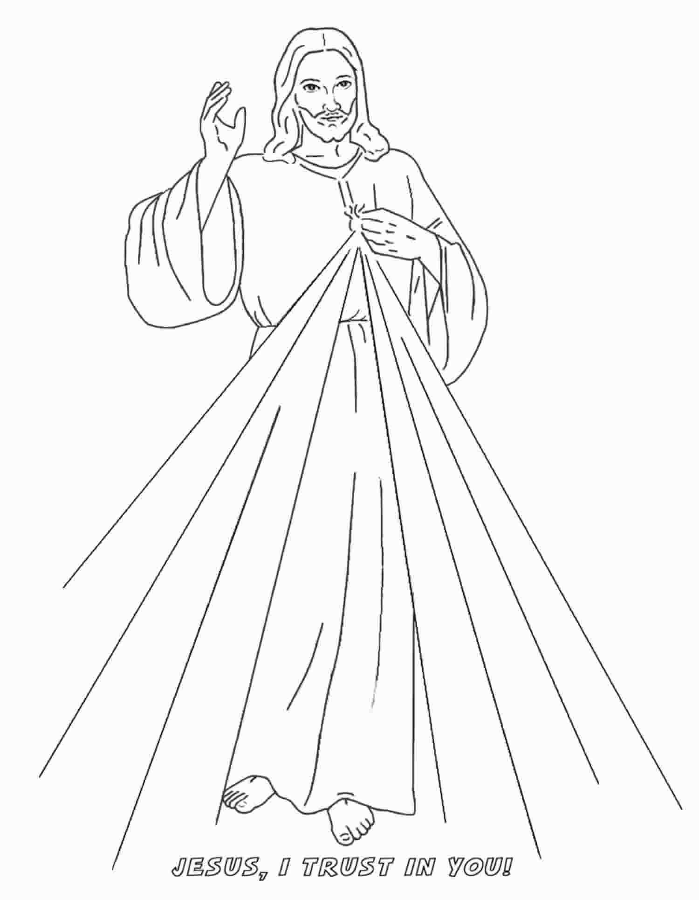

Grade 5- “Eucharistic Miracles and Faith in Jesus”
At times when people have struggled to believe in Him, God has brought miracles to remind them of His greatness, showing that they can put their trust in Him, because He is real, always with us, guiding us. We can put our faith, our belief, in God, knowing that He won’t leave us. Powerful miracles have happened around the world in the years after Jesus’ Death and Resurrection. Jesus made miracles happen during His life on Earth, and after He ascended into Heaven, He continued to work miracles: miracles of the Eucharist, His Body. Miracles can make our faith stronger when we see how much God does out of love for us. God shows us that what we might have thought isn’t possible, can be made possible, because His love is so great. It is bigger than our worries or questions. God’s love is the answer, and we can feel it in our hearts when we receive Communion. It is a miracle that Jesus came down to us, and has given us the gift of the Eucharist to know Him, giving us a taste of what it is like to be in Heaven with Him.
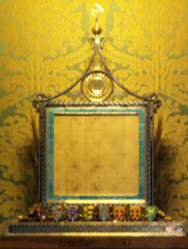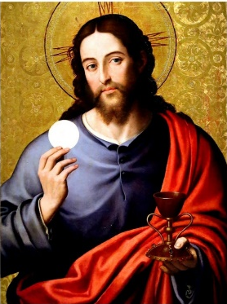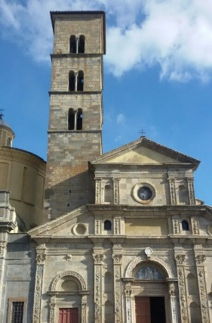
Corporal in Bolsena, Italy St. Christina’s Church, Bolsena
In Bolsena, Italy, in 1263, there was a priest who was having a hard time believing in Jesus’ Real Presence. He doubted that Jesus really could be in the Eucharist, that the Bread could become His Body at the consecration of the Mass. He couldn’t see the Eucharist as the miracle it is. When the priest was saying Mass, blood flowed out of the Sacred Host at the time of the consecration, as the Bread was changed into the Body. The blood on the corporal, the cloth under the chalice (the cup), was proof that this miracle happened. You can still see the corporal at the church where the miracle took place, St. Christina’s, in Bolsena.
The priest believed again after seeing this happen. He was reminded that Jesus shed His Blood for us out of love, that Jesus truly did die for us, and rise again. Now, the priest knew for sure that when we receive the Eucharist, we are receiving Jesus. The Bread is His resurrected Body. Jesus wants us to be friends with Him, to feel the love He has for us in our hearts. By helping the priest to have faith again, He was helping the priest to find friendship with Him again.
- How does the Eucharistic miracle in Bolsena, Italy, remind us of Jesus’ love?
____________________________________________________________________________________________________________________________________________________________
- How did learning about this miracle grow your faith in God?
____________________________________________________________________________________________________________________________________________________________
- In the Easter season, as we celebrate Jesus’ Resurrection, what can we do to share our love for the Eucharist, and continue growing in faith?
____________________________________________________________________________________________________________________________________________________________

Grade 6- “Eucharistic Miracles: Renewing our Faith in Christ”
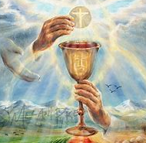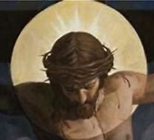
In the Easter season, we celebrate Jesus’ Resurrection, the miracle of Jesus rising from the dead. In His life on Earth, Jesus performed many miracles: He healed people, calmed stormy seas, and walked on water. Since Jesus’ time, He is continuing to work miracles through the Eucharist, because Jesus is Present in the Eucharist. When we receive the Sacred Host, we aren’t receiving just a symbol of Jesus’ Body in the Bread. We are really receiving Jesus’ resurrected Body.
God’s love has the power to change hearts. He brings about miracles to remind us that we are not alone. He is with us, making what might seem impossible, possible for us. He shows us that He can and will do anything out of love for us, including giving us His only Son to save us.
Eucharistic miracles can bring about conversion, or metanoia, when people turn away from sin and doubt, choosing to follow Jesus. For some, seeing is believing. They need to see proof before they can believe, like St. Thomas, who had to touch Jesus’ scars before he could believe that it was truly Jesus Who had come back after dying on the Cross. Jesus says that those who have faith, believing even without seeing, are blessed, because their hearts are fully open to Him.
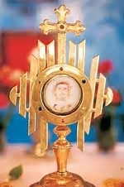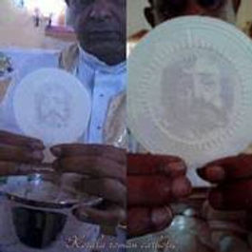
In 1649, in Peru, a priest saw the face of Christ in the Host. He showed it to the people in the church with him, and they all saw Jesus’ face as well. The next month, the priest saw three hearts appear on the Host, a reminder of the love of the Father, the Son, and the Holy Spirit. Similar miracles happened in India in 2001, with another priest in a different church. After seeing the face of Christ in the Host, the priest, Fr. Karnoor, opened His Bible at random, and the first story he saw was the story of St. Thomas.
In the late 1990s, a Host from a church in Argentina that had begun to bleed was analyzed by a scientist. The scientist had not believed in God, but after he studied the Host, he became Catholic. Test results from studying the Host showed that it was human heart tissue. Jesus is still showing us the love in His Sacred Heart through miracles like these, bringing our hearts to Him.
- What do you think God was telling the priest in India when the priest opened his Bible to find the story of St. Thomas?
____________________________________________________________________________________________________________________________________________________________
- Why do you think God continues to work miracles for us today, especially through the Eucharist?
__________________________________________________________________________________________________________________________________________________________________________________________________________________________________________
- Which of the Eucharistic miracle stories most inspired you? How did it grow your faith in Christ and His Real Presence in the Eucharist?
________________________________________________________________________________________________________________________________________________________________________________________________________________________________________________________________________________________________________________________
- Easter is a season celebrating new life in Christ. How do you think the Eucharist gives us new life, new hope, based on the miracle stories you read?
__________________________________________________________________________________________________________________________________________________________________________________________________________________________________________

April 2023 3-6 Review
Use this review sheet as a reference to track progress and check that learning goals are met.
Recap: What did we learn?
All Grades
- On Easter Sunday, we celebrate Jesus’ Resurrection
- The Resurrection is when Jesus rose from the dead, coming back to life
- Jesus died and rose for us, because He loves us, and love is greater than death
- Jesus gives us new life. At every Mass, we remember Jesus’ Passion, Death, and Resurrection. When we receive the Eucharist, we receive Jesus’ resurrected Body
- We can have faith in Jesus, trusting and believing in Him, because He is God. He can do anything, and will do amazing things to help us
Grade 3
- Holy Week is when we remember Jesus’ Passion, Death, and Resurrection
- Good Friday and Holy Saturday are two days during Holy Week that prepare us to celebrate Jesus’ Resurrection on Easter Sunday
- Jesus’ Passion was His suffering on the Cross. Jesus died on the Cross on Good Friday
- At the vigil on Holy Saturday, we watch and wait to celebrate Jesus’ rising on Easter
- Sharing the good news of Jesus’ Resurrection is one way we can practice our faith, showing our love and belief in God
- The story of St. Thomas is read from the Bible on Divine Mercy Sunday, the Sunday after Easter. This is a story of Jesus’ forgiveness and love
- St. Thomas was unsure at first if Jesus really came back from the dead, but after he touched Jesus’ wounds, he believed
- Then he went out and shared the good news, telling other people about his faith in God. We can do this, too, using our talents to live out our faith and share God’s love
Grade 4
- During Holy Week, we celebrate the Easter Triduum, three special days remembering Jesus’ life
- The evening of Holy Thursday to the evening of Good Friday is one day of the Triduum. The next full day is Good Friday evening to Holy Saturday evening. The third full day is Holy Saturday evening to the evening of Easter Sunday
- Holy Thursday was the night of the Last Supper. Good Friday was the day Jesus died. Holy Saturday is when we wait for Jesus, and Easter Sunday is when He rose back to life
- St. Gemma is an example of faith. Her faith in God helped to heal and strengthen her
- St. Gemma offered up the difficult times she faced to God. Her love for God helped her get through her challenges, because she kept her focus on Him, and His love for her
- The saints show us how to live out our faith through loving God
- One way we can practice our faith is by celebrating saints’ feast days, when they went to Heaven. We can learn about the saints and do things to be like them every day
- St. Faustina shared her faith by bringing the message of Divine Mercy to other people
- We can be like St. Faustina by being merciful to others. God blesses us when we are merciful, because being merciful means being kind and loving like Jesus
- On Divine Mercy Sunday, Adoration often takes place. When praying at Adoration, we are living out our faith, sharing our love for God by spending time with Him
Grade 5
- Mary Magdalene poured out expensive perfume on Jesus’ feet, cleansing them
- Mary wanted to share this special gift with Jesus. She showed that she believed in Him, and wanted to follow Him, because He is the Savior. He poured out His life for us
- God wants us to spend our time with Him, and use what special gifts He has given us to love Him, like Mary did
- Easter is a time to make our hearts clean, ready to welcome Jesus
- The pope is the leader of the Catholic Church who shares Jesus’ teachings with the world
- Pope Benedict was an example of faith, because he lived like Jesus. He was loyal to Jesus
- Jesus continues to work miracles through the Eucharist to boost our faith
- The Bolsena Eucharistic miracle reminds us of Jesus’ Presence in the Eucharist. It shows we can confidently place our faith in Christ, knowing He died for us and loves us
Grade 6
- Jesus is our friend. His Heart goes out to us. He feels compassion for us, just like when He cried for His friend, Lazarus, after Lazarus died
- Jesus raised up Lazarus from the dead. This hinted at Jesus’ Resurrection to come
- Jesus’ miracles teach us that we can put our faith in Him. He hears us, and is there for us
- St. Faustina was faithful to Jesus’ calling for her. She shows us how powerful it is to be a messenger of Christ’s mercy
- Sharing Christ’s forgiveness and mercy with others can reach people everywhere, making a deep impact
- Eucharistic miracles have happened all around the world, in many different time periods
- These miracles show that God can and will do anything to help us, including increasing our faith and transforming our hearts, so that we want to become closer to Him
What vocabulary words did we practice?
Grade 3
Week 1
Resurrection
Week 2
Virtue
Week 3
Faith
Grade 4
Week 1
Triduum
Week 2
Liturgy
Week 3
Adoration
Grade 5
Week 1
Vestments
Week 2
Pope
Week 3
Corporal
Grade 6
Week 1
Sacred Scripture
Week 2
Psalm
Week 3
Metanoia
What prayers did we practice?
Grade 3
Divine Mercy Chaplet Prayers
Grade 4
Divine Mercy Chaplet Prayers
Grade 5
Divine Mercy Chaplet Prayers
Grade 6
Divine Mercy Chaplet Prayers
Checklist: Activity Completion
Grade 3
Week 1: “Holy Week Bulletins: Sharing the Good News of Easter”
Week 2: “New Life in Jesus: New You, New Virtue”
Week 3: “The Light of Faith: Seeing and Believing”
Grade 4
Week 1: “Triduum Triptych”
Week 2: “Faith like St. Gemma”
Week 3: “Faith in God’s Mercy”
Grade 5
Week 1: “The Sweetness of Faith”
Week 2: “Faith like Pope Benedict”
Week 3: “Eucharistic Miracles and Faith in Jesus”
Grade 6
Week 1: “Faith in Jesus’ Promises: The Story of Lazarus”
Week 2: “Faith like St. Faustina”
Week 3: “Eucharistic Miracles: Renewing our Faith in Christ”
Quick Check:
Tell us about your experience with these activities this month! Our April 2023 Google Form for Grades 3-6 is available here: https://forms.gle/i7UuXxE6VbMwXG2y6

