Our Lady of the Valley Religious Education

January 2023 Activity Packet

Grades Pre-K-2

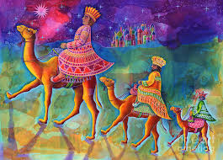

Materials Included in Packet
Overview…………………………………………………………………………………………3
Standards………………………………………………………………………………………...4
Pacing Guide……………………………………………………………………………………..7
Activities………………………………………………………………………………………...11
Week 1…………………………………………………………………………………..11
Pre-K/Kindergarten……………………………………………………………11
Grade 1………………………………………………………………………….12
Grade 2………………………………………………………………………….13
Week 2…………………………………………………………………………………..14
Pre-K/Kindergarten……………………………………………………............14
Grade 1………………………………………………………………………….16
Grade 2………………………………………………………………………….17
Week 3…………………………………………………………………………………..19
Pre-K/Kindergarten……………………………………………………………19
Grade 1………………………………………………………………………….20
Grade 2………………………………………………………………………….21
Review…………………………………………………………………………………………..23

January 2023 Overview: Grades Pre-K-2
Theme: Peace (Pax)
Thematic Guiding Questions, Pre-K-2:
- What makes you feel peaceful?
- What can you do to help a friend or family member feel peaceful?
Monthly Challenge: Devote a few minutes of quiet time to be with God. Visit a Eucharistic Adoration chapel to pray, or create a quiet area, perhaps a home shrine, in your house dedicated to family prayer. How did it affect your prayer life and sense of peace to take time to visit a special place devoted to spiritual reflection?
Overall Learning Goals: This month’s overarching goal is to continue to grow in faith through learning more about how God’s presence in the sacraments, our families, church community, and within our hearts brings us peace. Our goal is to learn about how we can connect more deeply with God, finding greater peace, through prayer and sharing our faith together.
Summary of Activities: To achieve our goals, we will participate in reflection- and arts-based activities, learning about finding peace by trusting in God, using the story of the Three Kings as an example. Looking at how participating in the life of the Church brings us together as a family in Christ, our activities will center around traditions celebrated during the feast of the Epiphany.
In preparation for First Confession, the traditional Act of Contrition is included as a prayer to practice. A simplified, newer version of prayer is also available to practice:
My God, I am sorry for my sins with all my heart.
In choosing to do wrong and failing to do good,
I have sinned against you whom I should love above all things.
I firmly intend, with your help, to do penance,
to sin no more, and to avoid whatever leads me to sin.
Our Savior Jesus Christ suffered and died for us.
In his name, my God, have mercy.
Amen.

This version is used in the Week 1, Grade 2 activity. Links to both versions of the prayer are here: https://www.usccb.org/prayers/act-contrition. An answer key for the Week 3, Grade 2 10 Commandments matching activity is available on page 26.
Enrichment Ideas: The Guardian Angel prayer can be connected to Epiphany house blessings (“Peace be to this house”) in talking about how God watches over us, bringing us peace by sending His angels to guard and guide us.
Choosing prayer cards, writing original prayers, or making a Cross to put in a family home shrine/prayer corner is another way to expand upon our theme of peace this month.

Standards
Grade Level | Week | Activities | Learning Standards
Pre-K, Kindergarten | 1 | “Peace in Prayer” | K.4 We talk to God through prayer. We pray every day to help us do the right things. Praying helps us to know God. We say prayers such as the “Hail Mary,” the “Our Father” and the “Glory Be.”  K.5 Jesus’ Name is holy. Saying His name is a prayer in itself.
Pre-K, Kindergarten | 2 | “Peace in Church” | K.6 We acknowledge God’s holy presence with respect, such as when we go into a church, and pray at Mass.  K.7 When we go to church, we are in God’s house. It is a holy place of God’s love, so we are respectful. We attend Mass at church and pray… Outside of church, we can love God through the kind things we do, because God is always with us, and is happy when He sees us being loving like Him.
Pre-K, Kindergarten | 3 | “Our Lady of Peace” | K.8 We are never alone, because God is always with us. We meet God by reading the Bible (the book of God’s words) and receiving the sacraments. He gave us Sacred Scripture (the Bible) and Sacred Tradition (the sacraments) so that we could know Him.
Grade 1 | 1 | “Peace at Epiphany” | 1.1 We are a community of faithful who show our faith in God by trusting in His plan for our lives.
Grade 1 | 2 | “Peaceful Prayer Corner” | 1.1 Jesus and Mary are examples of faith in God the Father. They lived with love. We can follow their example, especially as we prepare to receive sacraments that will bring us closer to God.
Grade 1 | 3 | “The Treasure of Peace” | 1.8 Hosts are kept in the church’s tabernacle, a gold shrine that is beautifully decorated. When we pass by the tabernacle, we genuflect in recognition of God’s holy presence.
Grade 2 | 1 | “Peace at Confession” | 2.7 God forgives us because He loves us. We see that He loves us because He gave us the sacraments to help us get to know Him and become closer to Him.
Grade 2 | 2 | “Peace Within” | 2.6 The sacraments are special celebrations of God’s love, signs of His Presence. Some sacraments are received only once, including Baptism, Confirmation, and Holy Orders, because they leave marks on the soul for life, but other sacraments, Communion and Confession, are received often. God is always part of our lives, and when we encounter Christ in the sacraments, our connection to Him is made stronger.
Grade 2 | 3 | “Peace in God’s Mercy” | (Confession Standard) 1.5 Confession allows for prayerful reflection on your choices, especially through an examination of conscience that looks at how your actions align with the 10 Commandments.  (Confession Standard) 1.8 Confession cleanses the soul before Communion, restoring the state of grace needed to receive the Host.  (Confession Standard) 1.9 Sacraments such as Confession allow us to meet God in our earthly lives, receiving a glimpse of Heaven through experiencing His merciful love.

January 2023 Pacing Guide (Suggested Schedule)
Grades Pre-K-2
Week Number/Date | Grade Level | Activities
Week 1  (January 3-6, 2023) | Pre-K, Kindergarten | “Peace in Prayer”
Week 1  (January 3-6, 2023) | Grade 1 | “Peace at Epiphany”
Week 1  (January 3-6, 2023) | Grade 2 | “Peace at Confession”
Week 2  (January 9-13, 2023) | Pre-K, Kindergarten | “Peace in Church”
Week 2  (January 9-13, 2023) | Grade 1 | “Peaceful Prayer Corner”
Week 2  (January 9-13, 2023) | Grade 2 | “Peace Within”
Week 3  (January 17-20, 2023) | Pre-K, Kindergarten | “Our Lady of Peace”
Week 3  (January 17-20, 2023) | Grade 1 | “The Treasure of Peace”
Week 3  (January 17-20, 2023) | Grade 2 | “Peace in God’s Mercy”

Week Number/Date | Grade Level | Words to Practice | Definitions
Week 1  (January 3-6, 2023) | Pre-K, Kindergarten | Jesus Christ | Jesus is God the Father’s Son. He was sent to save people from sin. “Jesus” means “God saves,” and “Christ” means “Messiah” or “Savior.”
Week 1  (January 3-6, 2023) | Grade 1 | Epiphany | The Feast of the Three Kings on January 6, the last day of the 12 Days of Christmas. Epiphany celebrates when the three wisemen traveled to see Baby Jesus in Bethlehem.
Week 1  (January 3-6, 2023) | Grade 2 | Contrition | Being sorry for when you didn’t do what God asked you to do (in the Ten Commandments, His rules for us to follow). When you say the Act of Contrition, you are asking God to forgive you, telling Him that you will make better choices to follow Him.
Week 2  (January 9-13, 2023) | Pre-K, Kindergarten | Mass | Praise and worship of God as a family in Christ each week at church. Together, we read stories from the Bible about God’s love, pray, and remember the life of Christ. We show our love and respect for God at Mass as we remember Jesus’ life, and think about how much we are loved by Him. Once we have made the sacrament of First Communion, we can receive the Eucharist, the Body of Christ, at Mass.
Week 2  (January 9-13, 2023) | Grade 1 | Sacrament | A sign of God’s love, a holy meeting with Christ. Through the sacraments, we come to know God, who lives in Heaven, while on Earth. There are seven sacraments: Baptism, Confirmation, Confession, Communion, Holy Orders, Marriage, and Anointing of the Sick.
Week 2  (January 9-13, 2023) | Grade 2 | Conscience | Knowing the difference between right and wrong. God’s made our hearts. Inside, we can tell when something is wrong. Then, we know to stay away from what is wrong so we can make good choices and stay close to God.
Week 3  (January 17-20, 2023) | Pre-K, Kindergarten | Heaven | God the Father is in Heaven. He made everything. Heaven is a beautiful, holy, and joyful place, because it is where God is, and God is love. Everyone in Heaven loves God. People who love God on Earth, living with love just like Jesus, can someday go to Heaven after they have lived their life on Earth.
Week 3  (January 17-20, 2023) | Grade 1 | Tabernacle | The gold shrine that holds the consecrated Hosts on the altar.
Week 3  (January 17-20, 2023) | Grade 2 | Examination of conscience | Before we go to Confession, we “examine,” or look at, our consciences, thinking about what our heart tells us is right and wrong. When we think back about the things we have done, we go through the Ten Commandments, thinking about how we followed them. We think about what has brought us away from God, so that we know what to tell the priest at Confession. Then, we can ask God to forgive us for those things. The examination of conscience helps us to tell what we can do better in the future so that we can love God more, and open our hearts to receive more of God’s love.

Week Number/Date | Grade Level | Prayers to Practice | Text of Prayers
Week 1  (January 3-6, 2023) | Pre-K, Kindergarten | Guardian Angel Prayer | Angel of God, my Guardian dear,  To whom His love commits me here,  Ever this day be at my side,  To light and guard, rule and guide. Amen.
Week 1  (January 3-6, 2023) | Grade 1 | Guardian Angel Prayer | Angel of God, my Guardian dear,  To whom His love commits me here,  Ever this day be at my side,  To light and guard, rule and guide. Amen.
Week 1  (January 3-6, 2023) | Grade 2 | Act of Contrition | Oh my God, I am heartily sorry for having offended Thee, and I detest all my sins, because I dread the loss of Heaven and the pains of Hell, but most of all because they offend Thee, my God, Who art all good, and deserving of all my love. I firmly resolve, with the help of Thy grace, to confess my sins, to do penance, and to amend my life. Amen.
Week 2  (January 9-13, 2023) | Pre-K, Kindergarten | Guardian Angel Prayer | Angel of God, my Guardian dear,  To whom His love commits me here,  Ever this day be at my side,  To light and guard, rule and guide. Amen.
Week 2  (January 9-13, 2023) | Grade 1 | Guardian Angel Prayer | Angel of God, my Guardian dear,  To whom His love commits me here,  Ever this day be at my side,  To light and guard, rule and guide. Amen.
Week 2  (January 9-13, 2023) | Grade 2 | Act of Contrition | Oh my God, I am heartily sorry for having offended Thee, and I detest all my sins, because I dread the loss of Heaven and the pains of Hell, but most of all because they offend Thee, my God, Who art all good, and deserving of all my love. I firmly resolve, with the help of Thy grace, to confess my sins, to do penance, and to amend my life. Amen.
Week 3  (January 17-20, 2023) | Pre-K, Kindergarten | Guardian Angel Prayer | Angel of God, my Guardian dear,  To whom His love commits me here,  Ever this day be at my side,  To light and guard, rule and guide. Amen.
Week 3  (January 17-20, 2023) | Grade 1 | Guardian Angel Prayer | Angel of God, my Guardian dear,  To whom His love commits me here,  Ever this day be at my side,  To light and guard, rule and guide. Amen.
Week 3  (January 17-20, 2023) | Grade 2 | Act of Contrition | Oh my God, I am heartily sorry for having offended Thee, and I detest all my sins, because I dread the loss of Heaven and the pains of Hell, but most of all because they offend Thee, my God, Who art all good, and deserving of all my love. I firmly resolve, with the help of Thy grace, to confess my sins, to do penance, and to amend my life. Amen.

January 2023 Pre-K-2 Activities
Week 1
Pre-K/Kindergarten- “Peace in Prayer”
In January, we celebrate the Holy Name of Jesus. Saying Jesus’ name is a prayer. At Mass, when we hear Jesus’ name, we can show our respect for Jesus by bowing our heads. The name “Jesus” means “God saves,” because God the Father sent His Son, Jesus, to save us. “Christ” also means “Savior,” the One who saves us. Jesus is holy, because of His love, kindness, and goodness in healing and helping us. Jesus’ holiness means that His name is holy. We can talk to Jesus every day in prayer, saying His name with love, asking Him to bless us and bring us peace.
Draw a picture of you praying. How can you call on the name of Jesus?

Grade 1- “Peace at Epiphany”
On January 6, we celebrate Epiphany, when the Three Kings followed the star, traveling to see Baby Jesus in the manger in Bethlehem. The Three Kings were peaceful on their journey, trusting that God would help them to find what they were looking for- and He did.
Jesus came to Earth to be with us, to know us, help us, and save us. God shows us His love through Jesus. The Three Kings, or wisemen, went to visit Jesus to be near Him, and show Him their love. The name of Jesus is holy, because Jesus is King. Jesus is the greatest of Kings, because He leads His Kingdom on Earth and Heaven with love. Like the wisemen, we can follow Jesus, the light. God is good. He wants us to be joyful. He does everything for us out of love, so when we listen to Him, following Him, we can be peaceful.
What is something you can do to follow Jesus in this new year?

______________________________________________________________________________
______________________________________________________________________________
Grade 2- “Peace at Confession”
God gave us the sacraments, including Communion and Confession, so that we could better know Him. God wants to know us, because He loves us. The sacrament of Confession allows us to know God’s forgiveness. When we make a choice we know was not right, we tell the priest at Confession. God works through the priest, who hears what we confess (tell), but it is God Who forgives us. At Confession, we say a prayer called the Act of Contrition. “Contrition” means that we are sorry for things we did that did not follow God’s rules, the Ten Commandments. When we say the Act of Contrition, we tell God that we will do better, and work on becoming closer to Him by doing good things.
God is our friend. We tell God that we are sorry, because we love Him, and want to make Him happy. When we go to Confession, we heal our friendship with God, by doing penance (what the priest tells us we should do to make things right with God, such as saying the “Our Father” prayer). Doing penance shows our love for God. Then, we are ready to receive Communion, because our hearts have more room to receive God’s graces, His love and blessings. Our worries can go away, our hearts filled with peace.
Practice learning the Act of Contrition by putting these eight lines of the prayer in order. You can cut them out and paste them in order on a separate page, or write the correct numbers in order next to each line.
I firmly intend, with your help, to do penance,

Our Savior, Jesus Christ, suffered and died for us.

to sin no more, and to avoid whatever leads me to sin.
Amen.

I have sinned against you whom I should love above all things.

In choosing to do wrong and failing to do good,
My God, I am sorry for my sins with all my heart.

In His name, my God, have mercy.

Week 2
Pre-K/Kindergarten- “Peace in Church”
Christmas Day has gone by, but we still celebrate the 12 Days after Christmas! The song “The 12 Days of Christmas,” is about gifts like five golden rings. Jesus is the One who gives us every gift out of His love, like our families, and the Mass. Epiphany, also called Three Kings Day, is the 12th Day of Christmas, January 6. The Three Kings traveled very far to see Jesus when He was born, following the brightest star in the sky to find their way to where Jesus was in the manger. People around the world do special things to celebrate Epiphany, like Three Kings parties where they wear crowns like the Three Kings. Some people bake Three Kings cakes, or put on plays acting out the travels of the Three Kings to Bethlehem.
Going to Mass is one way we can celebrate Epiphany. When we go to church to pray to God at the Mass, we remember Jesus. We hear stories from the Bible about His love for us. We sing and pray about our love for God. Traditions are things we do every year to celebrate holidays like Christmas or Epiphany. Going to Mass is part of Sacred Tradition, a holy tradition, that we can take part in every week.
At Mass, we share our love for God as a Church family. This is like the Three Kings, who went to see Jesus together, and all brought a gift to show their love for God. Being with Jesus is a gift. When we go to Mass, we can give the love in our hearts to Jesus as a gift, especially when we pray, telling Jesus that we love Him. Praying as a family in Christ brings us peace, because we can help and love each other to honor Jesus, which makes our hearts, and Jesus’ Sacred Heart, happy.
Think about three things you love about Jesus. Draw or write them on the crown (on the next page). You can also draw what you love about the Mass, or how you can show your love for Jesus at Mass.
Then, with the help of a family member, cut out the crown, hole-punch the sides, and thread a piece of yarn through the punched holes (from behind), making knots at the end. You can adjust the length of the yarn as needed so that you can wear the crown.
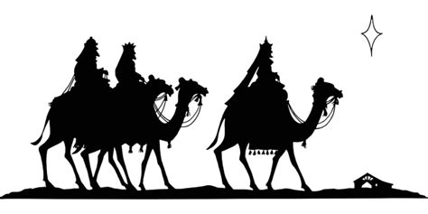
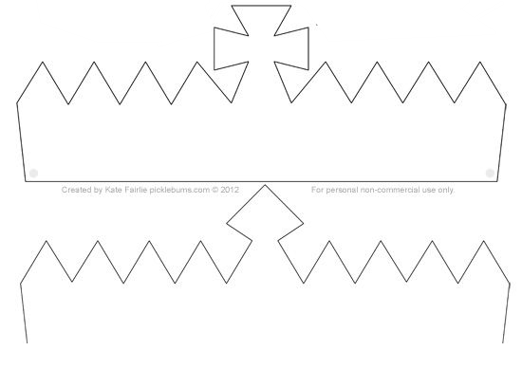
Grade 1- “Peaceful Prayer Corner”
Praying brings us peace. We can tell God our thoughts and feelings, thank Him for the gifts He has given us, and ask Him to help us. In the morning, when you wake up, you can start the day by praying, and when you go to bed at night, you can end the day by praying, too. You can tell God what makes you happy, and what you would like to work on. Trusting in God, Who loves us, can make us feel happy and peaceful, because then we don’t have to worry, knowing that God has a special plan for us, and will give us what we need each day.
We get to know God through prayer and the sacraments. As you get ready to make your sacraments of First Confession and First Communion, you can be like Jesus and Mary by praying. You could make a corner of your room to go to pray.
Draw what your prayer corner would look like. What would you put in your prayer corner to remind you of God, and to bring you peace? How can this help you to get ready to make your sacraments?

______________________________________________________________________________
______________________________________________________________________________

Grade 2- “Peace Within”
Like the Three Kings who followed the star, finding their way to Jesus, we can find peace by following Jesus. We can be with Jesus when we go to Mass, and when we receive the sacraments of Confession and Communion.
The Three Kings listened to God, to Jesus, the King, instead of to the kings of the world. They trusted in God, doing the right thing, by going where God the Father guided them: to His Son.
God gave us each a conscience. This means that within our hearts, we know what the right thing to do is. We know that God would want us to be kind and loving. We can follow God by following His rules, the Ten Commandments, listening to what He is telling us in our hearts.

Grade 2- “Peace Within”
Read the examples of some of the 10 Commandments below. Write about how you can follow each of these Commandments as you prepare to make your sacraments. You may also draw pictures.
- Commandment 3: Keep the Sabbath day holy. (Sunday is the Lord’s Day. Honor God.)
What is something you can do to live out this Commandment and follow Jesus?
______________________________________________________________________________

- Commandment 4: Honor your mother and father. (We respect our parents.)
What is something you can do to live out this Commandment and follow Jesus?
______________________________________________________________________________

How does following the 10 Commandments bring us peace?
______________________________________________________________________________

Week 3
Pre-K/Kindergarten- “Our Lady of Peace”
On January 24, we celebrate Our Lady of Peace. This is another name for Mary, the Mother of Jesus. Mary’s name is also very holy. When we pray, we can ask Mother Mary to help us know Jesus better and become closer to Him. As Jesus’ Mother, Mary can help us to love Jesus even more, because She loves Jesus so much, and She loves us. Mother Mary was always peaceful, because She trusted in God the Father. Jesus trusted in God the Father, too. Like Jesus and Mary, we can trust in God, our Father in Heaven (a place of perfect peace), knowing that He loves us and will help us. Mother Mary, Our Lady, brings peace into our hearts through Her Son, Jesus.
Draw a picture of Mother Mary, Our Lady of Peace. What does it mean to be peaceful like Mary?

Grade 1- “The Treasure of Peace”
This month, we celebrated the feast of Epiphany, remembering the Three Kings who brought Jesus gifts when He was born. The Three Kings honored Jesus as the greatest King. One of the gifts they brought Jesus was gold, a gift given to kings.
In church, the tabernacle is a gold container holding consecrated Hosts on (or near) the altar. The Eucharist, the Host, is Jesus’ Body. Jesus is Present in the Host. The tabernacle is like a beautifully decorated palace for Jesus, the King. We genuflect (kneel on the right knee and bless ourselves with the Sign of the Cross) when we go by the tabernacle to show our love and respect for Jesus.
The gifts the wisemen gave to Jesus were treasures. We can give Jesus the treasures of our heart when we share our love for God by listening to Him, going to Mass, praying, and treating others with kindness. Mother Mary treasured God’s love in Her heart. She thanked God for the gifts He gave Her, most of all, Her Son, Jesus. She remembered the amazing things God had done, and kept peace in Her Heart, knowing God would continue to do good things.
What do you treasure (love) that God has given you? (Write or draw below)
__________________________________________________________________
How can you share the love in your heart with God? (Write or draw below)
______________________________________________________________________________
Tabernacle
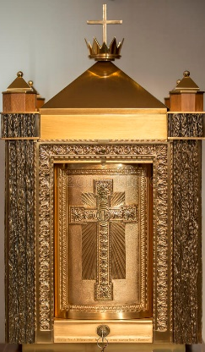
Grade 2- “Peace in God’s Mercy”
When we go to Confession, God shows us His mercy, or forgiveness. We see God’s love in each of the sacraments, including Confession. God forgives us because He loves us, and wants us to continue growing in holiness, so that we can become closer to Him. Every time we go to Confession is a new start, another chance to learn. We can be peaceful in knowing that God will help us to grow stronger in our faith.
Right before we go to Confession, we do an examination of conscience. To “examine” something means to look closely. We learned that God gave us a “conscience,” which means that we know in our hearts what is right and wrong. An examination of conscience is when we look at what we have done, thinking about how we followed God’s rules.
When we think about how we lived out the 10 Commandments, we know what we can talk to the priest about at Confession. We know that if we did not follow one of the 10 Commandments, we should tell the priest, who can help us to think about how we can better follow the Commandments in the future.
To complete an examination of conscience, we go through each one of the 10 Commandments, and ask ourselves if we followed that Commandment, looking back at what we have done. The Commandments are in order: the first three have to do with loving God, and the rest have to do with loving others. Practice learning the 10 Commandments in numerical order. Draw a line matching each Commandment to its correct number (continued on next page).
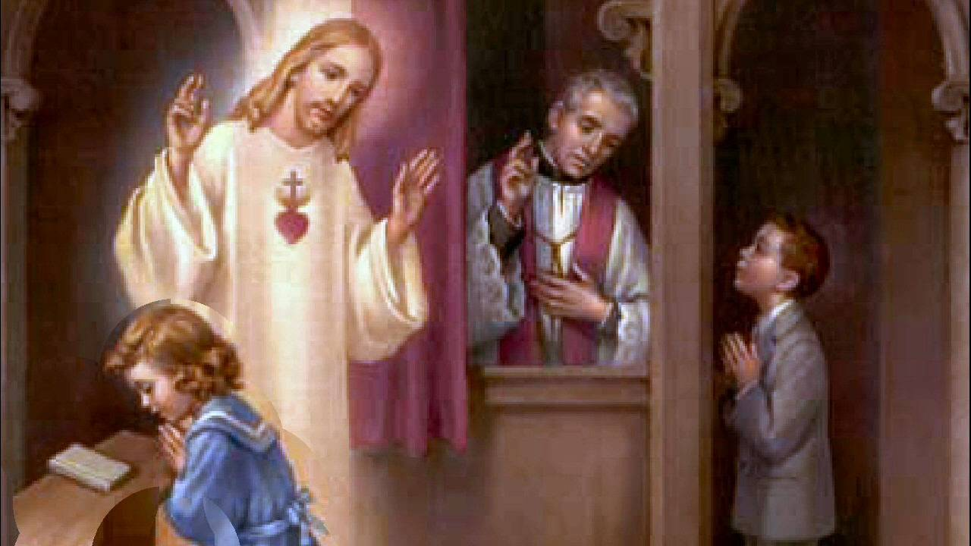

We are happy with what we have 1. 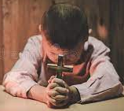
We tell the truth 2. 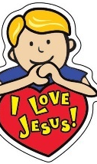
We are loving and gentle 3. 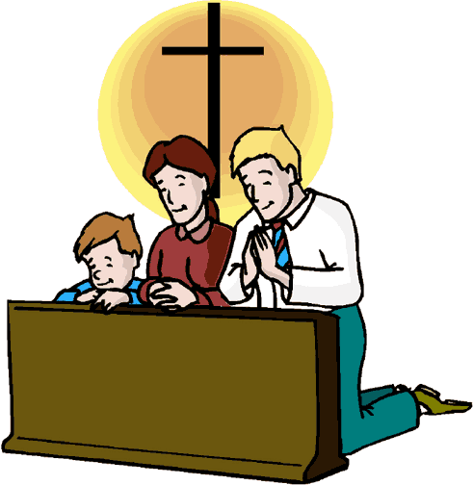
Sunday is the Lord’s Day- we go to Mass and rest 4. 
We respect our parents 5. 
We say God’s name with respect 6. 
7. 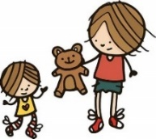
We respect our bodies and the bodies of others 8. 
We respect things belonging to other people
We pray to one true God 9. 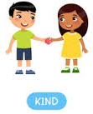
Instead of being jealous, we are kind to each other 10. 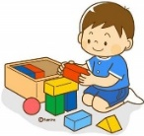
January 2023 Pre-K-2 Review
Use this review sheet as a reference to track progress and check that learning goals are met.
Recap: What did we learn?
All Grades
- The feast of Epiphany is on January 6
- On Epiphany, we remember the Three Kings traveling to visit Jesus
- Praying brings us peace
- Trusting in God the Father, like Jesus and Mary, helps us to be peaceful
Pre-K/Kindergarten
- Jesus’ Name is holy. “Jesus” means “God saves”
- Saying Jesus’ Name is a prayer
- We can talk with Jesus and ask Him to bless us and help us
- When we pray, we can tell Jesus that we love Him
- At Mass, we share our love for Jesus as a Church family
- Going to Mass brings us peace as we learn about God’s love for us
- Mother Mary is also called “Our Lady of Peace”
- Mother Mary helps us to trust in God and have peace in our hearts like Her
Grade 1
- The Three Kings followed the star, trusting that God would help them find their way
- We can be like the Three Kings by following Jesus
- Jesus is the greatest King, because Jesus leads His Kingdom with kindness and love
- We get to know God through praying
- Praying can help us to get ready to receive the sacraments
- When we talk to God through prayer, we can ask Him to help us, thank Him for the gifts He has given us, and tell Him about our feelings
- The tabernacle is where consecrated Hosts are kept in the church
Grade 2/First Confession & Communion
- God forgives us because He loves us
- We experience God’s mercy (forgiveness) through the sacrament of Confession
- Before we go to Confession, we do an examination of conscience, looking at each of the 10 Commandments, and thinking about how we followed them
- God gave us our conscience to help us to know what is right and wrong
- We can follow God by following the 10 Commandments
- We say the Act of Contrition prayer at Confession to tell God we are sorry for when we have not followed His rules, the 10 Commandments
- We do penance to show God that we are sorry, and that we love Him. Penance helps us to make things right. We work on making better choices to make God happy
- After we receive the sacrament of Confession, we are ready to receive Communion. God’s mercy opens our heart to the graces of Communion, which we receive when we make a good Confession out of our love for God
What vocabulary words did we practice?
Pre-K/Kindergarten
Week 1
Jesus Christ
Week 2
Mass
Week 3
Heaven
Grade 1
Week 1
Epiphany
Week 2
Sacrament
Week 3
Tabernacle
Grade 2
Week 1
Contrition
Week 2
Conscience
Week 3
Examination of conscience
What prayers did we practice?
Pre-K/Kindergarten
Guardian Angel Prayer
Grade 1
Guardian Angel Prayer
Grade 2
Act of Contrition
Checklist: Activity Completion
Pre-K/Kindergarten
Week 1: “Peace in Prayer”
Week 2: “Peace in Church”
Week 3: “Our Lady of Peace”
Grade 1
Week 1: “Peace at Epiphany”
Week 2: “Peaceful Prayer Corner”
Week 3: “The Treasure of Peace”
Grade 2
Week 1: “Peace at Confession”
Week 2: “Peace Within”
Week 3: “Peace in God’s Mercy”
Quick Check:
Did your child fully answer all of the questions (in spoken discussion or in writing)?
Did your child demonstrate their understanding of concepts through their artistic response (i.e. drawings)?
Did your child use their vocabulary words in spoken discussion or in writing?
Did your child practice saying their prayers and applying their knowledge, such as by making the Sign of the Cross or helping to say grace at a meal?
Did you and your child work on the monthly challenge to put our theme into practice?
Did you use the thematic guiding questions to discuss concepts related to the theme?
Tell us about your experience with these activities this month! Our January 2023 Google Form for Grades Pre-K/K-2 is available here: https://forms.gle/41Xifqi6YV5Z2HTX9
Answer Key: Activity 3, Grade 2- 10 Commandments, “Peace in God’s Mercy”
- Commandment 1: You shall not worship any other gods before me. (We pray to one true God. We put God first.)
- Commandment 2: You shall not use the name of the Lord in vain. (We use God’s name with respect. We don’t say it with anger, but with love. We use God’s name to pray and bless.)
- Commandment 3: Keep the Sabbath day holy. (We go to Mass on Sunday, spending this day becoming closer to God. Rest, pray, and spend time with family to stay focused on God. Sunday is the Lord’s Day.)
- Commandment 4: Honor your mother and father. (We respect our parents.)
- Commandment 5: You shall not kill. (We do not hurt ourselves or others. We are loving and gentle.)
- Commandment 6: You shall not commit adultery. (We respect our bodies and the bodies of others.)
- Commandment 7: You shall not steal. (We respect things belonging to other people instead of taking them.)
- Commandment 8: You shall not bear false witness. (We tell the truth instead of telling lies.)
- Commandment 9: You shall not covet your neighbor’s wife. (Instead of being jealous, we are kind to each other.)
- Commandment 10: Do not covet your neighbor’s goods. (We are happy with what we have. We focus on what God has given us, like our families and friends, and not only on things.)

